Retail member insights
  - Project report, Sharon Okolo
Code: https://github.com/SharonOkolo/retail-member-insights
Two years of transactions from a UK online retailer (1.07m rows) turned into three decision tools: who our customers are, which valuable customers are about to stop buying, and how much stock to plan for the next 8 weeks, plus a check that the model treats every customer group fairly.
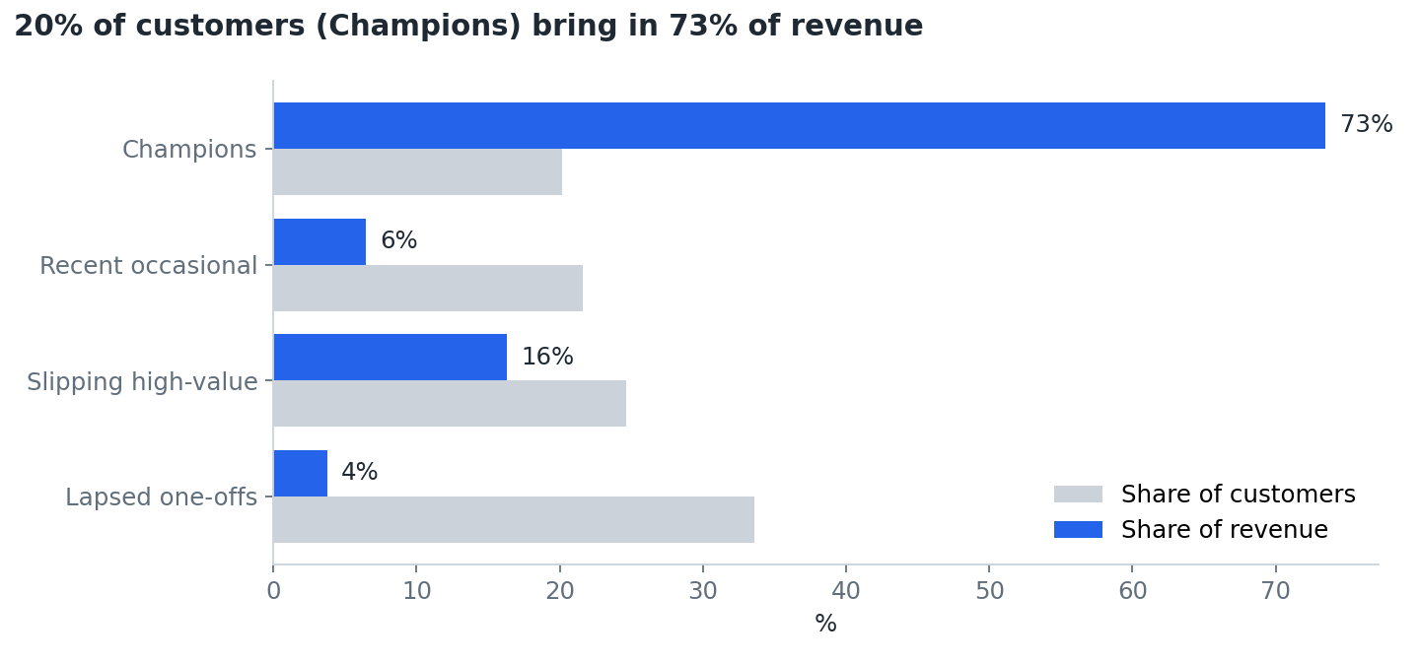
Segments

The problem I solved
A retail CRM or membership team needs to know where to spend a limited retention budget, and a buying team needs a forecast better than “same as last week”. The raw data couldn’t answer either question: 23% of rows had no customer ID, about 30,000 rows were cancellations or orders that were later cancelled, and 25,728 rows were exact duplicates. Analysed as it was, the data would have made two customers look like the biggest spenders, purely because of large orders that were later reversed.

The process I optimised
Before (a typical manual approach) | Now (this pipeline)
Spreadsheet exports cleaned by hand, with rules applied inconsistently | Layered SQL: bronze (raw) → silver (clean) → gold (customer and weekly marts), the same layers on Databricks Delta tables
Excluded rows disappear silently | Every excluded row is counted by reason in a data-quality log, and the run fails if counts don’t reconcile
Segments defined by gut feel | k-means on recency, frequency and spend, with k chosen by silhouette score and segments named by rules
A list of “inactive” customers after they have already gone | A lapse model that scores every customer before they leave
Forecast = last week’s sales | A global gradient-boosting forecast tested on a hold-out against three baselines
Re-running means redoing the work | python3 analysis.py rebuilds everything from 1.07m raw rows in about 8 seconds, with built-in data-quality checks

The results I got
Data quality. 1,067,371 raw rows → 767,349 clean sales lines. Removed: 242,257 with no customer ID, 25,728 exact duplicates, 19,494 cancellations, 9,915 order lines matched to a later cancellation (a rule I added after two customers showed £168k and £77k of “spend” that had been fully reversed), 2,560 postage, fee and adjustment codes, and 68 zero-price lines.
Segments (5,838 customers, £16.3m revenue over two years).
Segment | Customers | Median days since last order | Median orders | Share of revenue
Champions | 1,178 (20%) | 17 | 13 | 73%
Recent occasional | 1,261 (22%) | 24 | 3 | 6%
Slipping high-value | 1,438 (25%) | 185 | 4 | 16% (£2.66m)
Lapsed one-offs | 1,961 (34%) | 401 | 1 | 4%
Lapse prediction. Trained on customers’ history before 1 Sep 2011; label = no purchase in the next 90 days (base rate 57%).
Model | ROC AUC | Precision | Recall | F1
Logistic regression | 0.80 | 0.74 | 0.82 | 0.78
Decision tree (depth 4) | 0.80 | 0.72 | 0.83 | 0.77
Gradient boosting | 0.82 | 0.75 | 0.83 | 0.79
Demand forecast (top 20 products, 8-week hold-out from 3 Oct 2011).
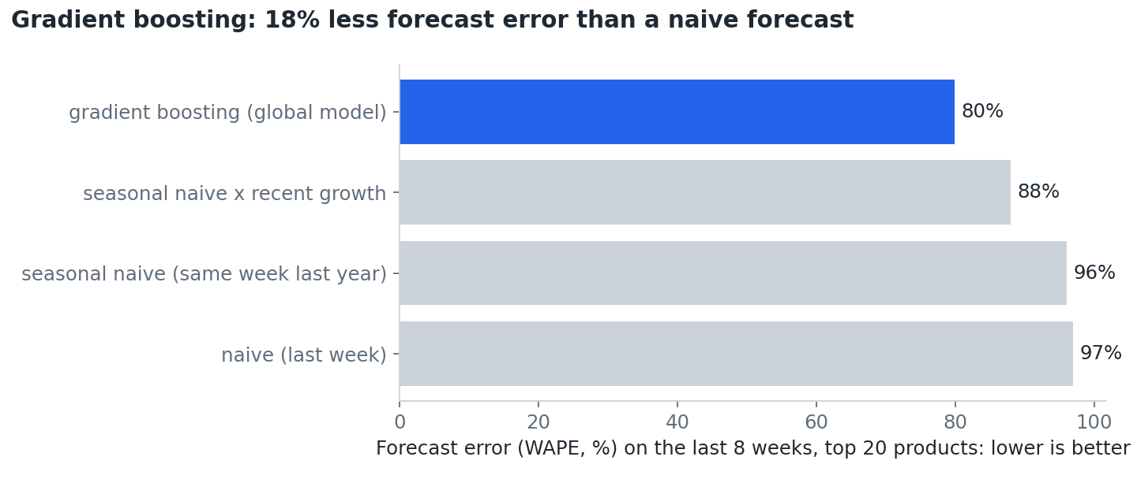
Forecast error
The global gradient-boosting model has 18% less forecast error (WAPE) than a naive forecast and 17% less than the same week last year: 15,770 fewer units forecast wrongly over 8 weeks, about £17,000 of stock at average sale price.
Responsible AI: the finding that changes the recommendation.
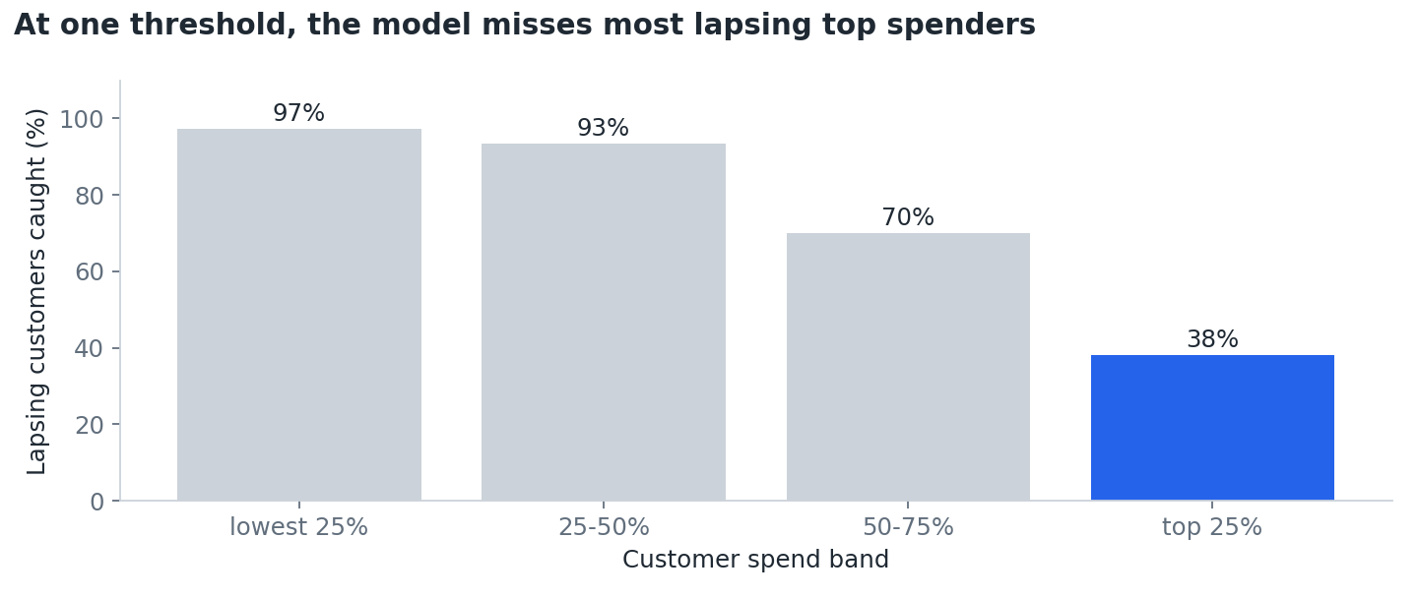
Fairness
With one 0.5 threshold, the model catches 97% of lapsing low spenders, but only 38% of lapsing top-25% spenders, the customers worth the most, while flagging 86% of loyal low spenders by mistake. A single threshold would send most of the retention budget to the wrong people. Lowering the top-spend threshold to 0.3 raises recall for that group to 69%, with 26% of loyal top spenders flagged.

Recommendations
- Protect the Champions. 20% of customers bring in 73% of revenue: give them a named account owner and early access to offers.
- Win back the 408 top-quartile customers flagged at the 0.3 threshold (£1.81m of spend over two years), using the ranked list in customer_scores.csv, before they reach the “Lapsed one-offs” segment.
- Use segment-specific thresholds, not one cut-off. Lower the threshold for high spenders and raise it for low spenders, so contact spend follows customer value.
- Replace “same as last week” ordering with the global forecast for the top 20 lines, and review error weekly.
- Fix cancellations at source. Linking each cancellation to its original order line in the order system would remove the need for the matching rule.

Limitations: what I’d do with more data
- No member data. There are no demographics or membership status, so fairness is checked by market (UK vs international) and spend band only. With member data I would also check age, region and deprivation (IMD).
- Wholesale-heavy customers. Many customers are small businesses, so “lapse” partly reflects ordering cycles.
- One split, one hold-out. Results vary by a few points with different random splits; next step is time-based cross-validation and backtesting the forecast over several origins.
- Cancellation matching pairs on customer, product and exact quantity, so partial returns are not matched.
- Two years of history gives the forecast only one previous season to learn from.

Appendix A: model card (customer lapse model)
Model: scikit-learn GradientBoostingClassifier (default settings, random_state 42), chosen over logistic regression and a depth-4 decision tree on ROC AUC.
Intended use: rank existing customers by the chance they will make no purchase in the next 90 days, so a CRM team can prioritise win-back contact. A person reviews the list; the model should not trigger automatic decisions such as withdrawing offers or changing prices.
Not for: credit, pricing or any decision about an individual’s eligibility for something.
Training data: 5,214 customers with purchases before 1 Sep 2011 (UCI Online Retail II, CC BY 4.0). Label = no purchase from 1 Sep to 29 Nov 2011. Base rate 57%. Features: recency, frequency, spend, tenure, average basket, distinct products, UK flag. No personal or protected characteristics are available or used.
Evaluation (25% stratified hold-out, 1,304 customers): ROC AUC 0.82, precision 0.75, recall 0.83, F1 0.79 at threshold 0.5.
Fairness and performance by group: | Group | Lapse rate | Recall | False-positive rate | ROC AUC | |—|—|—|—|—| | UK | 58% | 0.83 | 0.37 | 0.81 | | International | 51% | 0.84 | 0.29 | 0.83 | | Lowest 25% spend | 80% | 0.97 | 0.86 | 0.71 | | Top 25% spend | 26% | 0.38 | 0.08 | 0.80 |
Known issue: at one threshold, the model under-detects lapse among top spenders (their base rate is much lower) and over-flags low spenders. Mitigation: use a threshold per spend band (0.3 for the top band gives recall 0.69 and a false-positive rate of 0.26) and review the list by hand.
Limitations: two years of data; wholesale ordering cycles blur what “lapse” means; one random split (metrics move by a few points with other seeds); no demographic data, so fairness can only be checked by market and spend.
Monitoring if deployed: monthly AUC and recall by spend band, lapse base rate drift, and feature drift for recency and frequency.

Appendix B: data dictionary

silver_sales (one clean sales line)
Column | Type | Meaning
invoice | text | Invoice number (6 digits; cancellations start with C and are excluded)
stock_code | text | Product code (5 digits, optionally a letter suffix)
description | text | Product name
quantity | int | Units on the line (> 0)
invoice_ts | timestamp | Invoice date and time
price | float | Unit price, £ (> 0)
customer_id | int | Anonymous customer number (never null in silver)
country | text | Customer’s country
revenue | float | quantity × price
Exclusion rules (counted in silver_dq_log): cancellation invoices; no customer ID; order lines matched to a later cancellation (same customer, product and opposite quantity); quantity ≤ 0; price ≤ 0; non-product codes (postage, bank charges, manual adjustments); exact duplicate rows.

gold_customer_features (one row per customer at a snapshot date)
Column | Meaning
recency_days | Days from the last order to the snapshot
frequency | Number of distinct invoices
monetary | Total spend, £
tenure_days | Days from the first order to the snapshot
avg_basket | Average invoice value, £
distinct_products | Number of different products bought
country | Most common country on the customer’s orders
Snapshots: 2011-09-01 for training the lapse model (gold_lapse_features) and 2011-12-10 for segmentation and current scoring (gold_customer_features).

gold_lapse_labels
Column | Meaning
lapsed | 1 if the customer made no purchase in the 90 days from 2011-09-01, else 0

gold_weekly_product_sales
Column | Meaning
stock_code, week_start | Product and week (weeks start on Monday)
units, revenue | Units sold and revenue that week

customer_scores.csv (written by analysis.py)
Customer features plus cluster, segment and lapse_prob (gradient boosting, scored at 2011-12-10).

Appendix C: data source
Online Retail II, UCI Machine Learning Repository (Chen, D. 2012), https://archive.ics.uci.edu/dataset/502/online+retail+ii, licence CC BY 4.0. All transactions of a UK online gift-ware retailer, 1 Dec 2009 to 9 Dec 2011: 1,067,371 rows. Prices in pounds sterling; customer IDs are anonymous.

