KIJANI KIOSK CAPSTONE

Pipeline Demonstration Evidence

Infrastructure- Track A

Demonstration Video

Loom video: https://www.loom.com/share/07a84669875e4570b2d97c6cfd2009e6

The Loom demonstration covers the CI/CD workflow through the production approval gate. The accompanying screenshot evidence document continues from the approval gate and provides the remaining implementation, failure/recovery, Kubernetes, Serverless, and Prometheus evidence.

Production Approval Gate

This evidence shows the production approval gate reached at the end of the successful CI/CD pipeline execution, continuing directly from the Loom demonstration.

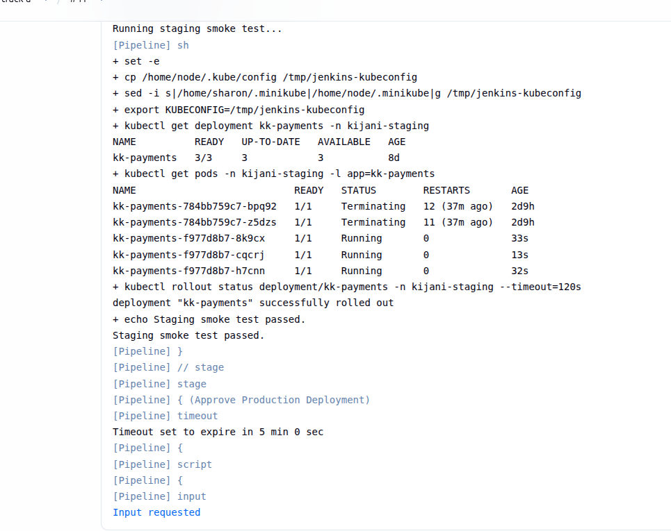

Production Approval Granted

This evidence shows the approval being granted, allowing the validated deployment process to proceed.

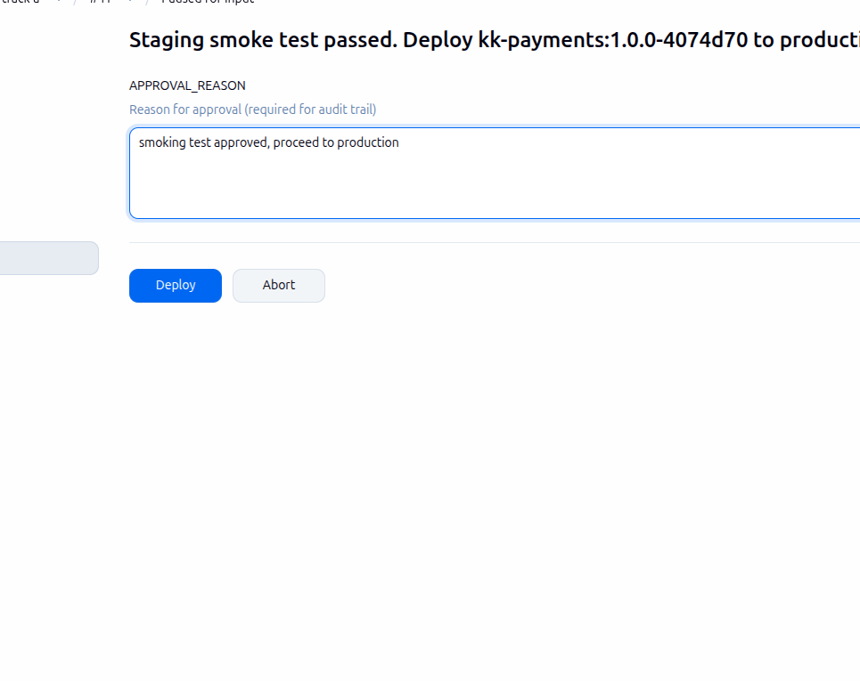

Successful Deployment

This evidence confirms that the approved deployment completed successfully in the target environment.

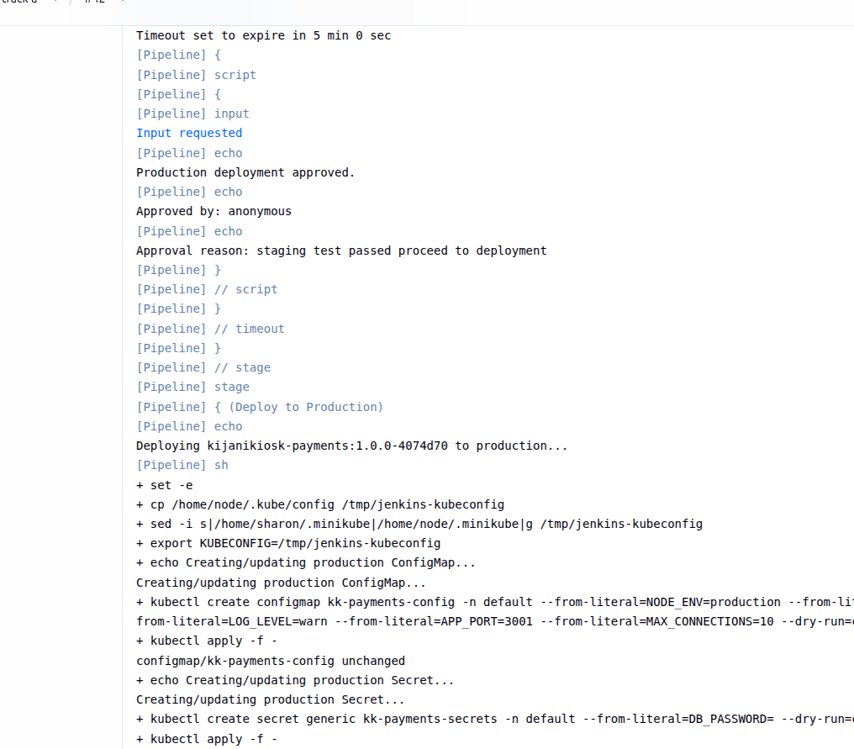

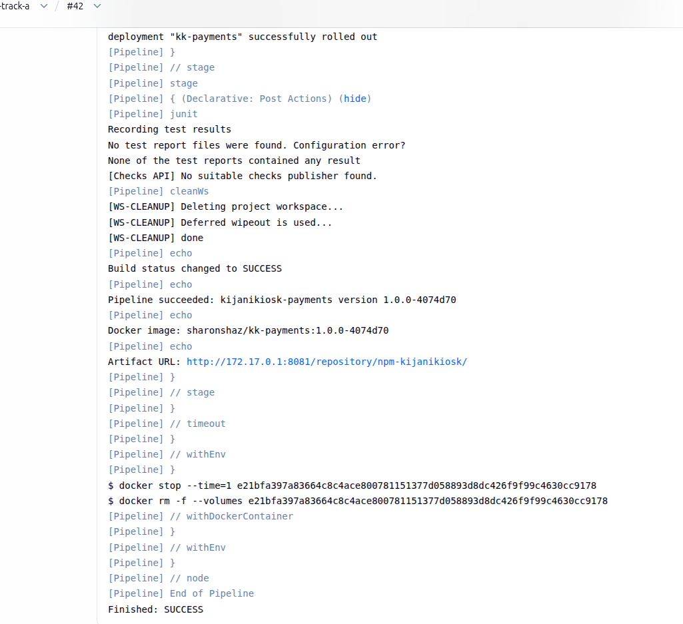

Deliberate Failure Introduced

This evidence shows the intentionally introduced faulty deployment condition used to demonstrate failure detection and operational recovery.

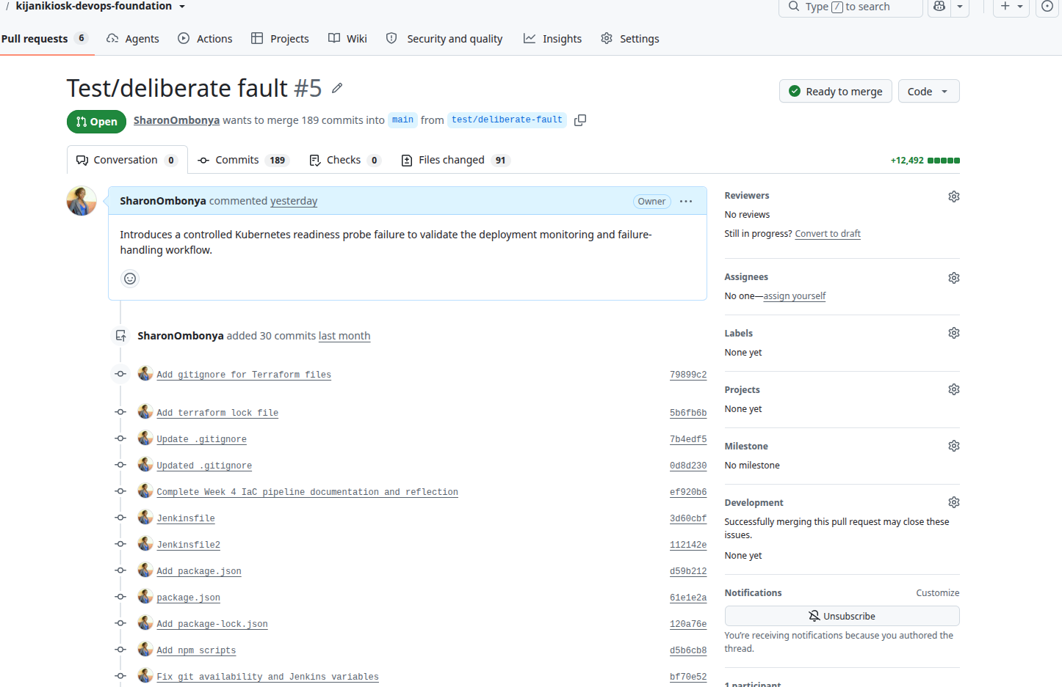

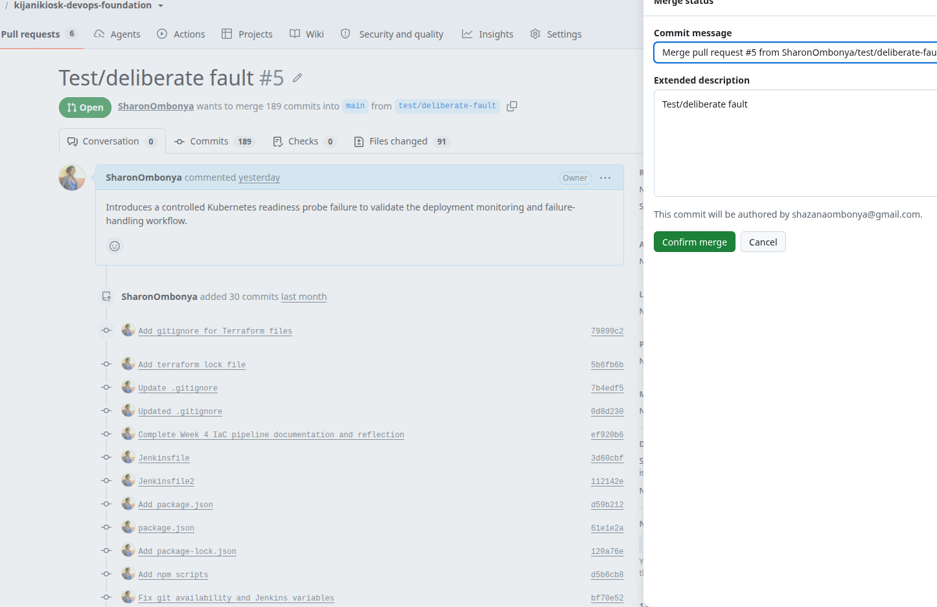

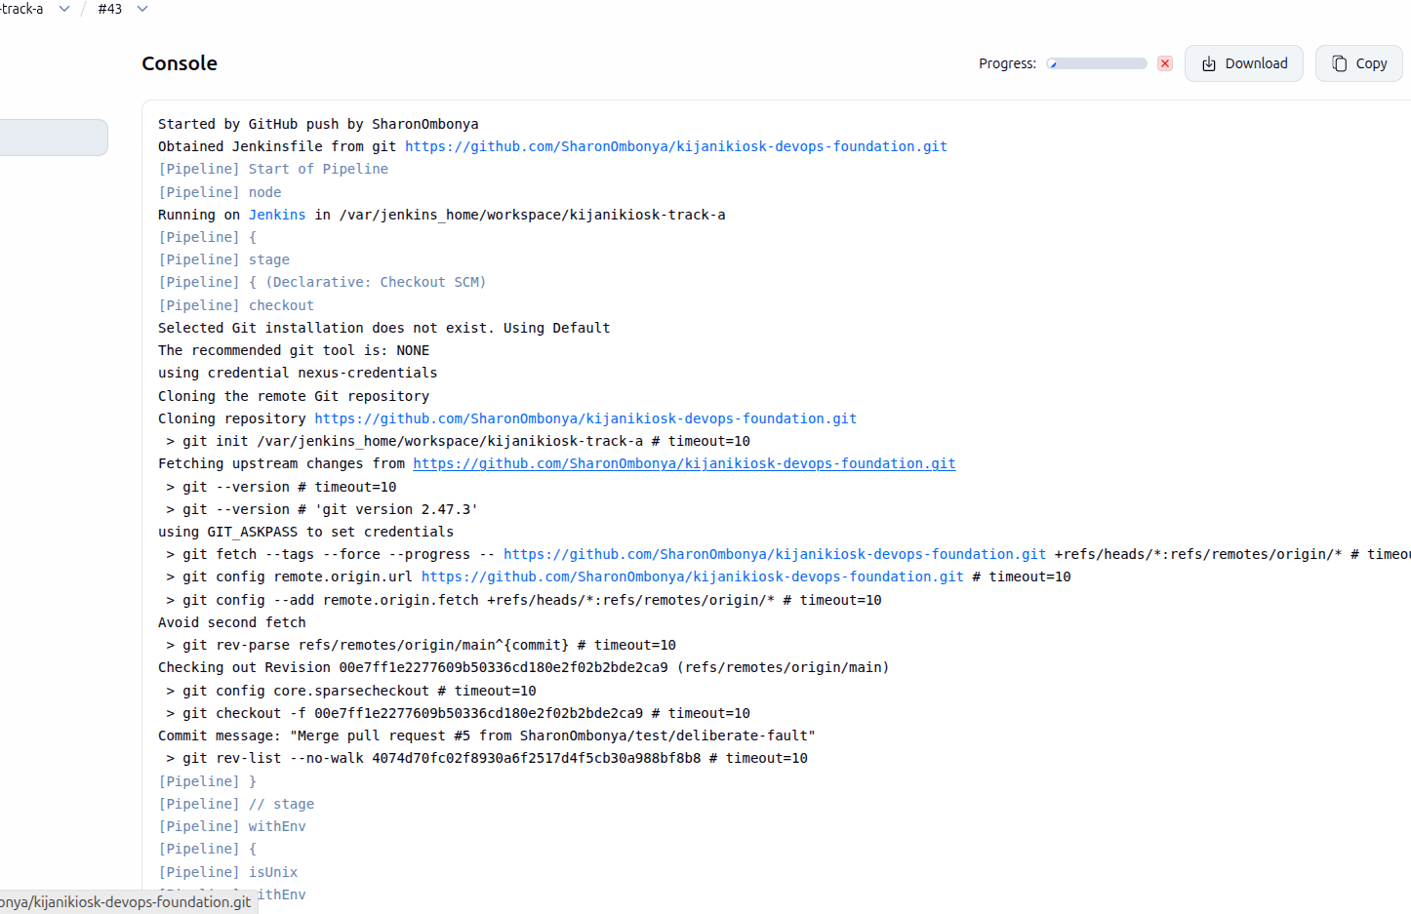

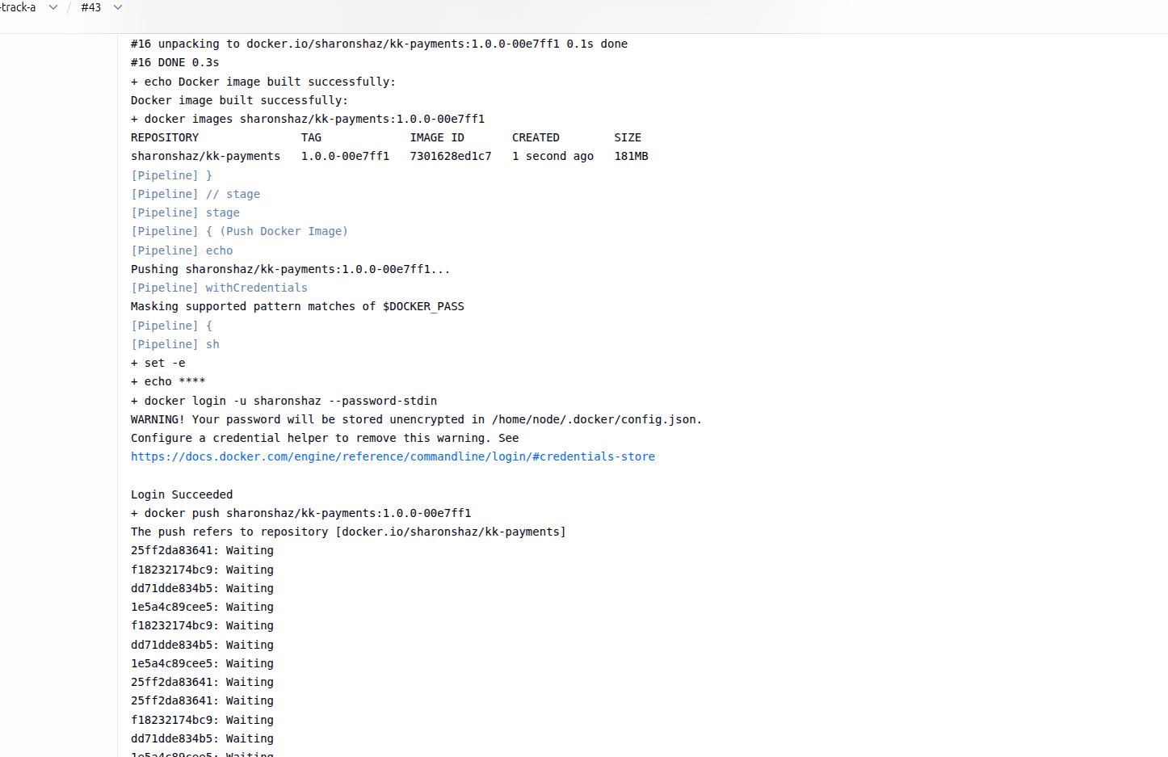

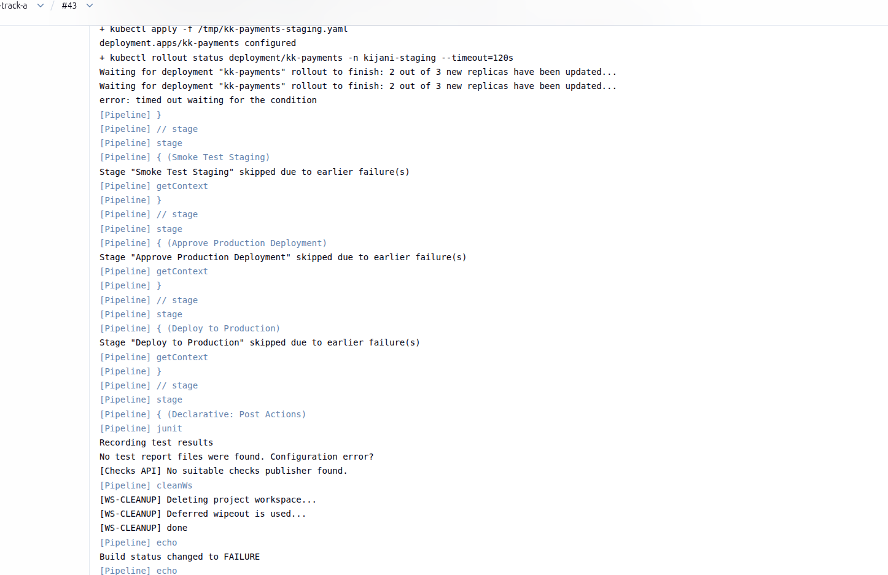

Kubernetes Pod Evidence

This evidence shows the Kubernetes workload state following the faulty deployment and provides evidence of the resulting application impact.

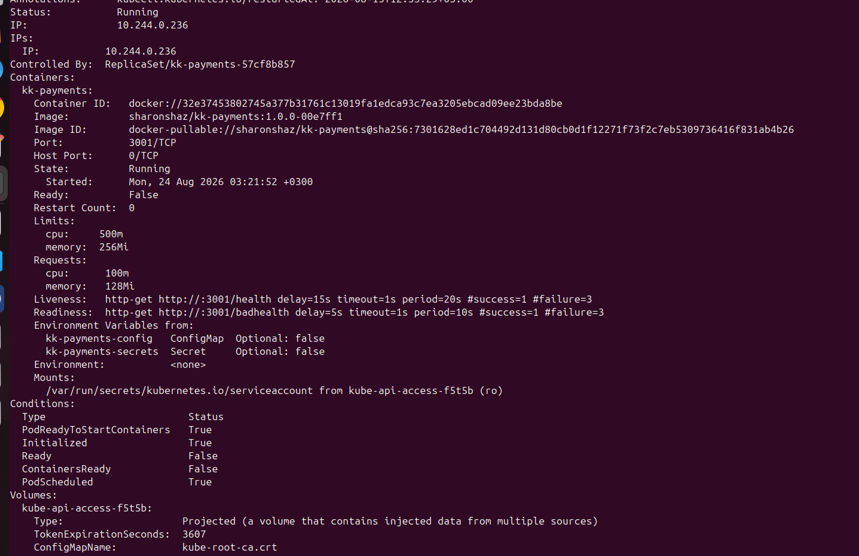

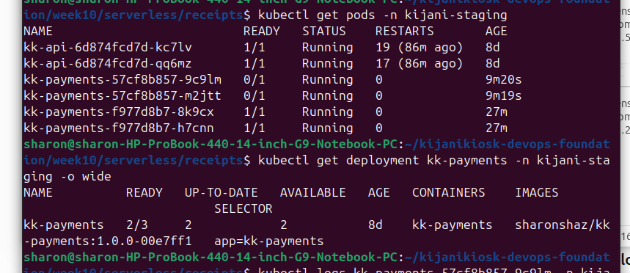

Recovery

This evidence shows the application returning to a healthy state after the faulty condition was corrected.

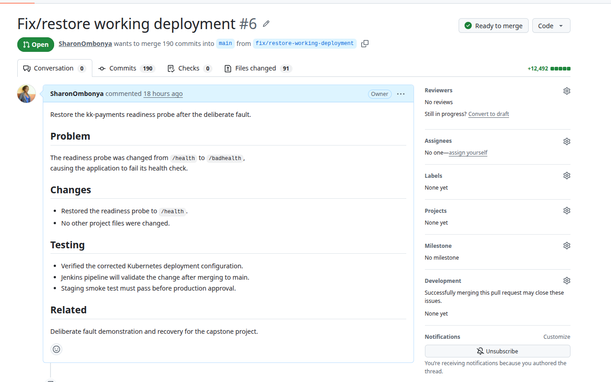

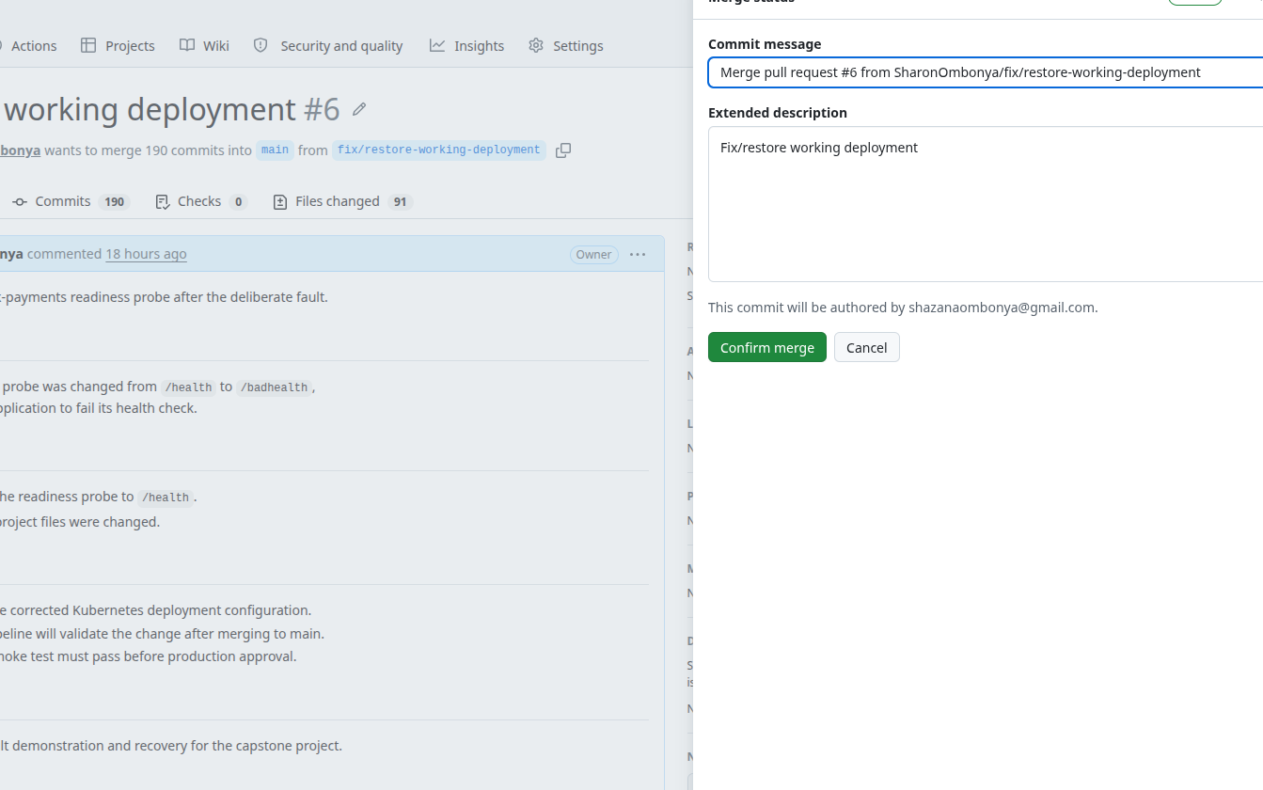

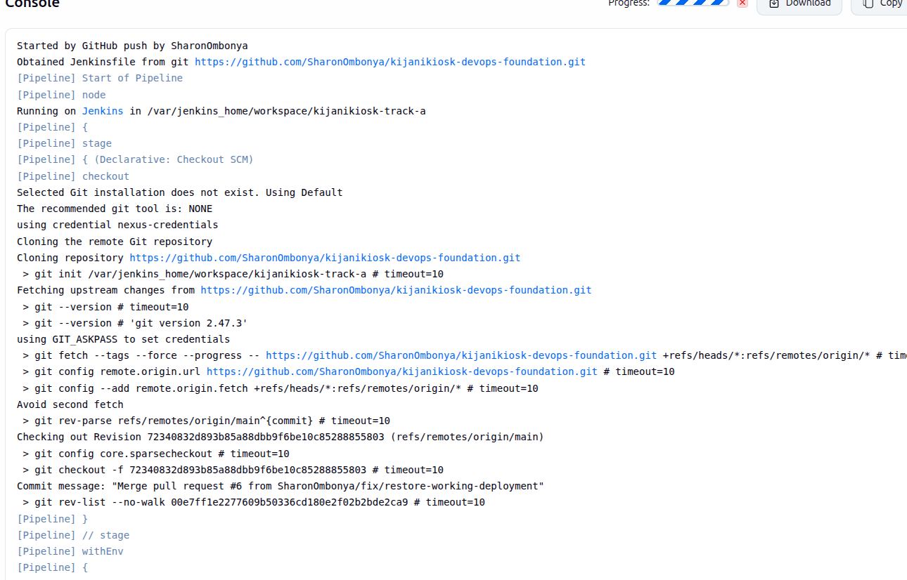

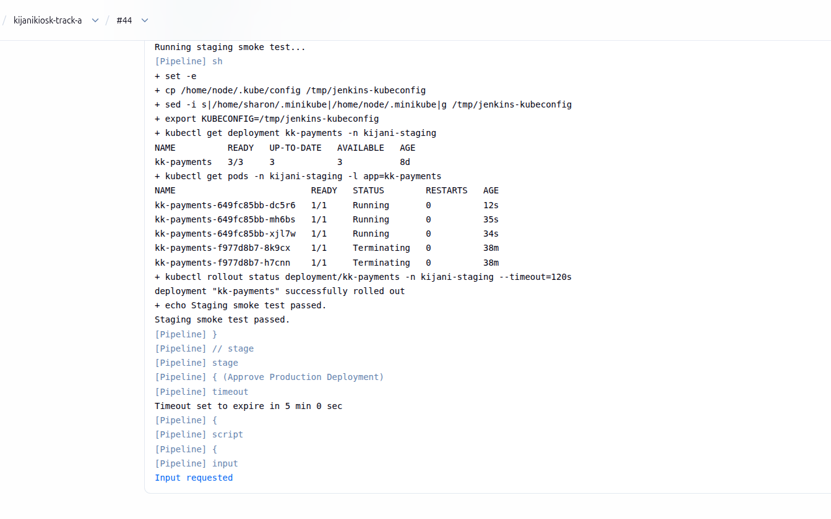

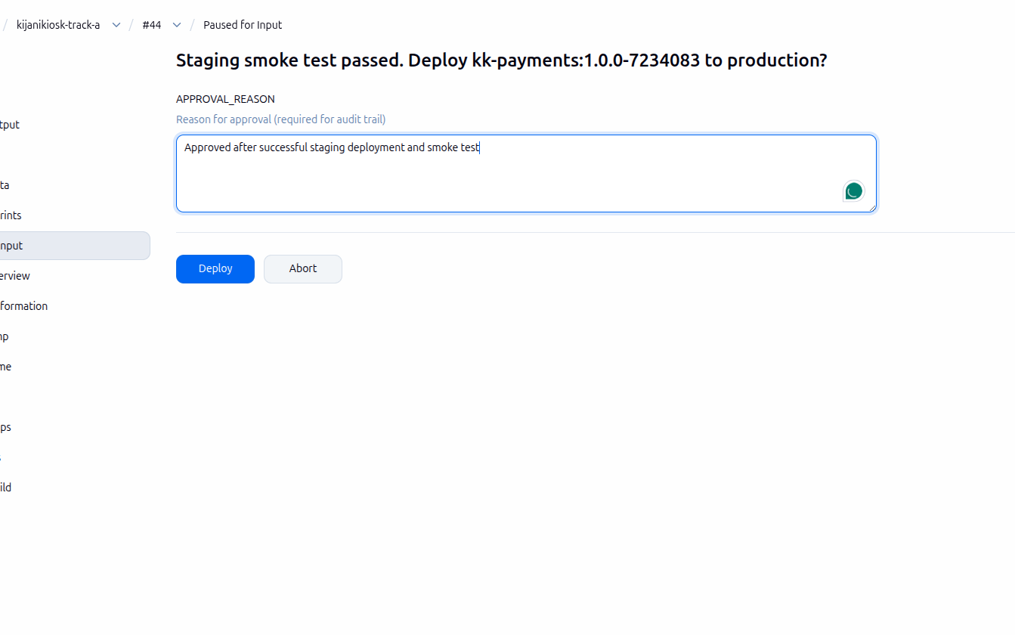

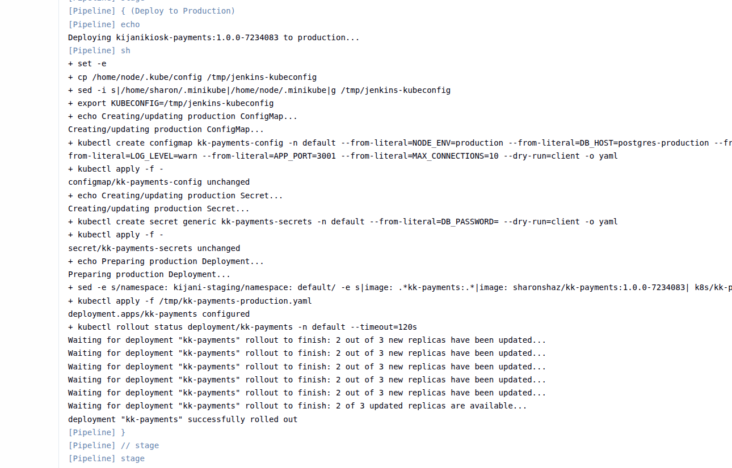

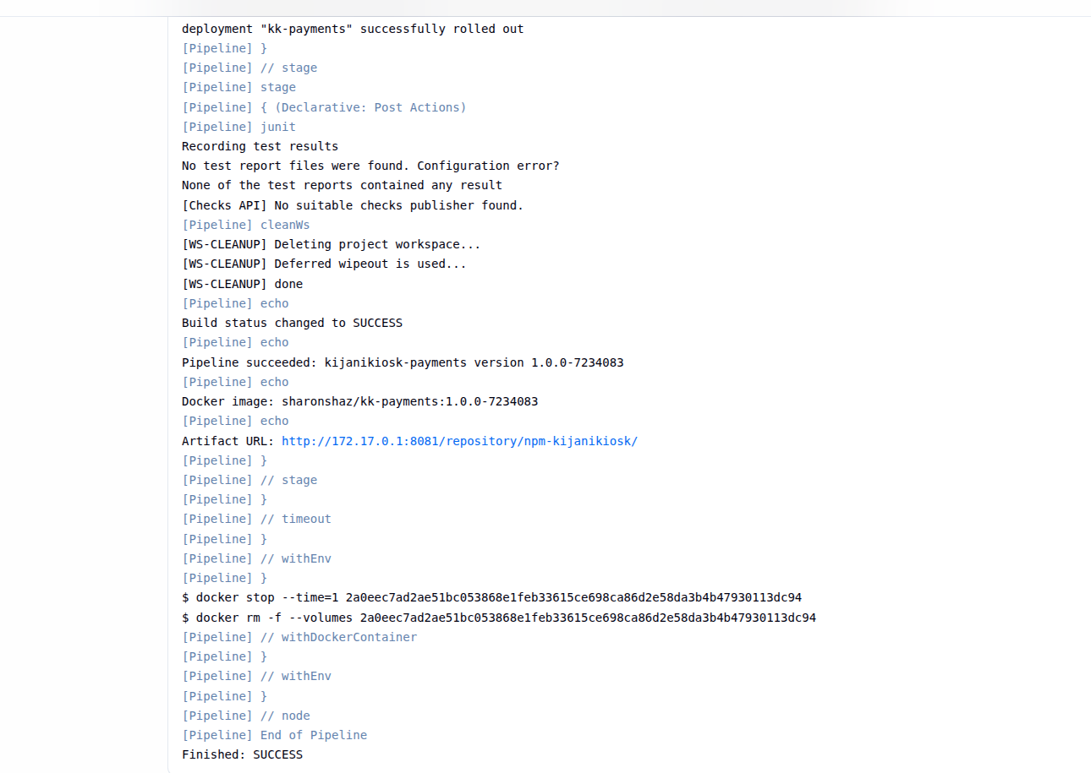

Kubernetes Recovery Evidence
This evidence confirms recovery of the kk-payments workload, with the Kubernetes pods returning to a healthy Running and Ready state after the faulty condition was corrected.

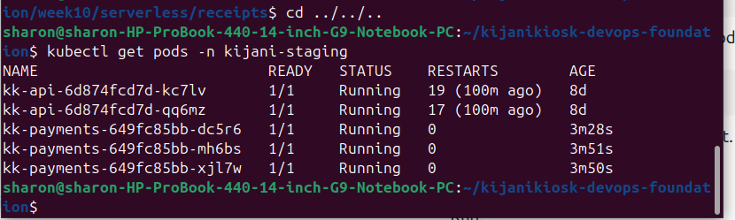

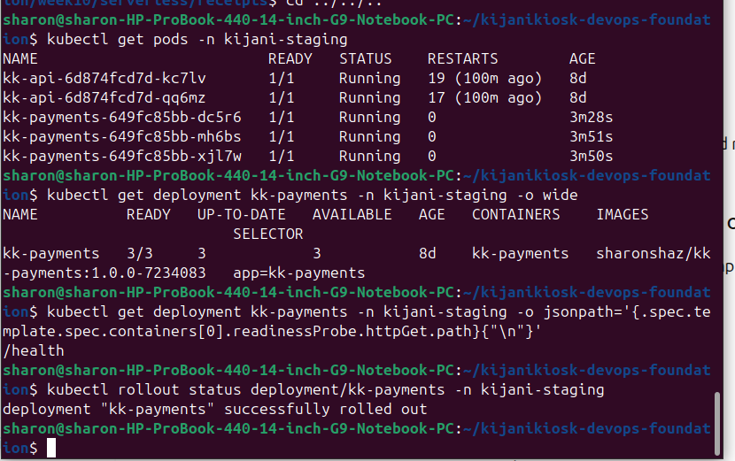

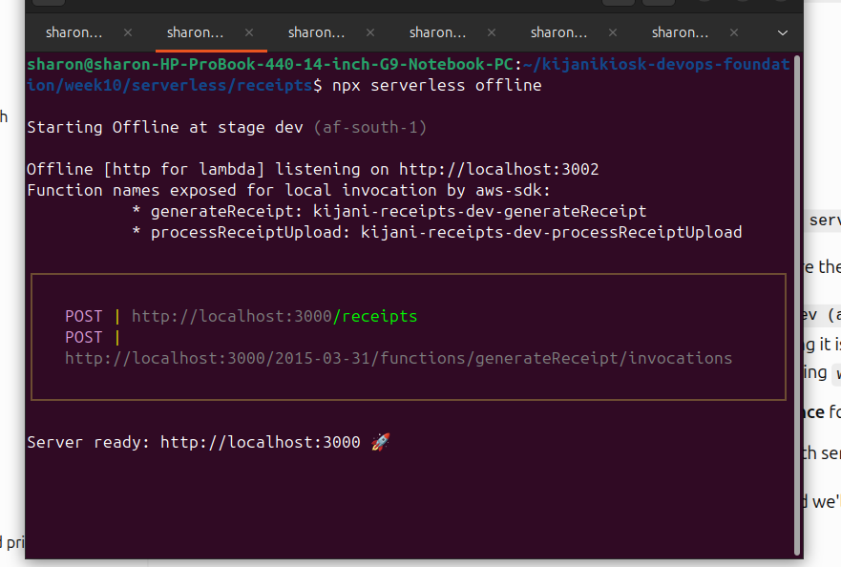

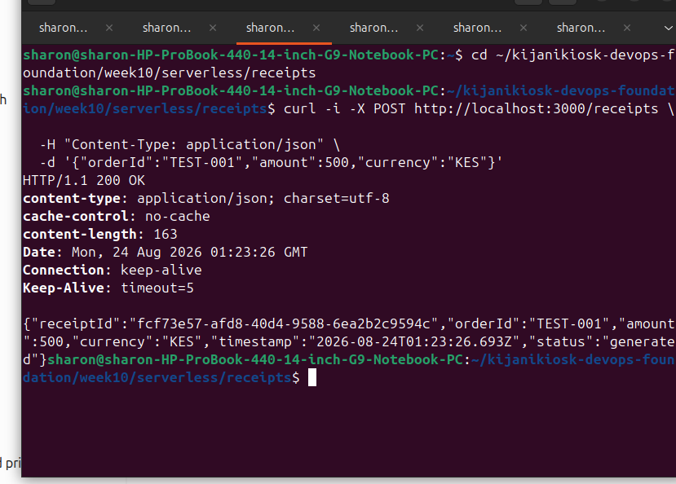

Prometheus Monitoring Stack

This evidence shows the Prometheus monitoring stack running in the Kubernetes cluster, providing the monitoring infrastructure for the application.

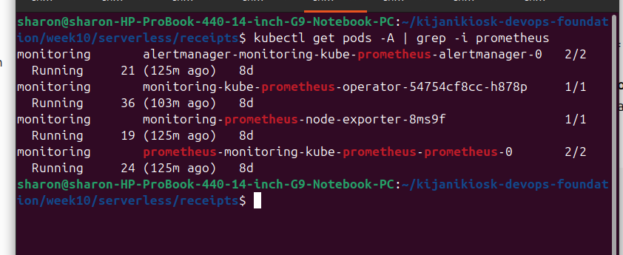

Prometheus Alert Rule

This evidence shows the custom KKPaymentsPodRestart alert rule deployed in Prometheus to monitor payment-service container restarts.

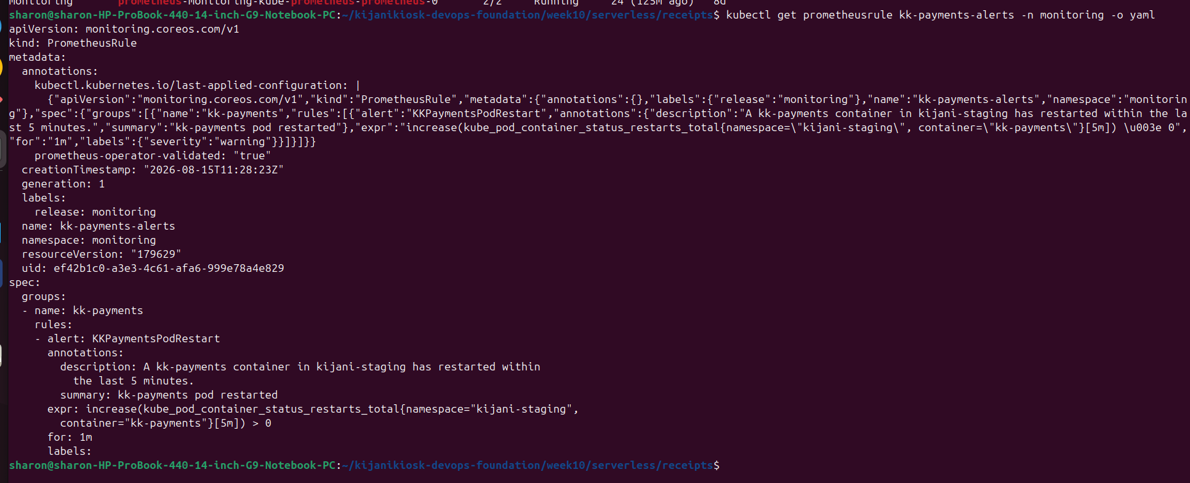

Prometheus Alert Evaluation

This evidence confirms that Prometheus has successfully loaded and evaluated the KKPaymentsPodRestart rule. The rule is currently inactive because no qualifying payment pod restart is occurring.

