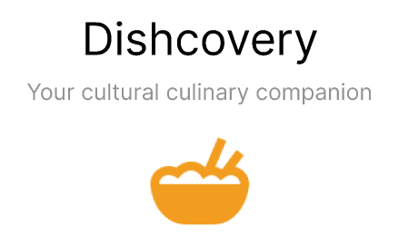

Defne Genç | Janet Zhong | Amrita Palaparthi | Kyla Guru

### **Med-Fi Prototype Figma Link:**

[Figma Demo Link](https://www.figma.com/proto/kJbYMdKZmAbuYmf9PPZimU/Version-1?node-id=1%3A8&scaling=min-zoom&page-id=0%3A1&starting-point-node-id=1%3A8)

### **Design Tools**

Our team used **Figma** to create the med-fi prototype. Our chosen screen for the interactive demo is an iPhone 14 screen. The additional context information was sourced from various internet pages, though a system for finding this information for the hi-fi prototype has not been decided yet. We also used **Picular** to gain inspiration for color palettes, and **Pinterest/Google Drive** for moodboarding.

### **Operating Instructions**

Onboarding

* In the final hi-fi prototype there will be an onboarding page where users can input dietary requirements and preferences but this has not been included in the med-fi prototype.

Navigation bar (bottom of screen):

* The navigation bar contains all the functionality of the app. It has three buttons:  
  - search button (for searching for ingredients using the keyboard)  
  - the camera button (for scanning an unfamiliar food item)  
  - the saved button (for saved recipes).
* The camera button is the largest as this is the main function of our app.

 Scanning an ingredient and ingredient context

* The camera button opens the iPhone camera. We implemented a UI that mimics scanning a QR code but with an ingredient. Although not implemented in this med-fi prototype, it would also be good to have an upload from camera roll instead of just a scanning camera feature.
* After the camera focuses on the ingredient the top image-recognition results for the ingredient and their confidence interval is shown. Users can click on the > arrow to go to the additional context page.
* In hidden tabs (so as to not overwhelm the user) the user can manually click to receive further information about an unfamiliar ingredient (“Flavor Profile/Texture”. “My Origins”, “Cultural Context” and “Tips and Nutritional Information”)

Searching and filtering recipes

* Users can click on the search icon which brings the user to the explore page
* Searching for an ingredient while give dishes where it is filtered by recipe. A user can then further filter these recipes by occasion, difficulty, dietary requirements, time required and user reviews.

Saved recipes

* The saved button is fairly straightforward and reveals a gallery of saved recipes.

### **Limitations**

Interactive Maps

* In the contextualization flow, our prototype doesn’t yet include a map that shows a clickable journey of the ingredient rather than a static image of the maps for context.

Functionality to Add Reviews

* In the recipe flow, the user is currently unable to add their own reviews to recipes that they try, or filter by review star-rating.

Sharing

* In our med-fi prototype, we do not have screens to share recipes you’ve shared over social media or other messaging apps.

Full Filter Options

* User cannot dynamically change filters currently or see how results change depending on the filters applied.

### **Wizard of Oz Techniques (and hard-coded items)**

Image Recognition

* We do not have the hard-coded image recognition API installed. Thus, to mimic the scanning of an ingredient feature, we include a pre-selected bitter melon image.

Previous Scans (recommendation feature based on scanned images)

* We do not have a saved database of previously scanned images so this feature is not functional in our med-fi prototype and are instead replaced with various images of dishes to simulate the experience).

Contextual information of the food

* We do not have a systematic way of finding the additional information (“Flavor Profile/Texture”. “My Origins”, “Cultural Context” and “Tips and Nutritional Information”) so we have manually sourced this information in this prototype.