第二次实验报告

姓名：张书琪 学号：04016606

程序目的：本文档旨在说明协作通信网络中，中继采用AF协作网络的结构框架。

以及非协作系统中AF的实际和理论误码率曲线

运行环境：Matlab R2018b

通信模型：三端点通信模型：

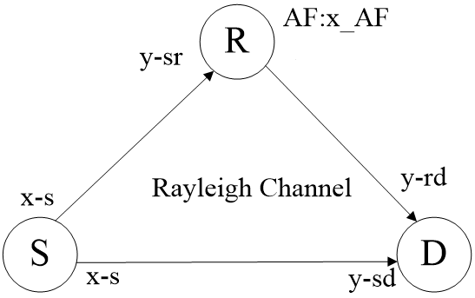

程序入口：code.m

程序结构图：

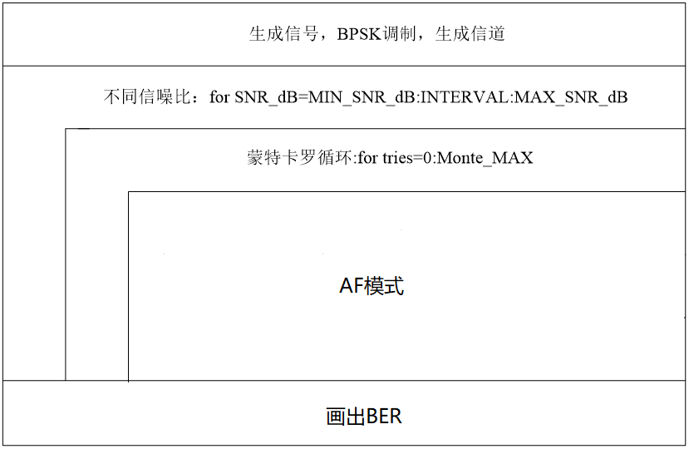

程序流程图：

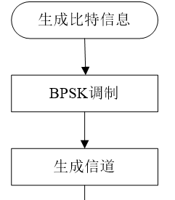

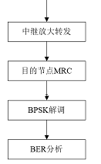

AF策略流程图

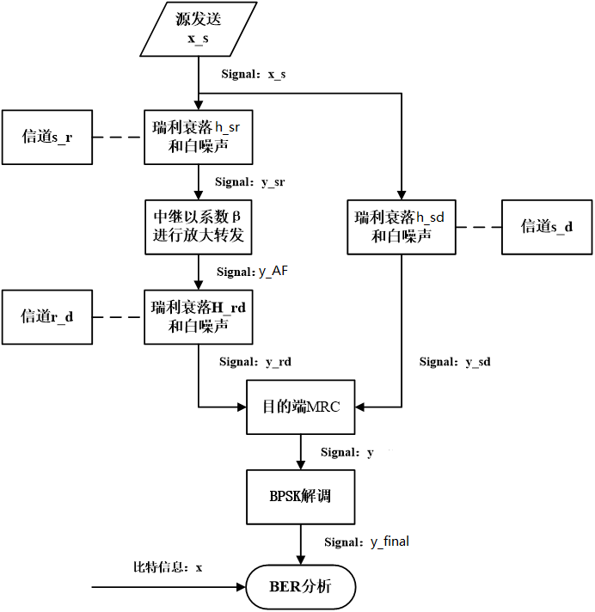

程序代码：

%% original definition

MIN_SNR_dB = 0;

MAX_SNR_dB = 14;

INTERVAL = 0.5; % SNR interv

POW_DIV = 1/2; % Power division factor功率分配系数,with cooperation, in order to guarantee a certain power of the total,

% respectively, the Source using the 1/2 of the power to send signals to the Relay and Destination

POW = 1; % without cooperation,Source send signals directly to the Restination with full power

Monte_MAX=10^1; % the times of Monte Carlo,Limited to the computer configuration level, select the number to 10

%% (Signal Source) Generate a random binary data stream

sigma = 2; %方差开方

M = 2; % number of symbols

N = 10000; % number of bits

x = randi([0,1],1,N); % Random binary data stream %产生一个1*N的矩阵，矩阵中元素取值范围为[0,(M-1)]

%% Modulate using bpsk

h = modem.pskmod(2);%产生2psk调制器

x_s= modulate(h,x); %调制产生源信号

%x_s = modulate(pskmod(M),x); % The signal 'x_s' after bpsk modulation

%%

h_sr = Rayleigh(1); %源与中继节点 信道衰落系数

h_sd = Rayleigh(1); %源与目的节点 信道衰落系数

h_rd = Rayleigh(1); %中继与目的节点 信道衰落系数

%% In different SNR in dB

snrcount = 0;

for SNR_dB=MIN_SNR_dB:INTERVAL:MAX_SNR_dB

snrcount = snrcount+1; % count for different BER under SNR_dB

%err_num_SD = 0; % Used to count the error bit

err_num_AF = 0;

%err_num_DF = 0;

for tries=0:Monte_MAX

sig = 10^(SNR_dB/10); % SNR, said non-dB 信噪比 非分贝单位

POW_S = POW_DIV; % Signal power信号功率

POW_N = POW_S / sig; % Noise power噪声功率

%SNR_dB = 1.5;

%n_sr = 0.5; %源与中继节点之间的信道噪声

%n_sd = 0.6; %源与目的节点之间的信道噪声

%n_rd = 0.65; %中继与目的节点之间的信道噪声

%y_sr = h_sr*(Ps^0.5)*x_s + n_sr; %中继节点接收到的信号

%y_sd = h_sd*(Ps^0.5)*x_s + n_sd; %目的节点首先接收到的信号

y_sr = awgn( h_sr*(POW_S^0.5)*x_s, SNR_dB, 'measured'); %中继节点接收到的信号

y_sd = awgn( h_sd*(POW_S^0.5)*x_s, SNR_dB, 'measured'); %目的节点首先接收到的信号

beta = sqrt( POW_S/(POW_S*(h_sr)^2 + POW_N) ); %放大系数β

y_AF = beta*y_sr; %中继放大后的信号y_AF

y_rd = awgn( h_rd*(POW_S^0.5)*y_AF, SNR_dB, 'measured');

Pr = 0.5*y_AF.^2; %中继放大后的信号功率

%y_rd = [0.5*(y_AF)^2]^0.5*h_rd*y_AF + n_rd; %目的节点接收到来自中继节点的信号

a1 = ((POW_S)^0.5*h_sd)/POW_N; % 目的接收来自源的加权系数

a2 = (beta*Pr.^0.5*h_sr*h_rd)/((beta^2*h_rd^2+1)*POW_N); %目的接收来自中继的加权系数

y = a1.*y_sd + a2.*y_rd; %按照MRC方案进行合并，得到信号y （未解调）

y_final = demodulate(modem.pskdemod(M),y); %BPKS解调

err_num_AF = err_num_AF + Act_ber(x,y_final); % wrong number of bits with AF

end

% Calculated the actual BER for each SNR %通过统计蒙特卡罗的误码数，与全部比特数目作对比

ber_AF(snrcount) = err_num_AF/(N*Monte_MAX);

% Calculated the theoretical BER for each SNR %调用自定义函数得到

theo_ber_AF(snrcount) = Theo_ber(h_sd,h_sr,h_rd,POW_S,POW_N,POW_S,POW_N);

end

%% draw BER curves

SNR_dB = MIN_SNR_dB:INTERVAL:MAX_SNR_dB;

disp('theo_ber_AF=');disp(theo_ber_AF);

figure(1) % the actual BER of Direct and AF,DF

semilogy(SNR_dB,theo_ber_AF,'r-o',SNR_dB,ber_AF,'b-*');%semilogx用半对数坐标绘图,x轴是log10，y是线性的；semilogy用半对数坐标绘图,y轴是log10，x是线性的

legend('理论','实际');

grid on; %增加网格

ylabel('The AVERAGE BER');

xlabel('SNR(dB)');

title('the theoretical and actual BER of AF ');

axis([MIN_SNR_dB,MAX_SNR_dB,10^(-5),1]);

程序仿真图：

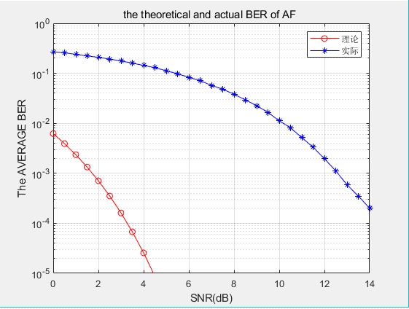

图1 非协作系统AF的理论和实际误码率曲线

多次运行

