COMPX576 Programming Project
Campus Parking Availability and Violation Monitoring System
Project summary (final report)

Sharon Zhu
Student ID 1666262
Master of Information Technology, University of Waikato
Submitted 23 October 2026
Links
Source code: https://github.com/SharonZhu0122/campus-parking-system
Website: https://campus-parking-waikato.vercel.app (the website runs on free hosting. The free trial for the server and database ended before submission, so the live site can no longer load its data. The screenshots in this report were taken from the same code running on my computer. A recorded demonstration is in the presentation video.)
Contents
1 Project description 1
2 Functionality completed 1
3 Functionality planned but not finished 1
4 How a person uses the application 1
5 Technologies 1
6 How the system works 1
7 Testing 1
8 Challenges and how I dealt with them 1
9 How this report matches the presentation 1
10 Conclusion 1
References 1
Appendix A Bug log 1
Appendix B Running the project 1

1 Project description

1.1 The problem
A student arriving at the University of Waikato has no way to find out whether there is a space. Student parking is spread over five gate areas (Gate 1, Gate 2b, Gate 3A, Gate 3B and Gate 10). Parking is paid from 8:30am to 4:30pm on weekdays, numbered or named bays are reserved for permit holders, and mobility bays are free for drivers with a valid mobility card (University of Waikato, n.d.-a). Staff find violations by walking around and looking.

1.2 What the project is
The project is a website with a server behind it. Anyone can open the main page and see how many spaces are free at each gate, which is updated every 5 seconds, together with a map that shows where each car park is. A Busy times page shows when each car park is usually busy, in the same way as the popular times on Google Maps (Google, n.d.-a). A parking assistant and a list of common questions answer everyday questions, including the current fees. Drivers can register their plate, see violations recorded against it and change their details. Staff can see violations that are waiting, add one they find on patrol, correct it, resolve it and notify the owner.

1.3 Why the data is simulated
The campus has no working parking sensors or cameras. My proposal said that I would ask the parking, security and IT teams for real data, and that I would use my own simulated data if none was available. No real data was available, so a program in the server creates simulated parked cars. I used real things wherever I could: the real gate names, the real capacity of each gate (487, 239, 101, 60 and 281 spaces, 1,168 in total), the real paid hours and the real fees. In a real deployment the simulator would be replaced by a feed from sensors or plate-recognition cameras, and the rest of the system would stay the same.

1.4 How people would use it if it were finished
A driver would check the website on a phone before leaving home. The main page says which gates have space and the Busy times page says whether it is better to come earlier. If the driver has a registered plate, the site tells them when a violation is recorded and how it ended. Payment would stay on the university's payment service, PayMyPark, which the site links to (PayMyPark, n.d.). Parking staff would open the admin page, see the violations waiting, add anything they find on patrol, and record whether a ticket was issued. With real sensors behind it, the same pages would show real numbers.

1.5 Who uses it
Role | Needs an account? | What they can do
Visitor | No | See free spaces and maps, Busy times, ask the assistant, send a question to staff, follow the link to pay.
Registered driver | Yes (self-registered) | Everything a visitor can do, plus see violations on their own plate, change their plate, contact details and password, and reset a forgotten password.
Admin | Yes (created by the developer) | See and handle violations, add or correct one, notify the owner, read visitors' questions.

At a glance: 5 gates, 1,168 spaces, 3 violation rules, 3 kinds of user, 6 database tables, about 2,000 lines of server code, about 2,600 lines of website code, 117 automated tests and 78 commits in the git history.

2 Functionality completed
Everything below works and is covered by tests or by checks in a browser.

2.1 For everyone
- Live free spaces for each of the five gates, refreshed every 5 seconds, with a colour that goes from green to red as the car park fills.
- Gate maps. Each card has a thumbnail of the campus map with that gate's car parks highlighted. Clicking it opens a larger map with a description and a link to Google Maps. The full campus map is also on the page.
- Busy times for each gate: a plain status (plenty of space, getting busy, almost full), how it compares with usual, the usual busy hours for each day of the week, and a collapsed section with a next-hour forecast.
- Busy-date warning. Three days before a busy university date (graduations, orientation, the start of a trimester) the pages show a banner. The dates come from the university's published key dates (University of Waikato, n.d.-c).
- Parking assistant (Google Gemini) that answers only from a fact sheet, a list of fixed questions, and a form that sends a question to staff.
- Pay for parking link to PayMyPark, and the current fees ($3 a day, $9 a week, $90 a trimester) in the assistant and the questions (University of Waikato, n.d.-a, n.d.-b).
- Works on a phone. The layout changes for narrow screens.

2.2 For registered drivers
- Register with a username, password (at least 6 characters), plate, email and phone number. Plates must be unique and the formats are checked.
- My vehicle: the violations recorded for the driver's own plate and what happened to each. The page updates by itself.
- Account settings: change the plate, email, phone number and password.
- Forgot password: a link by email that works once and expires after an hour. The feature is finished and tested, but it needs an email service key that is not set up in the deployed version.

2.3 For admins
- A list of open violations, newest first, that refreshes every 10 seconds, with a Handled tab that keeps the record.
- Resolve a violation as ticket issued, false positive or other. A ticket looks up the registered owner by plate and shows the message that would be sent.
- Add a violation found on patrol (plate, gate, type and a note) and edit an open one, for example when a plate was read wrongly. The list shows who added or edited it and when. A handled violation cannot be edited.
- A button that fills the list with 19 random demonstration violations.
- The questions that visitors sent.

2.4 Behind the pages
- A data generator that creates simulated parked cars every 2 minutes, different for each gate, each day of the week and each hour.
- A rule engine that flags the three kinds of violation from the proposal.
- Two forecast methods (moving average and linear regression) compared by a backtest.
- Sign-in with roles, password hashing, rate limiting and a set of security measures (section 6.8).
- 117 automated tests, a README, and a bug log.

3 Functionality planned but not finished
This table compares the work with the objectives in my proposal. "Done" means it works. The percentages say how far each unfinished item got.
Proposal item | Status | How far | Notes
Show live occupancy for each gate | Done | 100% | Five gates, refreshed every 5 seconds.
Generate realistic parking events | Done | 100% | Different for each gate, day and hour.
Detect the three violations automatically | Done | 100% | Reserved bay, unpaid in paid hours, invalid mobility card.
Predict occupancy from past data, with two methods, and compare them | Done | 100% | Moving average and linear regression, compared by a backtest.
Two user roles with different access | Done | 100% | Plus the visitor who needs no account.
Desktop and mobile in one design | Done | 100% | Checked at phone width.
Admin can see violations and choose how to handle each | Done | 100% | Also add, edit and see handled ones.
Flag cases where real occupancy differs from the prediction | Partly | About 30% | Busy times shows "busier or quieter than usual" to everyone. There is no alert or list for staff, and no link to unregistered parking.
Admin can view all parking events | Partly | About 50% | Admins see violations, not the full list of parking records.
Notify the owner of a violation | Partly | About 60% | The owner is found by plate and the message is shown on screen. No email or text is sent.
Admin can set rules (paid hours, reserved gates) | Not started | 0% | The rules and numbers live in the code and in one settings file. There is no page to change them.
Patrol priority score and order | Not started | 0% | The proposal said this and the kiosk could be reduced if time ran short. The admin list is sorted by newest instead.
Kiosk display page for a car park entrance | Not started | 0% | There is no physical screen at an entrance to build it for, so I put the time into the pages people can actually use.
Test the API with Postman | Changed | Done another way | The API tests are written in Jest with Supertest instead, because they run automatically.
Host the demo on free services | Done, then ended | 100%, then offline | Vercel and Railway. The Railway free trial ended on about 17 October, so the server and database are switched off.
Use real occupancy data if available | Not possible | 0% | No real data was available.

3.1 Features I added that were not in the proposal
Feedback from my lecturer and teaching assistant and my own use of the site led to features that the proposal did not have: the gate maps, the campus map, the questions panel with a staff inbox, the AI assistant, the busy-date warning, Busy times in the style of popular times, My vehicle, account settings, forgot password, adding and editing violations by hand, and the link to PayMyPark.

4 How a person uses the application

4.1 A visitor checks for a space
- Open the website. The main page shows the five gates and their free spaces (Figure 1).
- Click a gate's map to see where its car park is and open it in Google Maps (Figure 2).
- Open Busy times, choose a gate, and see whether it is usually busy now and at what hours (Figure 3). Open the collapsed section for the forecast (Figure 4).
- Click Questions? and ask the assistant, for example how much parking costs (Figure 5).
- Click Pay for parking to pay on PayMyPark.
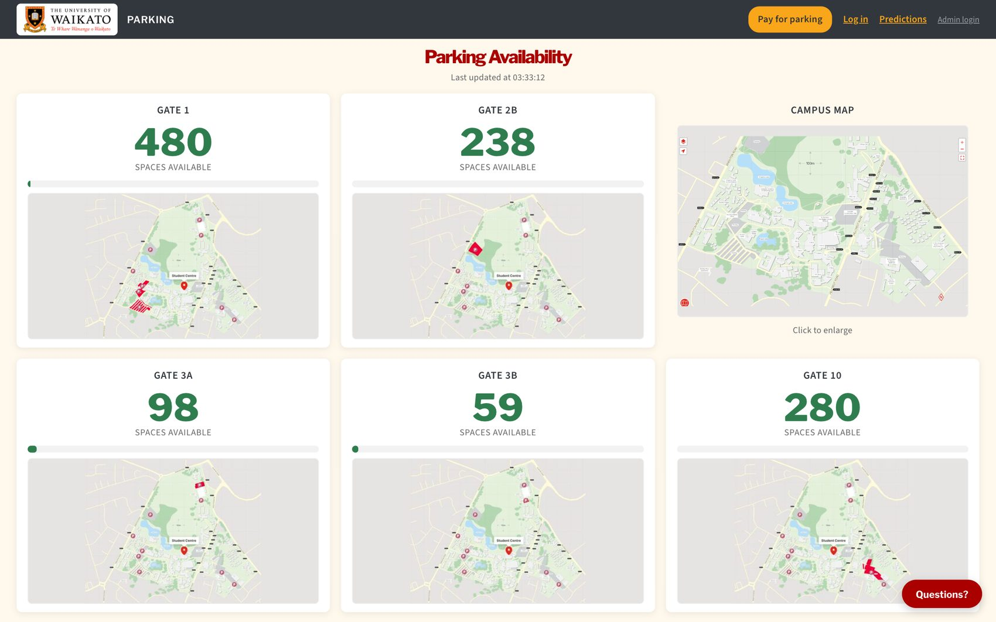
Figure 1: The main page: free spaces and a highlighted map for each gate, and the campus map.
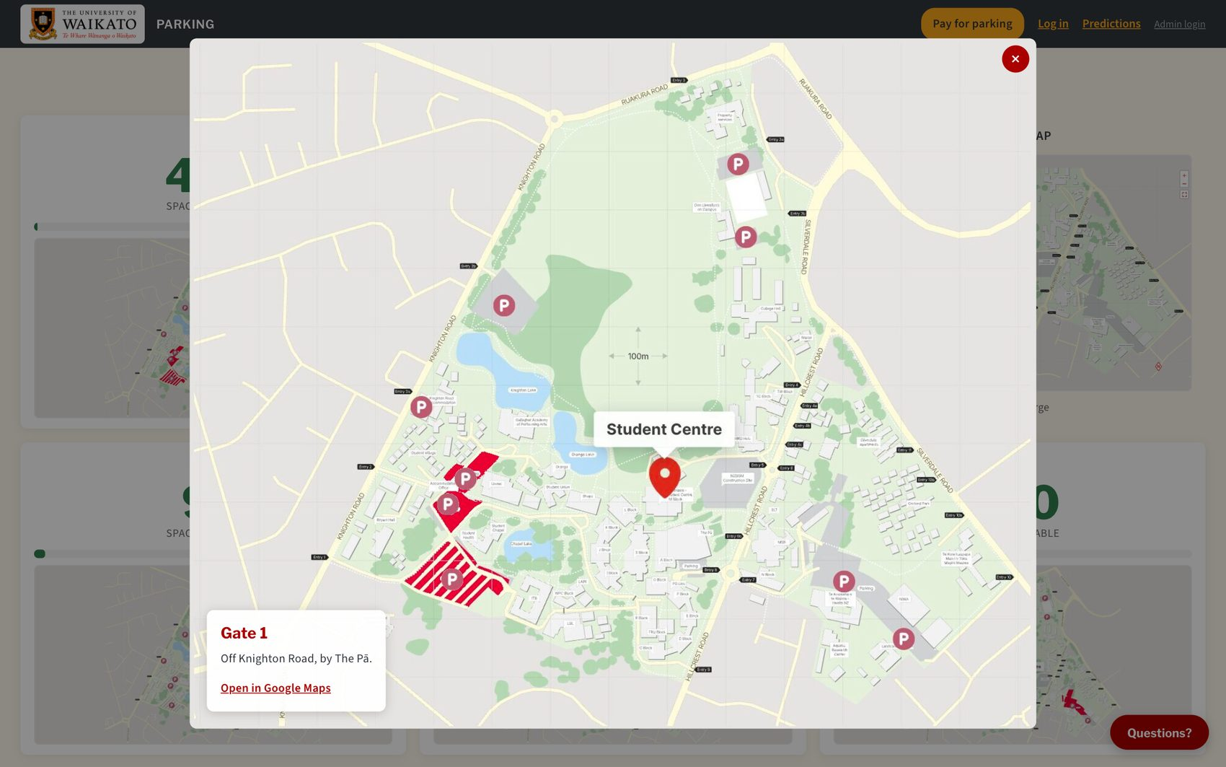
Figure 2: A gate map opened: Gate 1's car parks are in red.

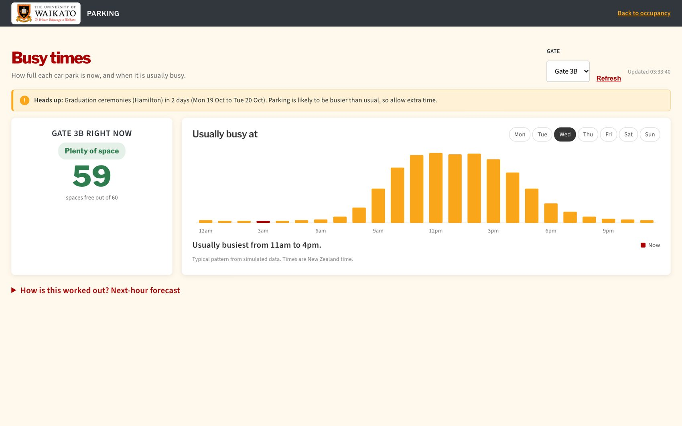
Figure 3: Busy times for Gate 3B: the status now, and the hours it is usually busy. The red bar is the current hour.
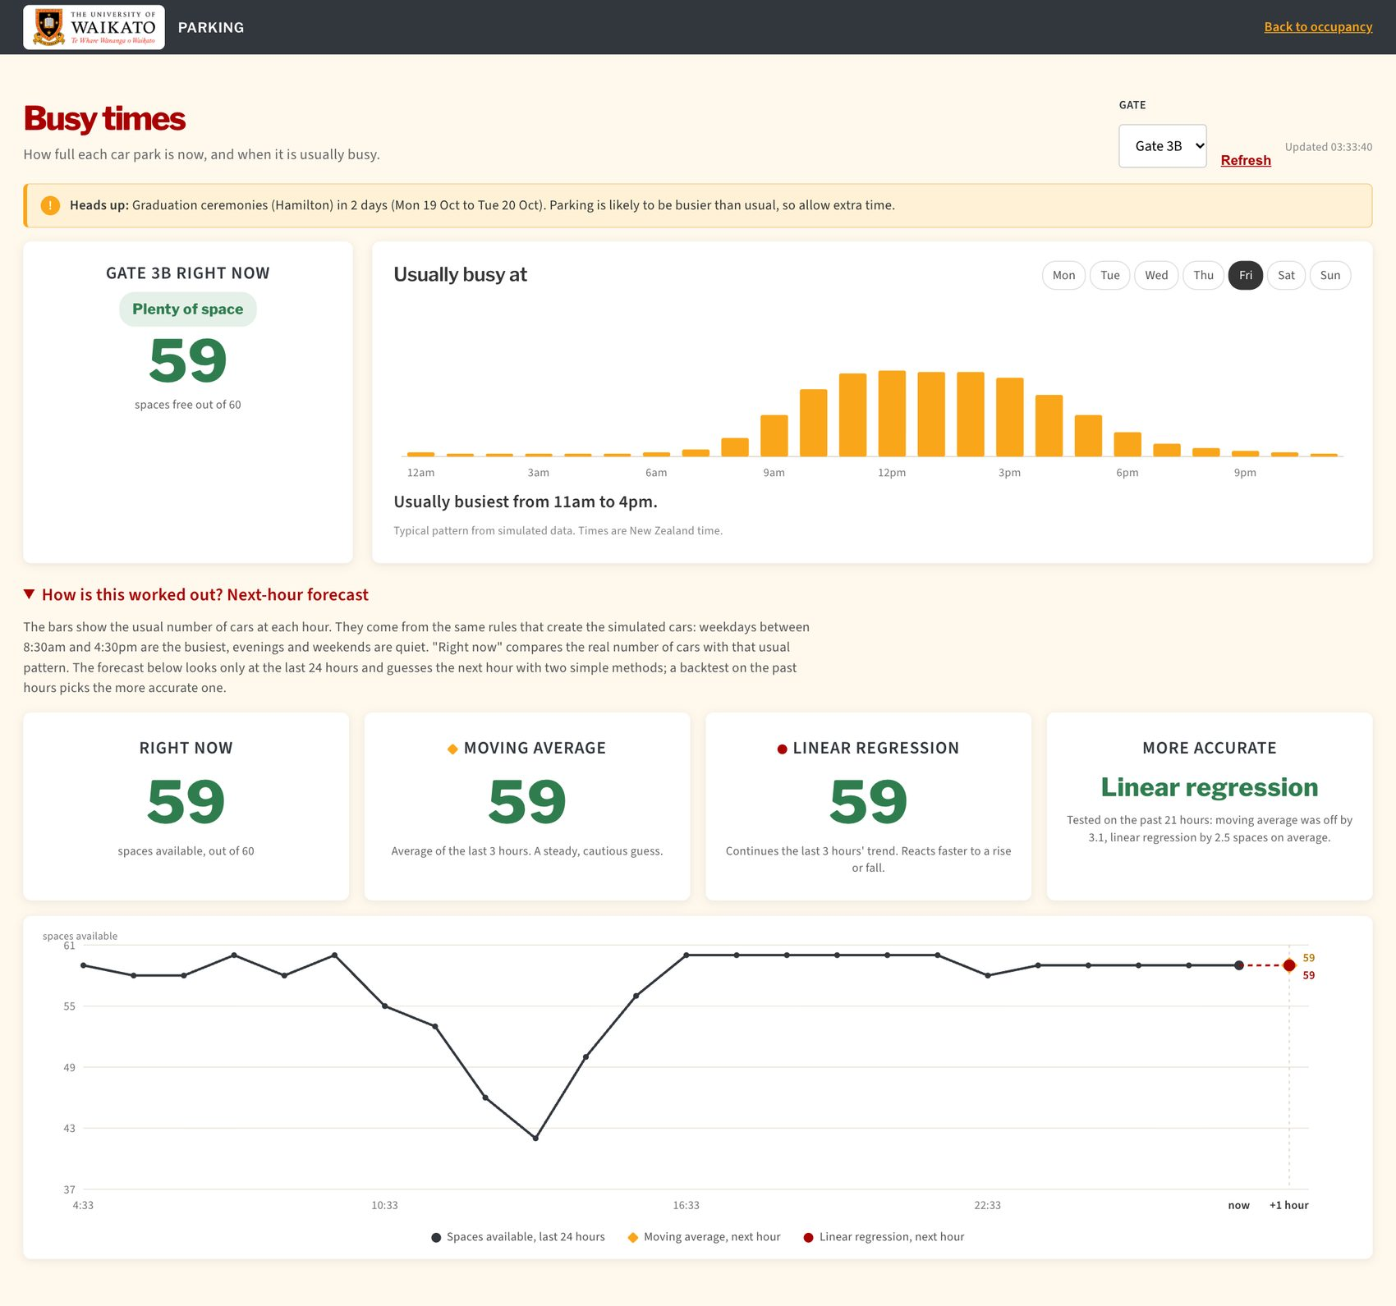
Figure 4: The collapsed section: the next-hour forecast from two methods, and which one was closer on the past hours.
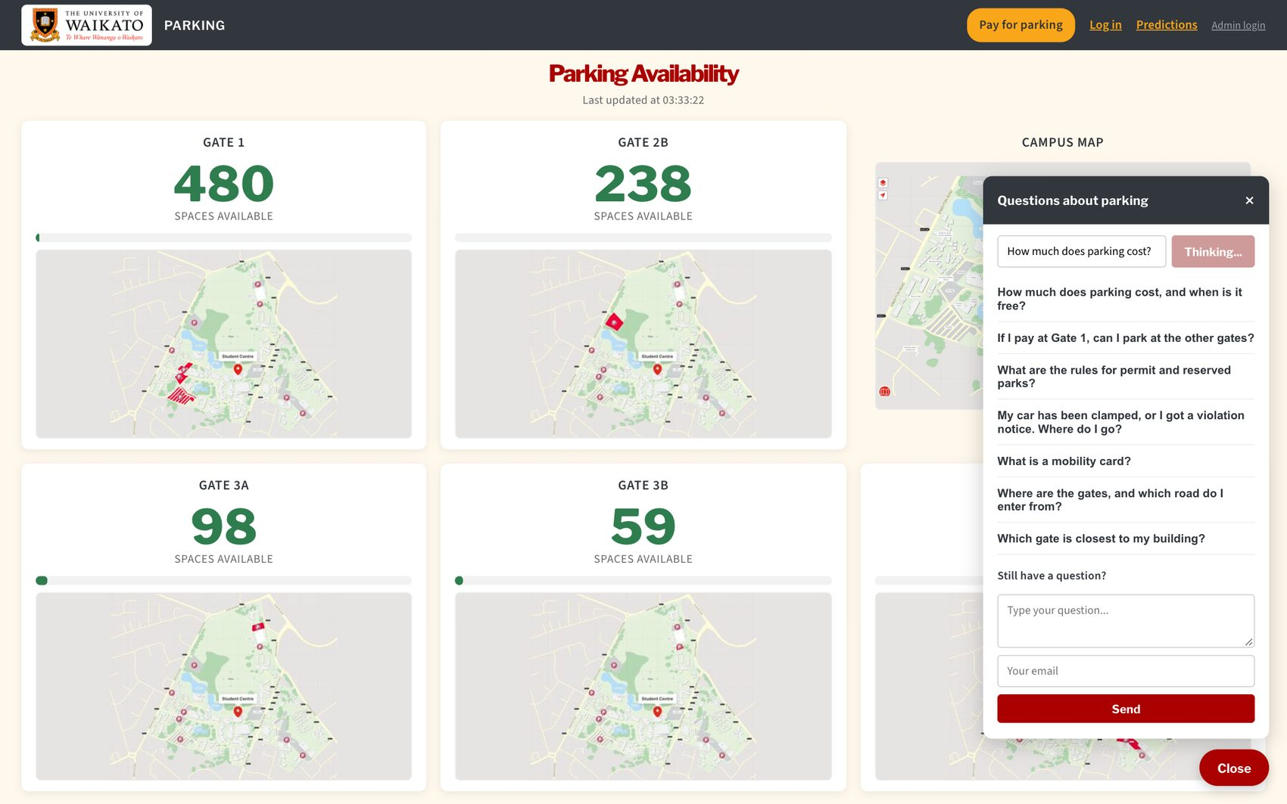 | 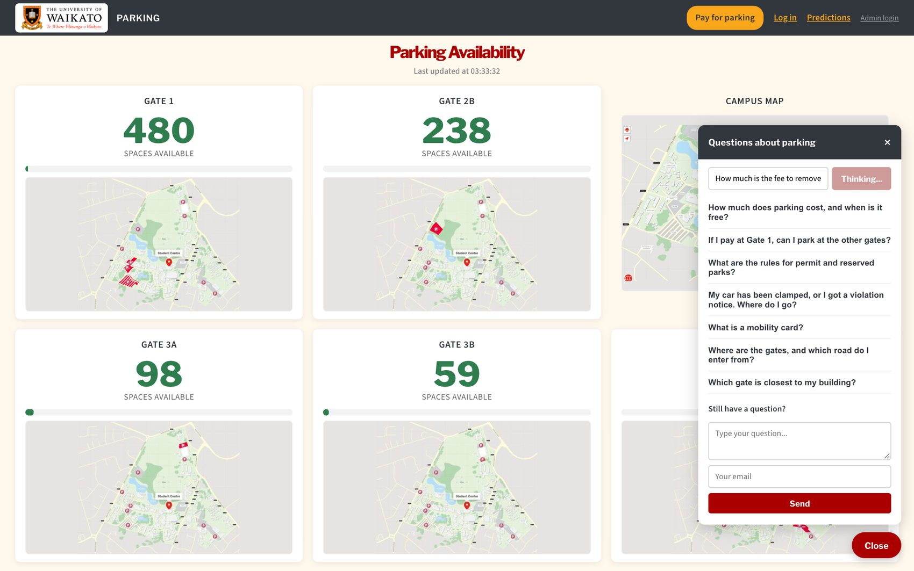
Figure 5: The assistant gives the published fees (left) and says when it does not know something (right).

4.2 A driver registers and checks their vehicle
- Click Log in, then Register. Enter a username, a password, the plate, an email and a phone number. If the plate is already registered the form says so (Figure 6).
- Log in. Click My vehicle to see violations recorded for the plate and their status (Figure 7).
- Click Account settings to change the plate, contact details or password (Figure 8).
- If the password is forgotten, click Forgot your password?, enter the email, and follow the link in the email to choose a new one.
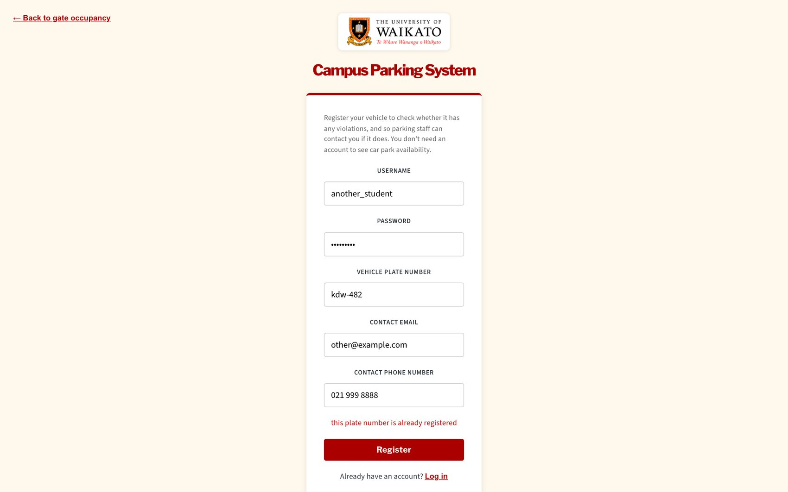
Figure 6: Registering with a plate that already belongs to another account is refused.
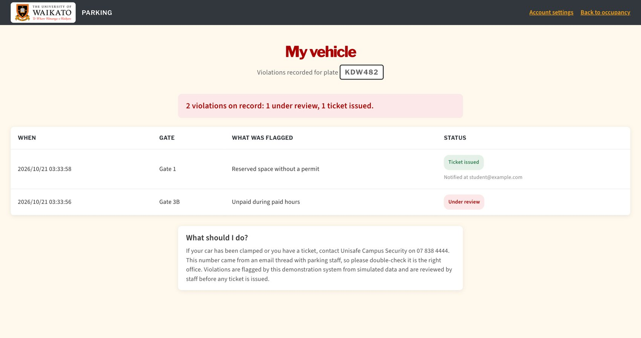
Figure 7: My vehicle: violations on the driver's plate, with the outcome of each.
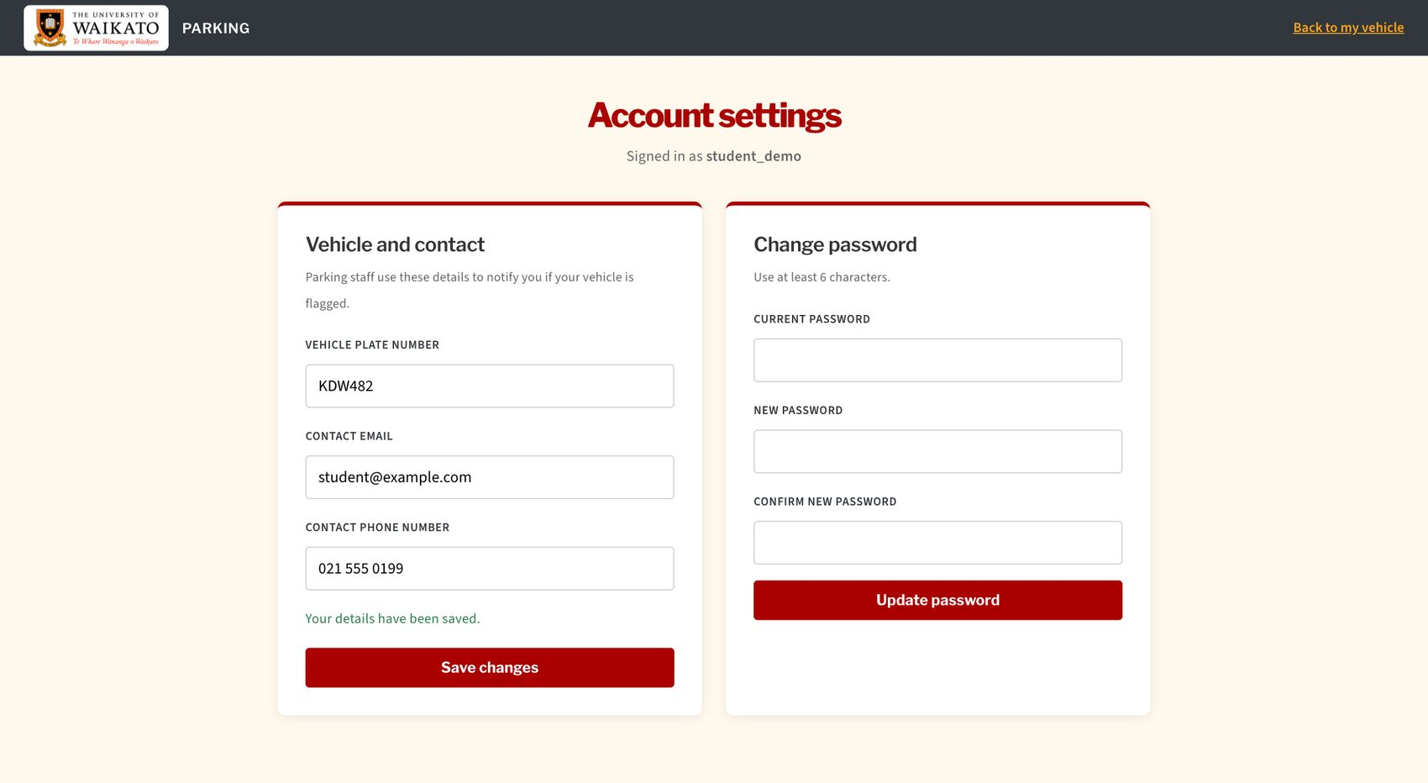
Figure 8: Account settings: vehicle and contact details, and the password form.

4.3 An admin handles violations
- Click Admin login and sign in. Open Admin. The page shows the violations waiting (Figure 9).
- To record something found on patrol, click Add violation and fill in the plate, gate, what was found and a note (Figure 10).
- To fix a mistake in an open violation, click Edit. The list then shows who edited it and when.
- Choose how a violation was handled (ticket issued, false positive or other) and click Resolve. For a ticket the system shows the message sent to the owner (Figure 11).
- The violation leaves the open list. Click Handled to see the record (Figure 12).
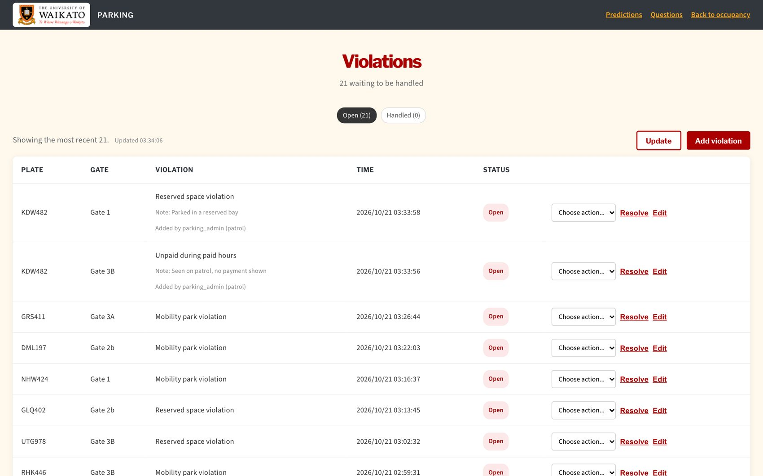
Figure 9: The admin list of open violations.
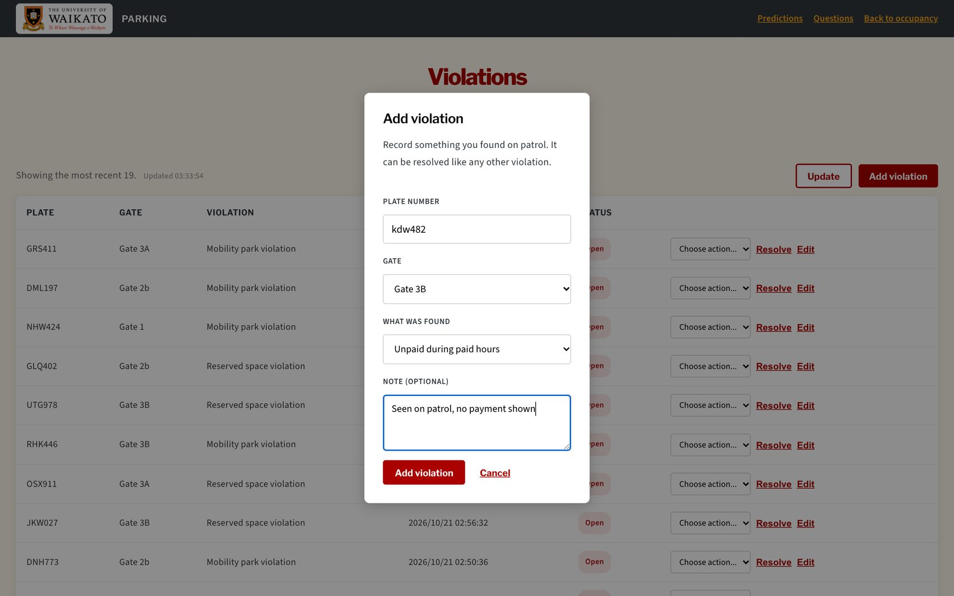
Figure 10: Adding a violation found on patrol.
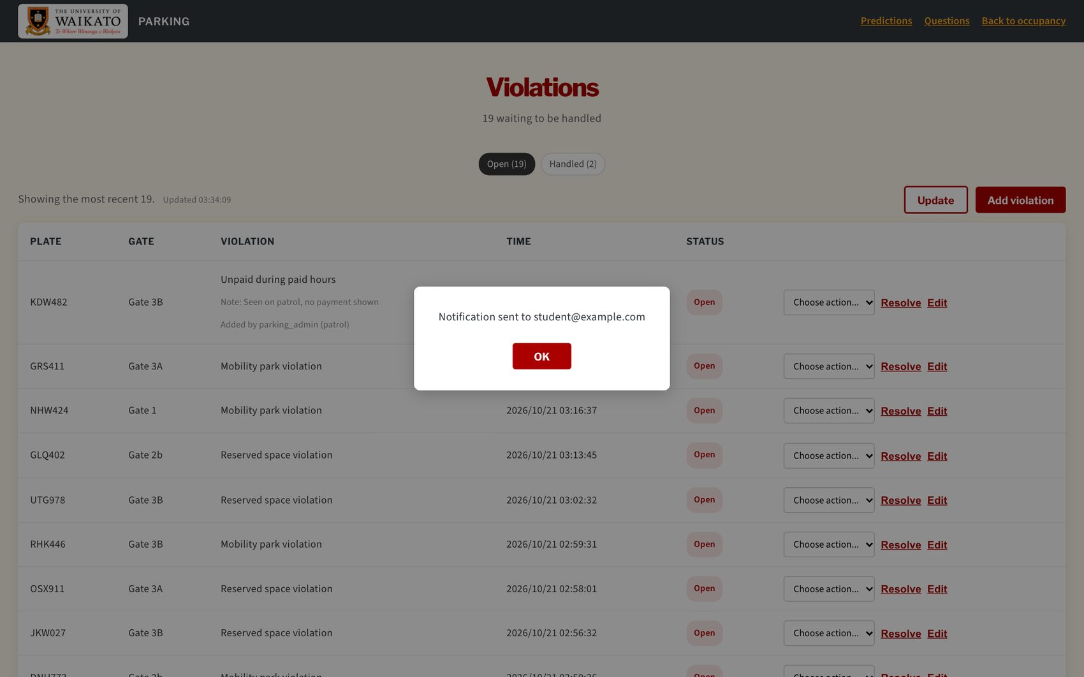
Figure 11: Resolving a violation as a ticket shows the message to the owner.

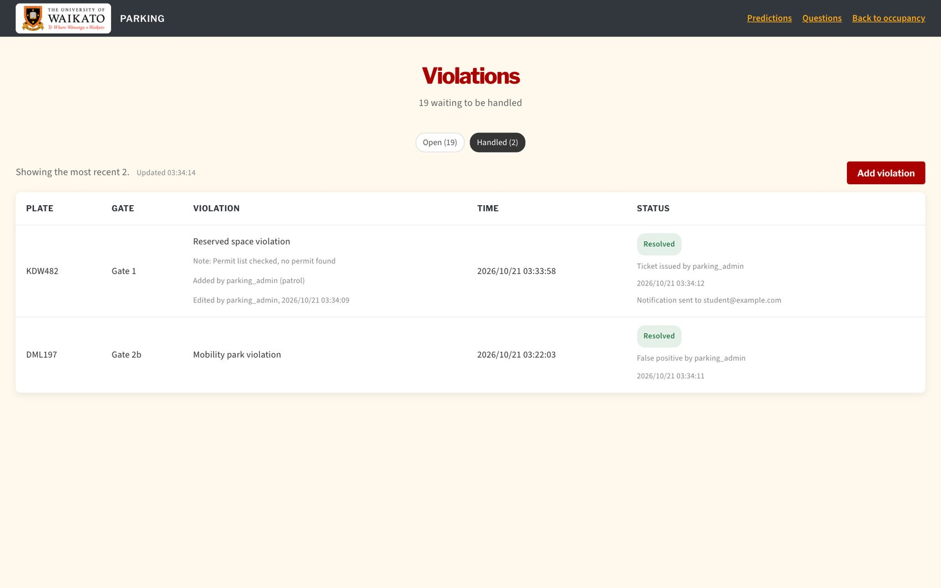
Figure 12: The Handled tab keeps who did what and when.
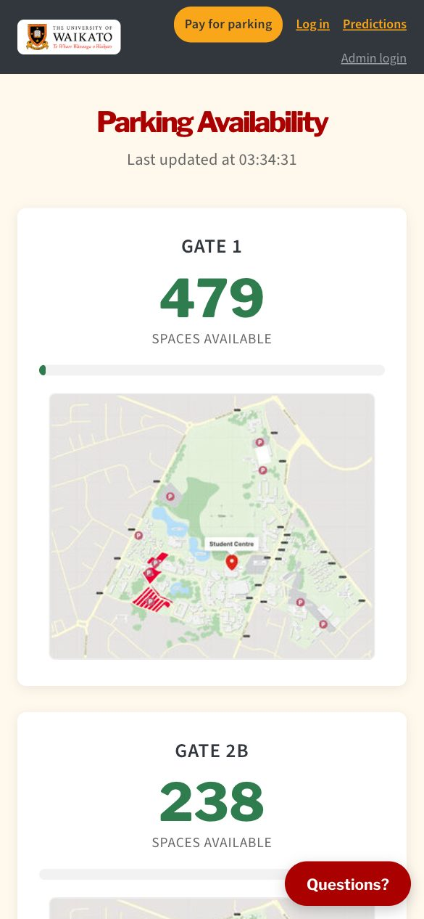 | 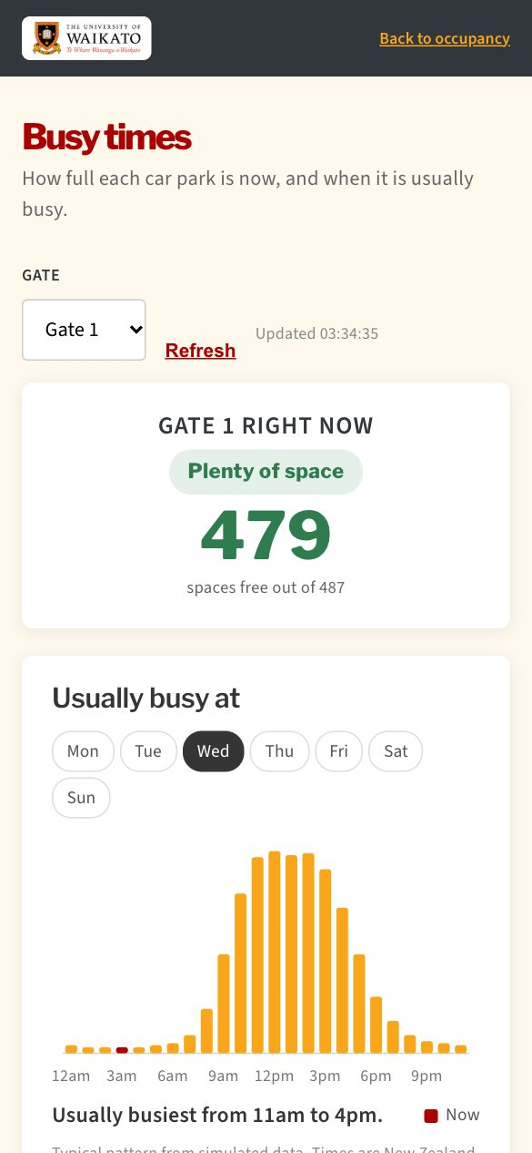
Figure 13: The main page and Busy times on a phone.

5 Technologies
The proposal listed React, Node.js with Express, MySQL with Sequelize, JWT, node-cron and Jest. I used all of them. The table says what each one does in the project and why I chose it.
Area | Technology | What it does here and why
Website | React 19 and Vite (Meta Open Source, n.d.; Vite, n.d.) | Builds the pages from small components. React keeps the screen in step with the data, and Vite gives a fast build.
Server | Node.js and Express 5 (Express, n.d.) | A REST API in JavaScript, so the website and the server use one language.
Database | MySQL with Sequelize (Oracle, n.d.; Sequelize, n.d.) | Six related tables. Sequelize sends values separately from the SQL, which prevents SQL injection.
Sign-in | JSON Web Tokens and bcrypt (Jones et al., 2015; Provos & Mazières, 1999) | A signed token says who the user is and their role. Passwords are stored only as bcrypt hashes.
Schedule | node-cron | Runs the data generator every 2 minutes.
AI assistant | Google Gemini API (Google, n.d.-b) | A free tier, called from the server so the key never reaches the browser.
Email | Brevo email API (Brevo, n.d.) | Sends the password-reset link over HTTPS. SMTP is blocked on many free hosts.
Tests | Jest and Supertest (Jest, n.d.; Supertest, n.d.) | Unit tests for the logic and API tests that call the real routes with a real database.
Hosting | Vercel (website) and Railway (server and database) (Vercel, n.d.; Railway, n.d.) | Free tiers that deploy straight from the code.
Other | Git and GitHub, Google Maps links, PayMyPark link | Version control, directions to each gate, and payment.

6 How the system works

6.1 Architecture
The website talks to the server with JSON over HTTPS. The server checks the sign-in token and the role, asks the database for rows and sends the answer back. A scheduled job creates the simulated parked cars. The server calls Gemini for the assistant and Brevo for email. The website only links out to PayMyPark and Google Maps.
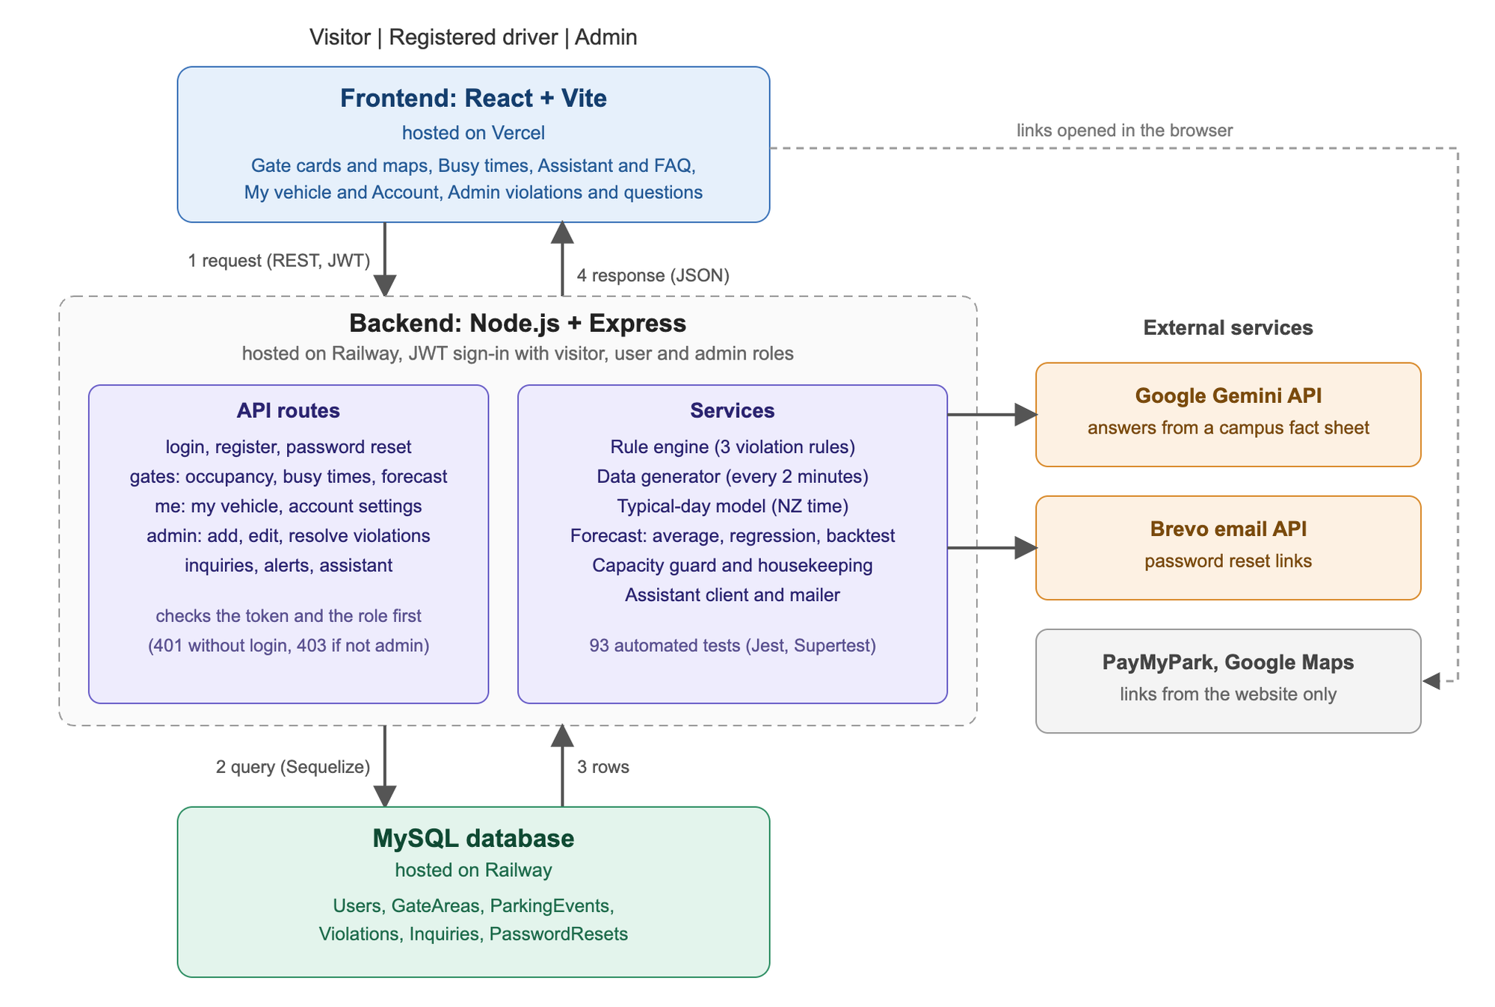
Figure 14: The architecture: website, server, database and outside services.

6.2 Data model
There are six tables. A ParkingEvent is one simulated car: its plate, gate, type of bay, whether it paid, and when it arrived and for how long. A Violation belongs to an event. One event can have several violations. A user is tied to parking records only through the plate number, so a driver who changes plate sees the history of the new plate.
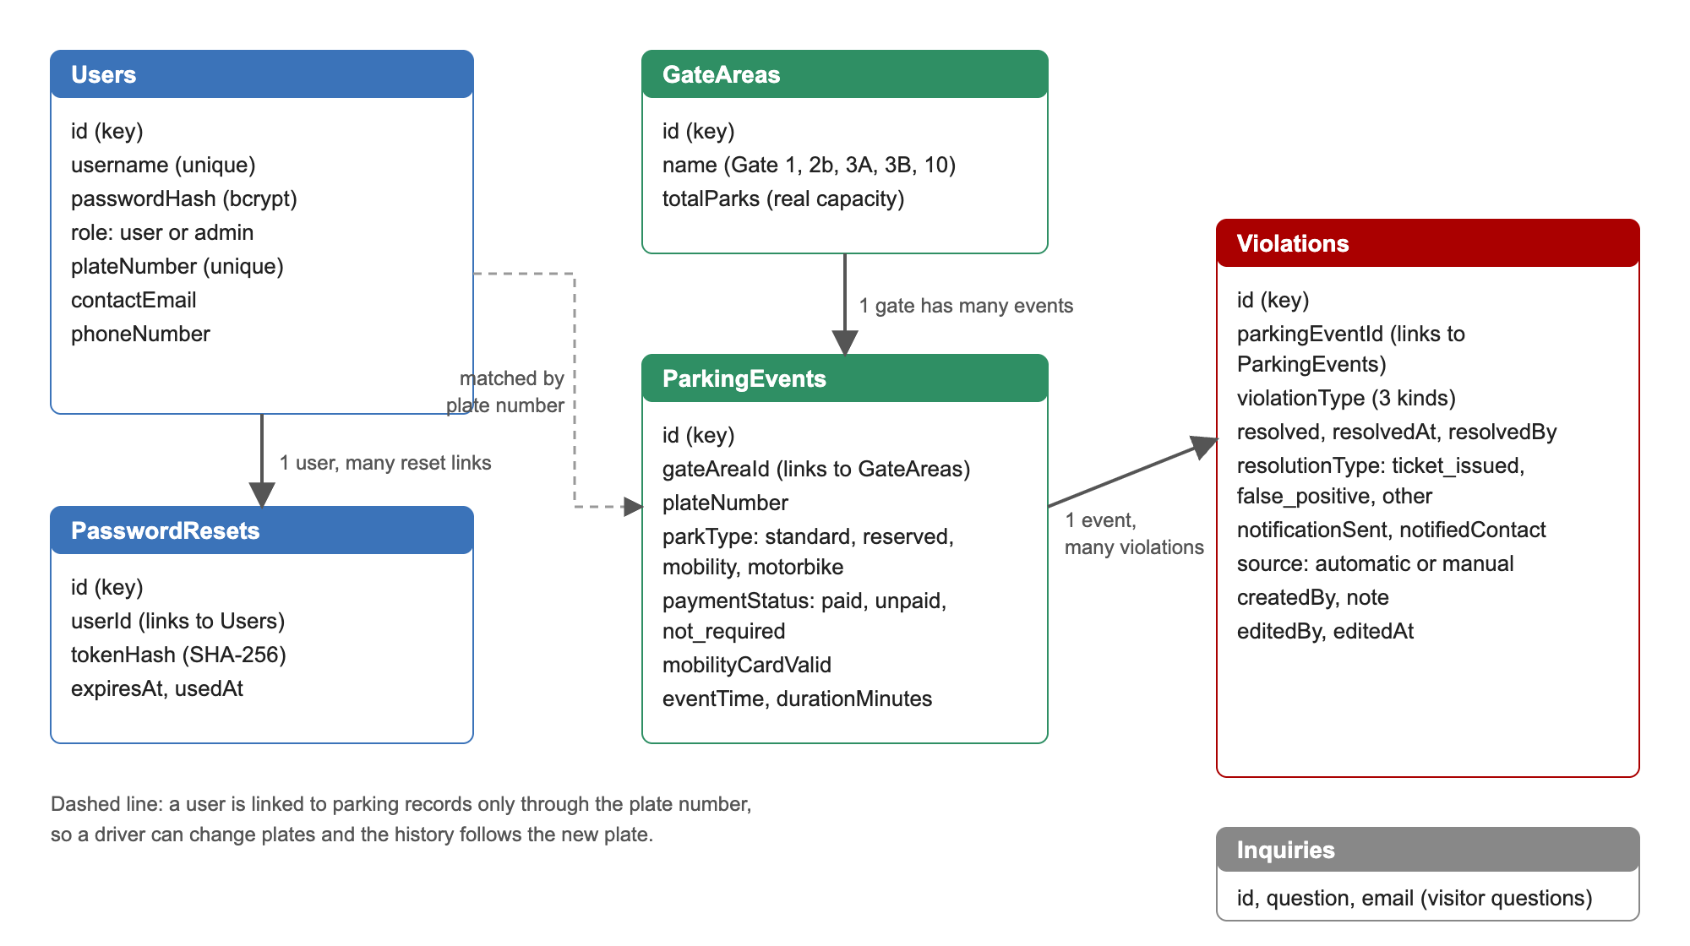
Figure 15: The six tables and how they connect.

6.3 The simulated data
Every 2 minutes the generator decides how many cars arrive at each gate. The number depends on three things, all kept in one settings file (simulationConfig.js):
- The gate. Each gate fills to a different share at its busiest hour: Gate 3B 95%, Gate 3A 80%, Gate 1 55%, Gate 2b 50% and Gate 10 30%.
- The day. Tuesday and Wednesday are the busiest, Monday and Thursday a little less, Friday lighter, and weekends quiet. Each real date is also a little different, up to 15% busier or quieter.
- The hour. A morning rush, a small dip at lunch, an afternoon bump and a quiet evening, in New Zealand time.
Each car stays between 20 and 240 minutes. Only about one car in a hundred breaks a rule, so roughly 20 violations appear in a day. A full car park turns cars away, and the number of cars can never be more than the number of spaces.

6.4 The rule engine
Each parking record is checked for three violations. The checks are separate, so one record can give none, one or several (Figure 16). "Paid hours" are worked out in New Zealand time (8:30am to 4:30pm, Monday to Friday), whatever time zone the server is in.
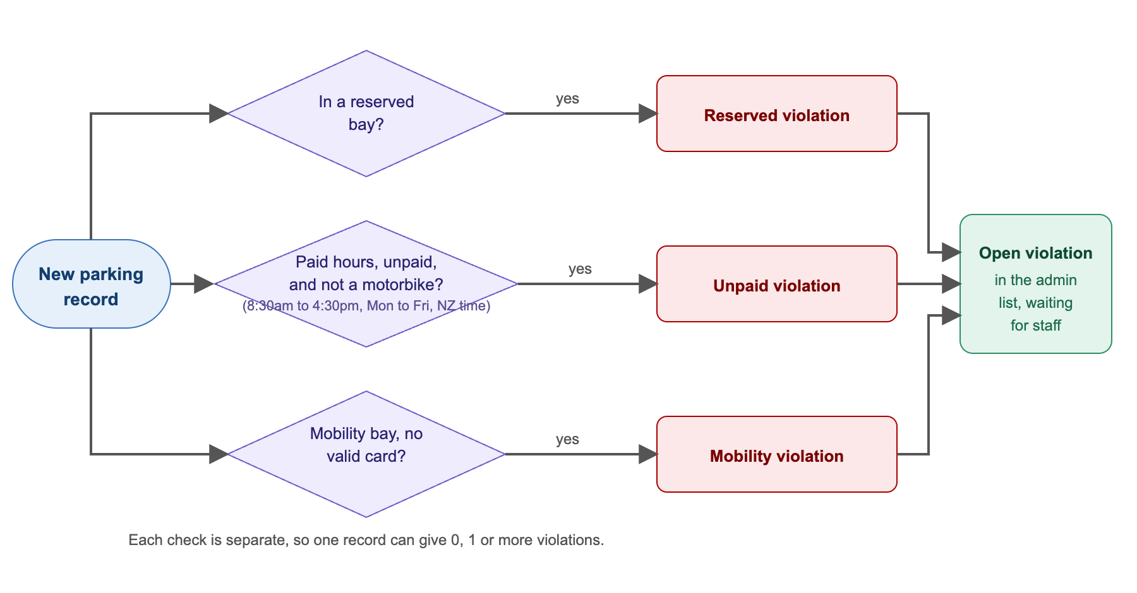
Figure 16: The rule engine: three separate checks on every parking record.

6.5 Busy times
The usual busy hours are calculated from the same numbers that drive the generator. For a chosen day and time, the expected number of cars is the sum, over the last four hours, of the cars that arrived multiplied by the chance that each is still there. This matches what the generator produces on an average day. I took the idea from the popular times on Google Maps, where a chart of typical hours is shown with the current hour marked (Google, n.d.-a). The page then compares the real number of cars with the usual number and says "busier than usual" or "quieter than usual" when the difference is more than a few cars. The chart says clearly that the pattern comes from simulated data.

6.6 The forecast
The collapsed section guesses the next hour from the last 24 hours of free spaces. The moving average is the mean of the last 3 hours. The linear regression fits a straight line through the last 3 hours by least squares and extends it by one hour (Hyndman & Athanasopoulos, 2021). A backtest then pretends not to know each of the past hours, predicts it with both methods and averages the mistakes. The method with the smaller average mistake is shown as the more accurate one. Because the data is simulated, this shows that the method works, not how accurate it would be on real data.

6.7 The assistant
The assistant sends the question to Gemini together with a fact sheet written for this project: paid hours, gate locations, the closest buildings, the fees, how the violations work, and the busy dates. The instructions tell it to answer only from the sheet, to say it does not know otherwise, and never to guess prices. Every answer is labelled as AI-generated. Each visitor may ask 8 questions in 10 minutes, and the whole site 300 a day, because the free tier is shared. If the service fails the page shows a message and the fixed questions still work.

6.8 Accounts and security
- Passwords are hashed with bcrypt and never sent back. Login tokens are signed and last one day. Admin routes check the role on the server.
- All input is validated (plate, email, phone, password length, whole-number ids). The database is only used through Sequelize.
- Wrong logins, assistant questions and password-reset requests are rate limited.
- A reset link is stored only as a hash, works once and expires after an hour. The reply to "forgot password" is the same whether or not the email is known.
- Only the deployed website and localhost may call the API from a browser. Errors never show internal details. The X-Powered-By header is removed and browsers are told not to guess content types.
The threats I considered follow the OWASP Top 10: broken access control, injection, identification and authentication failures, and security misconfiguration (OWASP Foundation, 2021). Section 7.3 lists how each was tested.

6.9 How the code is organised
The server is split into routes (one file per area, with its tests beside it), services (the rule engine, the simulation, the forecast, the assistant), models, middleware and small utilities. The website has one file per page, with small components and "hooks" for each page in folders of their own. In the last week I split the longest page components: the longest function went from 263 lines to 103, and 11 of 210 functions are over 50 lines. The comments are in English.

7 Testing

7.1 The approach
There are four kinds of testing. Unit tests check the logic on its own. API tests call the real routes with Supertest and a real MySQL database, then remove the rows they made. In these tests the Gemini call and the email service are replaced by fakes, so tests are quick, free and do not need the internet. Security tests try to break the rules (section 7.3). Manual tests in a browser cover the screens, which have no automated tests. The tests are automatic because I kept changing the system, for example the time zone fix and the Busy times page, and after each change I could run all of them in about three seconds and know that nothing else had broken.

7.2 The automated tests
Area | Tests | What they check
Admin routes | 18 | Access by role, resolving, adding, editing, the Open and Handled lists, the Update button.
Security | 24 | Injection, tokens, privileges, what is revealed, login limits, CORS, error handling (section 7.3).
Simulation and Busy times | 15 | Each gate's peak, different days, never more cars than spaces, comparing real with usual.
My vehicle and account | 12 | A driver sees only their own plate, changing details, changing the password.
Rule engine | 10 | The three violations, motorbikes, and paid hours in New Zealand time including daylight saving.
Password reset | 7 | One use, one hour, hashed token, same reply for unknown emails.
Assistant | 6 | Empty and long questions, the rate limit, the fallback.
Registration and login | 5 | Duplicate plates, formats.
Public pages | 5 | Gates, occupancy, forecast.
Key dates | 4 | When the busy-date banner starts and ends.
Forecast methods | 4 | Moving average, regression, backtest.
Violation housekeeping and samples | 5 | The open list is kept short, random violations are valid.
Busy times route | 2 | The response and an unknown gate.
Total | 117 | All pass. They run one file at a time because they share one database.

7.3 Security testing
The proposal planned to test that a normal user cannot reach admin actions, even by calling the API directly. This is tested, and 24 further tests in security.test.js go beyond it:
- Injection: SQL in the login fields, in the plate number and in a query string, objects sent instead of text, and ids such as 1abc or 1 OR 1=1. All are refused.
- Tokens: no token, a broken token, a token signed with another secret, a token whose payload was edited, a token with no signature, and an expired token are all refused.
- Privileges: a normal user is refused on every admin action. Asking for the admin role while registering, or adding extra fields to a profile update, changes nothing.
- What the API reveals: passwords are hashed and never returned, a wrong user name and a wrong password get the same answer, and no X-Powered-By header is sent.
- Guessing passwords: ten wrong tries lock an address out, successful logins are not counted, and short passwords are refused.
- Browsers: a website that is not on the list gets no CORS permission.
- Errors: unknown addresses give a JSON 404, broken JSON a 400, a very large body a 413, and an internal failure a 500 that does not reveal the cause.
These tests found seven weaknesses, which were fixed (Appendix A, S01 to S07). The most useful was that MySQL read an id such as 1abc as 1.

7.4 Manual testing
I used the site in a browser after each change. For the larger changes A script drives a real browser through every page (log in, add a violation, edit it, resolve it, change account details, reset a password) and it was run again after the refactoring, to check that nothing had changed on screen. I also checked the pages at phone width (390 pixels), stopped and restarted the server to see how the page recovered, and tested on the deployed site.

7.5 Bug tracking and fixing
A bug log was kept during the project. Each entry says what went wrong, the cause, the fix and how it was checked (Appendix A). It has 35 entries: 28 found while building and 7 found by the security tests. One example: the simulated car parks were busiest at night in New Zealand. The cause was that "paid hours" used the server's clock, which is UTC. It was fixed to use New Zealand time, with six new tests, including the change of daylight saving time. Another: free spaces showed as -11 for Gate 3B, because the random demonstration violations were counted as parked cars. Now they are not, the count is limited to the number of spaces, and extra cars are released early.

7.6 What testing did not cover
The screens have no automated tests, so they were checked by hand. I did not test how many people the server can serve at once, and I did not run an accessibility audit. The tests and the website share one database in development, so the tests clean up the rows they create.

8 Challenges and how I dealt with them

8.1 Making simulated data useful
At first every weekday looked the same and every gate behaved the same, so the busy-times chart showed nothing. I gave each gate and day its own pattern in one settings file, and I worked out the usual pattern from the same numbers so that the chart and the data agree. I also found that the server clock was in UTC, which made the simulation peak at night in New Zealand. Using New Zealand time fixed it.

8.2 Making the forecast understandable
My first forecast page showed algorithm names and two competing numbers, which a visitor cannot use. After looking at how Google shows busy times, I rebuilt the page around a plain status and a chart of usual hours, and kept the two methods and the backtest in a collapsed section for people who want the detail.

8.3 Keeping the assistant honest
A chatbot can make things up. I limited it to a fact sheet, told it to say when it does not know, labelled its answers, limited how often it can be used, and used the university's published fees. When I tested it with a place that was not in the sheet it correctly said it did not know.

8.4 Highlighting the car parks on the map
The gate maps are made from the campus map with each gate's car parks coloured. Colouring by area filling leaked into similar-looking areas or missed parts. I filled inside a small box around each lot, used several starting points and cut the result to a shape, and I compared the result with the campus map and Google Maps. Gate 1's car parks are my best reading of the map and are worth confirming with the parking office.

8.5 Deployment and hosting
The site went offline several times because of the limits of free hosting. I moved the website to Vercel and the server and database to Railway, gave the site a short permanent address, and checked it after each deployment. The Railway free trial then ended, so the live site no longer has a server. Code cannot fix this. The system runs on a computer with the steps in the README, and I took the screenshots in this report from that.

8.6 Keeping demonstration data sensible
Random demonstration data caused two problems: far too many open violations, and negative free spaces. I made violations rare, kept the open list to a fixed number, and made it impossible for a gate to hold more cars than spaces.

8.7 Security gaps found late
Security tests written near the end showed gaps that normal use does not show, such as no limit on login attempts and a CORS setting that allowed every website. They were fixed and the tests stay, so the gaps cannot come back.

8.8 Keeping the code readable
As features grew, some page components became very long. I split them into small components and hooks, kept the screens looking exactly the same, and used the browser script and the tests to check this.

8.9 Using feedback
Feedback from my lecturer and teaching assistant asked for gate locations, the university logo and a way to ask questions. I answered with the gate maps, the logo on every page, and the questions panel, which later became the AI assistant.

9 How this report matches the presentation
The presentation has nine slides. This table shows where each one is covered in this report.
Presentation slide | Where in this report
1 Title | Title page
2 The problem | 1.1 to 1.3
3 The main page | 2.1 and 4.1
4 How it is built | 5 and 6.1
5 Live demo (main page, Busy times, assistant, My vehicle, admin, notifying the owner) | 4.1, 4.2 and 4.3
6 Technical highlights (simulation, rule engine, access control, assistant) | 6.3, 6.4, 6.7 and 6.8
7 Testing and lessons | 7 and 8
8 Limits and next steps | 3
9 Thank you and questions | 10

10 Conclusion
The project is a working campus parking website, with a server and a database, that shows free spaces for the five student gates, when each car park is usually busy, and lets staff handle violations from detection to notifying the owner. The data is simulated, because the campus has no sensors, but it uses the real capacities, paid hours and fees, and it is designed so that a real feed could replace the simulator. The parts of the proposal that I did not finish are the entrance kiosk, the patrol priority score and the rules settings page. I chose to spend the time on features that people can use and on testing. If I had more time I would connect real data, send real notifications, add automated tests for the screens, and build the kiosk and the staff alerts for unusual occupancy.

References
All web pages were last visited on 21 October 2026.
Brevo. (n.d.). Brevo API documentation. https://developers.brevo.com/
Express. (n.d.). Express: Fast, unopinionated, minimalist web framework for Node.js. OpenJS Foundation. https://expressjs.com/
Google. (n.d.-a). Get information about busy areas from Google Maps. Google Maps Help. https://support.google.com/maps/answer/11323117
Google. (n.d.-b). Gemini API documentation. Google AI for Developers. https://ai.google.dev/gemini-api/docs
Hyndman, R. J., & Athanasopoulos, G. (2021). Forecasting: Principles and practice (3rd ed.). OTexts. https://otexts.com/fpp3/
Jest. (n.d.). Jest: Delightful JavaScript testing. OpenJS Foundation. https://jestjs.io/
Jones, M., Bradley, J., & Sakimura, N. (2015). JSON Web Token (JWT) (RFC 7519). Internet Engineering Task Force. https://www.rfc-editor.org/rfc/rfc7519
Meta Open Source. (n.d.). React. https://react.dev/
Oracle. (n.d.). MySQL 8.0 reference manual. https://dev.mysql.com/doc/refman/8.0/en/
OWASP Foundation. (2021). OWASP Top 10:2021. https://owasp.org/Top10/
PayMyPark. (n.d.). PayMyPark. https://www.paymypark.com/
Provos, N., & Mazières, D. (1999). A future-adaptable password scheme. In Proceedings of the 1999 USENIX Annual Technical Conference, FREENIX Track (pp. 81–91). USENIX Association.
Railway. (n.d.). Railway documentation. https://docs.railway.com/
Sequelize. (n.d.). Sequelize ORM documentation. https://sequelize.org/
Supertest. (n.d.). Supertest: HTTP assertions made easy [Computer software]. GitHub. https://github.com/ladjs/supertest
University of Waikato. (n.d.-a). Drive to campus. https://www.waikato.ac.nz/students/transport/drive-to-campus/
University of Waikato. (n.d.-b). Changes to Hamilton campus parking. https://www.waikato.ac.nz/news-events/news/changes-to-hamilton-campus-parking/
University of Waikato. (n.d.-c). Key university dates. https://www.waikato.ac.nz/study/key-university-dates
Vercel. (n.d.). Vercel documentation. https://vercel.com/docs
Vite. (n.d.). Vite: Next generation frontend tooling. https://vite.dev/

Appendix A Bug log
The same log is kept in the repository as docs/bug-log.md. Dates come from the git history. "Test" means an automated test and "by hand" means I tried it in a browser. Entries B01 to B28 were found while building. Entries S01 to S07 were found by the security tests.

A. Data and simulation
ID | Date | What went wrong | Cause | Fix | Checked
B01 | 21 Sep | Gate capacities on the page did not match the campus. | The first capacities were placeholder numbers. | Replaced them with the real numbers (487, 239, 101, 60, 281). setup.js now corrects them on every start. | By hand
B02 | 21 Sep | Existing violations had no notificationSent column after the deploy. | A column was added to the model but the live table was not changed. | setup.js adds missing columns safely (addColumnIfMissing) and can be run again. | By hand on the deployed site
B03 | 23 Sep | Owners could not be notified because violations were not linked to a real registered plate. | The notification only looked at a made-up flag. | Resolving a violation looks up the registered owner by plate and shows the real contact. | Test (adminRoutes.test.js)
B04 | 13 Oct | The simulated car parks were busiest at night in New Zealand and "unpaid during paid hours" was flagged at night. | "Paid hours" used the server clock, which is UTC on Railway. | Paid hours are worked out in Pacific/Auckland time (utils/nzTime.js). | 6 tests, including the change of daylight-saving time
B05 | 13 Oct | Every weekday looked the same and every gate behaved the same, so the busy-times chart told nothing. | The generator picked a random gate and used one fixed rate. | Each gate and weekday has its own pattern, with a small random difference for each date (simulationConfig.js). | Tests in typicalDay.test.js
B06 | 13 Oct | Free spaces showed -11 at Gate 3B. | The random demo violations were counted as parked cars, and pressing Update added more each time. | Demo violations no longer count as parked cars. Occupancy is limited to the number of spaces, and extra cars are released early (enforceCapacity). | Tests, and a local run with 80 extra cars in a 60-space gate
B07 | 13 Oct | About 1,700 open violations, far too many to be useful. | One car in six produced a violation. | Violations are rare (about 1 car in 100) and the open list keeps the newest 19 detections. | Tests, and the live list
B08 | 13 Oct | Reading occupancy got slower as data grew. | Every request read all parking events ever stored. | Only the last few hours of events are read. | By hand, response time

B. Pages and interface
ID | Date | What went wrong | Cause | Fix | Checked
B09 | 24 Aug | Buttons on the register page looked wrong. | A CSS rule was too general and overrode the button style. | A more specific selector. | By hand
B10 | 25 Sep | Some "Open in Google Maps" links went to the wrong place. | The search words had not been checked. | Checked each gate against Google Maps and used the right landmark. | By hand
B11 | 2 Oct | Gate map highlights spilled past the car park (Gate 10), covered only part of the lot (Gate 3A) or hid the lot under the P icon (Gate 3B). | The colour fill leaked into similar-looking areas. | Filled inside a small box around each lot, with extra start points, and cut the result to a shape. | By hand, zoomed in
B12 | 3 Oct | Map thumbnails cut off the car parks. | A fixed-height crop. | The whole map is shown. | By hand
B13 | 5 Oct | The forecast chart looked like a flat line. | The vertical axis started at zero. | The axis fits the data and has whole-number ticks. | By hand
B14 | 13 Oct | The forecast page was too technical for a visitor. | It showed algorithm names and two competing numbers. | Rebuilt as a plain status plus a typical-day chart. The forecast moved into a collapsed section. | By hand
B15 | 13 Oct | The busy-times grid was wider than a phone screen. | A grid column could not shrink below its chart. | minmax(0, 1fr) columns. | By hand at 390 px wide
B16 | 13 Oct | The busy-times page showed "Could not load" and stayed that way after the server restarted. | One failed request stopped the page and nothing tried again. | Each request is handled separately and failed ones are retried every 5 seconds. | By hand: stopped and restarted the server
B17 | 13 Oct | New violations did not appear until the page was reloaded. | The admin and My vehicle pages loaded once. | They refresh by themselves (every 10 and 15 seconds), and pause while a form is open. | By hand
B18 | 13 Oct | The admin page downloaded every violation and showed the oldest first. | The list had no limit and no filter. | The server returns only the newest 100, with Open and Handled tabs and separate totals. | Tests
B19 | 13 Oct | Gate 1's map highlighted only one of its car parks. | Two more car parks on the map were missed. | Highlighted them too. | By hand

C. Accounts and the assistant
ID | Date | What went wrong | Cause | Fix | Checked
B20 | 10 Oct | Two accounts could register the same plate, and wrong emails or phone numbers were accepted. | No uniqueness or format checks. | A unique index, format checks, and 409 for duplicates. | Tests (authRoutes.test.js)
B21 | 4 Oct | The assistant failed for new users. | The model I first chose (gemini-2.5-flash-lite) was no longer offered. | Found a working model by a real test call and made it a setting. | A live call
B22 | 4 Oct | Risk found at design time: a chatbot can make up answers. | Nothing limited what it could say. | It answers only from a fact sheet, never guesses prices, and is rate limited. | Tests (assistantRoutes.test.js)
B23 | 13 Oct | The assistant said it did not know the fees. | The fact sheet had no prices. | Added the official fees from the university website ($3 a day, $9 a week, $90 a trimester). | A live call

D. Testing and deployment
ID | Date | What went wrong | Cause | Fix | Checked
B24 | 17 Sep | The site dropped offline several times. | Free hosting has limits and can sleep. | Frontend on Vercel, API and database on Railway. | By hand
B25 | Oct | A stray Vercel project was created. | I deployed from the wrong folder. | Deleted it, and always deploy with --cwd. | vercel project ls
B26 | 4 Oct | The new setting was not used after setting it on Railway. | The variable was staged, not deployed. | Deployed it from the dashboard. | A live call
B27 | 13 Oct | Tests sometimes failed by themselves. | Test files ran at the same time and changed each other's rows in one database. | npm test runs one file at a time. | Nine full runs in a row
B28 | 20 Oct | The live site had no data. | The free Railway trial ended and the API and database were switched off. | Not fixed by code. The system runs locally from the README, and screenshots were taken from a local run. | railway status

E. Found by the security tests (21 Oct)
ID | What went wrong | Cause | Fix | Checked
S01 | Asking for the occupancy of a gate that does not exist crashed with a 500. | The code read a field of a missing gate. | It returns 404. | Test
S02 | /api/gates/1abc/occupancy showed gate 1. | MySQL quietly reads "1abc" as the number 1. | Ids must be whole numbers, otherwise 404 (gates and violations). | Test with 1abc, 1 OR 1=1, -1, 1e0
S03 | Anyone could try unlimited passwords. | No limit on login. | 10 wrong tries per 15 minutes per address gives 429. Successful logins are not counted. | Test
S04 | Any website could call the API from a browser. | CORS allowed every origin. | Only the deployed site and localhost are allowed (CORS_ORIGINS can change this). | Test
S05 | A one-letter password could be registered. | No minimum length. | At least 6 characters, on the server and in the form. | Test
S06 | Unknown addresses and server errors returned Express's default HTML pages. | No handlers at the end of the chain. | JSON 404, 400 for broken JSON, 413 for large bodies, and a 500 that keeps the cause in the log only. | 4 tests
S07 | Every response said X-Powered-By: Express. | Express default. | Removed, and X-Content-Type-Options: nosniff added. | Test

Appendix B Running the project
The full steps are in the README.md in the repository. In short, you need Node.js 20 or newer and MySQL 8.
- Create a database called campus_parking.
- In backend, copy .env.example to .env, fill in the database details and a JWT_SECRET, run npm install and npm start. This creates the tables and the five gates and starts the server on port 4000.
- Create an admin: node src/scripts/createAdmin.js admin YourPassword123.
- In frontend, run npm install and npm run dev, then open http://localhost:5173. Drivers register on the website.
- In backend, run npm test to run the 117 tests.
The assistant needs a GEMINI_API_KEY and the password-reset email needs Brevo settings. Without them those two features say they are unavailable and everything else works.

