CREATE TABLE Bank ( BankID NUMBER(3) PRIMARY KEY, bankname VARCHAR(100),headoffice VARCHAR(100), branch VARCHAR(100), branchcode NUMBER(5) );

INSERT INTO Bank VALUES (1, 'SBI', 'Mumbai', 'Alappuzha', 101);

INSERT INTO Bank VALUES (2, 'HDFC Bank','Trivandrum','Kottayam', 102);

INSERT INTO Bank VALUES (3,'ICICI Bank','Mumbai','Ernakulam', 103);

select \* from bank;

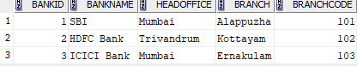

commit;

committed.

savepoint A;

savepoint A

delete from bank where branchcode=103;

1 rows deleted.

select \* from bank;



rollback to savepoint A;

rollback complete.

select \* from bank;

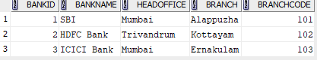

INSERT INTO Bank VALUES (4,'Axis Bank','Mumbai','Palakkad', 104);

1 rows inserted.

select \* from bank;

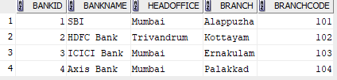

rollback;

rollback complete.

select \* from bank;

