CREATE TABLE Bank ( BankID NUMBER(3) PRIMARY KEY, bankname VARCHAR(100),headoffice VARCHAR(100), branch VARCHAR(100), branchcode NUMBER(5) );

INSERT INTO Bank VALUES (1, 'SBI', 'Mumbai', 'Alappuzha', 101);

INSERT INTO Bank VALUES (2, 'HDFC Bank','Trivandrum','Kottayam', 102);

INSERT INTO Bank VALUES (3,'ICICI Bank','Mumbai','Ernakulam', 103);

select \* from bank;

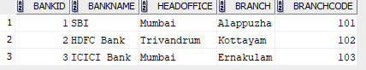

GRANT

grant select on Bank TO c22csa56;

grant succeeded.

select \* from c22csa56.bank;

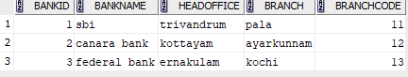

REVOKE

REVOKE SELECT ON BANK FROM C22CSA56;

REVOKE succeeded.

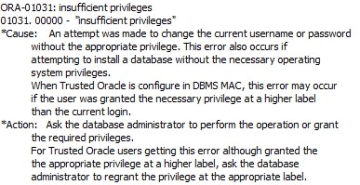

update c22csa56.bank set branchcode=007 where bankid=1;

commit;

committed

select \* from c22csa56.bank;

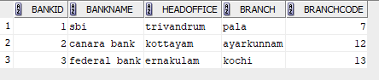

REVOKE SELECT,UPDATE ON BANK FROM C22CSA56;

REVOKE succeeded.

GRANT

grant select,UPDATE on Bank TO c22csa56;

grant succeeded.



After updation by other user

