CREATE TABLE Bank_12 (bankcode VARCHAR(3) PRIMARY KEY,bankname VARCHAR(255) NOT NULL,headoffice VARCHAR(255),branches INT CHECK (branches > 0));

INSERT INTO Bank_12 (bankcode, bankname, headoffice, branches) VALUES ('SBT', 'Bank A', 'Kochi', 1);

INSERT INTO Bank_12 (bankcode, bankname, headoffice, branches) VALUES ('ABC', 'Bank B', 'Ernakulam', 2);

INSERT INTO Bank_12 (bankcode, bankname, headoffice, branches) VALUES ('DFG', 'Bank C', 'Alapuzha', 3);

INSERT INTO Bank_12 (bankcode, bankname, headoffice, branches) VALUES ('HIJ', 'Bank D', 'Kollam', 4);

INSERT INTO Bank_12 (bankcode, bankname, headoffice, branches) VALUES ('KLM', 'Bank E', 'Pala', 5);

SELECT * FROM Bank_12;

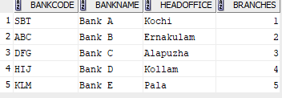

CREATE TABLE Branch_12 (branchid VARCHAR(3) PRIMARY KEY,branchname VARCHAR(100) DEFAULT 'New Delhi',bankid VARCHAR(3),FOREIGN KEY (bankid) REFERENCES Bank_12(bankcode) ON DELETE CASCADE);

INSERT INTO Branch_12 (branchid, branchname, bankid) VALUES ('001', 'Pathanamthitta', 'SBT');

INSERT INTO Branch_12 (branchid, branchname, bankid) VALUES ('002', 'Kottayam', 'ABC');

INSERT INTO Branch_12 (branchid, branchname, bankid) VALUES ('003', 'Karunapuram', 'DFG');

INSERT INTO Branch_12 (branchid, branchname, bankid) VALUES ('004', 'Arunapuram', 'HIJ');

INSERT INTO Branch_12 (branchid, branchname, bankid) VALUES ('005', 'Idukki', 'KLM');

SELECT * FROM Branch_12;

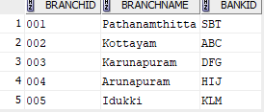

DELETE FROM Bank_12 WHERE bankcode = 'SBT';

SELECT * FROM Bank_12;

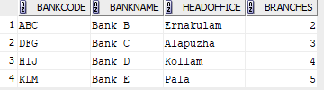

SELECT * FROM Branch_12;

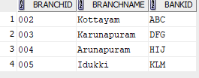

Describe Branch_12;

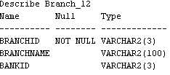

ALTER TABLE Branch_12 DROP PRIMARY KEY;

table BRANCH_12 altered.

Describe Branch_12;

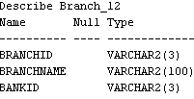

CREATE VIEW Bank12_head_office AS SELECT * FROM Bank_12 WHERE headoffice = 'Ernakulam';

view BANK12_HEAD_OFFICE created.

SELECT * FROM Bank12_head_office;



CREATE VIEW Bank12_Branch2 AS SELECT * FROM Branch_12 WHERE branchname = 'Kottayam';

SELECT * FROM Bank1_Branch2;

