**Table Creation**

create table Customer_ex8_57(CustomerID number(10) primary key,CustomerName varchar(20),ContactNo number(10),Address varchar(10),City varchar(10),PostalCode number(6),Country varchar(10));

create table Employee_ex8_57(EmployeeID number(10) primary key,LastName Varchar(20),FirstName Varchar(20),BirthDate date,Photo Varchar(10));

create table orders_ex8_57(OrderID number(10) primary key,CustomerID number(10),EmployeeID number(10),OrderDate date,ShipperID number(10),foreign key(CustomerID) references Customer_ex8_57(CustomerID),foreign key(EmployeeID) references Employee_ex8_57(EmployeeID));

**INSERTION**

insert into customer_ex8_57 values(1,'Ben Beck' ,8901234567,'Pala','Kottayam',688291,'India');

insert into customer_ex8_57 values(2,'Levi A' ,8901227567,'Westwood','Alappuzha',681291,'India');

insert into customer_ex8_57 values(3,'Axel Blaze' ,8904534567,'WindGale','Kochi',689091,'India');

insert into customer_ex8_57 values(4,'Jude Foster' ,8901114567,'Fireend','Malabar',645291,'India');

insert into customer_ex8_57 values(5,'Mark Evans' ,8901677567,'Forza','Kochi',677291,'India');

SELECT * FROM customer_ex8_57;

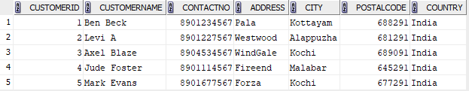

insert into employee_ex8_57 values(1,'Black' ,'Jack',('2-APR-02'),'2');

insert into employee_ex8_57 values(2,'Tennyson' ,'Ben',('21-FEB-00'),'6');

insert into employee_ex8_57 values(3,'Smith' ,'Will',('2-APR-02'),'2');

insert into employee_ex8_57 values(4,'Kubo' ,'TITE',('27-MAR-01'),'2');

insert into employee_ex8_57 values(6,'Kevin' ,'Win',('2-APR-04'),'2');

SELECT * FROM employee_ex8_57;

