CREATE TABLE Items_57 (itemid NUMBER PRIMARY KEY,Itemname VARCHAR(50),

category VARCHAR(50), Price NUMBER(10, 2),Instock INT CHECK (Instock >= 0));

CREATE TABLE Customers_57 (custid NUMBER PRIMARY KEY,Custname VARCHAR(50),Address VARCHAR(100),state VARCHAR(50));

CREATE TABLE Orders_57 (orderid NUMBER PRIMARY KEY,Itemid NUMBER REFERENCES Items_57(itemid),Custid NUMBER REFERENCES Customers_57(custid),Quantity NUMBER,Orderdate DATE);

CREATE TABLE Delivery_57 (deliveryid NUMBER PRIMARY KEY,Custid NUMBER REFERENCES Customers_57(custid),Orderid NUMBER REFERENCES Orders_57(orderid));

INSERT INTO Items_57 VALUES (1, 'Samsung Galaxy S4', 'Electronics', 10000.00, 50);

INSERT INTO Items_57 VALUES (2, 'iPhone 13', 'Electronics', 20000.00, 30);

INSERT INTO Items_57 VALUES (3, 'Nike Air Max', 'Footwear', 5000.00, 100);

INSERT INTO Items_57 VALUES (4, 'Sony Headphones', 'Electronics', 2500.00, 20);

INSERT INTO Items_57 VALUES (5, 'Leather Jacket', 'Clothing', 3000.00, 10);

INSERT INTO Customers_57 VALUES (1, 'Mickey', '123 Main St', 'California');

INSERT INTO Customers_57 VALUES (2, 'Jane Doe', '456 Maple Ave', 'New York');

INSERT INTO Customers_57 VALUES (3, 'John Smith', '789 Oak Dr', 'Texas');

INSERT INTO Customers_57 VALUES (4, 'Alice Johnson', '101 Pine Ln', 'California');

INSERT INTO Customers_57 VALUES (5, 'Bob Brown', '202 Birch Blvd', 'Nevada');

INSERT INTO Orders_57 VALUES (1, 1, 1, 2, TO_DATE('2024-08-01', 'YYYY-MM-DD'));

INSERT INTO Orders_57 VALUES (2, 2, 2, 1, TO_DATE('2024-07-15', 'YYYY-MM-DD'));

INSERT INTO Orders_57 VALUES (3, 3, 1, 1, TO_DATE('2024-06-30', 'YYYY-MM-DD'));

INSERT INTO Orders_57 VALUES (4, 4, 3, 1, TO_DATE('2024-05-20', 'YYYY-MM-DD'));

INSERT INTO Orders_57 VALUES (5, 5, 4, 1, TO_DATE('2024-09-10', 'YYYY-MM-DD'));

INSERT INTO Delivery_57 VALUES (1, 1, 1);

INSERT INTO Delivery_57 VALUES (2, 3, 4);

INSERT INTO Delivery_57 VALUES (3, 4, 5);

SELECT DISTINCT c.*,o.orderid FROM Customers_57 c JOIN Orders_57 o ON c.custid = o.custid;

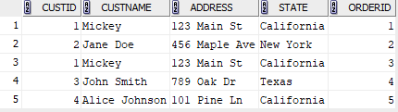

SELECT DISTINCT c.*,d.deliveryid FROM Customers_57 c JOIN Delivery_57 d ON c.custid = d.custid;

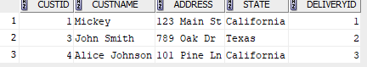

SELECT o.Orderdate FROM Orders_57 o JOIN Customers_57 c ON o.custid = c.custid WHERE c.Custname LIKE 'J%';



SELECT i.Itemname, i.Price FROM Items_57 i JOIN Orders_57 o ON i.itemid = o.Itemid JOIN Customers_57 c ON o.custid = c.custid WHERE c.Custname = 'Mickey';

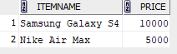

SELECT DISTINCT c.* FROM Customers_57 c JOIN Orders_57 o ON c.custid = o.custid LEFT JOIN Delivery_57 d ON o.orderid = d.Orderid WHERE o.Orderdate > TO_DATE('2013-01-31', 'YYYY-MM-DD') AND d.deliveryid IS NULL;

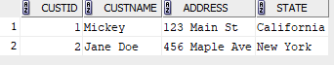

SELECT DISTINCT o.itemid FROM Orders_57 o UNION SELECT DISTINCT o.itemid FROM Orders_57 o LEFT JOIN Delivery_57 d ON o.orderid = d.Orderid WHERE d.deliveryid IS NULL;



SELECT DISTINCT c.Custname FROM Customers_57 c JOIN Orders_57 o ON c.custid = o.custid JOIN Delivery_57 d ON o.orderid = d.Orderid;



SELECT DISTINCT c.Custname FROM Customers_57 c JOIN Orders_57 o ON c.custid = o.custid LEFT JOIN Delivery_57 d ON o.orderid = d.Orderid WHERE d.deliveryid IS NULL MINUS SELECT DISTINCT c.Custname FROM Customers_57 c JOIN Orders_57 o ON c.custid = o.custid JOIN Delivery_57 d ON o.orderid = d.Orderid;



SELECT c.Custname FROM Customers_57 c JOIN Orders_57 o ON c.custid = o.custid GROUP BY c.Custname ORDER BY COUNT(o.orderid) DESC FETCH FIRST ROW ONLY;



SELECT DISTINCT c.* FROM Customers_57 c JOIN Orders_57 o ON c.custid = o.custid JOIN Items_57 i ON o.Itemid = i.itemid WHERE i.Price > 5000;



SELECT DISTINCT c.Custname, c.Address FROM Customers_57 c LEFT JOIN Orders_57 o ON c.custid = o.custid LEFT JOIN Items_57 i ON o.itemid = i.itemid AND i.Itemname = 'Samsung Galaxy S4' WHERE i.Itemname IS NULL;

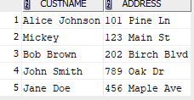

SELECT c.*, o.* FROM Customers_57 c LEFT JOIN Orders_57 o ON c.custid = o.custid;

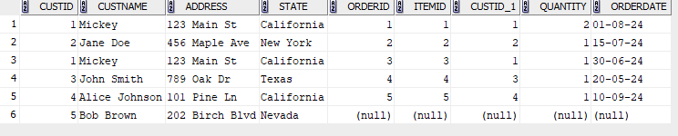

SELECT c.*, o.* FROM Customers_57 c RIGHT JOIN Orders_57 o ON c.custid = o.custid;

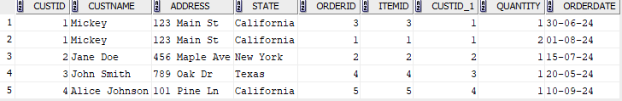

SELECT state, COUNT(*) AS number_of_customers FROM Customers_57 GROUP BY state;

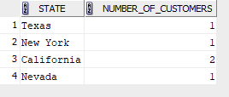

SELECT category, itemid, Itemname, Price FROM Items_57 WHERE Price > (SELECT AVG(Price) FROM Items_57) GROUP BY category, itemid, Itemname, Price;

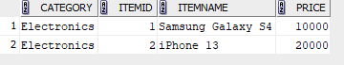

SELECT * from Delivery_57;

