Traineeship Application
Sprint Report
noNameTeam
Κωνσταντίνος Λευτέρης Μπουζούκας 5302
Νικολακόπουλος Αριστείδης 5308

Versions History
Date | Version | Description | Author
20/5/2025 | 1.0 | Sprint report for project “Traineeship Management” | 5302,5308

Introduction
This document provides information concerning the 1st sprint of the "Traineeship Management" project.

Purpose
The purpose of the project was to build a web application that works as a platform for Traineeships of students, where companies open Traineeships, students apply, professors supervise them and commissioners are admins that manage the whole process.

Document Structure
The rest of this document is structured as follows. Section 2 describes out Scrum team and specifies the this Sprint's backlog. Section 3 specifies the main design concepts for this release of the project.

Scrum team and Sprint Backlog

Scrum team
Product Owner | University
Scrum Master | Κωνσταντίνος Λευτέρης Μπουζούκας
Development Team | Νικολακόπουλος Αριστείδης

Sprints
<List below the sprints that you performed and the user stories that have been realized in each Sprint>
Sprint No | Begin Date | End Date | Number of weeks | User stories
1 | 10/5 | 20/5 | 1.5 | User,Student,Company,Professor,Commitee

Use Cases
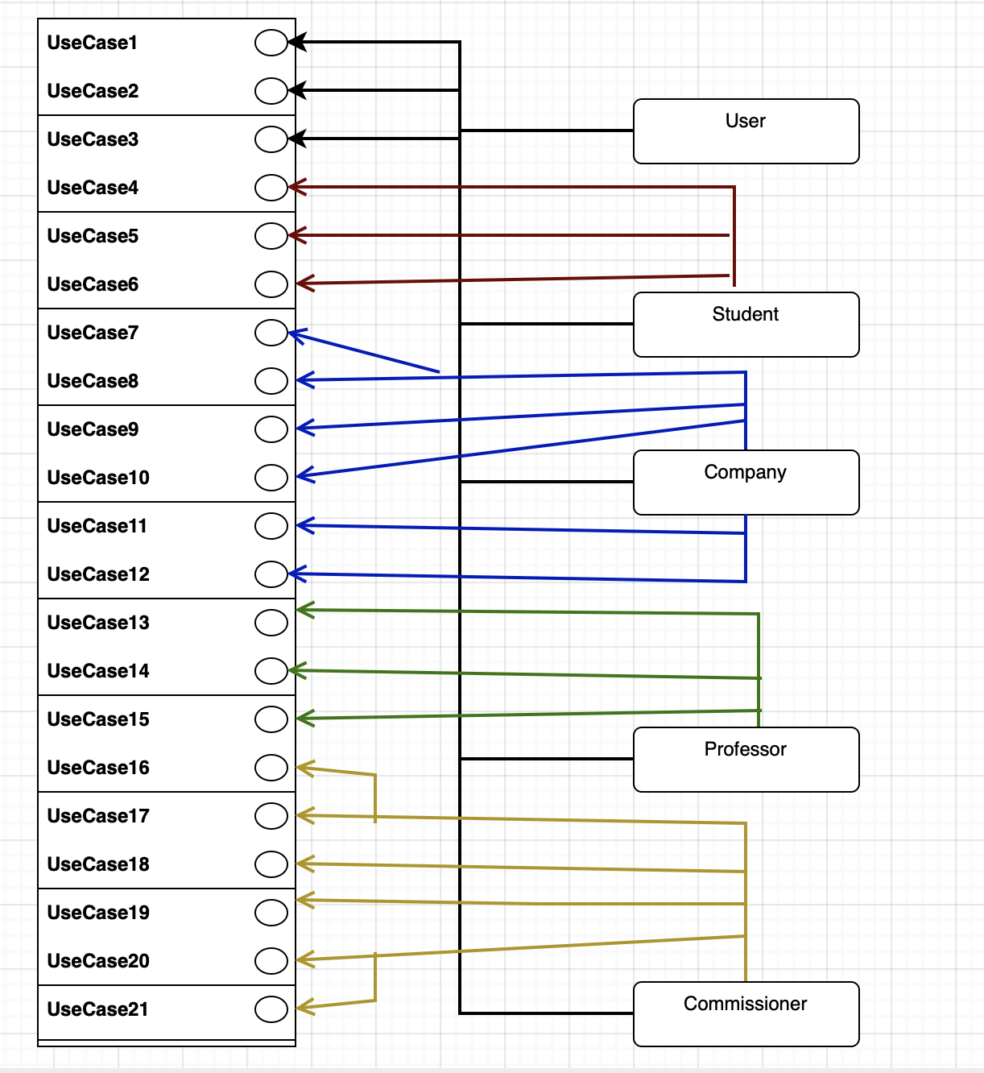

<Use Case 1>
Use case ID | US1
Actors | User
Pre conditions | -
Main flow of events | - The use case starts when the user opens the website and the login page is shown  - After the they click the register button another page is shown where they have to give the credentials (Username, Password, Role)  - Then if the registration is successful they can go back to the login page
Post conditions | A new user is added in the repository of users and depending on the role there is another entity in the repository of the selected role

<Use Case 2>
Use case ID | US2
Actors | User
Pre conditions | To have an account registered
Main flow of events | 1. The use case starts when the user opens the website and the login page is shown  2. After the they click the login button another page is shown different for each role with the basic ui for the role of the user
Alternative flow 1 | If the username and password do not match in the repository the page with reload
Post conditions | The user is now logged and is not a user actor but the specific role that they have

<Use Case 3>
Use case ID | US3
Actors | User
Pre conditions | To have an account registered and logged in
Main flow of events | 1. The use case starts when the logs in.  2. There is always a button on the top right of the page that they can click to log out.  3. After clicking it they are redirected to the login page.
Post conditions | It is needed a login to have access to the functionalities of the app

<Use Case 4>
Use case ID | US4
Actors | Student
Pre conditions | To login as a student
Main flow of events | 1. The use case starts when the student click the profile button  2. After the click to another page is shown with the profile and another button “Edit Profile”.  3. After They click it a page Is shown with a form that needs to be filled with all the required fields of the use case.  4. Then there is a redirect to the New Profile
Alternative flow 1 | The student can just look at the profile and is not mandatory to edit it.
Post conditions | The students name ,location etc are now visible for the committee and they can be used to find traineeships

<Use Case 5>
Use case ID | US5
Actors | Student
Pre conditions | To be logged in as a student
Main flow of events | - The use case starts when the student is at the page where there is always a button to apply for a traineeship.  - After clicking it the student is now visible for selection of Traineeship by the comitee
Post conditions | The student is now visible for selection of Traineeship by the comiteee

<Use Case 6>
Use case ID | US6
Actors | Student
Pre conditions | To login as a student
Main flow of events | 1. The use case starts when the student click the logbook button  2. After the they click the can view the reported in the logbook. Also a button is appeared that they can add reports.  3. After They click it a page Is shown with a form for the report.  4. After they add it to logbook they are redirected to the logbook page.
Alternative flow 1 | The student can just look at the logbook and is not mandatory to edit it.
Post conditions | The students logbook is now updated.

<Use Case7>
Use case ID | US7
Actors | Company
Pre conditions | To login as a company
Main flow of events | 1. The use case starts when the company click the profile button  2. After the they click to another page is shown with the profile and another button “Edit Profile”.  3. After They click it a page Is shown with a form that needs to be filled with all the required fields of the use case.  4. Then there is a redirect to the New Profile
Alternative flow 1 | The company can just look at the profile and is not mandatory to edit it.
Post conditions | The company name, location etc are now visible to the positions they open.

<Use Case 8-9>
Use case ID | US8 & US9
Actors | Company
Pre conditions | To login as a Company, to have announced a position
Main flow of events | 1. The use case starts when the company clicks the Traineeship Positions button.  2. After the they click another page is shown with a table for the open positions and their requirements .etc and also there is another table for the filled positions and their fields.

<Use Case 10>
Use case ID | US10
Actors | Company
Pre conditions | To login as a company
Main flow of events | 1. The use case starts when the company click the “Open A Position” button.  2. After the they click another page is shown with a form to fill with the data of the position.  3.After they have clicked “Make Position” they are redirected to the TraineeshipPositions page.
Post conditions | A new TraineeshipPosition is now created and added to the database of the OpenPositions

<Use Case 11>
Use case ID | US11
Actors | Company
Pre conditions | To login as a company and to have clicked the Traineeship Positions button
Main flow of events | 1. The use case starts when the company is viewing the open positions.  2. There is a button at the table of each position that at the click, the position is deleted.
Post conditions | The position is no longer available for a student assignment.

<Use Case 12>
Use case ID | US12
Actors | Company
Pre conditions | To login as a company and to have clicked the Traineeship Positions button
Main flow of events | 1. The use case starts when the company is viewing the open positions.  2. There is a button at the table of each filled position for each of the evaluation arguments that the company can select the rating and rate the position.
Post conditions | The position’s field of the specific rating is filled.

<Use Case 13>
Use case ID | US13
Actors | Professor
Pre conditions | To login as a Professor
Main flow of events | 1. The use case starts when the professor click the profile button  2. After the they click another page is shown with the profile and another button “Edit Profile”.  3. After They click it a page Is shown with a form that needs to be filled with all the required fields of the use case.  4. Then there is a redirect to the New Profile
Post conditions | The professor can just look at the profile and is not mandatory to edit it.

<Use Case 13>
Use case ID | US14
Actors | Professor
Pre conditions | To login as a Professor
Main flow of events | 1. The use case starts when the professor click the “My Positions” button  2. After the they click another page is shown a table of the positions that have been assigned to the professor.

<Use Case 11>
Use case ID | US15
Actors | Professor
Pre conditions | To login as a professor and to have clicked the My Positions button
Main flow of events | 1. The use case starts when the professor is viewing the positions.  2. There is a button at the table of each position for each of the required ratings  3. The professor can pick a rating and rate the specific field with their evaluation
Post conditions | The position have a field of evaluation filled.

<Use Case 16>
Use case ID | US16
Actors | Commissioner
Pre conditions | To login as a commissioner
Main flow of events | 1. The use case starts when the commissioner clicks the “Applied Students” button.  2. Then a page is shown with a table of Students who have applied for a traineeship.

<Use Case 17-18>
Use case ID | US17 & US18
Actors | Commissioner
Pre conditions | To login as a commissioner and click the “Applied Students” button.
Main flow of events | 1. The use case starts when the commissioner is viewing the table of Applied Students  2. There are a filed at the table for each of the entities with three buttons  2.1Click of the “Based On Interests” Button opens a page with a table for the available positions that are fitted for the student based on their interests  2.2 Click of the “Based On Interests” Button opens a page with a table for the available positions that are fitted for the student based on their location  2.3 Click of the “Based On Interests” Button opens a page with a table for the available positions that are fitted for the student based both the interests and location  3.After clicking a position the student is assigned to it.
Post conditions | The position is deleted form the openPosition Repository and is saved to the filledPosition Repository and the student is assigned to it.

<Use Case 19>
Use case ID | US19
Actors | Commissioner
Pre conditions | To login as a commissioner and click the “Traineeships In Progress” button.
Main flow of events | 1. The use case starts when the commissioner is viewing the table of Traineeships  2. There are a filed at the table for each of the entities with 2 buttons  2.1Click of the “Based On Interests” Button allocates a professor based on the interests.  2.2 Click of the “Based On Load” Button allocates the professor with the minimum load
Post conditions | The position’s fields of professor have now been updated and the professor can see the traineeship.

<Use Case 20>
Use case ID | US20
Actors | Commissioner
Pre conditions | To login as a commissioner.
Main flow of events | 1. The use case starts when the commissioner clicks the “Traineeships in progress” button.  2. After Clicking it another pages opens with al the Traineeships in progress (filled positions)

<Use Case 21>
Use case ID | US21
Actors | Commissioner
Pre conditions | To login as a commissioner and to have clicked the Traineeship In Progress button
Main flow of events | 1. The use case starts when the commissioner is viewing the traineeships.  2. There is a button at the table of each position that at the click, another page is shown with the details of the position and al the evaluations .  3. There the commissioner can select between “pass”, “fail”.
Post conditions | The position is now rated as pass or fail and is deleted from the filled positions.

Design

Architecture

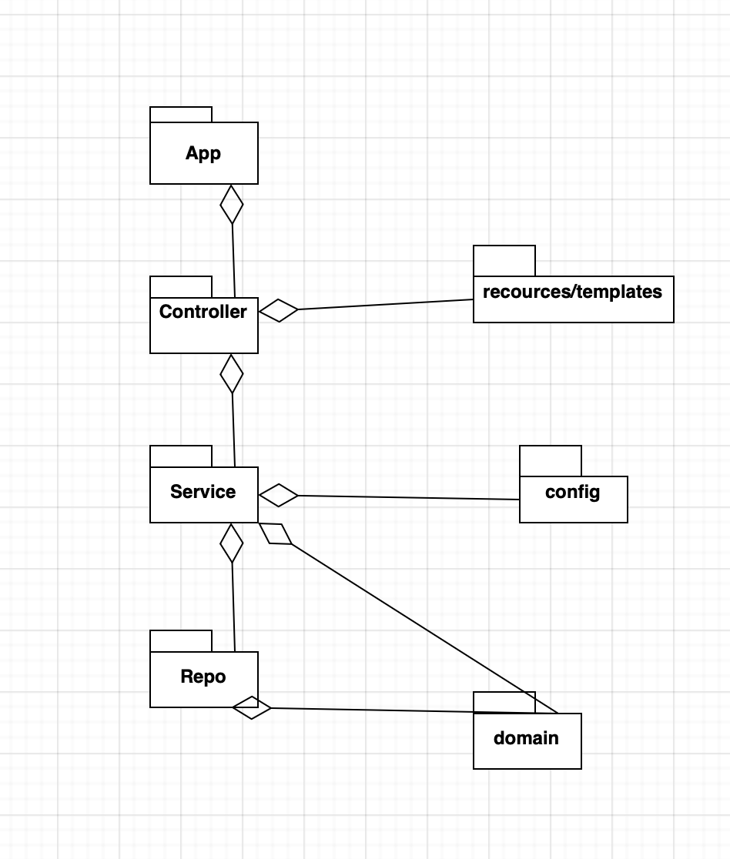

Design

Class Name: User
Responsibilities:  - Store the user Info | Collaborations:  - UserRepository: Stores the user into to the repository  - UserService: provides the information of the user to this class

Class Name: Student
Responsibilities:  - Stores the students info | Collaborations:  - StudentService: provides information of the student to this classs  - UserRepository: Stores the student into to the repository

Class Name: Company
Responsibilities:  - Stores the company info | Collaborations:  - CompanyService: provides information of the company to this classs  - CompanyRepository: Stores the company into to the repository

Class Name: Professor
Responsibilities:  - Stores the professor info | Collaborations:  - ProfessorService: provides information of the professor to this classs  - ProfessorRepository: Stores the professor into to the repository  - CommissionerService is assigning professors to positions

Class Name: OpenPosition
Responsibilities:  - Stores the OpenPosition info | Collaborations:  - CompanyService is making new entities of OpenPosition  - CommissionerService is assigning them to students  - OpenPositionsRepository: Stores the OpenPosition into to the repository

Class Name: FilledPosition
Responsibilities:  - Stores the OpenPosition info | Collaborations:  - CommissionerService is assigning them to professors and it closes them  - ProfessorService and CompanService are rating them  - FilledPositionsRepository: Stores the FilledPosition into to the repository

Class Name: SecurityConfig
Responsibilities:  - Makes the configuration of the application | Collaborations:

Class Name: Each of the Repositories (Interfaces)
Responsibilities:  - Stores the information to a H2 database | Collaborations:  - All the services are using them to get info

Class Name: UserService
Responsibilities:  - Provides the functionalities of the user  - Registers  - Saves to repository  - Gives information of the users  - Loads user  - Checks if user is already registered | Collaborations:  - UserController: functionality of the User Actor into the controller  - Uses repositories  - Uses the password encoder  - Get info from User.classs

Class Name: StudentService
Responsibilities:  - Provides the functionalities of the student  - Gives information of the students  - Update Profile and Logbook  - Makes student applied for Traineeship | Collaborations:  - StudentController: functionality of the Student Actor into the controller and information  - Uses repositories  - Get info from Student.class

Class Name: CompanyService
Responsibilities:  - Provides the functionalities of the company  - Gives information of the company  - Gives information of the Positions (Open and filled)  - Update Profile  - Make Open Positions  - Rates students evaluation fields | Collaborations:  - StudentController: functionality of the Student Actor into the controller and information  - Uses repositories  - Get info from Company.class  - OpenPosition: create object of OpenPosition  - FilledPosition: Provides the rate of the company’s evaluation

Class Name: ProfessorService
Responsibilities:  - Provides the functionalities of the professor  - Gives information of the professor  - Gives info of the professor’s positions  - Update Profile  - Rates the evaluation of the student and company | Collaborations:  - ProfessorController: functionality of the Student Actor into the controller and information  - Uses repositories  - Get info from Professor.class  - FilledPosition: Provides the rate of the professor’s evaluation

Class Name: Commissioner
Responsibilities:  - Provides the functionalities of the commissioner  - Gives info of the applied students  - Assigns students to positions  - Gives info of the Open and filled positions  - Returns a list of positions for students based on the strategies  - Allocates a professor to a Traineeship based on the Strategies | Collaborations:  - CommissionerController: functionality of the Commissioner Actor into the controller and information  - Uses repositories  - FilledPosition: Provides the rate of the traineeship and deletes  - Professor: allocates professors to filled positions  - Student: assigns open positions to students

Class Name: All Controlers
Responsibilities:  - Controls the program by controlling the PostMappings and GetMappings and connects backend to frontend  - Different Controllers are just controlling the app based on the actor (role of user) | Collaborations:  - Only with services to provide the functionality

