day&year
tian1 nian2
the day
before yesterday qian2 tian1 qian2 nian2
/2 years ago

yesterday/last year zuo2 tian1 qu4 nian2

today& this year jin1 tian1 jin1 nian2
tomorrow& next year ming2 tian1 ming2 nian2
the day
after tomorrow hou4 tian1 hou4 nian2
/2 years later

ming2-bright
qian2-front
hou4- back
zuo2-past
qu4 - to go to

I go to school
wo3 qu4 xue2 xiao4

week&month
xing1 qi1 yue4
last week
last month shang4(ge) xing1 qi1 shang4 ge yue4
this week
this month zhe4（ge）xing1 qi1 zhe4 ge yue4
next week
next month xia4 (ge) xing1 qi1 xia4 ge yue4

this morning= today morning
jin1 tian1 zao3 shang4
this noon
jin1 tian1 zhong1 wu3
this afternoon
jin1 tian1 xia4 wu3
tonight=this evening
jin1 tian1 wan3 shang4
last night=last evening(yesterday evening)
zuo2 tian1 wan3 shang4
last late morning
zuo2 tian1 shang4 wu3

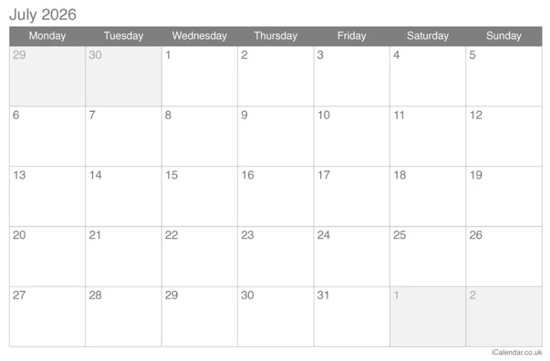
zhe4 ge xing1 qi1

This Friday- zhe4 ge xing1 qi1 wu3
last Wednesday- shang4 ge xing1 qi1 san1
next Tuesday- xia4 ge xing1 qi1 er4

this Feb(Feb of this year)=this year Feb
jin1 nian2 er4 yue4

last Feb=last year Feb
qu4 nian2 er4 yue4

next Feb
=next year Feb
ming2 nian2 er4 yue4

every morning
=everyday morning - mei3 tian1 zao3 shang4

every,each,per- mei3
every student- mei3 ge xue2 sheng1
every dog- mei3 zhi1 gou3

every afternoon- mei3 tian1 xia4 wu3
every night- mei3 tian1 wan3 shang4

time-shi2 jian1
ji3

general question:statement+ma?

questions with question words-no 'ma'
- change the question into answer(make an answer)
- find out the part you want to ask about ,replace it with'ji3'
- change the subject(optional)

What time? - ji3 dian3?
10:00-10 dian3

What day(of the week)?-xing1 qi1 ji3?
xing1 qi1 yi1

What date? - ji3 yue4 ji3 hao4
7 yue4 20 hao4

Which month? - ji3 yue4?
7 yue4

Which day? - ji3 hao4?
20 hao4

Homework
some new words:
lai2-come
xiu1 xi- to rest
fa3 guo2- France

Translate the following sentences
- I go to China to attend university next March.
- Peter come to my home at noon on the 6th.
- I go to a French restaurant to have dinner at eight o'clock last night.
- I am on vacation from August 7th to August 21st.
=I rest (from) August 7th to August 21st

Could you ask some questions based on these sentences?
For instance:
What time?
What date?
Which month?
Which day(of the month)

Once you finish, you may listen to the questions in the audio for comparison. However, I have rearranged the order of the questions in the recording. You can also try answering the questions directly while listening to the audio as oral practice.

