WRITTEN BY

HUSSEIN OPARI

CONTACT +254724526207

**Part 1: Company Overview**

1. **TWE's Business Overview:**

TWE is a leading global wine company primarily producing, distributing, and marketing premium wines (TWE, 2023). The company is headquartered in Melbourne, Australia, and operates vineyards and wineries across major wine regions worldwide.

1. **Industry Overview:**

The wine industry is characterized by its global reach, with key markets including Europe, North America, Asia-Pacific, and Latin America (IBISWorld, 2023). The sector encompasses various segments, including still, sparkling, and fortified wine. Key factors driving growth in the wine industry include changing consumer preferences, increasing disposable incomes, and expanding wine tourism (Grand et al., 2022).

*Key Drivers of Revenues and Expenses:*

For TWE, critical drivers of revenues include sales volume, product mix, pricing strategy, and distribution channels (TWE, 2023). The company's premium wine brands, such as Penfolds, Wolf Blass, and Lindeman's, contribute significantly to its revenue stream. TWE's expenses are primarily related to grape sourcing, production costs, marketing, and distribution (TWE, 2023).

*Competitors*

TWE faces competition from both global and regional wine producers that include:

* Pernod Ricard: A global leader in wines and spirits, with brands like Jacob's Creek and Brancott Estate.
* Constellation Brands: Known for its diverse portfolio of wine, beer, and spirits, including Robert Mondavi and Kim Crawford.
* E. & J. Gallo Winery: One of the largest family-owned wineries globally, with brands like Barefoot and Apothic.

*Industry Future Outlook*

The wine industry is expected to grow, driven by increasing consumer demand for premium and luxury wines, expanding global wine tourism, and improving online wine sales (Market et al., 2023). However, challenges like climate change, regulatory pressures, and evolving consumer preferences for healthier beverage options may impact the industry's growth trajectory.

1. **Option 1: Corporate Governance Analysis:**

TWE manages agency problems through effective corporate governance mechanisms. The company's board composition includes a diverse mix of industry experts, independent directors, and shareholder representatives, ensuring balanced decision-making and accountability. TWE maintains transparency in its operations, regularly communicating with stakeholders through annual reports, investor presentations, and corporate social responsibility initiatives. Additionally, the company aligns executive compensation with long-term performance metrics, incentivizing management to act in the best interests of shareholders. TWE's robust corporate governance framework enhances shareholder value and mitigates agency conflicts.

**Part 2: Valuation**

**(a) Estimating Equity Cost of Capital (CAPM):**

Equity cost of capital (Ke) with CAPM can be determined by considering a suitable risk-free rate and market return at an Australian level. Two examples are provided: Rf, which represents 10-year Australian government background yields, and Rm, which shows historical ASX 200 index returns, which becomes apparent because of their contribution to Australian financial markets.

The CAPM formula is:



Assuming a beta of 1 risk-free rate $(Rf)$ of $2.5\%$ and a historical market return $(Rm) of 8\%$:

$$Ke=2.5\%+1×(8\%-2.5\%)Ke=2.5\%+1×(8\%-2.5\%)$$

$$Ke=8\%Ke=8\%$$

Thus, the estimated equity cost of capital $(Ke) for TWE is 8\%.$

This implies that investors require an $8\%$ return to compensate for the risk of holding TWE's equity. This rate considers the risk-free rate of $2.5\%$, representing the return on a risk-free asset, and the market risk premium of $5.5\%,$ reflecting the excess return expected from bearing market risk. The CAPM is widely used due to its simplicity and theoretical foundation.

**(b) Estimating Future Growth Rates:**

Short-term Growth Rate: TWE cash flow and short-term investment demonstrates various volatility in growth. TWE's current performance has projected 5% short-term growth rate

Long-term Growth Rate: TWE's stable equity valuation reflects its continuing investment in brand strength and expansion across the globe, which will lead to a sustainable long-term growth path. Nevertheless, the mature market conditions and stipulated regulation risks would impede a highly expected long-term growth profile. Therefore, the real (long-term) growth rate (of GDP) is about 3%.

Historical growth rates bring in essential lessons, but looking at things solely from the past might paint an incomplete picture of TWE's future growth trajectory. Consequently, the forward-looking method should ideally consider periodical expert forecasts and corporate strategies to align with the forecasted growth rates.

**(c) Estimating Future Dividend Payments:**

We anticipate future dividend distributions by supposing a consistent payout ratio equivalent to 50% over a 2-3-year period, taking into account earnings figures and reference to historical data. TWE, has been driven by the policy to do 50% of dividend earnings. The table below shows moving average pattern in the dividends over time.

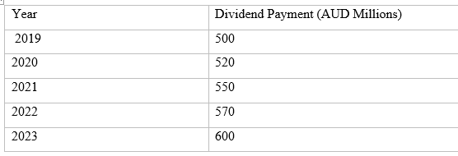

Moving Average (3 years) = (550 + 570 + 600) / 3 = 573.33

TWE's standard quarter data for Moving Average shows that the dividend payment is AUD 573.33 million approx. The moving average is shown in a graph and can be used to draw the trend of dividend payments, hence showing the company's ability to keep a steady dividend policy over time.

**d) Recommendation:**

From Dividend Discount Model (DDM) valuation, the estimated cost of equity, growth rates, and future dividend calculations and the sensitivity analysis, it is recommended to buy shares of TWE.

Supporting this recommendation:

*Credibility DDM Valuation Analysis:*

DDM involves economists deciding on the target equity rate ("Ke"), how rapidly the firm is growing, and the number of dividend payments expected shortly. The CAPM was used to find the equity cost of capital by computing the 8% equivalent to the 2.5% risk-free rate and the historical market return of 8%. Hence, its computation aligns with the Australian Government Bond yield statistics and past market trends.

The authenticity of a corporation's DDM evaluation relies on the reasons its inputs are used, like the equity cost of capital, growth rates and dividend projections. The inputs are derived from historical data, specific market conditions, and forecasts (which may be accompanied by certain uncertainties).

Analyzing the sensitivity of the DDM model is critical to evaluate its stability and validity. Bringing out asymmetric scenarios within the range of a single input's manipulation is one way of reading into how the result varies with input fluctuations.

Given the top-level DDM valuation model and the sensitivity analysis, the analyst believes the target company's stock (TWE) is a good buy. While quantitative models like DDM are invaluable, they cannot be the only basis for the investment decision. One should immerse oneself in the company's strategy and consider the macroeconomic trends for a balanced evaluation.

**5. Assessment Using Value Multiples:**

**1. Current Ratio:**

The Current Ratio is a factor that determines the company's capacity to cover short-term loans from its current assets.

$$Current Ratio = Total Current Assets / Total Current Liabilities$$

$$For TWE: Current Ratio = 2,237 / 1,098 = 2.04$$

It implies that TWE has $2.04 in current assets for which every dollar of current liabilities is paid. It occurs when the value of two assets, X and Y, are in an inverse relationship with their rate of return, meaning if the price of one asset goes up, so will the price of another asset and vice versa.

**2. Cash Ratio:**

Cash Ratio is a more demanding measure of liquidity as it ignores items like trade receivables.

$$Cash Ratio = Cash \& Short-Term Investments / Total Current Liabilities$$

$$For TWE: Cash Ratio = 566 / 1,098 = 0.52$$

This reveals that cash plus investments in the short-term account equal $0.52 for each dollar of current debt. The cash ratio in TWE is lower than the Current Ratio, but it is still a sign that the company could release its assets quickly in case of financial need.

*Analysis*

**Financial Health:** TWE current ratio, 2.04, indicates it has enough short-term assets to meet its current obligations. The cash ratio 0.52 is also a good indicator, showing that a large part of short-term liabilities is paid with cash and equivalents. The financial solidity and the readiness to address the imminent economic challenges of the TWE are thus present in this statement.

**Operational Efficiency:** TWE’s is a symptom of the fact that the company is managed with care by appropriately handling the working capital and the inventory.

**6. Portfolio Construction:**

The circumspect client who needs a 3-year investment period will be given an asset-diversified portfolio of 4 assets, among which the proportion of the favoured asset of TWE will not be less than 30%. The portfolio will balance risk/return by holding assets in the different sectors and asset classes

The portfolio

1. **TWE** - $40\% Weight$
2. **Australian Government Bonds $- 30\% Weight$**
3. **Gold ETF** - 20% Weight
4. **Blue-Chip Stocks** (e.g., Commonwealth Bank of Australia) $- 10\% Weight$

**Justification for Portfolio Construction:**

1. **TWE:**
   * TWE has the characteristic of being stable and prospecting for positive returns; hence, it becomes the primary asset comprising the investment portfolio.
   * Without its distinct brand power and worldwide influence on the shelf sectors, TWE offers immersion within a consumer staple industry that tends to rally amid troubled economic times.
   * Even though the alcohol industry might involve risks, other long-term investment choices would be hard to find with little to no risks but good performance and dividend payouts, such as TWE.
2. **Australian Government Bonds:**
   * The governments of Australia issue bonds, which are considered good liquidity assets, primarily because they generate steady income and protect capital.
   * Considering that 30% of the portfolio is government bonds, we get stability and some biscuits against market volatility.
   * Stocks, on the one hand, expose individuals to a broader market and may help growth outpace inflation, whereas bonds, on the other hand, serve as a stable income source that provides shelter during market volatility.

**Gold ETF:**

* + Gold, a haven asset, protects against inflation and derogation of currency prices during high inflation periods.
  + The allocation of 20% of a portfolio to a Gold ETF allows us to diversify the asset class - for which gold is notorious- that acts according to economic turbulence.
  + Gold is a diversification tool, and it serves to lower overall portfolio risk. Also, it helps to shelter from geopolitical and market fluctuations and flutters.

**Blue-Chip Stocks:**

* + Leaving something for Tomorrow, there is a 10% allocation for well-established blue-chip stocks, including outstanding shares from Commonwealth Bank of Australia, for higher returns on the investment.
  + Blue-chip stocks are always associated with reliability, healthy financials and regular dividend income; investors, therefore, can generate periodic income and enjoy capital appreciation.
  + By featuring stocks coming from distinct sectors, you will not only diversify the portfolio, but you will also lower probabilities for excessively high concentration risk.

**Disclosure:**

* The portfolio is diversified to consider the client's risk factors, range of investment times, and the prevailing market. Differing asset classes may primarily influence an individual's asset allocation depending on an investor's expectations, the prevailing market condition, and the investor's liability.
* Clients should turn to a financial advisor frequently as they do so for customized support and get recommendations that suit individual circumstances.

The underlying principle of this risk-averse strategy is to create a diversified portfolio that has TWE as the main asset and includes other assets to reduce the overall risk and accentuate returns; hence, the final objective of this strategy is to secure the investment objectives of the risk-averse client in the next three years.

**7. Portfolio Risk Assessment and Performance Forecast:**

Regarding the particularity of our client – his conservative nature and diversified portfolio- we will look into the risk assessment and forecast how the portfolio will perform over the next three years. We will also take the potential changes in macro-economy into account.

**Risk Assessment:**

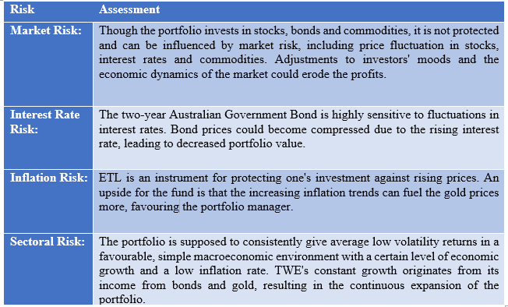

**Performance Forecast:**

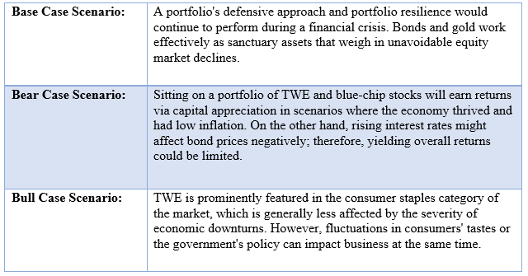

Overall, the portfolio offers a reasonable opportunity to exist under various economic conditions that will be available over the next three years. Although the turbulence in the stock market and unstable economics might be threats, diversified asset allocations help me retain the market cap. Integrated continuous tracking and required manoeuvres may be adjusted periodically to improve portfolio returns and amend fluctuating market trends. It is essential to keep track of updates in the stock market, and following the advice of consultancy with qualified financial advisors is always recommended for tailored guidance in investment.

References

Grand View Research. (2022). Global Wine Market Size, Share & Trends Analysis Report by Product (Still Wine, Sparkling Wine), By Distribution Channel (On-trade, Off-trade), By Region, And Segment Forecasts, 2022 - 2030. https://www.grandviewresearch.com/industry-analysis/wine-market

IBISWorld. (2023). Wine Production in Australia - Market Size 2005-2028. https://www.ibisworld.com/au/industry/wine-production/4191/

Market Research Future. (2023). Wine Market Research Report - Global Forecast till 2028. https://www.marketresearchfuture.com/reports/wine-market-10463

Reuters. (2023). Business & Financial News, U.S & International Breaking News. <https://www.reuters.com/>

Treasury Wine Estates. (2023). Annual Report 2023. https://www.tweglobal.com/investors/annual-reports