Мамонов Антон 3ИСиП-19-1

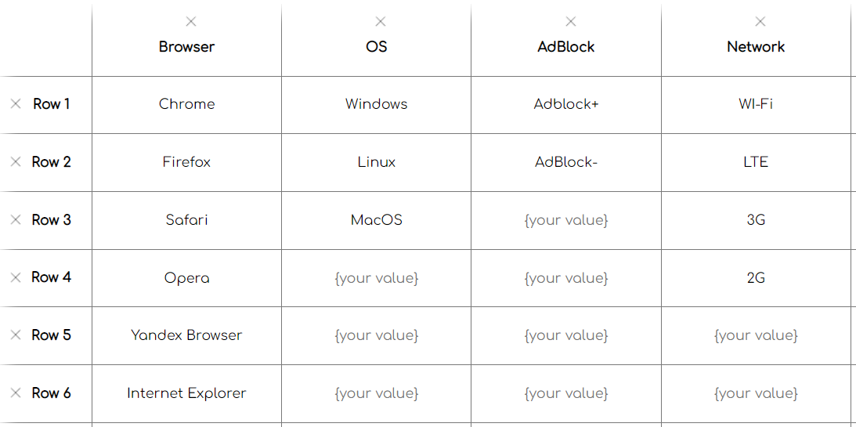Даем на вход наши параметры

На выходе получаем уникальные сочетания наших параметров

|  |  |  |  |  |
| --- | --- | --- | --- | --- |
|  | **Browser** | **OS** | **AdBlock** | **Network** |
| **1** | Chrome | MacOS | Adblock+ | 3G |
| **2** | Chrome | Windows | AdBlock- | 2G |
| **3** | Chrome | Linux | Adblock+ | WI-Fi |
| **4** | Chrome | MacOS | AdBlock- | LTE |
| **5** | Firefox | Linux | Adblock+ | 2G |
| **6** | Firefox | Linux | AdBlock- | WI-Fi |
| **7** | Firefox | MacOS | Adblock+ | LTE |
| **8** | Firefox | Windows | AdBlock- | 3G |
| **9** | Safari | Linux | Adblock+ | 3G |
| **10** | Safari | MacOS | AdBlock- | 2G |
| **11** | Safari | Windows | Adblock+ | WI-Fi |
| **12** | Safari | Linux | AdBlock- | LTE |
| **13** | Opera | Windows | Adblock+ | 2G |
| **14** | Opera | Windows | AdBlock- | WI-Fi |
| **15** | Opera | Linux | Adblock+ | LTE |
| **16** | Opera | MacOS | AdBlock- | 3G |
| **17** | Yandex Browser | Linux | Adblock+ | WI-Fi |
| **18** | Yandex Browser | MacOS | AdBlock- | LTE |
| **19** | Yandex Browser | Windows | Adblock+ | 3G |
| **20** | Yandex Browser | Linux | AdBlock- | 2G |
| **21** | Yandex Browser | MacOS | Adblock+ | WI-Fi |
| **22** | Yandex Browser | Windows | AdBlock- | LTE |
| **23** | Internet Explorer | MacOS | Adblock+ | 2G |
| **24** | Internet Explorer | Windows | AdBlock- | WI-Fi |
| **25** | Internet Explorer | Linux | Adblock+ | LTE |
| **26** | Internet Explorer | MacOS | AdBlock- | WI-Fi |
| **27** | Internet Explorer | Windows | Adblock+ | LTE |
| **28** | Internet Explorer | Linux | AdBlock- | 3G |

Теперь нужно исключить логические лишнее

1. Браузер Safari не работает на Linux – исключаем данные варианты

|  |  |  |  |  |
| --- | --- | --- | --- | --- |
| **№** | **Browser** | **OS** | **AdBlock** | **Network** |
| **9** | Safari | Linux | Adblock+ | 3G |
| **12** | Safari | Linux | AdBlock- | LTE |

2. Браузер Internet Explorer не работает на Linux и MacOS – исключаем данные варианты

|  |  |  |  |  |
| --- | --- | --- | --- | --- |
| **№** | **Browser** | **OS** | **AdBlock** | **Network** |
| **23** | Internet Explorer | MacOS | Adblock+ | 2G |
| **25** | Internet Explorer | Linux | Adblock+ | LTE |
| **26** | Internet Explorer | MacOS | AdBlock- | WI-Fi |
| **28** | Internet Explorer | Linux | AdBlock- | 3G |

Вид итоговой таблицы:

|  |  |  |  |  |
| --- | --- | --- | --- | --- |
| **№** | **Browser** | **OS** | **AdBlock** | **Network** |
| **1** | Chrome | MacOS | Adblock+ | 3G |
| **2** | Chrome | Windows | AdBlock- | 2G |
| **3** | Chrome | Linux | Adblock+ | WI-Fi |
| **4** | Chrome | MacOS | AdBlock- | LTE |
| **5** | Firefox | Linux | Adblock+ | 2G |
| **6** | Firefox | Linux | AdBlock- | WI-Fi |
| **7** | Firefox | MacOS | Adblock+ | LTE |
| **8** | Firefox | Windows | AdBlock- | 3G |
| **9** | Safari | MacOS | AdBlock- | 2G |
| **10** | Safari | Windows | Adblock+ | WI-Fi |
| **11** | Opera | Windows | Adblock+ | 2G |
| **12** | Opera | Windows | AdBlock- | WI-Fi |
| **13** | Opera | Linux | Adblock+ | LTE |
| **14** | Opera | MacOS | AdBlock- | 3G |
| **15** | Yandex Browser | Linux | Adblock+ | WI-Fi |
| **16** | Yandex Browser | MacOS | AdBlock- | LTE |
| **17** | Yandex Browser | Windows | Adblock+ | 3G |
| **18** | Yandex Browser | Linux | AdBlock- | 2G |
| **19** | Yandex Browser | MacOS | Adblock+ | WI-Fi |
| **20** | Yandex Browser | Windows | AdBlock- | LTE |
| **21** | Internet Explorer | Windows | AdBlock- | WI-Fi |
| **22** | Internet Explorer | Windows | Adblock+ | LTE |