College Symposium Management System Using Vue.js
Lab Report – Exercise 6
Subject Code: ICS1511
Subject: Web Application Development Lab
Student Name: Sharruk S
Register Number: 3122247001061
Year / Semester: III Year / V Semester
Batch: 2024–2029

1. Aim
To design and develop a Vue.js 3 based College Symposium Management System that allows students to browse, search, filter, and register for symposium events using reusable components, props, computed properties, conditional rendering, and dynamic class/style bindings.

2. Problem Statement
A college is organizing a three-day technical symposium consisting of multiple events such as coding contests, workshops, paper presentations, quizzes, and cultural programs. Manually tracking registrations, seat availability, and event status for many events is error-prone. A simple, reactive front-end system is needed where students can view event details, check live seat availability, and register for events, with the interface updating automatically as registrations happen.

3. Objectives
- To build a component-based Vue.js application using reusable components.
- To demonstrate parent-to-child communication using props.
- To demonstrate child-to-parent communication using emits.
- To render dynamic lists using v-for.
- To implement conditional UI using v-if, v-else-if, and v-else.
- To implement dynamic styling using :class and :style bindings.
- To implement search and category filtering using computed properties.
- To validate form input and update application state on submission.

4. Technologies Used
- Vue.js 3 (Composition API with <script setup>)
- Vite (development server and build tool)
- JavaScript (ES6+)
- HTML5 and CSS3
- Node.js and npm (for running/building the project)

5. System Requirements

Hardware Requirements
- A computer with at least 4 GB RAM
- Minimum 500 MB free disk space

Software Requirements
- Node.js (v16 or later) and npm
- A modern web browser (Chrome, Firefox, or Edge)
- A code editor such as VS Code

6. Project Structure
symposium-management/
├── package.json
├── vite.config.js
├── index.html
├── README.md
├── TESTING.md
└── src/
├── main.js
├── App.vue
└── components/
├── Header.vue
├── EventList.vue
├── EventCard.vue
├── EventDetails.vue
├── RegistrationForm.vue
└── Footer.vue

7. Component Description

App.vue
The root component. Holds the master list of symposium events (as reactive state), the selected category, search text, and the currently selected event id. Provides computed properties for filtering/searching and handles the registration update logic.

Header.vue
A static presentational component showing the symposium title and subtitle. Styled using normal (non-scoped) CSS, as required by the exercise.

EventList.vue
Receives the filtered array of events as a prop from App.vue and renders one EventCard per event using v-for. Re-emits the view-details event up to App.vue.

EventCard.vue
Displays a single event's summary: name, category, date, venue, fee, computed available seats, and status (via v-if/v-else-if/v-else). Uses :class for category-based border coloring and :style for dynamic title font sizing. Styled with scoped CSS.

EventDetails.vue
Displays the complete information of the selected event in a table. Shows a Register button only when registration is open and seats remain. Hosts RegistrationForm.vue once the student clicks Register, and emits the registration data back up to App.vue.

RegistrationForm.vue
A form collecting student name, register number, email, and department. Validates that all fields are filled before emitting submit-registration to its parent; otherwise shows a validation message.

Footer.vue
A static footer displayed at the bottom of the page.

8. Implementation

8.1 Event Data
Each event object in App.vue stores: eventId, eventName, category, date, venue, registrationFee, maxParticipants, registeredParticipants, and status. Eight sample events are defined, spanning all four categories (Technical, Cultural, Workshop, Competition) and demonstrating all three status states.

8.2 Props
Event data flows down the component tree via props: App.vue passes the filtered event array to EventList.vue, which passes a single event object to each EventCard.vue. App.vue also passes the selected event object directly to EventDetails.vue.

8.3 v-for
EventList.vue uses v-for to iterate over the events prop and render one EventCard per event, keyed by eventId.

8.4 Conditional Rendering
EventCard.vue and EventDetails.vue use v-if / v-else-if / v-else to display 'Registration Closed', 'Almost Full', or 'Registration Open' depending on the event's status.

8.5 Computed Properties
filteredEvents (App.vue) combines the selected category and search text to derive the visible event list. availableSeats, categoryClass, and titleFontSize (EventCard.vue) are also computed, so they automatically stay in sync with the underlying event data.

8.6 Dynamic Class Binding
:class is used in EventCard.vue to apply a category-specific CSS class (technical / cultural / workshop / competition), which changes the card's border color without any per-event styling code.

8.7 Dynamic Style Binding
:style is used in EventCard.vue to set the event title's font-size inline, based on the computed number of available seats: large (>20 seats), medium (10–20 seats), or small (<10 seats).

8.8 Event Handling
The app uses @input on the search box, @click on category buttons and the View Details/Register buttons, and @submit.prevent on the registration form to handle all user interactions.

8.9 Registration Logic
When a registration form is submitted with all fields filled, App.vue increments registeredParticipants for that event by 1. Because availableSeats is computed rather than stored, it updates automatically everywhere it is displayed. The event's status field is then recalculated: Registration Closed when seats reach 0, Almost Full when seats are 10 or fewer, and Registration Open otherwise.

8.10 Form Validation
RegistrationForm.vue checks that student name, register number, email, and department are all non-empty before emitting the submit-registration event; otherwise it displays an inline validation message and does not submit.

9. Screenshots
Screenshot 1 – Application Home Page
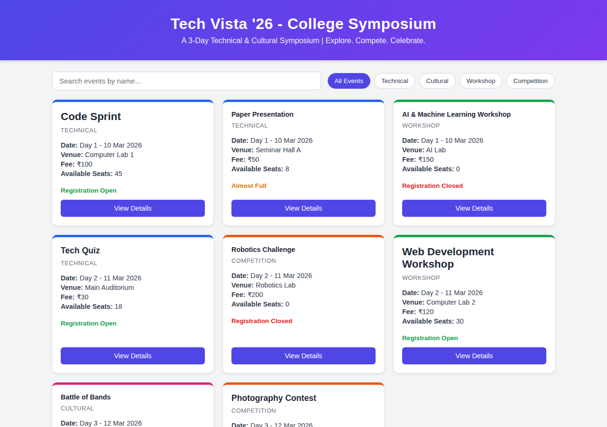
Screenshot 2 – Event List and Category Filter
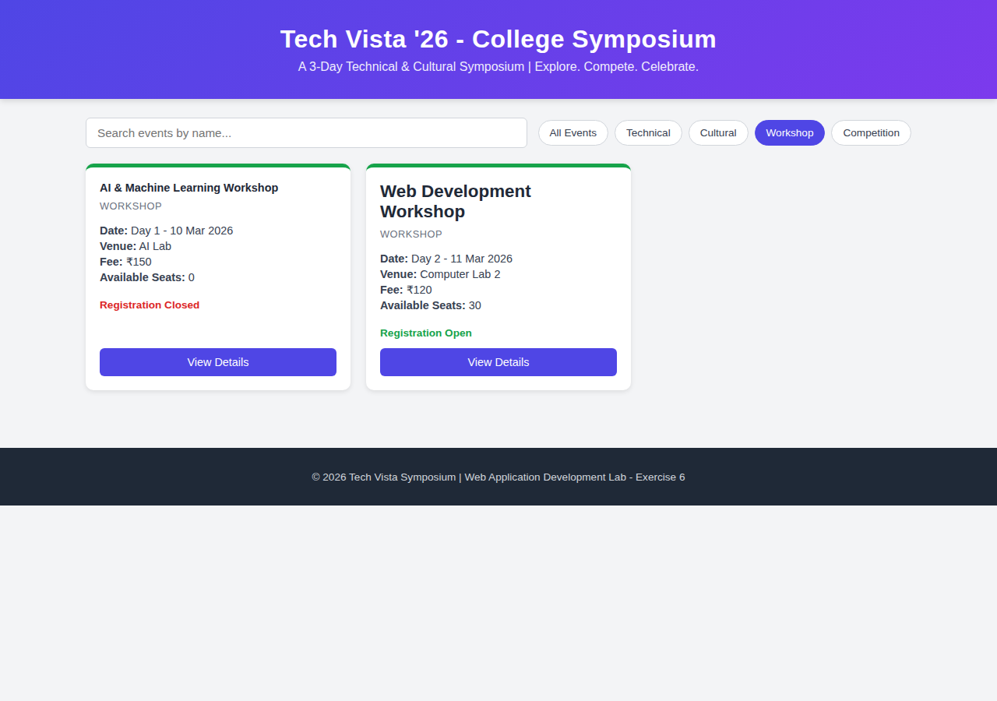
Screenshot 3 – Event Details
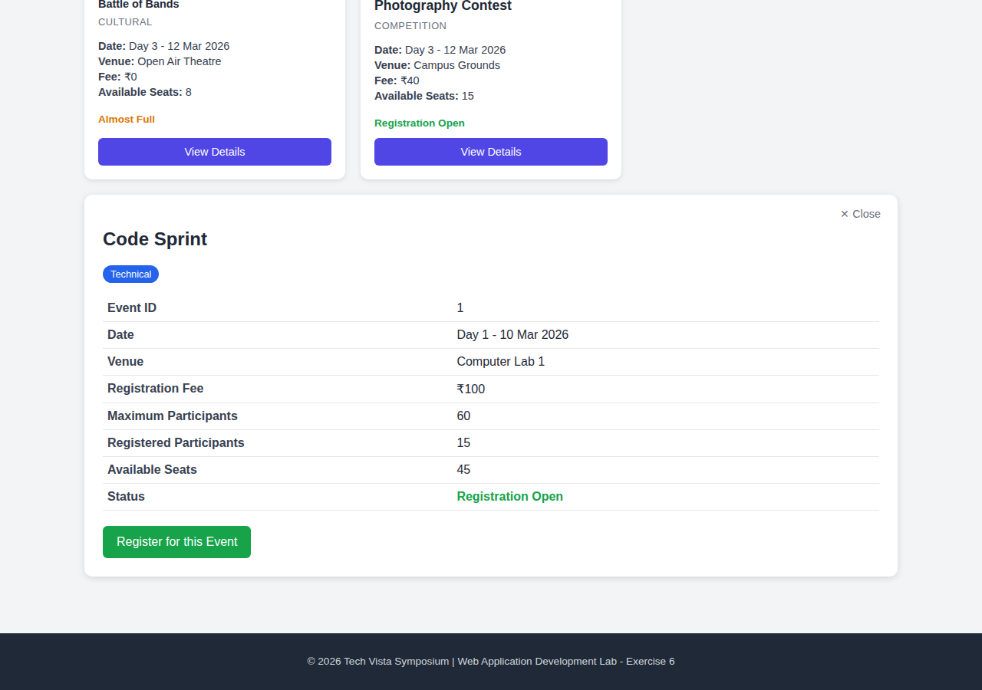
Screenshot 4 – Registration Form
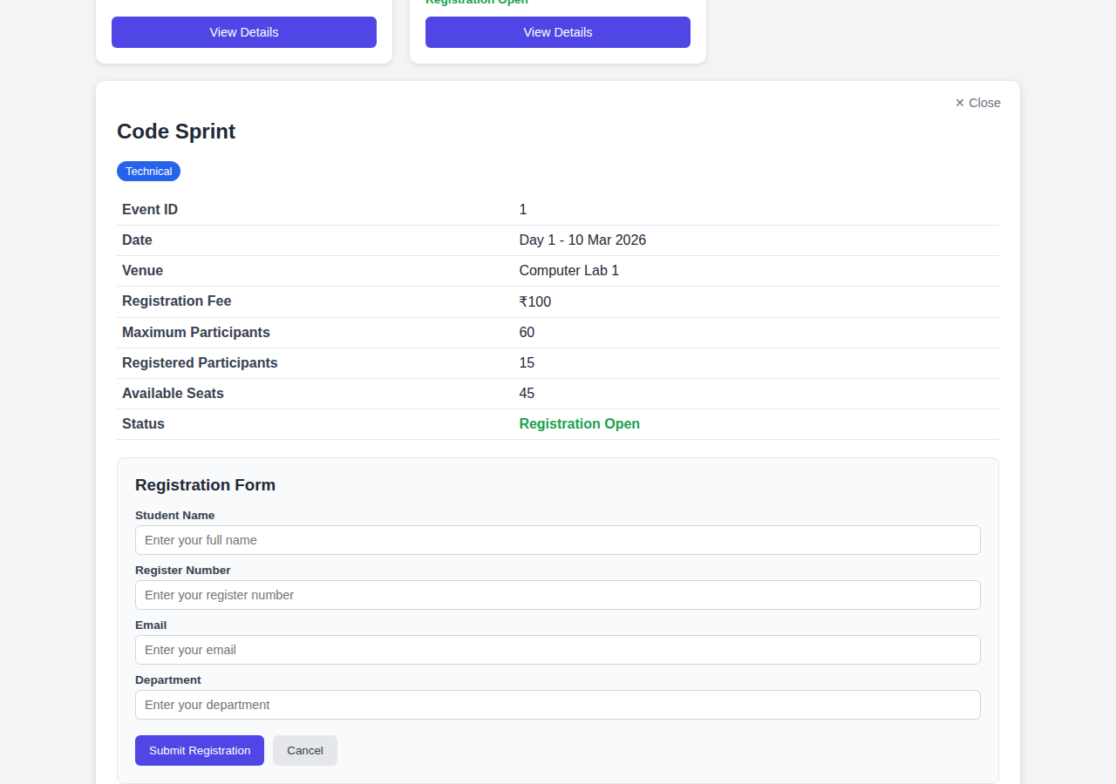
Screenshot 5 – Registration Success
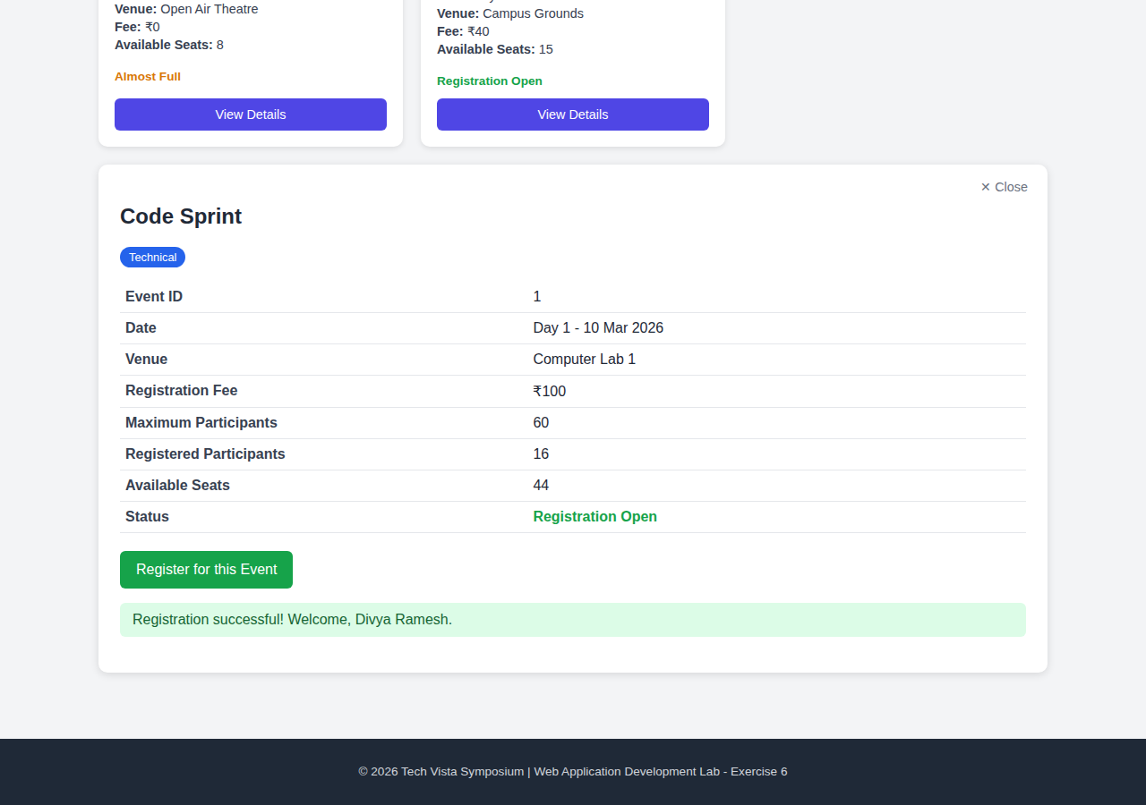
Screenshot 6 – Dynamic Status / Full Event
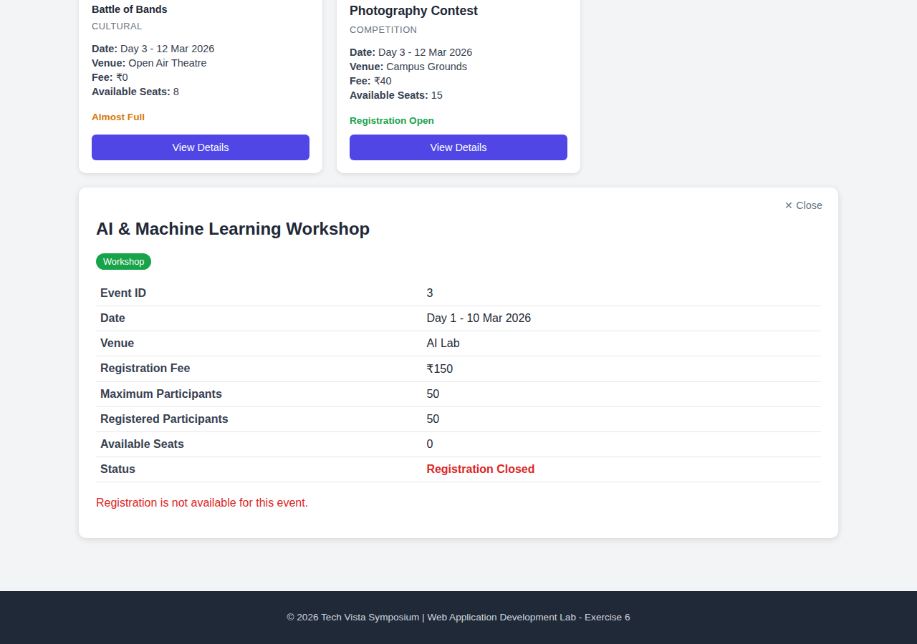

10. Expected Output
On running the application, the user sees a header, a search box with category filter buttons, a grid of event cards, and a footer. Searching or filtering updates the visible events instantly. Clicking View Details reveals full event information with a Register option (when applicable). Submitting a valid registration form increases the registered participant count, decreases the available seats, and updates the event status automatically, with a success message shown to the student.

11. Result
The College Symposium Management System was successfully developed using Vue.js 3 and Vite. The application satisfies all specified requirements: reusable components, props-based communication, v-for rendering, conditional rendering, computed-property-driven filtering and searching, dynamic class and style bindings, event handling, and form validation with automatic state updates. The project builds successfully with 'npm run build' and runs locally with 'npm run dev'.

12. Conclusion
This exercise provided hands-on experience in building a multi-component Vue.js 3 application with reactive, computed, and prop-driven data flow. It demonstrated how Vue's reactivity system keeps derived values such as available seats and event status automatically in sync with the underlying data, and how component communication patterns (props down, events up) keep the application modular and easy to extend — adding a new symposium event requires only adding a new object to the event data, with no changes to any component's code.

