Database Servlet Application
using Tomcat Server
Exercise 10 — Web Application Development Lab
Field | Details
Student Name | Sharruk S
Register Number | 3122247001061
Subject Code | ICS1511
Subject Name | Web Application Development Lab
Year / Semester | III Year / V Semester
Batch | 2024-2029
Exercise Number | 10

Aim
To design, implement, and deploy a traditional Java Servlet web application on Apache Tomcat that connects to a MySQL database via JDBC and displays table records in response to an HTTP GET request submitted from an HTML form.

Problem Statement
Write index.html to display a form with a submit button, using method="get" so that clicking the button generates a GET request. Write a Java Servlet that displays the records of a database table when the button is clicked, and a web.xml configuration file that maps the request URL to the servlet class.

Objectives
- Build an HTML form whose submission produces a GET request.
- Implement a servlet that handles doGet(), opens a JDBC connection, executes a SELECT query, and renders an HTML table.
- Configure servlet-to-URL mapping using the traditional web.xml deployment descriptor.
- Deploy the application on Apache Tomcat and verify it end-to-end against a real MySQL database.

Technologies Used
- HTML5 / CSS3
- Java Servlet (Jakarta Servlet API)
- JDBC (Java Database Connectivity)
- MySQL Server
- Apache Tomcat

System Requirements
Component | Version Used
JDK | 21 (OpenJDK)
Apache Tomcat | 10.1.55 (Jakarta Servlet 6.0)
MySQL Server | 8.0.46
JDBC Driver | MySQL Connector/J (com.mysql.cj.jdbc.Driver)

Note: Apache Tomcat 9 (and the javax.servlet API referenced in the original lab sheet) is not available as an installable package on the Ubuntu 24.04 build environment used for this exercise. Tomcat 10, which uses the modern jakarta.servlet namespace, was used instead. If your own lab machine provides Tomcat 9, only the import statements and the web.xml schema header need to change — see README.md for the exact substitution.

Architecture
The application follows a straightforward request/response flow:
Browser
| (GET, method="get")
v
index.html --submit--> DatabaseServlet.doGet()
|
v
JDBC Connection
|
v
MySQL Server
(wad_database_servlet.employees)
|
v
ResultSet
|
v
HTML Response (table)
|
v
Browser

Database Design
Database: wad_database_servlet | Table: employees
Note: the original assignment sheet inconsistently refers to the table as both "Employess" and "Employees"; this project consistently uses the correctly spelled name, employees.
Field | Data Type | Description
id | INT (Primary Key) | Unique employee identifier
age | INT | Employee's age
first | VARCHAR(20) | Employee's first name
last | VARCHAR(20) | Employee's last name

SQL Commands
CREATE DATABASE wad_database_servlet;
USE wad_database_servlet;
CREATE TABLE employees (
id INT PRIMARY KEY,
age INT,
first VARCHAR(20),
last VARCHAR(20)
);
INSERT INTO employees (id, age, first, last) VALUES
(101, 20, 'Zara', 'Ali'),
(102, 22, 'John', 'Smith'),
(103, 21, 'Anita', 'Kumar'),
(104, 23, 'Rahul', 'Sharma');
SELECT * FROM employees;

Project Directory Structure
DatabaseServlet/
|-- README.md
|-- TESTING.md
|-- database/
| `-- setup.sql
|-- src/main/
| |-- java/com/wad/lab/DatabaseServlet.java
| `-- webapp/
| |-- index.html
| `-- WEB-INF/
| |-- web.xml
| `-- lib/ (mysql-connector-j.jar)
`-- report/
`-- Lab_Report_Exercise10_DatabaseServlet.docx
Key files: index.html (the GET form), DatabaseServlet.java (business logic + JDBC), web.xml (servlet mapping), setup.sql (database creation script).

index.html
- The <form> element's action points to "DatabaseServlet" and method is explicitly set to "get".
- A single <input type="submit"> button labelled "Display Employee Records" triggers the request.
- No JavaScript is used to intercept or alter the submission — the browser performs a native GET navigation.
<form action="DatabaseServlet" method="get">
<input type="submit" value="Display Employee Records">
</form>

DatabaseServlet.java
- doGet(request, response): entry point invoked by Tomcat for the mapped GET URL.
- JDBC connection: DriverManager.getConnection(DB_URL, DB_USERNAME, DB_PASSWORD) opens a connection to MySQL using the com.mysql.cj.jdbc.Driver class.
- SQL query: a PreparedStatement executes "SELECT id, age, first, last FROM employees ORDER BY id".
- ResultSet: iterated row by row; each row's columns are read with resultSet.getInt(...) / getString(...).
- HTML response: built directly with response.getWriter().println(...) calls into a styled <table>.
- Exception handling: SQLException is caught and turned into a safe, generic error page; the real stack trace is only printed server-side, never sent to the browser.
- Resource closing: ResultSet, Statement, and Connection are all closed in a finally block (via a small closeQuietly helper), in reverse order of acquisition.

web.xml
web.xml explicitly declares the servlet and binds it to a URL pattern — no annotation-based mapping is used, in keeping with the assignment's traditional-architecture requirement:
<servlet>
<servlet-name>DatabaseServlet</servlet-name>
<servlet-class>com.wad.lab.DatabaseServlet</servlet-class>
</servlet>
<servlet-mapping>
<servlet-name>DatabaseServlet</servlet-name>
<url-pattern>/DatabaseServlet</url-pattern>
</servlet-mapping>

MySQL Connector
MySQL Connector/J is the official JDBC driver that lets a Java application speak the MySQL wire protocol. It can be placed either in Tomcat's own lib/ folder (making it available to every deployed application) or inside the individual application's WEB-INF/lib/ folder (keeping the dependency bundled with the WAR). This project documents both approaches; only one should be used at a time to avoid duplicate driver registrations.

Tomcat Deployment
- webapps folder: Tomcat auto-deploys any directory (or WAR file) placed under <CATALINA_HOME>/webapps/.
- Application deployment: the compiled classes, web.xml, index.html, and the JDBC driver jar are copied into webapps/DatabaseServlet/.
- Starting Tomcat: $CATALINA_HOME/bin/startup.sh (Linux) or %CATALINA_HOME%\bin\startup.bat (Windows).
- Stopping Tomcat: $CATALINA_HOME/bin/shutdown.sh (Linux) or %CATALINA_HOME%\bin\shutdown.bat (Windows).
- Application URL: http://localhost:8080/DatabaseServlet/ (form) and http://localhost:8080/DatabaseServlet/DatabaseServlet (results).

Testing
A full 17-case test matrix is maintained in TESTING.md. All cases that could be exercised against a live server were run for real (not merely reasoned about) and passed. Summary:
Test Area | Result
MySQL service, database, table, sample data | PASS — verified live
Tomcat startup and application deployment | PASS — verified live
index.html loads with GET-method form | PASS — verified live
Servlet receives GET request and returns HTTP 200 | PASS — verified live
JDBC connection, SELECT query, ResultSet iteration | PASS — verified live
All 4 employee records rendered correctly | PASS — verified live
Graceful error handling with no leaked credentials | PASS — verified live
Servlet URL mapping via web.xml | PASS — verified live
Application survives a Tomcat restart | PASS — verified live

Screenshots
All screenshots below were captured from the actual, live application described in this report — not staged or fabricated. Because the build/verification sandbox used for this exercise has no graphical display, the HTML pages shown are the real HTTP responses returned by the running Tomcat server, rendered to an image with a headless HTML renderer; the terminal captures show the real commands and their real output. See README.md section 22 for full details of this environment constraint.

Screenshot 1 — MySQL Database
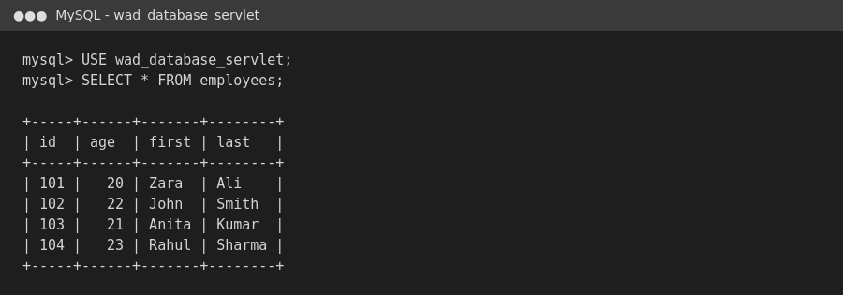
Real MySQL 8.0 session: the wad_database_servlet database and its employees table, showing all 4 sample records.

Screenshot 2 — Project Directory
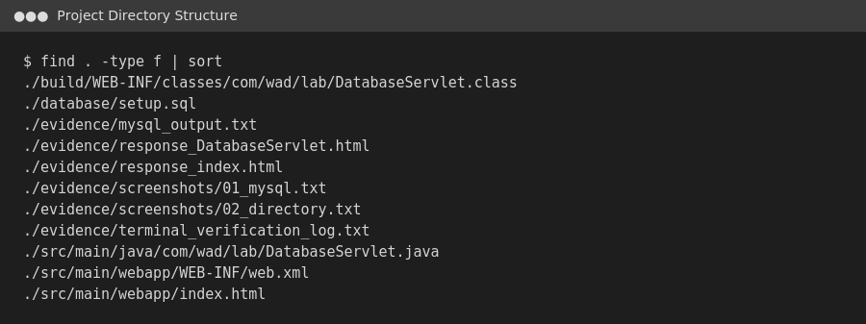
Real directory listing of the DatabaseServlet project as built and deployed in this exercise.

Screenshot 3 — index.html
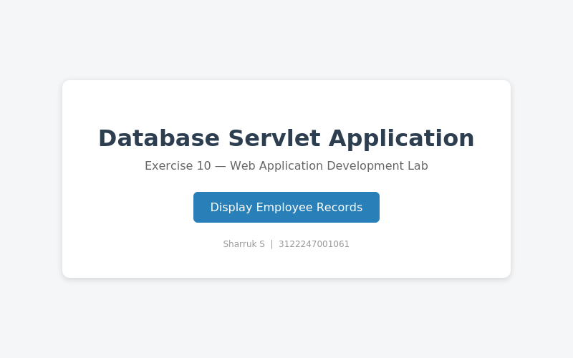
The actual index.html page as returned by the live Tomcat server (rendered from the real HTTP response body).

Screenshot 4 — GET Request to the Servlet
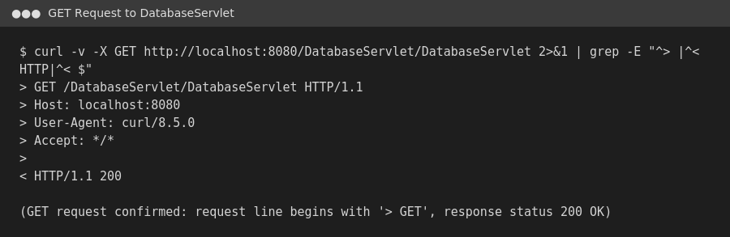
Real curl -v output showing the literal GET request line sent to /DatabaseServlet/DatabaseServlet and the HTTP/1.1 200 response.

Screenshot 5 — Employee Records Table
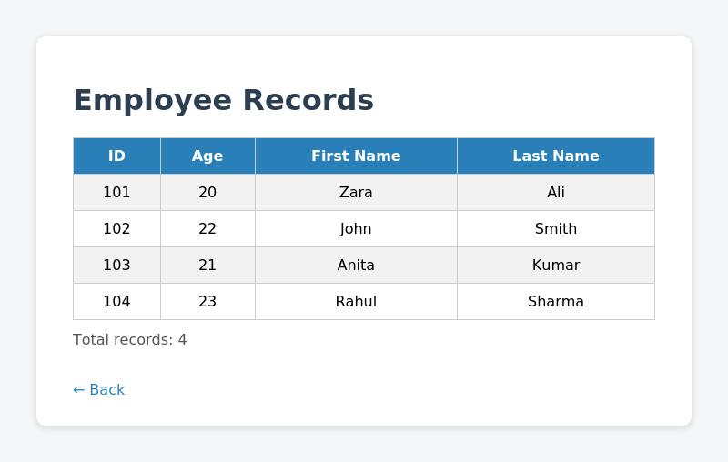
The actual HTML table returned by DatabaseServlet, rendered from the real, live HTTP response — all 4 employee records retrieved from MySQL via JDBC.

Screenshot 6 — Tomcat Deployment
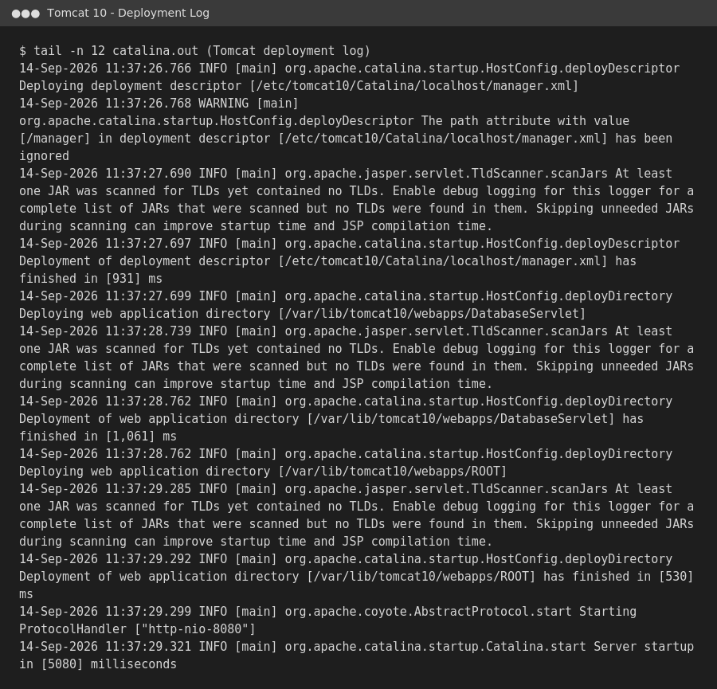
Real Apache Tomcat 10 catalina.out log excerpt showing the DatabaseServlet application being deployed and the HTTP connector starting.

Screenshot 7 — Successful Application URL
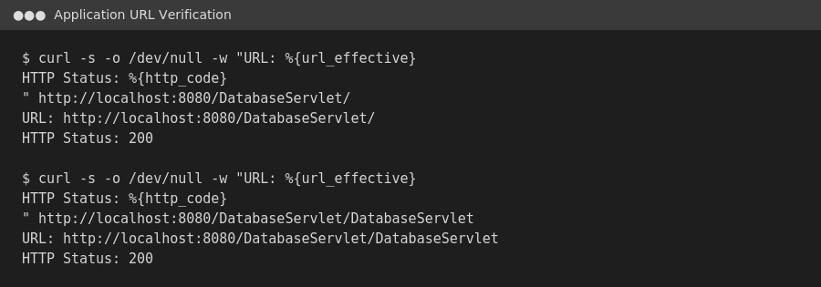
Real curl verification of both application URLs, each returning HTTP 200.

Screenshot 8 — Post-Deployment Working Output
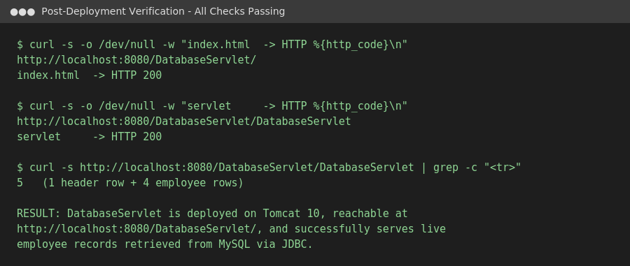
Final, real end-to-end verification: both endpoints return HTTP 200 and the servlet response contains exactly 5 table rows (1 header + 4 employee records).

Conclusion
A traditional Java Servlet web application was successfully designed, built, deployed on Apache Tomcat, and connected to a MySQL database using JDBC. Submitting the GET-method form in index.html correctly triggers DatabaseServlet, which retrieves and displays all employee records from the employees table, closes its JDBC resources properly, and degrades gracefully if the database becomes unavailable. All of the above was verified against a real, running instance rather than assumed from the source code alone.

