Sri Sivasubramaniya Nadar College of Engineering

(An Autonomous Institution, Affiliated to Anna University, Chennai)
Department of Computer Science and Engineering

Degree & Branch | Five Year Integrated M.Tech (CSE) |  |  | Semester | V
Subject Code & Name | ICS1511---Web Application Development Laboratory
Assignment - 1 | Mini Project: College Symposium Website using HTML alone
Academic Year | 2026-2027  ODD | Batch | 2024-2029 | Regulations – R2023
Name: Sharruk S | Register Number: 3122247001061 |  |  | Date:10/7/2026

Mini Project: College Symposium Website using HTML alone

Scenario
Your college is organizing a national-level technical symposium called "TechNova 2026". The organizing committee wants a website to provide information about the event, showcase competitions, display schedules, and allow students to register online.
Design and develop a website using only HTML and CSS.

Website Structure

Page 1: Home (index.html)

Purpose
Welcome visitors and provide an overview of the symposium.

Content
- College logo
- Symposium banner image
- Symposium name: TechNova 2026
- Theme of the event
- Date and venue
- Brief introduction
- Navigation menu to all pages
- Highlights section
  - 500+ Participants
  - 15 Events
  - Cash Prizes
Industry Experts

index.html

<!DOCTYPE html>
<html>

<head>
<title>TechNova 2026 - Home</title>
</head>

<body>

<!-- Header Section -->
<header>
<img src="assets/images/college_logo.png" alt="College Logo" width="80" height="80">
<h1>TechNova 2026</h1>
<h3>National Level Technical Symposium</h3>
</header>

<hr>

<!-- Navigation Menu -->
<nav>
<b>Navigate:</b>
<a href="index.html">Home</a> |
<a href="about.html">About</a> |
<a href="technical.html">Technical Events</a> |
<a href="nontechnical.html">Non-Technical Events</a> |
<a href="schedule.html">Schedule</a> |
<a href="register.html">Register</a> |
<a href="contact.html">Contact Us</a>
</nav>

<hr>

<!-- Banner Image -->
<section>
<img src="assets/images/banner.jpg" alt="TechNova 2026 Banner" width="800" height="200">
</section>

<!-- Symposium Overview -->
<section>
<h2>Welcome to TechNova 2026</h2>
<p><b>Theme:</b> Innovate. Integrate. Inspire.</p>
<p><b>Date:</b> March 15, 2026</p>
<p><b>Venue:</b> SSN College of Engineering, Main Auditorium, Kalavakkam, Chennai</p>
<p>
TechNova 2026 is a national-level technical symposium organized by the Department of Computer Science
and Engineering. The event brings together students from colleges across the country to compete,
learn, and network with industry experts. Join us for an exciting day of technical and non-technical
events, guest lectures, and prize distributions.
</p>
</section>

<hr>

<!-- Highlights Section -->
<section>
<h2>Event Highlights</h2>
<table border="1">
<tr>
<th>Highlights</th>
<th>Details</th>
</tr>
<tr>
<td>Participants</td>
<td>500+</td>
</tr>
<tr>
<td>Events</td>
<td>15</td>
</tr>
<tr>
<td>Cash Prizes</td>
<td>Worth Rs. 50,000</td>
</tr>
<tr>
<td>Industry Experts</td>
<td>5+ Guest Speakers</td>
</tr>
</table>
</section>

<hr>

<!-- Footer -->
<footer>
<p>TechNova 2026 | SSN College of Engineering</p>
<p>For queries: technova2026@ssn.edu.in</p>
</footer>

</body>

</html>

Output:
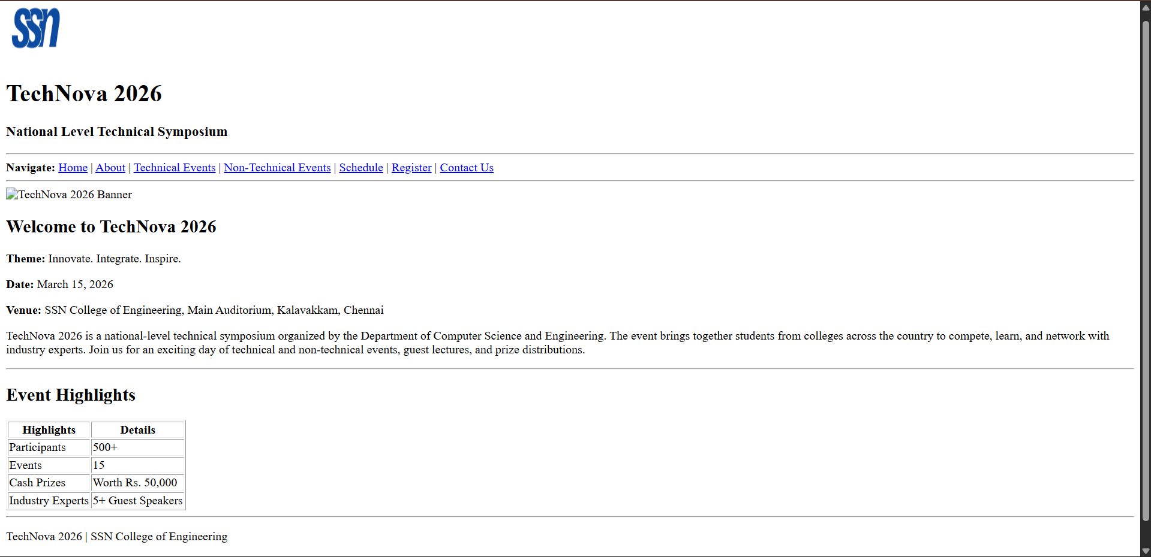

Page 2: About Symposium (about.html)

Purpose
Provide detailed information about the event.

Content
- Symposium objectives
- Event vision and mission
- Organizing department
- Why students should participate
- Benefits of participation

about.html

<!DOCTYPE html>
<html>

<head>
<title>TechNova 2026 - About</title>
</head>

<body>

<!-- Header Section -->
<header>
<img src="assets/images/college_logo.png" alt="College Logo" width="80" height="80">
<h1>TechNova 2026</h1>
<h3>National Level Technical Symposium</h3>
</header>

<hr>

<!-- Navigation Menu -->
<nav>
<b>Navigate:</b>
<a href="index.html">Home</a> |
<a href="about.html">About</a> |
<a href="technical.html">Technical Events</a> |
<a href="nontechnical.html">Non-Technical Events</a> |
<a href="schedule.html">Schedule</a> |
<a href="register.html">Register</a> |
<a href="contact.html">Contact Us</a>
</nav>

<hr>

<!-- About Page Heading -->
<section>
<h2>About the Symposium</h2>
</section>

<!-- Symposium Objectives -->
<section>
<h3>Objectives</h3>
<ul>
<li>To provide a platform for students to showcase their technical skills.</li>
<li>To encourage innovation and creative thinking among students.</li>
<li>To bridge the gap between academia and industry.</li>
<li>To promote healthy competition and teamwork.</li>
<li>To create networking opportunities among students from various colleges.</li>
</ul>
</section>

<hr>

<!-- Vision and Mission -->
<section>
<h3>Vision</h3>
<p>
To become the most prestigious national-level student symposium that nurtures future
technology leaders and innovators.
</p>

<h3>Mission</h3>
<p>
Our mission is to organize a well-structured, competitive, and knowledge-sharing platform
where students can enhance their skills, gain exposure, and develop confidence to face
real-world challenges.
</p>
</section>

<hr>

<!-- Organizing Department -->
<section>
<h3>Organizing Department</h3>
<p>
TechNova 2026 is organized by the <b>Department of Computer Science and Engineering</b>,
SSN College of Engineering (Sri Sivasubramaniya Nadar College of Engineering). The department
has a strong tradition of organizing student-driven events that promote technical excellence.
</p>
</section>

<hr>

<!-- Why Participate -->
<section>
<h3>Why Should You Participate?</h3>
<ol>
<li>Compete with talented students from across the country.</li>
<li>Win exciting cash prizes and certificates.</li>
<li>Get a chance to interact with industry professionals.</li>
<li>Enhance your resume with participation certificates.</li>
<li>Gain exposure to new technologies and ideas.</li>
</ol>
</section>

<hr>

<!-- Benefits of Participation -->
<section>
<h3>Benefits of Participation</h3>
<ul>
<li>Participation certificate for all registered students.</li>
<li>Winner and runner-up certificates for event winners.</li>
<li>Cash prizes for top performers.</li>
<li>Free lunch and refreshments for all participants.</li>
<li>Networking with students and faculty from other colleges.</li>
<li>Exposure to cutting-edge technical domains.</li>
</ul>
</section>

<hr>

<!-- Footer -->
<footer>
<p>TechNova 2026 | SSN College of Engineering</p>
<p>For queries: technova2026@ssn.edu.in</p>
</footer>

</body>

</html>

Output:
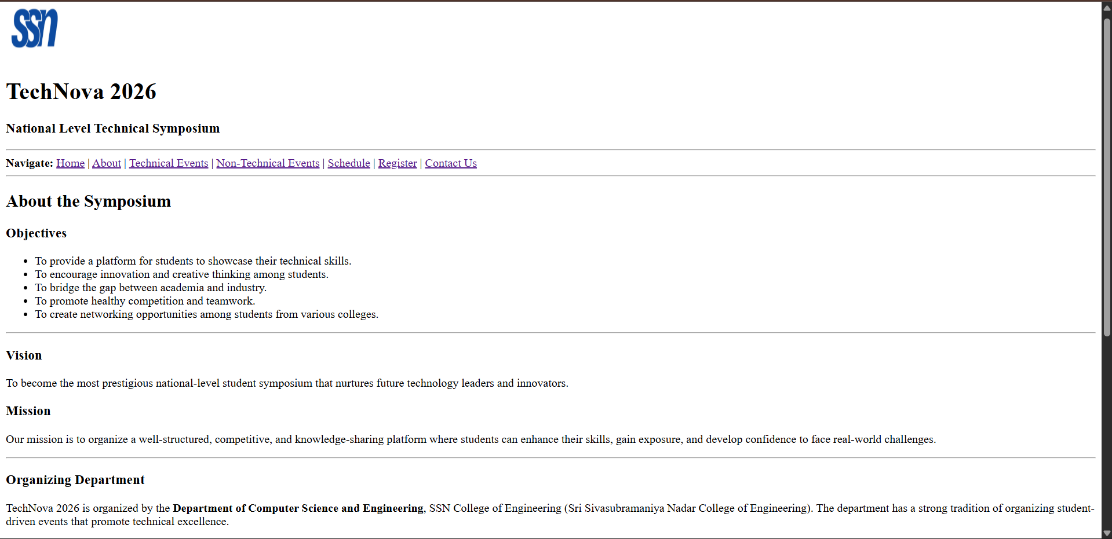

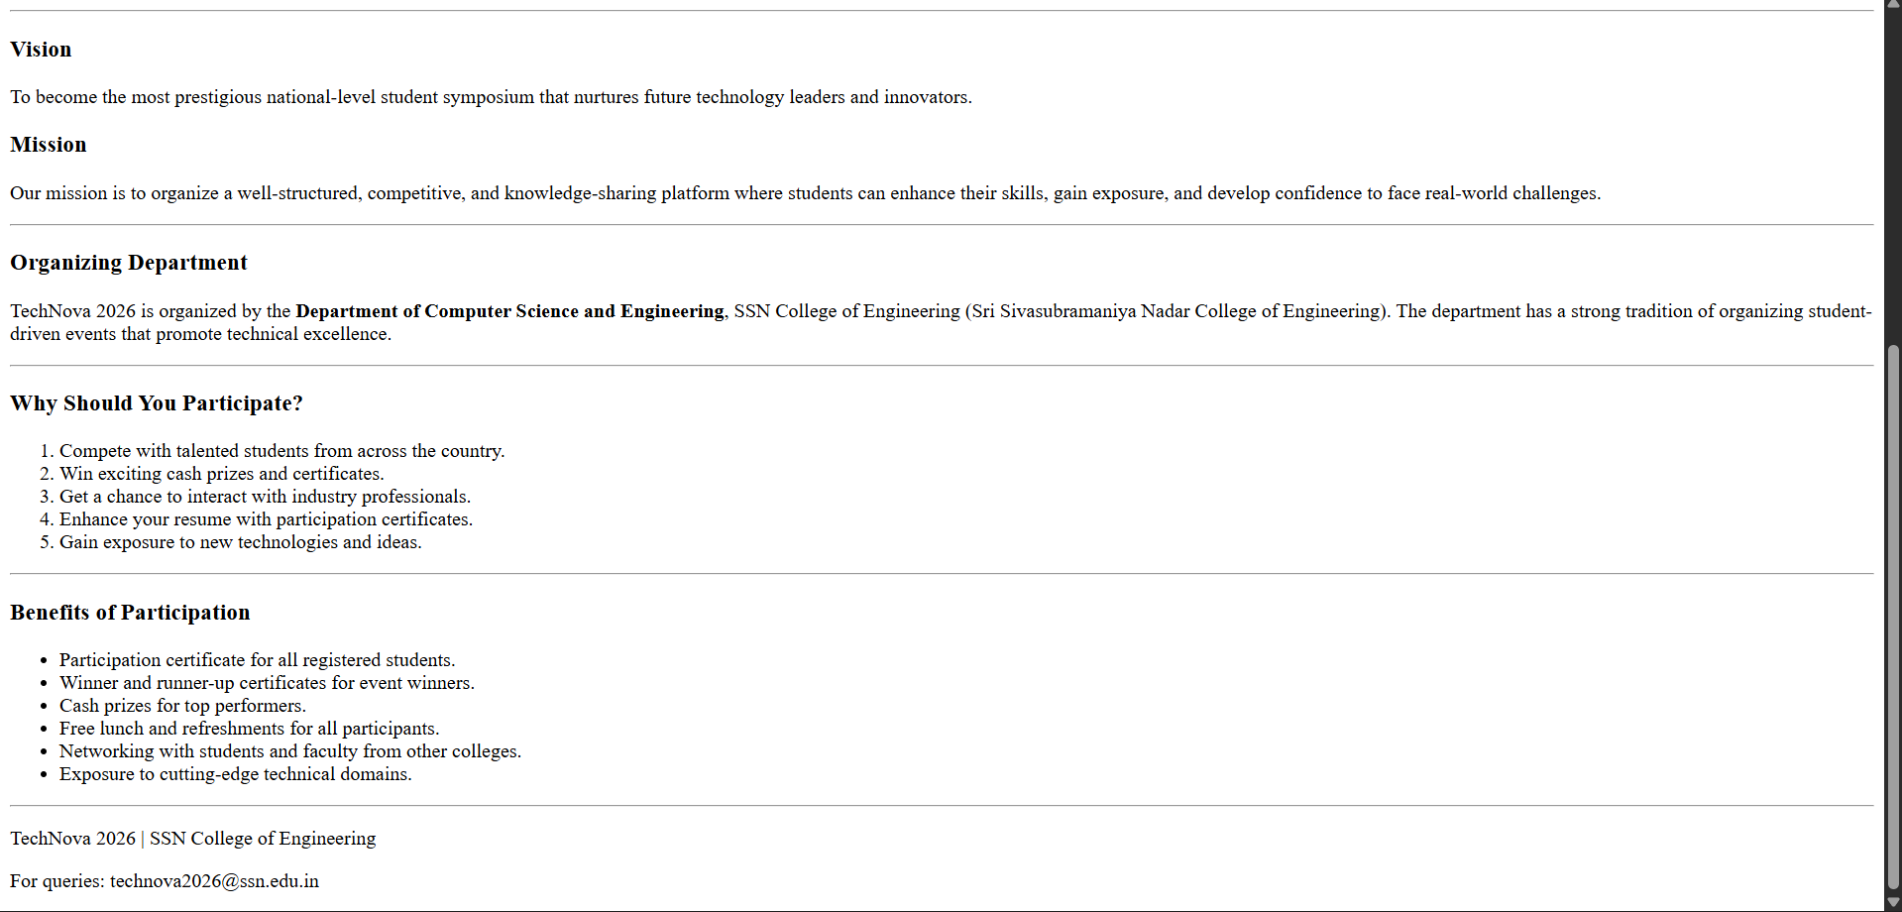

Page 3: Technical Events (technical.html)

Purpose
Display all technical competitions.

Content

Event 1: Paper Presentation
- Present innovative research ideas.

Event 2: Web Design Contest
- Build attractive websites.

Event 3: Coding Challenge
- Solve programming problems.

Event 4: Project Expo
- Showcase innovative projects.
For each event:
- Event image
- Description
- Rules
- Prize details

technical.html

<!DOCTYPE html>
<html>

<head>
<title>TechNova 2026 - Technical Events</title>
</head>

<body>

<!-- Header Section -->
<header>
<img src="assets/images/college_logo.png" alt="College Logo" width="80" height="80">
<h1>TechNova 2026</h1>
<h3>National Level Technical Symposium</h3>
</header>

<hr>

<!-- Navigation Menu -->
<nav>
<b>Navigate:</b>
<a href="index.html">Home</a> |
<a href="about.html">About</a> |
<a href="technical.html">Technical Events</a> |
<a href="nontechnical.html">Non-Technical Events</a> |
<a href="schedule.html">Schedule</a> |
<a href="register.html">Register</a> |
<a href="contact.html">Contact Us</a>
</nav>

<hr>

<!-- Page Heading -->
<section>
<h2>Technical Events</h2>
<p>Participate in our exciting technical competitions and showcase your talent!</p>
</section>

<hr>

<!-- Event 1: Paper Presentation -->
<article>
<h3>Event 1: Paper Presentation</h3>
<img src="assets/images/paper_presentation.png" alt="Paper Presentation" width="300" height="180">
<p><b>Description:</b> Present innovative research ideas on current technology topics. Teams must submit
an abstract before the event and present their paper in front of a panel of judges.</p>

<h4>Rules:</h4>
<ul>
<li>Team size: 1 to 2 members.</li>
<li>Abstract submission deadline: March 10, 2026.</li>
<li>Presentation time: 10 minutes + 5 minutes Q&amp;A.</li>
<li>Topic must be related to Computer Science or IT.</li>
<li>Plagiarism will lead to disqualification.</li>
</ul>

<h4>Prize Details:</h4>
<table border="1">
<tr>
<th>Position</th>
<th>Prize</th>
</tr>
<tr>
<td>Winner</td>
<td>Rs. 5000 + Certificate</td>
</tr>
<tr>
<td>Runner Up</td>
<td>Rs. 3000 + Certificate</td>
</tr>
</table>
</article>

<hr>

<!-- Event 2: Web Design Contest -->
<article>
<h3>Event 2: Web Design Contest</h3>
<img src="assets/images/web_design.png" alt="Web Design Contest" width="300" height="180">
<p><b>Description:</b> Build attractive and functional websites within the given time. Teams will be
given a theme on the spot and must design a complete website using HTML and CSS.</p>

<h4>Rules:</h4>
<ul>
<li>Team size: 1 to 2 members.</li>
<li>Duration: 3 hours.</li>
<li>Only HTML and CSS are allowed. No frameworks.</li>
<li>Internet access will not be provided.</li>
<li>Theme will be announced at the start of the event.</li>
</ul>

<h4>Prize Details:</h4>
<table border="1">
<tr>
<th>Position</th>
<th>Prize</th>
</tr>
<tr>
<td>Winner</td>
<td>Rs. 5000 + Certificate</td>
</tr>
<tr>
<td>Runner Up</td>
<td>Rs. 3000 + Certificate</td>
</tr>
</table>
</article>

<hr>

<!-- Event 3: Coding Challenge -->
<article>
<h3>Event 3: Coding Challenge</h3>
<img src="assets/images/coding.png" alt="Coding Challenge" width="300" height="180">
<p><b>Description:</b> Solve programming problems within a limited time. Problems range from easy
to hard and test participants on data structures, algorithms, and problem-solving skills.</p>

<h4>Rules:</h4>
<ul>
<li>Individual event only.</li>
<li>Duration: 2 hours.</li>
<li>Languages allowed: C, C++, Java, Python.</li>
<li>3 to 5 problems will be given.</li>
<li>Evaluation based on correctness and time taken.</li>
</ul>

<h4>Prize Details:</h4>
<table border="1">
<tr>
<th>Position</th>
<th>Prize</th>
</tr>
<tr>
<td>Winner</td>
<td>Rs. 6000 + Certificate</td>
</tr>
<tr>
<td>Runner Up</td>
<td>Rs. 3000 + Certificate</td>
</tr>
</table>
</article>

<hr>

<!-- Event 4: Project Expo -->
<article>
<h3>Event 4: Project Expo</h3>
<img src="assets/images/project_expo.png" alt="Project Expo" width="300" height="180">
<p><b>Description:</b> Showcase innovative projects that solve real-world problems. Teams will
present their working models to a panel of judges and industry experts.</p>

<h4>Rules:</h4>
<ul>
<li>Team size: 2 to 4 members.</li>
<li>Working prototype must be brought to the event.</li>
<li>Project report must be submitted in advance.</li>
<li>Presentation time: 15 minutes + 10 minutes Q&amp;A.</li>
<li>Project must be original work.</li>
</ul>

<h4>Prize Details:</h4>
<table border="1">
<tr>
<th>Position</th>
<th>Prize</th>
</tr>
<tr>
<td>Winner</td>
<td>Rs. 8000 + Certificate</td>
</tr>
<tr>
<td>Runner Up</td>
<td>Rs. 4000 + Certificate</td>
</tr>
</table>
</article>

<hr>

<!-- Footer -->
<footer>
<p>TechNova 2026 | SSN College of Engineering</p>
<p>For queries: technova2026@ssn.edu.in</p>
</footer>

</body>

</html>

Output:
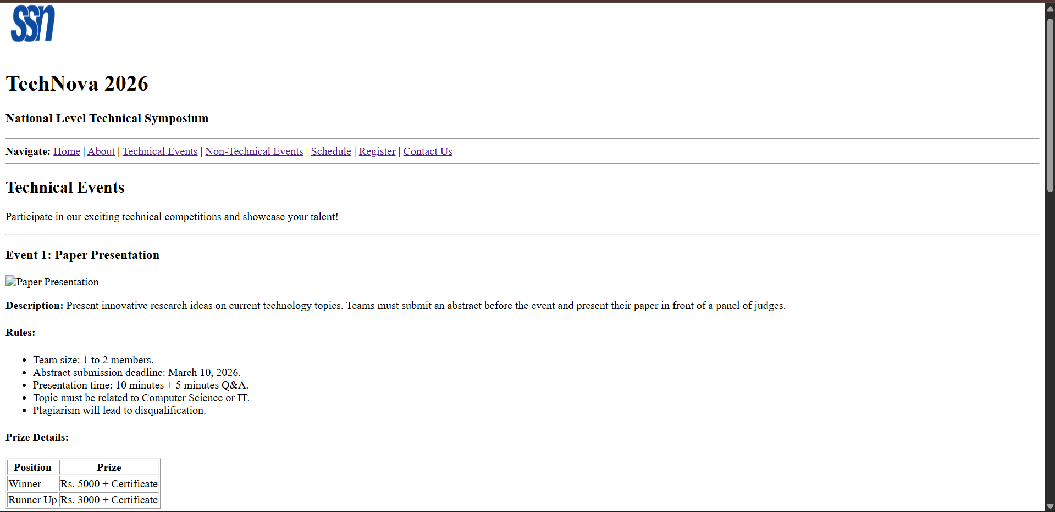

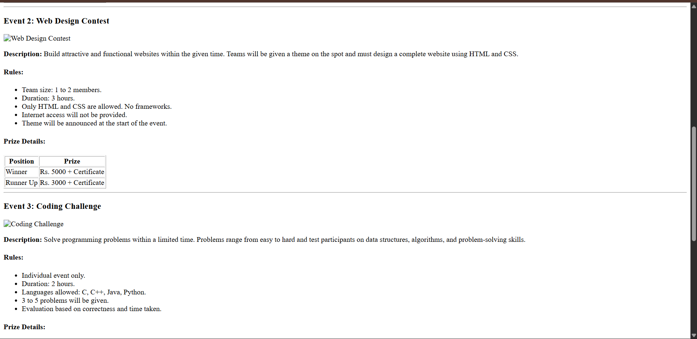

Page 4: Non-Technical Events (nontechnical.html)

Purpose
Display entertainment and fun events.

Content

Event 1: Photography

Event 2: Quiz Competition

Event 3: Treasure Hunt

Event 4: Gaming Tournament
For each event:
- Description
- Rules
- Registration fee
- Prize information

nontechnical.html

<!DOCTYPE html>
<html>

<head>
<title>TechNova 2026 - Non-Technical Events</title>
</head>

<body>

<!-- Header Section -->
<header>
<img src="assets/images/college_logo.png" alt="College Logo" width="80" height="80">
<h1>TechNova 2026</h1>
<h3>National Level Technical Symposium</h3>
</header>

<hr>

<!-- Navigation Menu -->
<nav>
<b>Navigate:</b>
<a href="index.html">Home</a> |
<a href="about.html">About</a> |
<a href="technical.html">Technical Events</a> |
<a href="nontechnical.html">Non-Technical Events</a> |
<a href="schedule.html">Schedule</a> |
<a href="register.html">Register</a> |
<a href="contact.html">Contact Us</a>
</nav>

<hr>

<!-- Page Heading -->
<section>
<h2>Non-Technical Events</h2>
<p>Take a break from tech and enjoy our fun and entertaining events!</p>
</section>

<hr>

<!-- Event 1: Photography -->
<article>
<h3>Event 1: Photography</h3>
<p><b>Description:</b> Capture the best moments of TechNova 2026. Participants must click photos
on the spot based on the given theme and submit them for judging.</p>

<h4>Rules:</h4>
<ul>
<li>Individual event only.</li>
<li>Participants must bring their own camera or smartphone.</li>
<li>Theme will be announced on the day of the event.</li>
<li>Maximum 5 photos can be submitted.</li>
<li>Photo editing is not allowed.</li>
</ul>

<p><b>Registration Fee:</b> Rs. 50 per participant.</p>

<h4>Prize Information:</h4>
<table border="1">
<tr>
<th>Position</th>
<th>Prize</th>
</tr>
<tr>
<td>Winner</td>
<td>Rs. 2000 + Certificate</td>
</tr>
<tr>
<td>Runner Up</td>
<td>Rs. 1000 + Certificate</td>
</tr>
</table>
</article>

<hr>

<!-- Event 2: Quiz Competition -->
<article>
<h3>Event 2: Quiz Competition</h3>
<p><b>Description:</b> Test your general knowledge and awareness in this fast-paced quiz competition.
Topics include current affairs, science, sports, and entertainment.</p>

<h4>Rules:</h4>
<ul>
<li>Team size: 2 members.</li>
<li>There will be 3 rounds: Written, Buzzer, and Rapid Fire.</li>
<li>No mobile phones allowed during the quiz.</li>
<li>Judge's decision is final.</li>
<li>Questions will be in English only.</li>
</ul>

<p><b>Registration Fee:</b> Rs. 60 per team.</p>

<h4>Prize Information:</h4>
<table border="1">
<tr>
<th>Position</th>
<th>Prize</th>
</tr>
<tr>
<td>Winner</td>
<td>Rs. 2500 + Certificate</td>
</tr>
<tr>
<td>Runner Up</td>
<td>Rs. 1200 + Certificate</td>
</tr>
</table>
</article>

<hr>

<!-- Event 3: Treasure Hunt -->
<article>
<h3>Event 3: Treasure Hunt</h3>
<p><b>Description:</b> Follow the clues, solve puzzles, and find the hidden treasure around the
college campus. The team that reaches the final clue first wins!</p>

<h4>Rules:</h4>
<ul>
<li>Team size: 3 to 4 members.</li>
<li>All team members must be present throughout the hunt.</li>
<li>Clues must not be shared with other teams.</li>
<li>Destroying or hiding clues will result in disqualification.</li>
<li>Duration: Approximately 1.5 hours.</li>
</ul>

<p><b>Registration Fee:</b> Rs. 100 per team.</p>

<h4>Prize Information:</h4>
<table border="1">
<tr>
<th>Position</th>
<th>Prize</th>
</tr>
<tr>
<td>Winner</td>
<td>Rs. 3000 + Certificate</td>
</tr>
<tr>
<td>Runner Up</td>
<td>Rs. 1500 + Certificate</td>
</tr>
</table>
</article>

<hr>

<!-- Event 4: Gaming Tournament -->
<article>
<h3>Event 4: Gaming Tournament</h3>
<p><b>Description:</b> Compete in popular mobile and PC games in this exciting gaming tournament.
Game titles will be announced one week before the event.</p>

<h4>Rules:</h4>
<ul>
<li>Individual or team participation (depends on the game).</li>
<li>Participants must bring their own devices for mobile games.</li>
<li>PCs will be provided for PC games.</li>
<li>No hacks, cheats, or mods allowed.</li>
<li>Matches will be conducted in a knock-out format.</li>
</ul>

<p><b>Registration Fee:</b> Rs. 80 per participant.</p>

<h4>Prize Information:</h4>
<table border="1">
<tr>
<th>Position</th>
<th>Prize</th>
</tr>
<tr>
<td>Winner</td>
<td>Rs. 2000 + Certificate</td>
</tr>
<tr>
<td>Runner Up</td>
<td>Rs. 1000 + Certificate</td>
</tr>
</table>
</article>

<hr>

<!-- Footer -->
<footer>
<p>TechNova 2026 | SSN College of Engineering</p>
<p>For queries: technova2026@ssn.edu.in</p>
</footer>

</body>

</html>

Output:
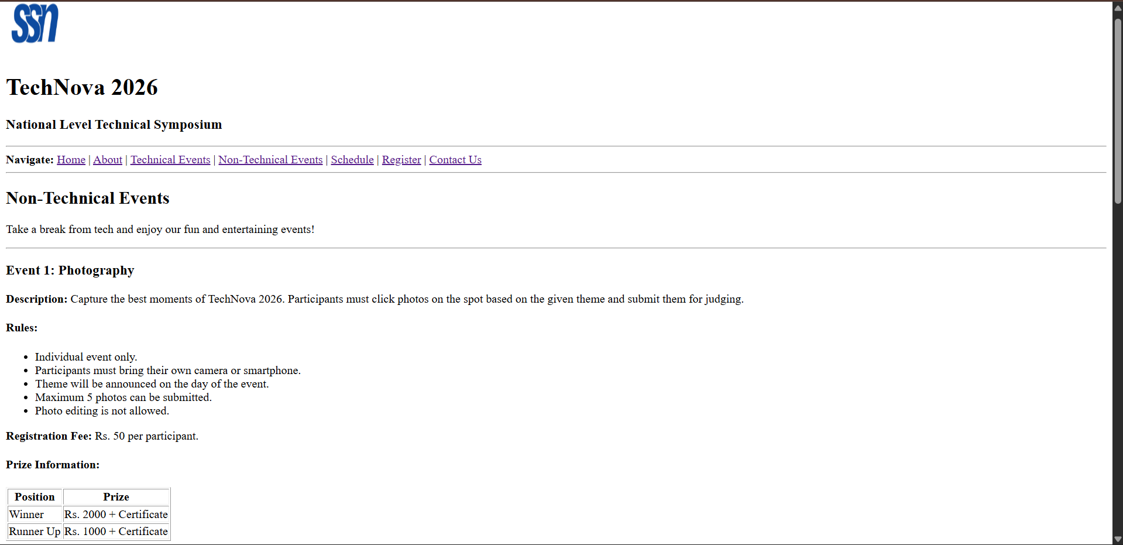

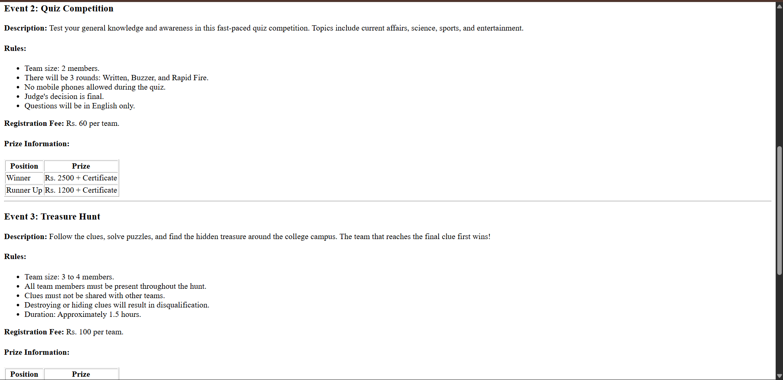

Page 5: Event Schedule (schedule.html)

Purpose
Display complete event timetable.

Content
Time | Event | Venue
9:00 AM | Inauguration | Auditorium
10:00 AM | Paper Presentation | Seminar Hall
11:30 AM | Coding Challenge | Lab 1
1:30 PM | Quiz Competition | Hall A
3:00 PM | Project Expo | Exhibition Hall
4:30 PM | Prize Distribution | Auditorium

schedule.html

<!DOCTYPE html>
<html>

<head>
<title>TechNova 2026 - Event Schedule</title>
</head>

<body>

<!-- Header Section -->
<header>
<img src="assets/images/college_logo.png" alt="College Logo" width="80" height="80">
<h1>TechNova 2026</h1>
<h3>National Level Technical Symposium</h3>
</header>

<hr>

<!-- Navigation Menu -->
<nav>
<b>Navigate:</b>
<a href="index.html">Home</a> |
<a href="about.html">About</a> |
<a href="technical.html">Technical Events</a> |
<a href="nontechnical.html">Non-Technical Events</a> |
<a href="schedule.html">Schedule</a> |
<a href="register.html">Register</a> |
<a href="contact.html">Contact Us</a>
</nav>

<hr>

<!-- Page Heading -->
<section>
<h2>Event Schedule</h2>
<p><b>Date:</b> March 15, 2026</p>
<p><b>Venue:</b> SSN College of Engineering, Kalavakkam, Chennai</p>
</section>

<!-- Schedule Table -->
<section>
<h3>Complete Timetable</h3>
<table border="1">
<tr>
<th>Time</th>
<th>Event</th>
<th>Venue</th>
</tr>
<tr>
<td>8:00 AM - 9:00 AM</td>
<td>Registration and Reporting</td>
<td>Main Gate</td>
</tr>
<tr>
<td>9:00 AM</td>
<td>Inauguration</td>
<td>Auditorium</td>
</tr>
<tr>
<td>10:00 AM</td>
<td>Paper Presentation</td>
<td>Seminar Hall</td>
</tr>
<tr>
<td>10:00 AM</td>
<td>Web Design Contest</td>
<td>Computer Lab 2</td>
</tr>
<tr>
<td>11:30 AM</td>
<td>Coding Challenge</td>
<td>Lab 1</td>
</tr>
<tr>
<td>11:30 AM</td>
<td>Photography Event</td>
<td>College Campus</td>
</tr>
<tr>
<td>1:00 PM - 1:30 PM</td>
<td>Lunch Break</td>
<td>Cafeteria</td>
</tr>
<tr>
<td>1:30 PM</td>
<td>Quiz Competition</td>
<td>Hall A</td>
</tr>
<tr>
<td>1:30 PM</td>
<td>Treasure Hunt</td>
<td>College Campus</td>
</tr>
<tr>
<td>2:00 PM</td>
<td>Gaming Tournament</td>
<td>Computer Lab 3</td>
</tr>
<tr>
<td>3:00 PM</td>
<td>Project Expo</td>
<td>Exhibition Hall</td>
</tr>
<tr>
<td>4:30 PM</td>
<td>Prize Distribution</td>
<td>Auditorium</td>
</tr>
<tr>
<td>5:30 PM</td>
<td>Valediction</td>
<td>Auditorium</td>
</tr>
</table>
</section>

<hr>

<!-- Note Section -->
<section>
<h3>Important Notes</h3>
<ul>
<li>Participants are requested to report 30 minutes before the event start time.</li>
<li>Carry your college ID card and registration confirmation.</li>
<li>Schedule is subject to change. Check the notice board on the event day.</li>
<li>For any queries, contact the student coordinators at the helpdesk.</li>
</ul>
</section>

<hr>

<!-- Footer -->
<footer>
<p>TechNova 2026 | SSN College of Engineering</p>
<p>For queries: technova2026@ssn.edu.in</p>
</footer>

</body>

</html>

Output:
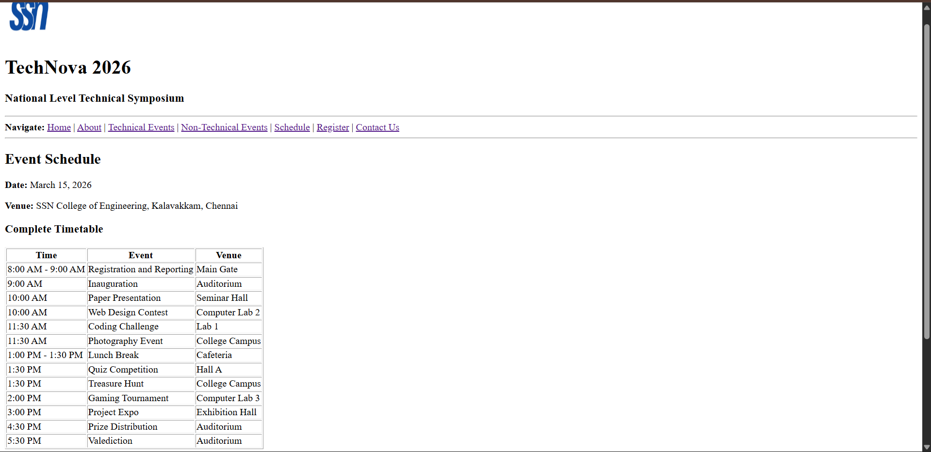

Page 6: Registration (register.html)

Purpose
Allow students to register.

Form Fields

Personal Information
- Full Name
- College Name
- Department
- Year of Study

Contact Information
- Email
- Phone Number

Event Selection
- Choose Technical Event
- Choose Non-Technical Event

Additional Information
- Address
- Comments

Buttons
- Submit
- Reset

register.html

<!DOCTYPE html>
<html>

<head>
<title>TechNova 2026 - Register</title>
</head>

<body>

<!-- Header Section -->
<header>
<img src="assets/images/college_logo.png" alt="College Logo" width="80" height="80">
<h1>TechNova 2026</h1>
<h3>National Level Technical Symposium</h3>
</header>

<hr>

<!-- Navigation Menu -->
<nav>
<b>Navigate:</b>
<a href="index.html">Home</a> |
<a href="about.html">About</a> |
<a href="technical.html">Technical Events</a> |
<a href="nontechnical.html">Non-Technical Events</a> |
<a href="schedule.html">Schedule</a> |
<a href="register.html">Register</a> |
<a href="contact.html">Contact Us</a>
</nav>

<hr>

<!-- Page Heading -->
<section>
<h2>Event Registration</h2>
<p>Fill in the form below to register for TechNova 2026. All fields marked with * are mandatory.</p>
</section>

<!-- Registration Form -->
<section>
<form action="#" method="post">

<!-- Personal Information -->
<h3>Personal Information</h3>

<p>
<label for="fullname">Full Name *</label><br>
<input type="text" id="fullname" name="fullname" size="40" placeholder="Enter your full name">
</p>

<p>
<label for="college">College Name *</label><br>
<input type="text" id="college" name="college" size="40" placeholder="Enter your college name">
</p>

<p>
<label for="department">Department *</label><br>
<input type="text" id="department" name="department" size="40" placeholder="e.g. Computer Science">
</p>

<p>
<label for="year">Year of Study *</label><br>
<select id="year" name="year">
<option value="">-- Select Year --</option>
<option value="1">1st Year</option>
<option value="2">2nd Year</option>
<option value="3">3rd Year</option>
<option value="4">4th Year</option>
</select>
</p>

<hr>

<!-- Contact Information -->
<h3>Contact Information</h3>

<p>
<label for="email">Email Address *</label><br>
<input type="email" id="email" name="email" size="40" placeholder="example@email.com">
</p>

<p>
<label for="phone">Phone Number *</label><br>
<input type="tel" id="phone" name="phone" size="40" placeholder="10-digit mobile number">
</p>

<hr>

<!-- Event Selection -->
<h3>Event Selection</h3>

<p>
<label for="technical_event">Choose Technical Event</label><br>
<select id="technical_event" name="technical_event">
<option value="">-- Select Technical Event --</option>
<option value="paper">Paper Presentation</option>
<option value="webdesign">Web Design Contest</option>
<option value="coding">Coding Challenge</option>
<option value="project">Project Expo</option>
<option value="none">Not Participating</option>
</select>
</p>

<p>
<label for="nontechnical_event">Choose Non-Technical Event</label><br>
<select id="nontechnical_event" name="nontechnical_event">
<option value="">-- Select Non-Technical Event --</option>
<option value="photography">Photography</option>
<option value="quiz">Quiz Competition</option>
<option value="treasure">Treasure Hunt</option>
<option value="gaming">Gaming Tournament</option>
<option value="none">Not Participating</option>
</select>
</p>

<hr>

<!-- Additional Information -->
<h3>Additional Information</h3>

<p>
<label for="address">Address</label><br>
<textarea id="address" name="address" rows="4" cols="40" placeholder="Enter your address"></textarea>
</p>

<p>
<label for="comments">Comments / Special Requirements</label><br>
<textarea id="comments" name="comments" rows="4" cols="40" placeholder="Any special requirements or comments"></textarea>
</p>

<hr>

<!-- Form Buttons -->
<p>
<input type="submit" value="Submit Registration">
&nbsp;&nbsp;
<input type="reset" value="Reset Form">
</p>

</form>
</section>

<hr>

<!-- Footer -->
<footer>
<p>TechNova 2026 | SSN College of Engineering</p>
<p>For queries: technova2026@ssn.edu.in</p>
</footer>

</body>

</html>

Output:

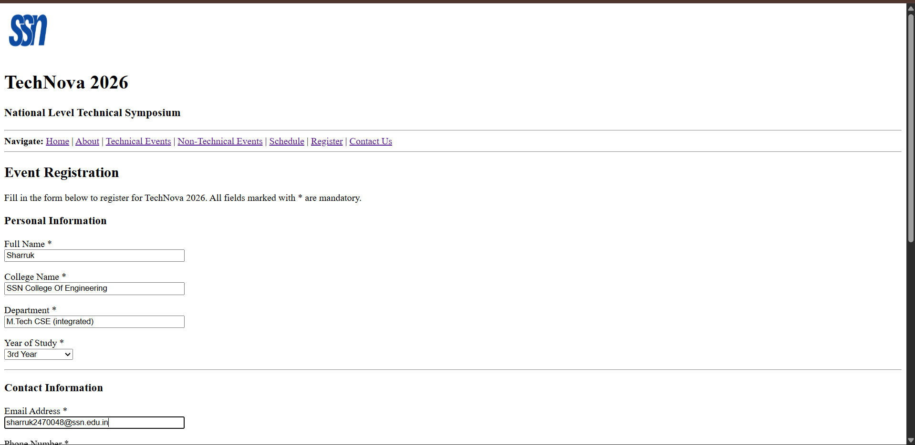

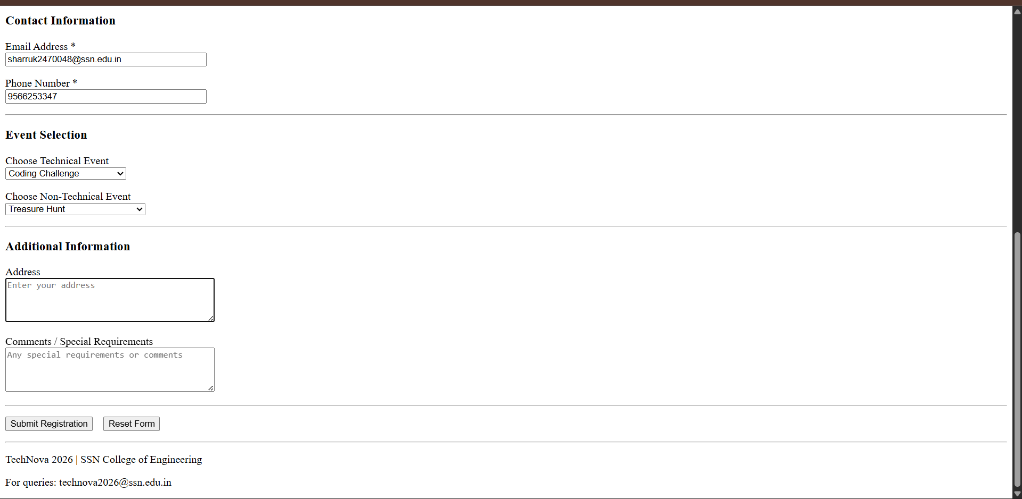

Page 7: Contact Us (contact.html)

Purpose
Provide communication details.

Content

Faculty Coordinator
- Name
- Email
- Phone

Student Coordinators
- Coordinator 1
- Coordinator 2

Venue Address

Social Media Links
- Instagram
- LinkedIn
- YouTube

Embedded College Location Image
(Static image, not a map)

<!DOCTYPE html>
<html>

<head>
<title>TechNova 2026 - Contact Us</title>
</head>

<body>

<!-- Header Section -->
<header>
<img src="assets/images/college_logo.png" alt="College Logo" width="80" height="80">
<h1>TechNova 2026</h1>
<h3>National Level Technical Symposium</h3>
</header>

<hr>

<!-- Navigation Menu -->
<nav>
<b>Navigate:</b>
<a href="index.html">Home</a> |
<a href="about.html">About</a> |
<a href="technical.html">Technical Events</a> |
<a href="nontechnical.html">Non-Technical Events</a> |
<a href="schedule.html">Schedule</a> |
<a href="register.html">Register</a> |
<a href="contact.html">Contact Us</a>
</nav>

<hr>

<!-- Page Heading -->
<section>
<h2>Contact Us</h2>
<p>For any queries regarding TechNova 2026, feel free to reach out to us.</p>
</section>

<!-- Faculty Coordinator -->
<section>
<h3>Faculty Coordinator</h3>
<table border="1">
<tr>
<th>Name</th>
<th>Email</th>
<th>Phone</th>
</tr>
<tr>
<td>Dr. R. Anitha</td>
<td>anitha.r@ssn.edu.in</td>
<td>+91 98765 43210</td>
</tr>
</table>
</section>

<hr>

<!-- Student Coordinators -->
<section>
<h3>Student Coordinators</h3>
<table border="1">
<tr>
<th>Name</th>
<th>Department</th>
<th>Phone</th>
</tr>
<tr>
<td>Rahul Kumar (Coordinator 1)</td>
<td>CSE - 4th Year</td>
<td>+91 91234 56789</td>
</tr>
<tr>
<td>Priya Sharma (Coordinator 2)</td>
<td>CSE - 4th Year</td>
<td>+91 98123 45678</td>
</tr>
</table>
</section>

<hr>

<!-- Venue Address -->
<section>
<h3>Venue Address</h3>
<p>
SSN College of Engineering<br>
(Sri Sivasubramaniya Nadar College of Engineering)<br>
Rajiv Gandhi Salai (OMR), Kalavakkam,<br>
Chennai - 603 110,<br>
Tamil Nadu, India.
</p>
</section>

<hr>

<!-- College Location Image -->
<section>
<h3>College Location</h3>
<img src="assets/images/college_map.png" alt="College Location Map" width="500" height="300">
</section>

<hr>

<!-- Social Media Links -->
<section>
<h3>Follow Us on Social Media</h3>
<ul>
<li><a href="#">Instagram - @TechNova2026</a></li>
<li><a href="#">LinkedIn - TechNova 2026</a></li>
<li><a href="#">YouTube - TechNova SSN</a></li>
</ul>
</section>

<hr>

<!-- Footer -->
<footer>
<p>TechNova 2026 | SSN College of Engineering</p>
<p>For queries: technova2026@ssn.edu.in</p>
</footer>

</body>

</html>

Output:
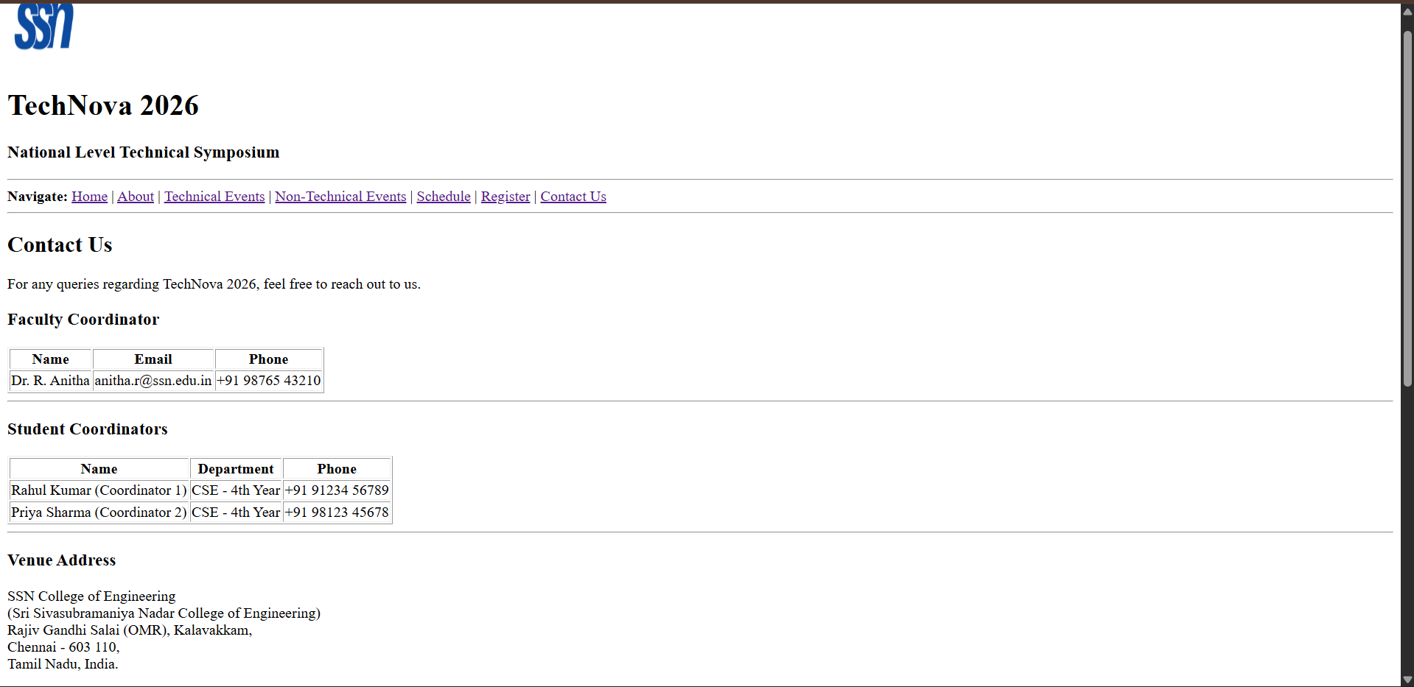

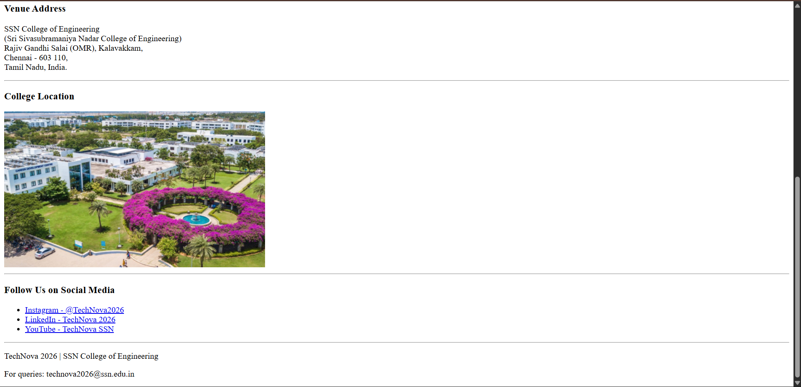

Learning Outcomes:
- Developed a multi-page website using basic HTML elements and semantic tags.
- Created navigation, tables, forms, images, and hyperlinks to build a complete website.
- Applied HTML to organize and present symposium information in a structured format.
- Gained practical experience in designing a simple static website for a real-world college event.

