Sri Sivasubramaniya Nadar College of Engineering

(An Autonomous Institution, Affiliated to Anna University, Chennai)
Department of Computer Science and Engineering

Degree & Branch | Five Year Integrated M.Tech (CSE) |  |  | Semester | V
Subject Code & Name | ICS1511---Web Application Development Laboratory
Assignment - 2 | Mini Project: College Symposium Website (HTML + CSS Only)
Academic Year | 2026-2027  ODD | Batch | 2024-2029 | Regulations – R2023
Name: Sharruk S | Register Number: 3122247001061 |  |  | Date:10/7/2026

Mini Project: College Symposium Website (HTML + CSS Only)

Scenario
Your college is organizing a national-level technical symposium called "TechNova 2026". The organizing committee wants a website to provide information about the event, showcase competitions, display schedules, and allow students to register online.
Design and develop a website using only HTML and CSS.

Website Structure

Page 1: Home (index.html)

Purpose
Welcome visitors and provide an overview of the symposium.

Content
- College logo
- Symposium banner image
- Symposium name: TechNova 2026
- Theme of the event
- Date and venue
- Brief introduction
- Navigation menu to all pages
- Highlights section
  - 500+ Participants
  - 15 Events
  - Cash Prizes
  - Industry Experts

index.html

<!DOCTYPE html>

<html lang="en">

<head>
<meta charset="UTF-8">
<meta name="viewport" content="width=device-width, initial-scale=1.0">
<title>TechNova 2026 - Home</title>
<link rel="stylesheet" href="css/style.css">
</head>

<body>

<!-- Header -->
<header>
<img src="assets/images/college_logo.png" alt="College Logo" class="header-logo">
<h1>TechNova 2026</h1>
<h3>National Level Technical Symposium</h3>
</header>

<!-- Navigation -->
<nav>
<span class="nav-label">Navigate:</span>
<a href="index.html" class="active-link">Home</a>
<a href="about.html">About</a>
<a href="technical.html">Technical Events</a>
<a href="nontechnical.html">Non-Technical Events</a>
<a href="schedule.html">Schedule</a>
<a href="register.html">Register</a>
<a href="contact.html">Contact Us</a>
</nav>

<div class="main-content">

<!-- Banner -->
<section class="banner-section">
<img src="assets/images/banner.jpg" alt="TechNova 2026 Banner" class="banner-img">
</section>

<!-- Symposium Overview -->
<section class="section-block" id="symposium-overview">
<h2>Welcome to TechNova 2026</h2>
<p><span class="text-inline">Theme:</span> Innovate. Integrate. Inspire.</p>
<p><span class="text-inline">Date:</span> March 15, 2026</p>
<p><span class="text-inline">Venue:</span> SSN College of Engineering, Main Auditorium, Kalavakkam, Chennai</p>
<p>
TechNova 2026 is a national-level technical symposium organized by the Department of Computer Science
and Engineering. The event brings together students from colleges across the country to compete,
learn, and network with industry experts. Join us for an exciting day of technical and non-technical
events, guest lectures, and prize distributions.
</p>
</section>

<hr>

<!-- Event Highlights -->
<section class="section-block">
<h2 class="page-heading">Event Highlights</h2>

<div class="highlights-container">

<div class="highlight-card">
<span class="highlight-number">500+</span>
<span class="highlight-label">Participants</span>
</div>

<div class="highlight-card">
<span class="highlight-number">15</span>
<span class="highlight-label">Events</span>
</div>

<div class="highlight-card">
<span class="highlight-number">&#8377;50K</span>
<span class="highlight-label">Cash Prizes</span>
</div>

<div class="highlight-card">
<span class="highlight-number">5+</span>
<span class="highlight-label">Industry Experts</span>
</div>

</div>
</section>

</div>

<!-- Footer -->
<footer>
<div class="footer-content">

<div class="footer-col">
<h4>TechNova 2026</h4>
<p>SSN College of Engineering</p>
<p>Kalavakkam, Chennai, Tamil Nadu</p>
<p>technova2026@ssn.edu.in</p>
</div>

<div class="footer-col">
<h4>Quick Links</h4>
<a href="index.html">Home</a>
<a href="about.html">About</a>
<a href="technical.html">Technical Events</a>
<a href="schedule.html">Schedule</a>
<a href="register.html">Register</a>
</div>

<div class="footer-col">
<h4>Follow Us</h4>
<a href="#">Instagram - @TechNova2026</a>
<a href="#">LinkedIn - TechNova 2026</a>
<a href="#">YouTube - TechNova SSN</a>
</div>

</div>

<div class="footer-bottom">
2026 TechNova | SSN College of Engineering. All Rights Reserved.
</div>
</footer>

</body>

</html>

Output:
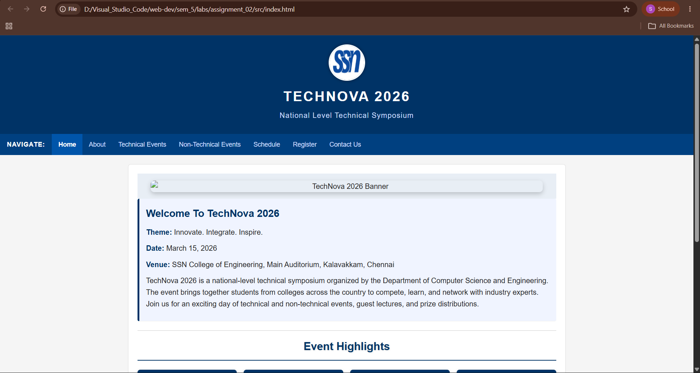

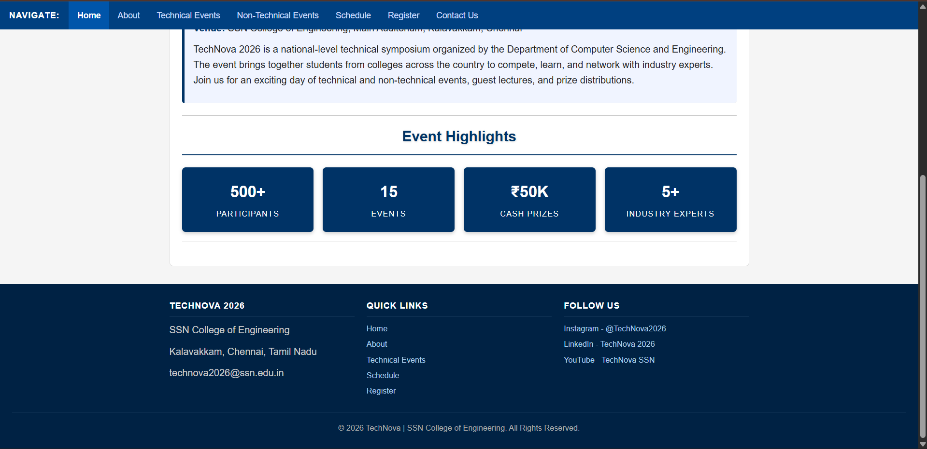

Page 2: About Symposium (about.html)

Purpose
Provide detailed information about the event.

Content
- Symposium objectives
- Event vision and mission
- Organizing department
- Why students should participate
- Benefits of participation

about.html
<!DOCTYPE html>

<html lang="en">

<head>
<meta charset="UTF-8">
<meta name="viewport" content="width=device-width, initial-scale=1.0">
<title>TechNova 2026 - About</title>
<link rel="stylesheet" href="css/style.css">
</head>

<body>

<!-- Header -->
<header>
<img src="assets/images/college_logo.png" alt="College Logo" class="header-logo">
<h1>TechNova 2026</h1>
<h3>National Level Technical Symposium</h3>
</header>

<!-- Navigation -->
<nav>
<span class="nav-label">Navigate:</span>
<a href="index.html">Home</a>
<a href="about.html" class="active-link">About</a>
<a href="technical.html">Technical Events</a>
<a href="nontechnical.html">Non-Technical Events</a>
<a href="schedule.html">Schedule</a>
<a href="register.html">Register</a>
<a href="contact.html">Contact Us</a>
</nav>

<div class="main-content">

<!-- About Section -->
<section class="section-block">
<h2 class="page-heading">About the Symposium</h2>
</section>

<!-- Objectives -->
<section class="section-block">
<h3>Objectives</h3>
<ul>
<li>To provide a platform for students to showcase their technical skills.</li>
<li>To encourage innovation and creative thinking among students.</li>
<li>To bridge the gap between academia and industry.</li>
<li>To promote healthy competition and teamwork.</li>
<li>To create networking opportunities among students from various colleges.</li>
</ul>
</section>

<!-- Vision and Mission -->
<section class="section-block">
<h3>Vision</h3>
<div class="vision-block">
<p>
To become the most prestigious national-level student symposium that nurtures future
technology leaders and innovators.
</p>
</div>

<h3>Mission</h3>
<div class="vision-block">
<p>
Our mission is to organize a well-structured, competitive, and knowledge-sharing platform
where students can enhance their skills, gain exposure, and develop confidence to face
real-world challenges.
</p>
</div>
</section>

<!-- Organizing Department -->
<section class="section-block">
<h3>Organizing Department</h3>
<div class="info-bar">
TechNova 2026 is organized by the <b>Department of Computer Science and Engineering</b>,
SSN College of Engineering (Sri Sivasubramaniya Nadar College of Engineering). The department
has a strong tradition of organizing student-driven events that promote technical excellence.
</div>
</section>

<!-- Why Participate -->
<section class="section-block">
<h3>Why Should You Participate?</h3>
<ol>
<li>Compete with talented students from across the country.</li>
<li>Win exciting cash prizes and certificates.</li>
<li>Get a chance to interact with industry professionals.</li>
<li>Enhance your resume with participation certificates.</li>
<li>Gain exposure to new technologies and ideas.</li>
</ol>
</section>

<!-- Benefits of Participation -->
<section class="section-block" style="border-bottom: none;">
<h3>Benefits of Participation</h3>
<ul>
<li><span class="badge">Certificate</span> Participation certificate for all registered students.</li>
<li><span class="badge">Award</span> Winner and runner-up certificates for event winners.</li>
<li><span class="badge">Prize</span> Cash prizes for top performers.</li>
<li><span class="badge">Food</span> Free lunch and refreshments for all participants.</li>
<li><span class="badge">Network</span> Networking with students and faculty from other colleges.</li>
<li><span class="badge">Exposure</span> Exposure to cutting-edge technical domains.</li>
</ul>
</section>

</div>

<!-- Footer -->
<footer>
<div class="footer-content">

<div class="footer-col">
<h4>TechNova 2026</h4>
<p>SSN College of Engineering</p>
<p>Kalavakkam, Chennai, Tamil Nadu</p>
<p>technova2026@ssn.edu.in</p>
</div>

<div class="footer-col">
<h4>Quick Links</h4>
<a href="index.html">Home</a>
<a href="about.html">About</a>
<a href="technical.html">Technical Events</a>
<a href="schedule.html">Schedule</a>
<a href="register.html">Register</a>
</div>

<div class="footer-col">
<h4>Follow Us</h4>
<a href="#">Instagram - @TechNova2026</a>
<a href="#">LinkedIn - TechNova 2026</a>
<a href="#">YouTube - TechNova SSN</a>
</div>

</div>

<div class="footer-bottom">
2026 TechNova | SSN College of Engineering. All Rights Reserved.
</div>
</footer>

</body>

</html>

Output:
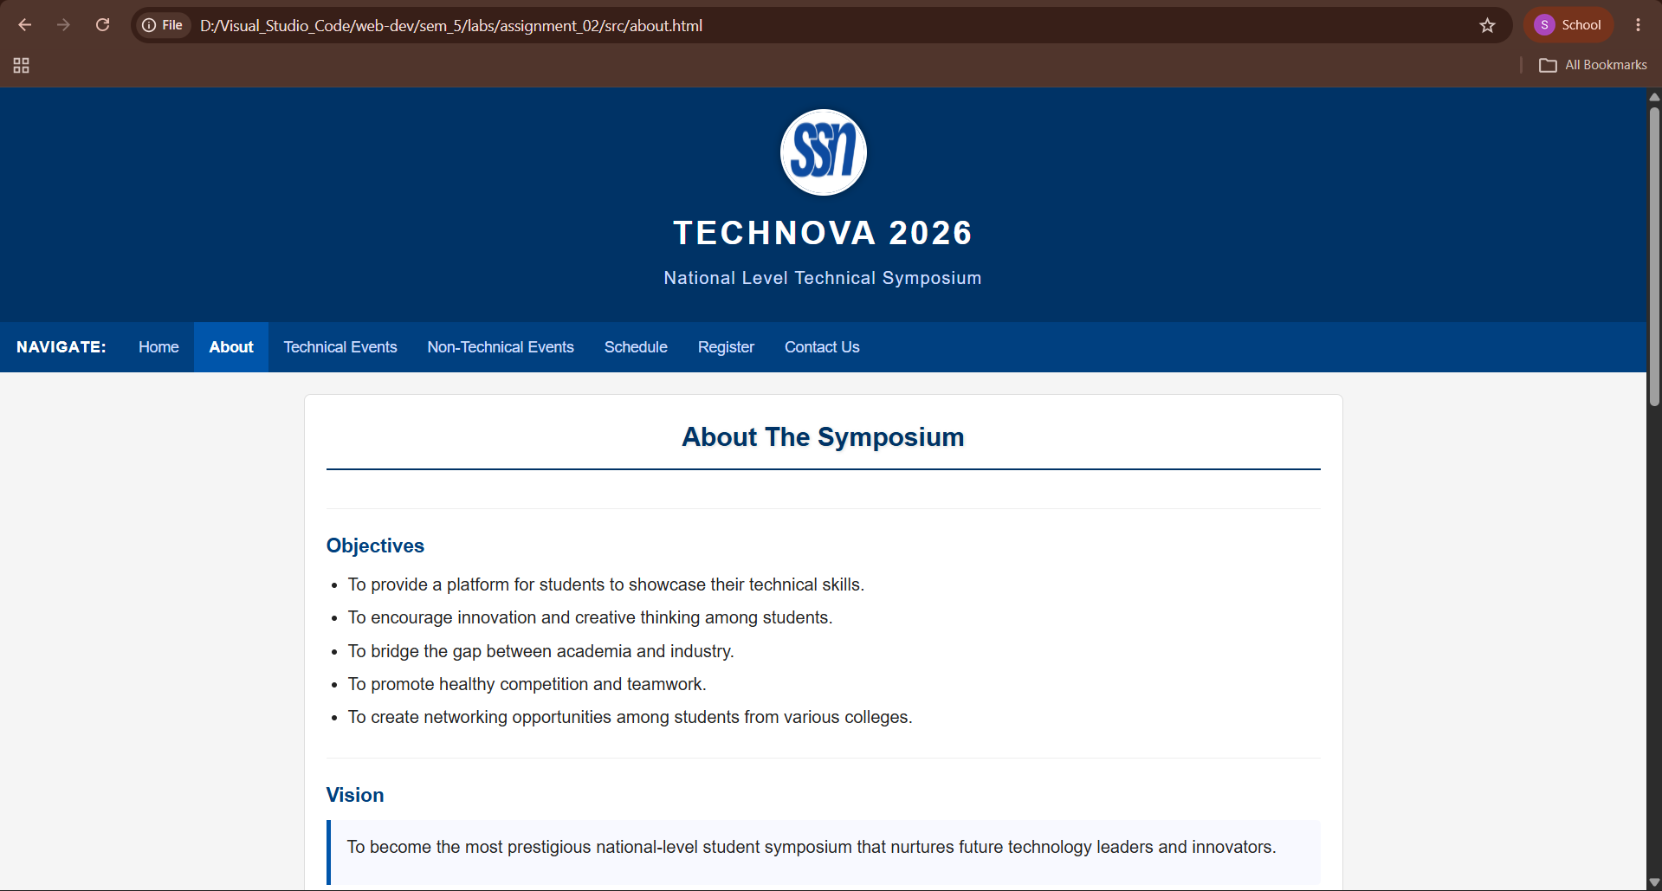

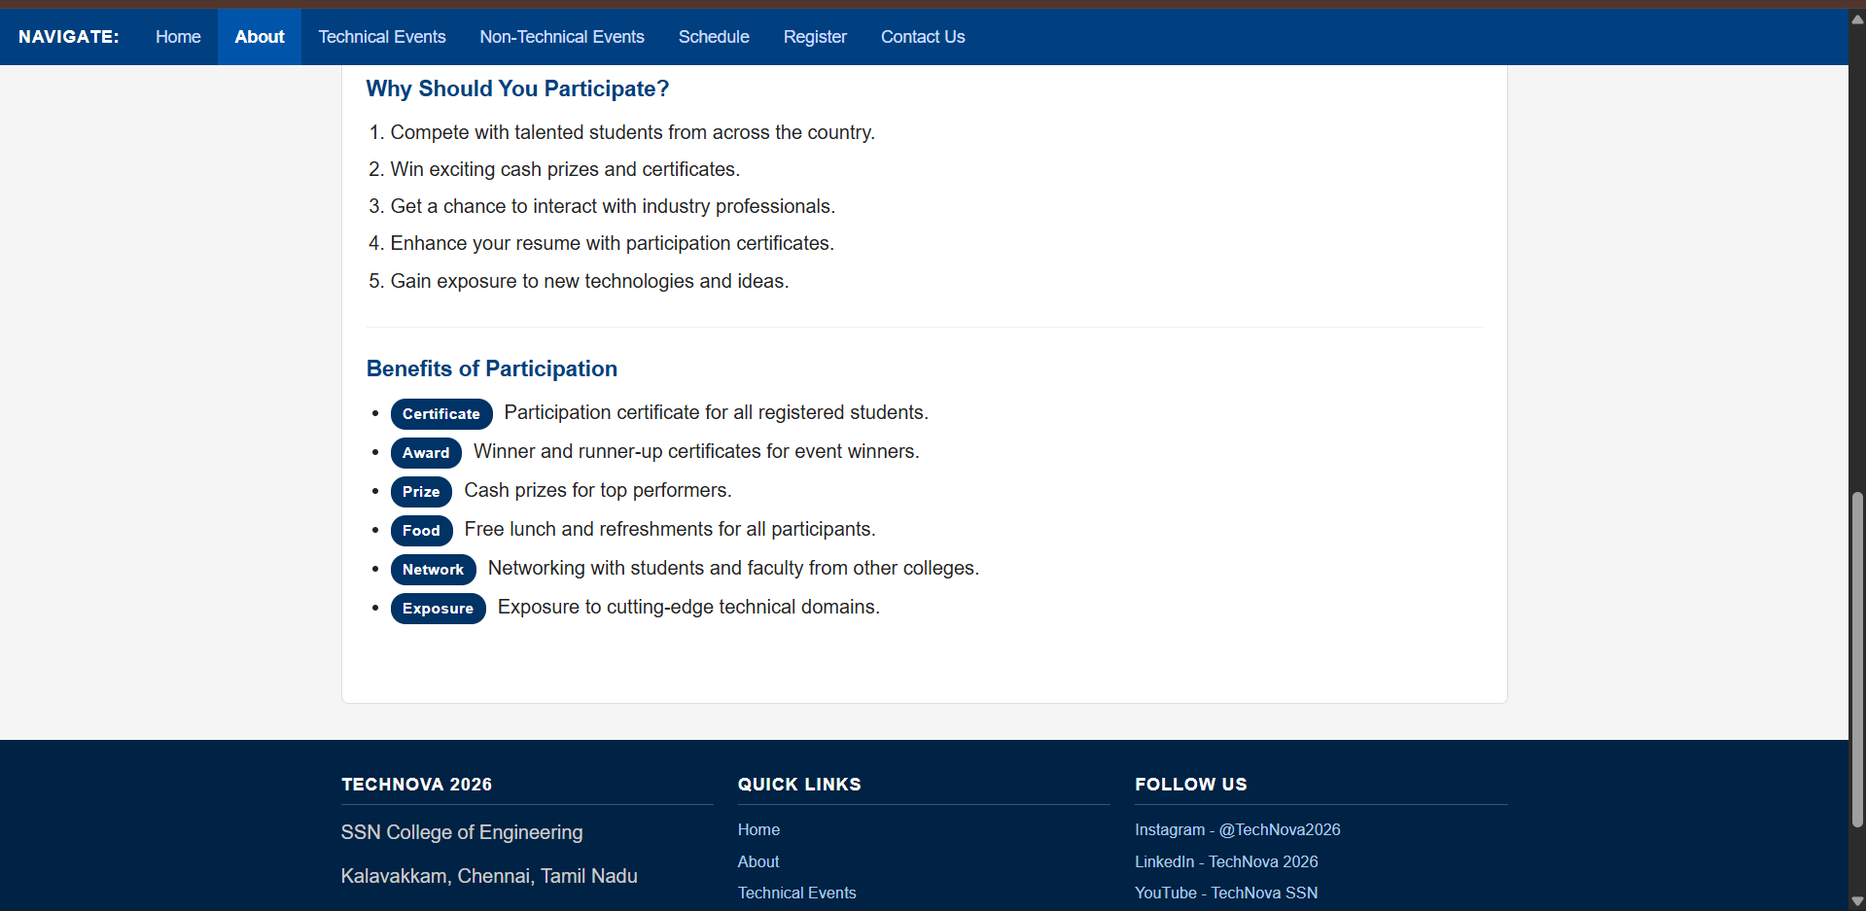

Page 3: Technical Events (technical.html)

Purpose
Display all technical competitions.

Content

Event 1: Paper Presentation
- Present innovative research ideas.

Event 2: Web Design Contest
- Build attractive websites.

Event 3: Coding Challenge
- Solve programming problems.

Event 4: Project Expo
- Showcase innovative projects.
For each event:
- Event image
- Description
- Rules
- Prize details

technical.html

<!DOCTYPE html>

<html lang="en">

<head>
<meta charset="UTF-8">
<meta name="viewport" content="width=device-width, initial-scale=1.0">
<title>TechNova 2026 - Technical Events</title>
<link rel="stylesheet" href="css/style.css">
</head>

<body>

<!-- Header -->
<header>
<img src="assets/images/college_logo.png" alt="College Logo" class="header-logo">
<h1>TechNova 2026</h1>
<h3>National Level Technical Symposium</h3>
</header>

<!-- Navigation -->
<nav>
<span class="nav-label">Navigate:</span>
<a href="index.html">Home</a>
<a href="about.html">About</a>
<a href="technical.html" class="active-link">Technical Events</a>
<a href="nontechnical.html">Non-Technical Events</a>
<a href="schedule.html">Schedule</a>
<a href="register.html">Register</a>
<a href="contact.html">Contact Us</a>
</nav>

<div class="main-content">

<!-- Technical Events Section -->
<section class="section-block">
<h2 class="page-heading">Technical Events</h2>
<p style="text-align: center;">Participate in our exciting technical competitions and showcase your talent!</p>
</section>

<!-- Event Cards -->
<div class="events-grid">

<!-- Event Card: Paper Presentation -->
<article class="event-card">
<h3>Event 1: Paper Presentation</h3>
<img src="assets/images/paper_presentation.png" alt="Paper Presentation" class="event-img">
<p><span class="text-inline">Description:</span> Present innovative research ideas on current technology topics. Teams must submit
an abstract before the event and present their paper in front of a panel of judges.</p>

<h4>Rules:</h4>
<ul>
<li>Team size: 1 to 2 members.</li>
<li>Abstract submission deadline: March 10, 2026.</li>
<li>Presentation time: 10 minutes + 5 minutes Q&amp;A.</li>
<li>Topic must be related to Computer Science or IT.</li>
<li>Plagiarism will lead to disqualification.</li>
</ul>

<h4>Prize Details:</h4>
<table class="styled-table">
<thead>
<tr>
<th>Position</th>
<th>Prize</th>
</tr>
</thead>
<tbody>
<tr>
<td>Winner</td>
<td>Rs. 5000 + Certificate</td>
</tr>
<tr>
<td>Runner Up</td>
<td>Rs. 3000 + Certificate</td>
</tr>
</tbody>
</table>
</article>

<!-- Event Card: Web Design Contest -->
<article class="event-card">
<h3>Event 2: Web Design Contest</h3>
<img src="assets/images/web_design.png" alt="Web Design Contest" class="event-img">
<p><span class="text-inline">Description:</span> Build attractive and functional websites within the given time. Teams will be
given a theme on the spot and must design a complete website using HTML and CSS.</p>

<h4>Rules:</h4>
<ul>
<li>Team size: 1 to 2 members.</li>
<li>Duration: 3 hours.</li>
<li>Only HTML and CSS are allowed. No frameworks.</li>
<li>Internet access will not be provided.</li>
<li>Theme will be announced at the start of the event.</li>
</ul>

<h4>Prize Details:</h4>
<table class="styled-table">
<thead>
<tr>
<th>Position</th>
<th>Prize</th>
</tr>
</thead>
<tbody>
<tr>
<td>Winner</td>
<td>Rs. 5000 + Certificate</td>
</tr>
<tr>
<td>Runner Up</td>
<td>Rs. 3000 + Certificate</td>
</tr>
</tbody>
</table>
</article>

<!-- Event Card: Coding Challenge -->
<article class="event-card">
<h3>Event 3: Coding Challenge</h3>
<img src="assets/images/coding.png" alt="Coding Challenge" class="event-img">
<p><span class="text-inline">Description:</span> Solve programming problems within a limited time. Problems range from easy
to hard and test participants on data structures, algorithms, and problem-solving skills.</p>

<h4>Rules:</h4>
<ul>
<li>Individual event only.</li>
<li>Duration: 2 hours.</li>
<li>Languages allowed: C, C++, Java, Python.</li>
<li>3 to 5 problems will be given.</li>
<li>Evaluation based on correctness and time taken.</li>
</ul>

<h4>Prize Details:</h4>
<table class="styled-table">
<thead>
<tr>
<th>Position</th>
<th>Prize</th>
</tr>
</thead>
<tbody>
<tr>
<td>Winner</td>
<td>Rs. 6000 + Certificate</td>
</tr>
<tr>
<td>Runner Up</td>
<td>Rs. 3000 + Certificate</td>
</tr>
</tbody>
</table>
</article>

<!-- Event Card: Project Expo -->
<article class="event-card">
<h3>Event 4: Project Expo</h3>
<img src="assets/images/project_expo.png" alt="Project Expo" class="event-img">
<p><span class="text-inline">Description:</span> Showcase innovative projects that solve real-world problems. Teams will
present their working models to a panel of judges and industry experts.</p>

<h4>Rules:</h4>
<ul>
<li>Team size: 2 to 4 members.</li>
<li>Working prototype must be brought to the event.</li>
<li>Project report must be submitted in advance.</li>
<li>Presentation time: 15 minutes + 10 minutes Q&amp;A.</li>
<li>Project must be original work.</li>
</ul>

<h4>Prize Details:</h4>
<table class="styled-table">
<thead>
<tr>
<th>Position</th>
<th>Prize</th>
</tr>
</thead>
<tbody>
<tr>
<td>Winner</td>
<td>Rs. 8000 + Certificate</td>
</tr>
<tr>
<td>Runner Up</td>
<td>Rs. 4000 + Certificate</td>
</tr>
</tbody>
</table>
</article>

</div>

</div>

<!-- Footer -->
<footer>
<div class="footer-content">

<div class="footer-col">
<h4>TechNova 2026</h4>
<p>SSN College of Engineering</p>
<p>Kalavakkam, Chennai, Tamil Nadu</p>
<p>technova2026@ssn.edu.in</p>
</div>

<div class="footer-col">
<h4>Quick Links</h4>
<a href="index.html">Home</a>
<a href="about.html">About</a>
<a href="technical.html">Technical Events</a>
<a href="schedule.html">Schedule</a>
<a href="register.html">Register</a>
</div>

<div class="footer-col">
<h4>Follow Us</h4>
<a href="#">Instagram - @TechNova2026</a>
<a href="#">LinkedIn - TechNova 2026</a>
<a href="#">YouTube - TechNova SSN</a>
</div>

</div>

<div class="footer-bottom">
2026 TechNova | SSN College of Engineering. All Rights Reserved.
</div>
</footer>

</body>

</html>

Output:

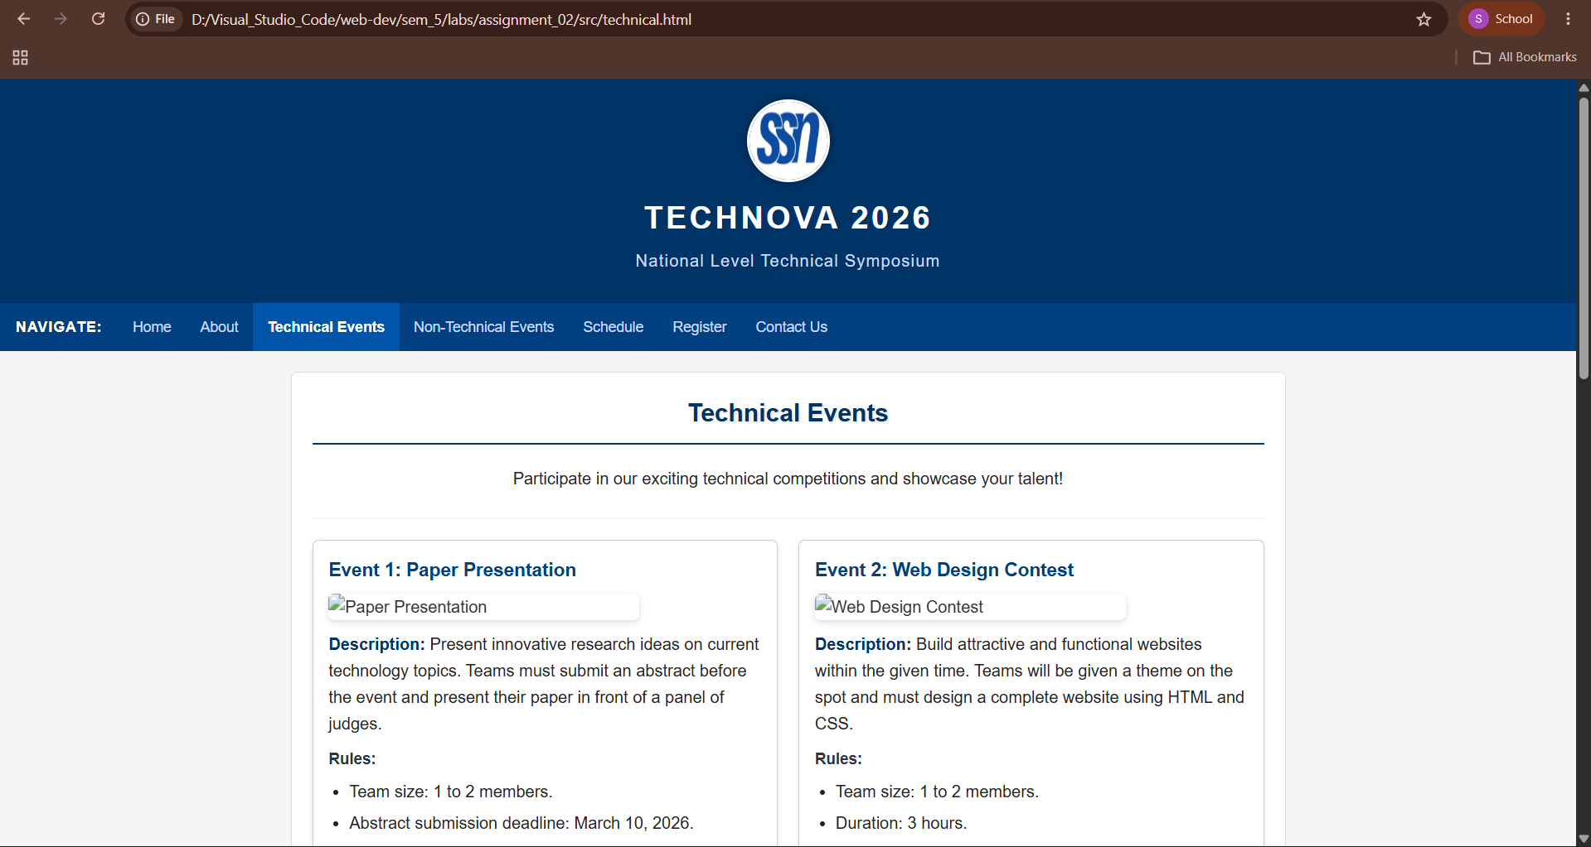

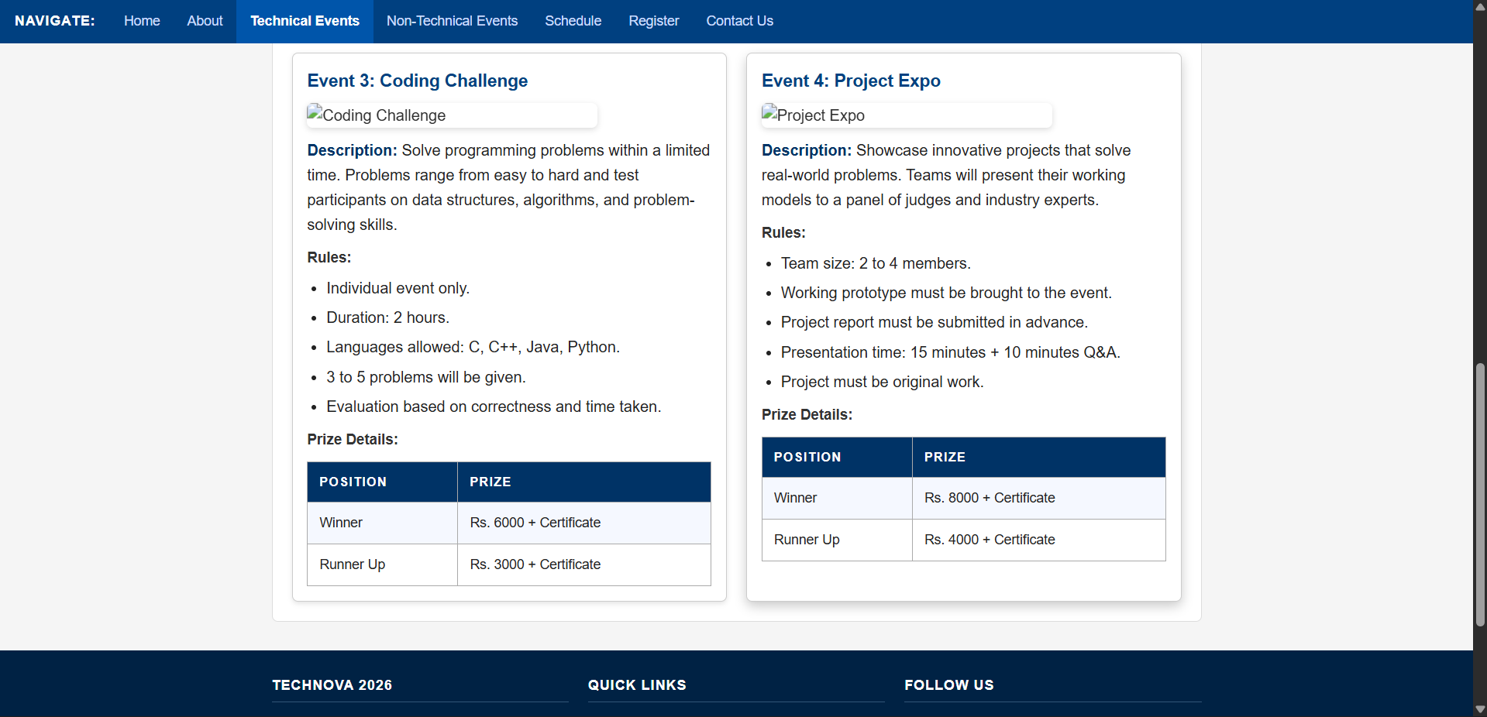

Page 4: Non-Technical Events (nontechnical.html)

Purpose
Display entertainment and fun events.

Content

Event 1: Photography

Event 2: Quiz Competition

Event 3: Treasure Hunt

Event 4: Gaming Tournament
For each event:
- Description
- Rules
- Registration fee
- Prize information

nontechnical.html
<!DOCTYPE html>

<html lang="en">

<head>
<meta charset="UTF-8">
<meta name="viewport" content="width=device-width, initial-scale=1.0">
<title>TechNova 2026 - Non-Technical Events</title>
<link rel="stylesheet" href="css/style.css">
</head>

<body>

<!-- Header -->
<header>
<img src="assets/images/college_logo.png" alt="College Logo" class="header-logo">
<h1>TechNova 2026</h1>
<h3>National Level Technical Symposium</h3>
</header>

<!-- Navigation -->
<nav>
<span class="nav-label">Navigate:</span>
<a href="index.html">Home</a>
<a href="about.html">About</a>
<a href="technical.html">Technical Events</a>
<a href="nontechnical.html" class="active-link">Non-Technical Events</a>
<a href="schedule.html">Schedule</a>
<a href="register.html">Register</a>
<a href="contact.html">Contact Us</a>
</nav>

<div class="main-content">

<!-- Non-Technical Events Section -->
<section class="section-block">
<h2 class="page-heading">Non-Technical Events</h2>
<p style="text-align: center;">Take a break from tech and enjoy our fun and entertaining events!</p>
</section>

<!-- Event Cards -->
<div class="events-grid">

<!-- Event Card: Photography -->
<article class="event-card">
<h3>Event 1: Photography</h3>
<p><span class="text-inline">Description:</span> Capture the best moments of TechNova 2026. Participants must click photos
on the spot based on the given theme and submit them for judging.</p>

<h4>Rules:</h4>
<ul>
<li>Individual event only.</li>
<li>Participants must bring their own camera or smartphone.</li>
<li>Theme will be announced on the day of the event.</li>
<li>Maximum 5 photos can be submitted.</li>
<li>Photo editing is not allowed.</li>
</ul>

<p><span class="text-inline">Registration Fee:</span> Rs. 50 per participant.</p>

<h4>Prize Information:</h4>
<table class="styled-table">
<thead>
<tr>
<th>Position</th>
<th>Prize</th>
</tr>
</thead>
<tbody>
<tr>
<td>Winner</td>
<td>Rs. 2000 + Certificate</td>
</tr>
<tr>
<td>Runner Up</td>
<td>Rs. 1000 + Certificate</td>
</tr>
</tbody>
</table>
</article>

<!-- Event Card: Quiz Competition -->
<article class="event-card">
<h3>Event 2: Quiz Competition</h3>
<p><span class="text-inline">Description:</span> Test your general knowledge and awareness in this fast-paced quiz competition.
Topics include current affairs, science, sports, and entertainment.</p>

<h4>Rules:</h4>
<ul>
<li>Team size: 2 members.</li>
<li>There will be 3 rounds: Written, Buzzer, and Rapid Fire.</li>
<li>No mobile phones allowed during the quiz.</li>
<li>Judge's decision is final.</li>
<li>Questions will be in English only.</li>
</ul>

<p><span class="text-inline">Registration Fee:</span> Rs. 60 per team.</p>

<h4>Prize Information:</h4>
<table class="styled-table">
<thead>
<tr>
<th>Position</th>
<th>Prize</th>
</tr>
</thead>
<tbody>
<tr>
<td>Winner</td>
<td>Rs. 2500 + Certificate</td>
</tr>
<tr>
<td>Runner Up</td>
<td>Rs. 1200 + Certificate</td>
</tr>
</tbody>
</table>
</article>

<!-- Event Card: Treasure Hunt -->
<article class="event-card">
<h3>Event 3: Treasure Hunt</h3>
<p><span class="text-inline">Description:</span> Follow the clues, solve puzzles, and find the hidden treasure around the
college campus. The team that reaches the final clue first wins!</p>

<h4>Rules:</h4>
<ul>
<li>Team size: 3 to 4 members.</li>
<li>All team members must be present throughout the hunt.</li>
<li>Clues must not be shared with other teams.</li>
<li>Destroying or hiding clues will result in disqualification.</li>
<li>Duration: Approximately 1.5 hours.</li>
</ul>

<p><span class="text-inline">Registration Fee:</span> Rs. 100 per team.</p>

<h4>Prize Information:</h4>
<table class="styled-table">
<thead>
<tr>
<th>Position</th>
<th>Prize</th>
</tr>
</thead>
<tbody>
<tr>
<td>Winner</td>
<td>Rs. 3000 + Certificate</td>
</tr>
<tr>
<td>Runner Up</td>
<td>Rs. 1500 + Certificate</td>
</tr>
</tbody>
</table>
</article>

<!-- Event Card: Gaming Tournament -->
<article class="event-card">
<h3>Event 4: Gaming Tournament</h3>
<p><span class="text-inline">Description:</span> Compete in popular mobile and PC games in this exciting gaming tournament.
Game titles will be announced one week before the event.</p>

<h4>Rules:</h4>
<ul>
<li>Individual or team participation (depends on the game).</li>
<li>Participants must bring their own devices for mobile games.</li>
<li>PCs will be provided for PC games.</li>
<li>No hacks, cheats, or mods allowed.</li>
<li>Matches will be conducted in a knock-out format.</li>
</ul>

<p><span class="text-inline">Registration Fee:</span> Rs. 80 per participant.</p>

<h4>Prize Information:</h4>
<table class="styled-table">
<thead>
<tr>
<th>Position</th>
<th>Prize</th>
</tr>
</thead>
<tbody>
<tr>
<td>Winner</td>
<td>Rs. 2000 + Certificate</td>
</tr>
<tr>
<td>Runner Up</td>
<td>Rs. 1000 + Certificate</td>
</tr>
</tbody>
</table>
</article>

</div>

</div>

<!-- Footer -->
<footer>
<div class="footer-content">

<div class="footer-col">
<h4>TechNova 2026</h4>
<p>SSN College of Engineering</p>
<p>Kalavakkam, Chennai, Tamil Nadu</p>
<p>technova2026@ssn.edu.in</p>
</div>

<div class="footer-col">
<h4>Quick Links</h4>
<a href="index.html">Home</a>
<a href="about.html">About</a>
<a href="technical.html">Technical Events</a>
<a href="schedule.html">Schedule</a>
<a href="register.html">Register</a>
</div>

<div class="footer-col">
<h4>Follow Us</h4>
<a href="#">Instagram - @TechNova2026</a>
<a href="#">LinkedIn - TechNova 2026</a>
<a href="#">YouTube - TechNova SSN</a>
</div>

</div>

<div class="footer-bottom">
2026 TechNova | SSN College of Engineering. All Rights Reserved.
</div>
</footer>

</body>

</html>

Output:

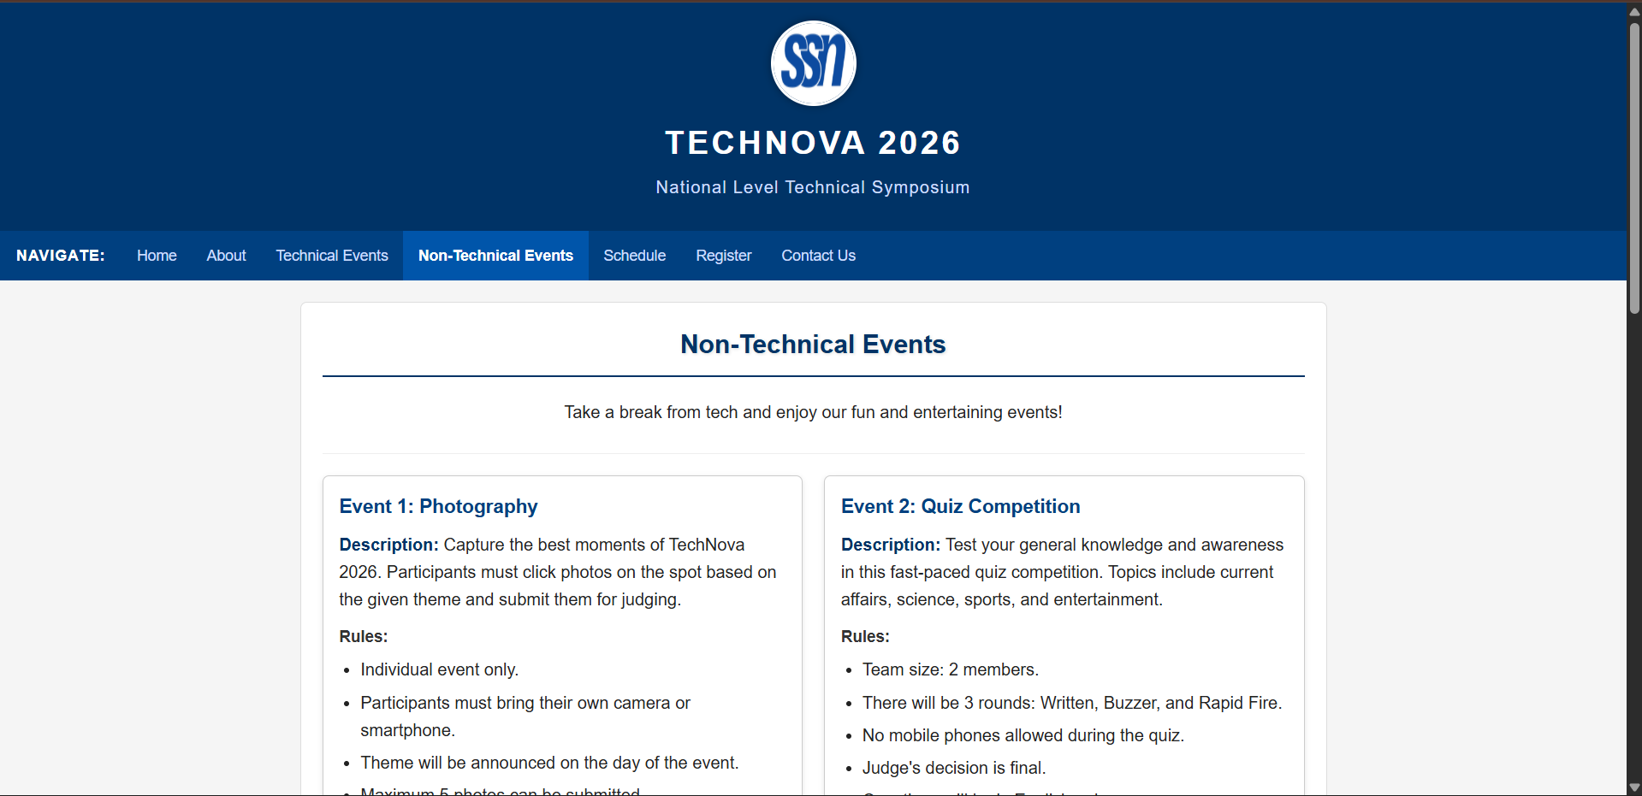

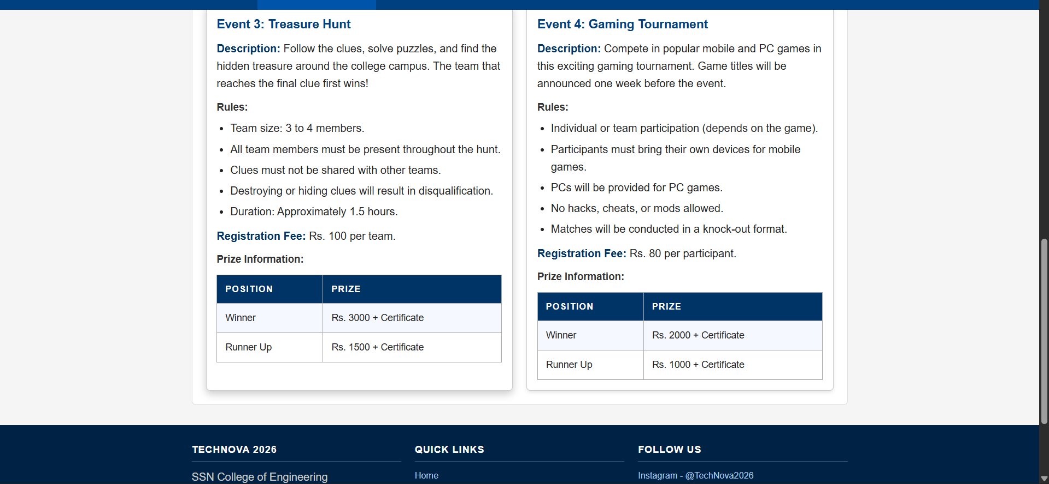

Page 5: Event Schedule (schedule.html)

Purpose
Display complete event timetable.

Content
Time | Event | Venue
9:00 AM | Inauguration | Auditorium
10:00 AM | Paper Presentation | Seminar Hall
11:30 AM | Coding Challenge | Lab 1
1:30 PM | Quiz Competition | Hall A
3:00 PM | Project Expo | Exhibition Hall
4:30 PM | Prize Distribution | Auditorium

schedule.html

<!DOCTYPE html>

<html lang="en">

<head>
<meta charset="UTF-8">
<meta name="viewport" content="width=device-width, initial-scale=1.0">
<title>TechNova 2026 - Event Schedule</title>
<link rel="stylesheet" href="css/style.css">
</head>

<body>

<!-- Header -->
<header>
<img src="assets/images/college_logo.png" alt="College Logo" class="header-logo">
<h1>TechNova 2026</h1>
<h3>National Level Technical Symposium</h3>
</header>

<!-- Navigation -->
<nav>
<span class="nav-label">Navigate:</span>
<a href="index.html">Home</a>
<a href="about.html">About</a>
<a href="technical.html">Technical Events</a>
<a href="nontechnical.html">Non-Technical Events</a>
<a href="schedule.html" class="active-link">Schedule</a>
<a href="register.html">Register</a>
<a href="contact.html">Contact Us</a>
</nav>

<div class="main-content">

<!-- Schedule Section -->
<section class="section-block">
<h2 class="page-heading">Event Schedule</h2>
<div class="info-bar">
<p><span class="text-inline">Date:</span> March 15, 2026</p>
<p><span class="text-inline">Venue:</span> SSN College of Engineering, Kalavakkam, Chennai</p>
</div>
</section>

<!-- Schedule Table -->
<section class="section-block">
<h3>Complete Timetable</h3>
<table class="styled-table">
<thead>
<tr>
<th>Time</th>
<th>Event</th>
<th>Venue</th>
</tr>
</thead>
<tbody>
<tr>
<td>8:00 AM - 9:00 AM</td>
<td>Registration and Reporting</td>
<td>Main Gate</td>
</tr>
<tr>
<td>9:00 AM</td>
<td>Inauguration</td>
<td>Auditorium</td>
</tr>
<tr>
<td>10:00 AM</td>
<td>Paper Presentation</td>
<td>Seminar Hall</td>
</tr>
<tr>
<td>10:00 AM</td>
<td>Web Design Contest</td>
<td>Computer Lab 2</td>
</tr>
<tr>
<td>11:30 AM</td>
<td>Coding Challenge</td>
<td>Lab 1</td>
</tr>
<tr>
<td>11:30 AM</td>
<td>Photography Event</td>
<td>College Campus</td>
</tr>
<tr>
<td>1:00 PM - 1:30 PM</td>
<td>Lunch Break</td>
<td>Cafeteria</td>
</tr>
<tr>
<td>1:30 PM</td>
<td>Quiz Competition</td>
<td>Hall A</td>
</tr>
<tr>
<td>1:30 PM</td>
<td>Treasure Hunt</td>
<td>College Campus</td>
</tr>
<tr>
<td>2:00 PM</td>
<td>Gaming Tournament</td>
<td>Computer Lab 3</td>
</tr>
<tr>
<td>3:00 PM</td>
<td>Project Expo</td>
<td>Exhibition Hall</td>
</tr>
<tr>
<td>4:30 PM</td>
<td>Prize Distribution</td>
<td>Auditorium</td>
</tr>
<tr>
<td>5:30 PM</td>
<td>Valediction</td>
<td>Auditorium</td>
</tr>
</tbody>
</table>
</section>

<!-- Important Notes -->
<section class="section-block" style="border-bottom: none;">
<h3>Important Notes</h3>
<ul>
<li>Participants are requested to report 30 minutes before the event start time.</li>
<li>Carry your college ID card and registration confirmation.</li>
<li>Schedule is subject to change. Check the notice board on the event day.</li>
<li>For any queries, contact the student coordinators at the helpdesk.</li>
</ul>
</section>

</div>

<!-- Footer -->
<footer>
<div class="footer-content">

<div class="footer-col">
<h4>TechNova 2026</h4>
<p>SSN College of Engineering</p>
<p>Kalavakkam, Chennai, Tamil Nadu</p>
<p>technova2026@ssn.edu.in</p>
</div>

<div class="footer-col">
<h4>Quick Links</h4>
<a href="index.html">Home</a>
<a href="about.html">About</a>
<a href="technical.html">Technical Events</a>
<a href="schedule.html">Schedule</a>
<a href="register.html">Register</a>
</div>

<div class="footer-col">
<h4>Follow Us</h4>
<a href="#">Instagram - @TechNova2026</a>
<a href="#">LinkedIn - TechNova 2026</a>
<a href="#">YouTube - TechNova SSN</a>
</div>

</div>

<div class="footer-bottom">
2026 TechNova | SSN College of Engineering. All Rights Reserved.
</div>
</footer>

</body>

</html>

Output:
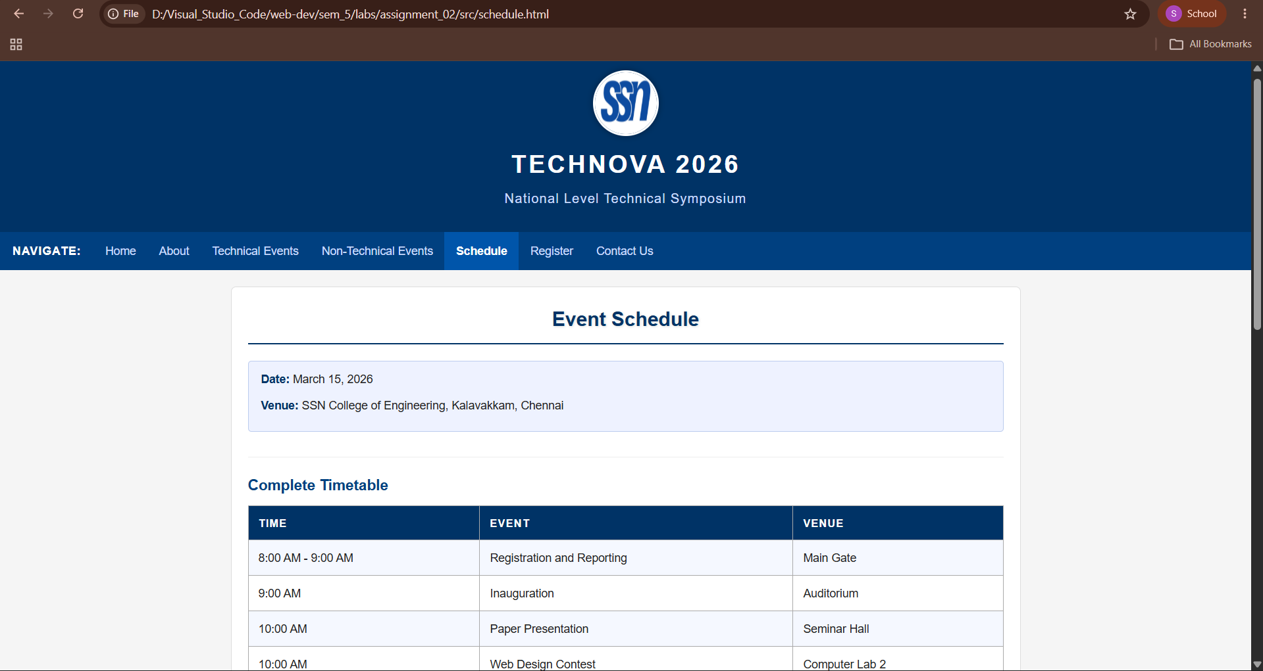

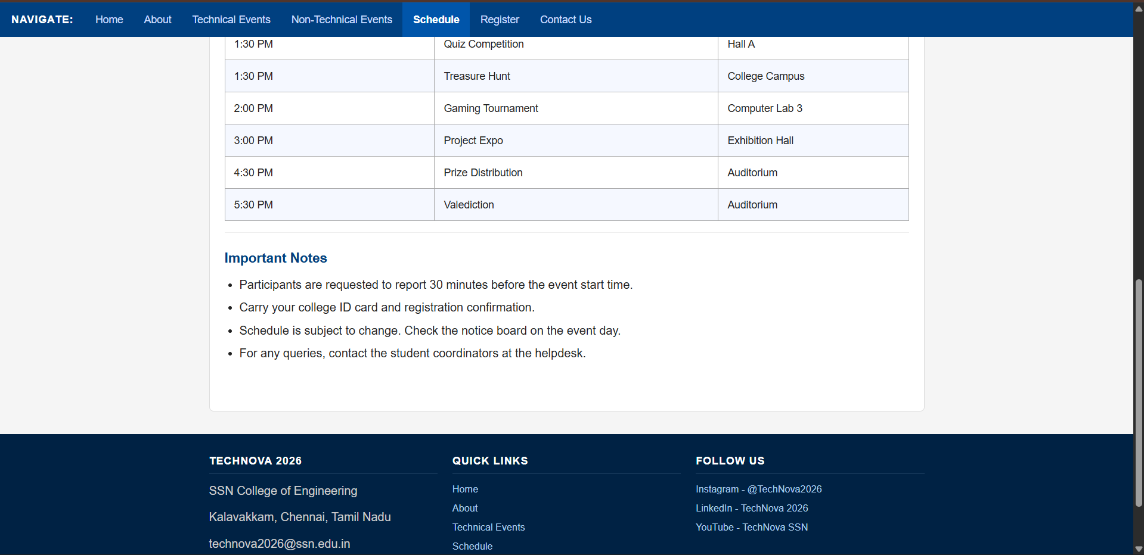

Page 6: Registration (register.html)

Purpose
Allow students to register.

Form Fields

Personal Information
- Full Name
- College Name
- Department
- Year of Study

Contact Information
- Email
- Phone Number

Event Selection
- Choose Technical Event
- Choose Non-Technical Event

Additional Information
- Address
- Comments

Buttons
- Submit
- Reset

register.html
<!DOCTYPE html>

<html lang="en">

<head>
<meta charset="UTF-8">
<meta name="viewport" content="width=device-width, initial-scale=1.0">
<title>TechNova 2026 - Register</title>
<link rel="stylesheet" href="css/style.css">
</head>

<body>

<!-- Header -->
<header>
<img src="assets/images/college_logo.png" alt="College Logo" class="header-logo">
<h1>TechNova 2026</h1>
<h3>National Level Technical Symposium</h3>
</header>

<!-- Navigation -->
<nav>
<span class="nav-label">Navigate:</span>
<a href="index.html">Home</a>
<a href="about.html">About</a>
<a href="technical.html">Technical Events</a>
<a href="nontechnical.html">Non-Technical Events</a>
<a href="schedule.html">Schedule</a>
<a href="register.html" class="active-link">Register</a>
<a href="contact.html">Contact Us</a>
</nav>

<div class="main-content">

<!-- Registration Form Section -->
<section class="section-block">
<h2 class="page-heading">Event Registration</h2>
<p style="text-align: center;">Fill in the form below to register for TechNova 2026. All fields marked with * are mandatory.</p>
</section>

<section class="section-block" style="border-bottom: none;">
<div class="form-container" style="margin: 0 auto;">
<form action="#" method="post">

<!-- Personal Information -->
<h3 class="form-section-title">Personal Information</h3>

<div class="form-group">
<label for="fullname">Full Name *</label>
<input type="text" id="fullname" name="fullname" placeholder="Enter your full name" required>
</div>

<div class="form-group">
<label for="college">College Name *</label>
<input type="text" id="college" name="college" placeholder="Enter your college name" required>
</div>

<div class="form-group">
<label for="department">Department *</label>
<input type="text" id="department" name="department" placeholder="e.g. Computer Science" required>
</div>

<div class="form-group">
<label for="year">Year of Study *</label>
<select id="year" name="year" required>
<option value="">-- Select Year --</option>
<option value="1">1st Year</option>
<option value="2">2nd Year</option>
<option value="3">3rd Year</option>
<option value="4">4th Year</option>
</select>
</div>

<!-- Contact Information -->
<h3 class="form-section-title">Contact Information</h3>

<div class="form-group">
<label for="email">Email Address *</label>
<input type="email" id="email" name="email" placeholder="example@email.com" required>
</div>

<div class="form-group">
<label for="phone">Phone Number *</label>
<input type="tel" id="phone" name="phone" placeholder="10-digit mobile number" required>
</div>

<!-- Event Selection -->
<h3 class="form-section-title">Event Selection</h3>

<div class="form-group">
<label for="technical_event">Choose Technical Event</label>
<select id="technical_event" name="technical_event">
<option value="">-- Select Technical Event --</option>
<option value="paper">Paper Presentation</option>
<option value="webdesign">Web Design Contest</option>
<option value="coding">Coding Challenge</option>
<option value="project">Project Expo</option>
<option value="none">Not Participating</option>
</select>
</div>

<div class="form-group">
<label for="nontechnical_event">Choose Non-Technical Event</label>
<select id="nontechnical_event" name="nontechnical_event">
<option value="">-- Select Non-Technical Event --</option>
<option value="photography">Photography</option>
<option value="quiz">Quiz Competition</option>
<option value="treasure">Treasure Hunt</option>
<option value="gaming">Gaming Tournament</option>
<option value="none">Not Participating</option>
</select>
</div>

<!-- Additional Information -->
<h3 class="form-section-title">Additional Information</h3>

<div class="form-group">
<label for="address">Address</label>
<textarea id="address" name="address" rows="4" placeholder="Enter your address"></textarea>
</div>

<div class="form-group">
<label for="comments">Comments / Special Requirements</label>
<textarea id="comments" name="comments" rows="4" placeholder="Any special requirements or comments"></textarea>
</div>

<!-- Form Buttons -->
<div class="form-group" style="text-align: center; margin-top: 30px;">
<input type="submit" value="Submit Registration" class="btn-submit">
<input type="reset" value="Reset Form" class="btn-reset">
</div>

</form>

</div>
</section>

</div>

<!-- Footer -->
<footer>
<div class="footer-content">

<div class="footer-col">
<h4>TechNova 2026</h4>
<p>SSN College of Engineering</p>
<p>Kalavakkam, Chennai, Tamil Nadu</p>
<p>technova2026@ssn.edu.in</p>
</div>

<div class="footer-col">
<h4>Quick Links</h4>
<a href="index.html">Home</a>
<a href="about.html">About</a>
<a href="technical.html">Technical Events</a>
<a href="schedule.html">Schedule</a>
<a href="register.html">Register</a>
</div>

<div class="footer-col">
<h4>Follow Us</h4>
<a href="#">Instagram - @TechNova2026</a>
<a href="#">LinkedIn - TechNova 2026</a>
<a href="#">YouTube - TechNova SSN</a>
</div>

</div>

<div class="footer-bottom">
2026 TechNova | SSN College of Engineering. All Rights Reserved.
</div>
</footer>

</body>

</html>

Output:

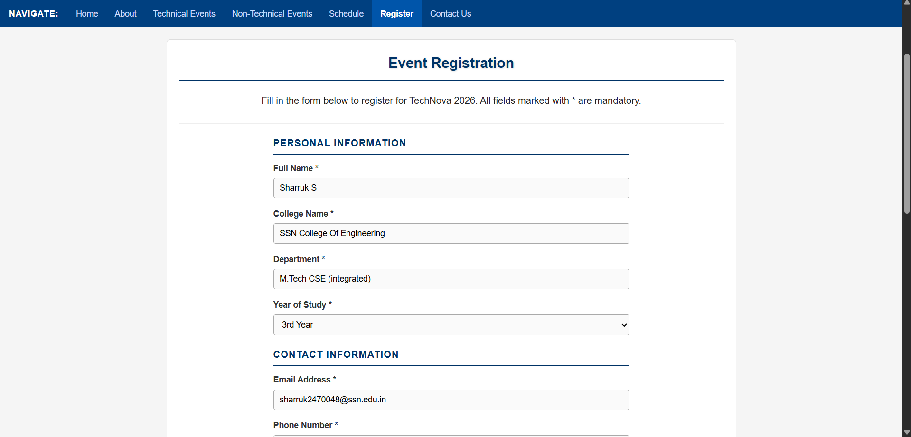

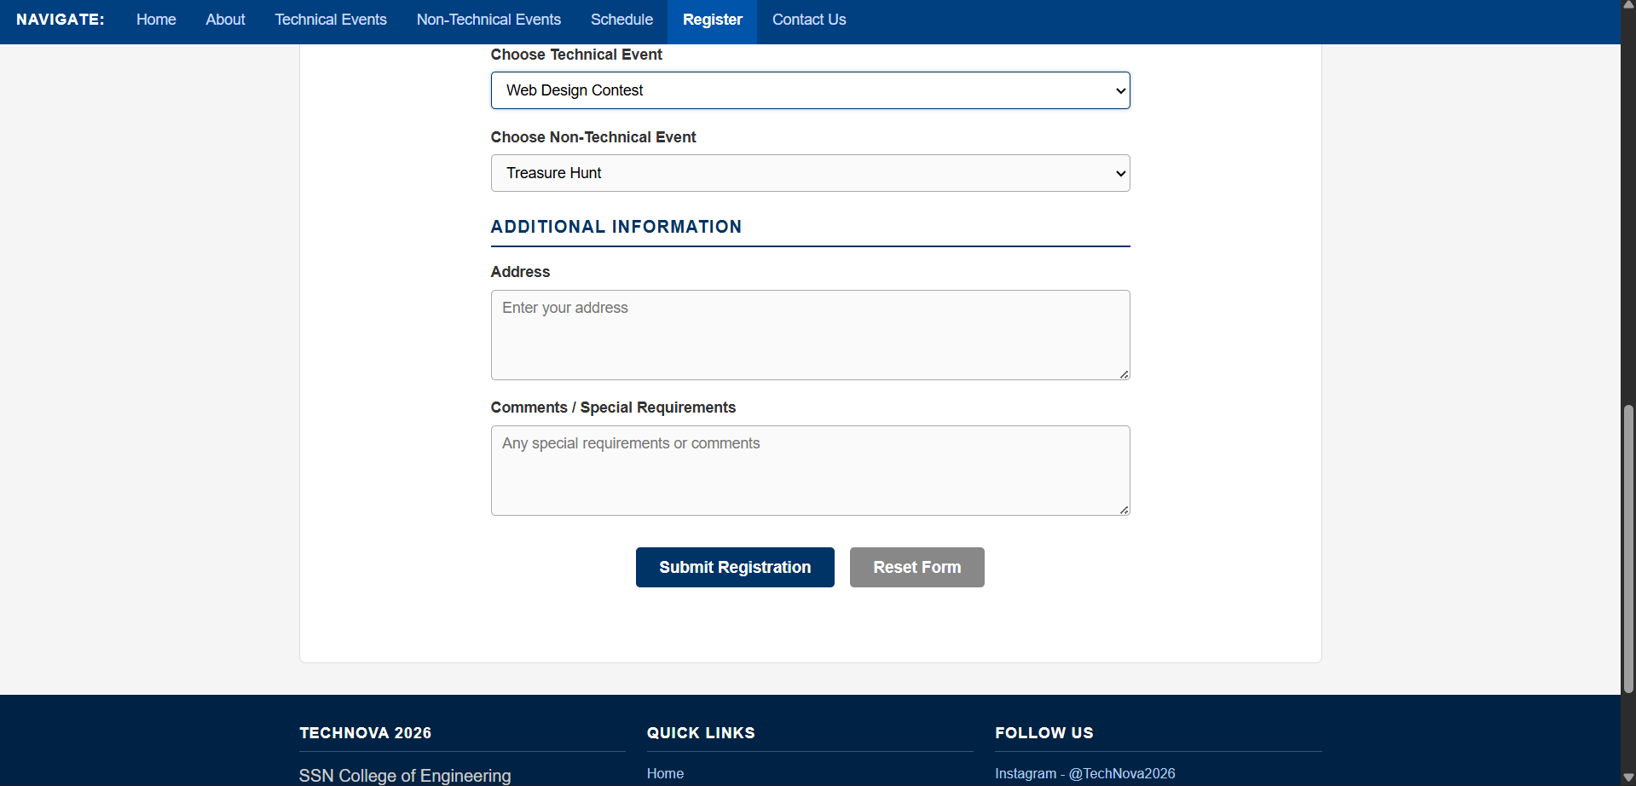

Page 7: Contact Us (contact.html)

Purpose
Provide communication details.

Content

Faculty Coordinator
- Name
- Email
- Phone

Student Coordinators
- Coordinator 1
- Coordinator 2

Venue Address

Social Media Links
- Instagram
- LinkedIn
- YouTube

Embedded College Location Image
(Static image, not a map)

Contact.html
<!DOCTYPE html>

<html lang="en">

<head>
<meta charset="UTF-8">
<meta name="viewport" content="width=device-width, initial-scale=1.0">
<title>TechNova 2026 - Contact Us</title>
<link rel="stylesheet" href="css/style.css">
</head>

<body>

<!-- Header -->
<header>
<img src="assets/images/college_logo.png" alt="College Logo" class="header-logo">
<h1>TechNova 2026</h1>
<h3>National Level Technical Symposium</h3>
</header>

<!-- Navigation -->
<nav>
<span class="nav-label">Navigate:</span>
<a href="index.html">Home</a>
<a href="about.html">About</a>
<a href="technical.html">Technical Events</a>
<a href="nontechnical.html">Non-Technical Events</a>
<a href="schedule.html">Schedule</a>
<a href="register.html">Register</a>
<a href="contact.html" class="active-link">Contact Us</a>
</nav>

<div class="main-content">

<!-- Contact Section -->
<section class="section-block">
<h2 class="page-heading">Contact Us</h2>
<p style="text-align: center;">For any queries regarding TechNova 2026, feel free to reach out to us.</p>
</section>

<!-- Contact Information -->
<section class="section-block">
<div class="contact-flex">

<div class="contact-block">
<h3>Faculty Coordinator</h3>
<p><b>Name:</b> Dr. R. Anitha</p>
<p><b>Email:</b> anitha.r@ssn.edu.in</p>
<p><b>Phone:</b> +91 98765 43210</p>
</div>

<div class="contact-block">
<h3>Student Coordinator 1</h3>
<p><b>Name:</b> Rahul Kumar</p>
<p><b>Department:</b> CSE - 4th Year</p>
<p><b>Phone:</b> +91 91234 56789</p>
</div>

<div class="contact-block">
<h3>Student Coordinator 2</h3>
<p><b>Name:</b> Priya Sharma</p>
<p><b>Department:</b> CSE - 4th Year</p>
<p><b>Phone:</b> +91 98123 45678</p>
</div>

</div>
</section>

<!-- Venue Address -->
<section class="section-block" style="border-bottom: none;">
<h3>Venue Address</h3>
<div class="info-bar">
SSN College of Engineering<br>
(Sri Sivasubramaniya Nadar College of Engineering)<br>
Rajiv Gandhi Salai (OMR), Kalavakkam,<br>
Chennai - 603 110,<br>
Tamil Nadu, India.
</div>

<h3 style="margin-top: 20px;">College Location</h3>
<img src="assets/images/college_map.png" alt="College Location Map" class="map-img">
</section>

</div>

<!-- Footer -->
<footer>
<div class="footer-content">

<div class="footer-col">
<h4>TechNova 2026</h4>
<p>SSN College of Engineering</p>
<p>Kalavakkam, Chennai, Tamil Nadu</p>
<p>technova2026@ssn.edu.in</p>
</div>

<div class="footer-col">
<h4>Quick Links</h4>
<a href="index.html">Home</a>
<a href="about.html">About</a>
<a href="technical.html">Technical Events</a>
<a href="schedule.html">Schedule</a>
<a href="register.html">Register</a>
</div>

<div class="footer-col">
<h4>Follow Us</h4>
<a href="#">Instagram - @TechNova2026</a>
<a href="#">LinkedIn - TechNova 2026</a>
<a href="#">YouTube - TechNova SSN</a>
</div>

</div>

<div class="footer-bottom">
2026 TechNova | SSN College of Engineering. All Rights Reserved.
</div>
</footer>

</body>

</html>

Output:

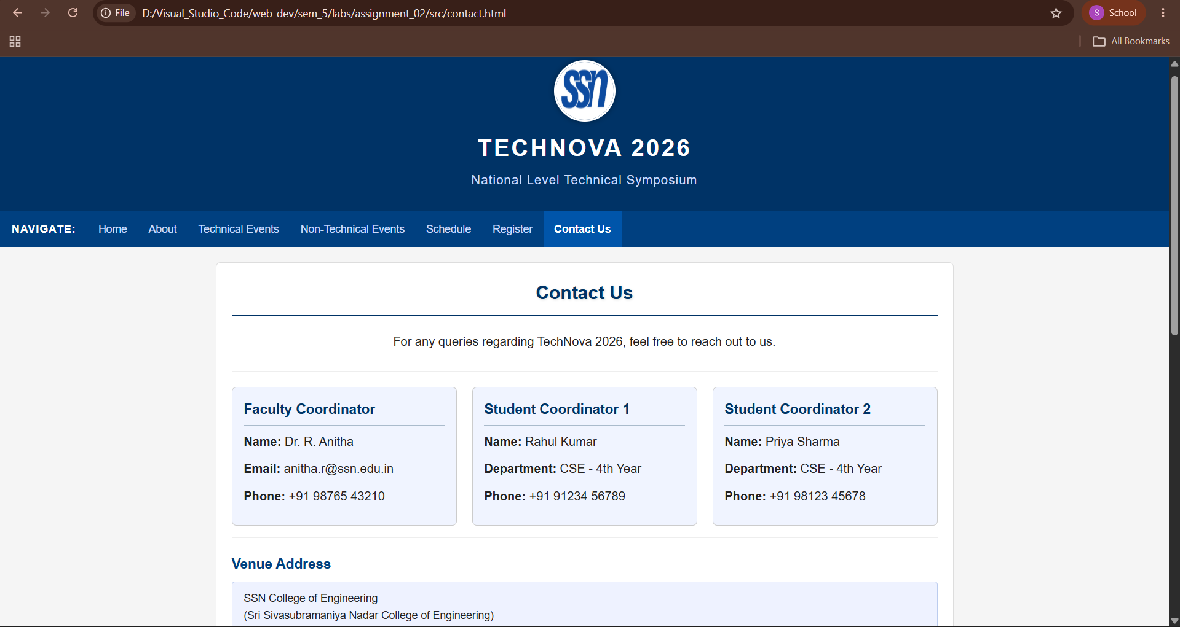

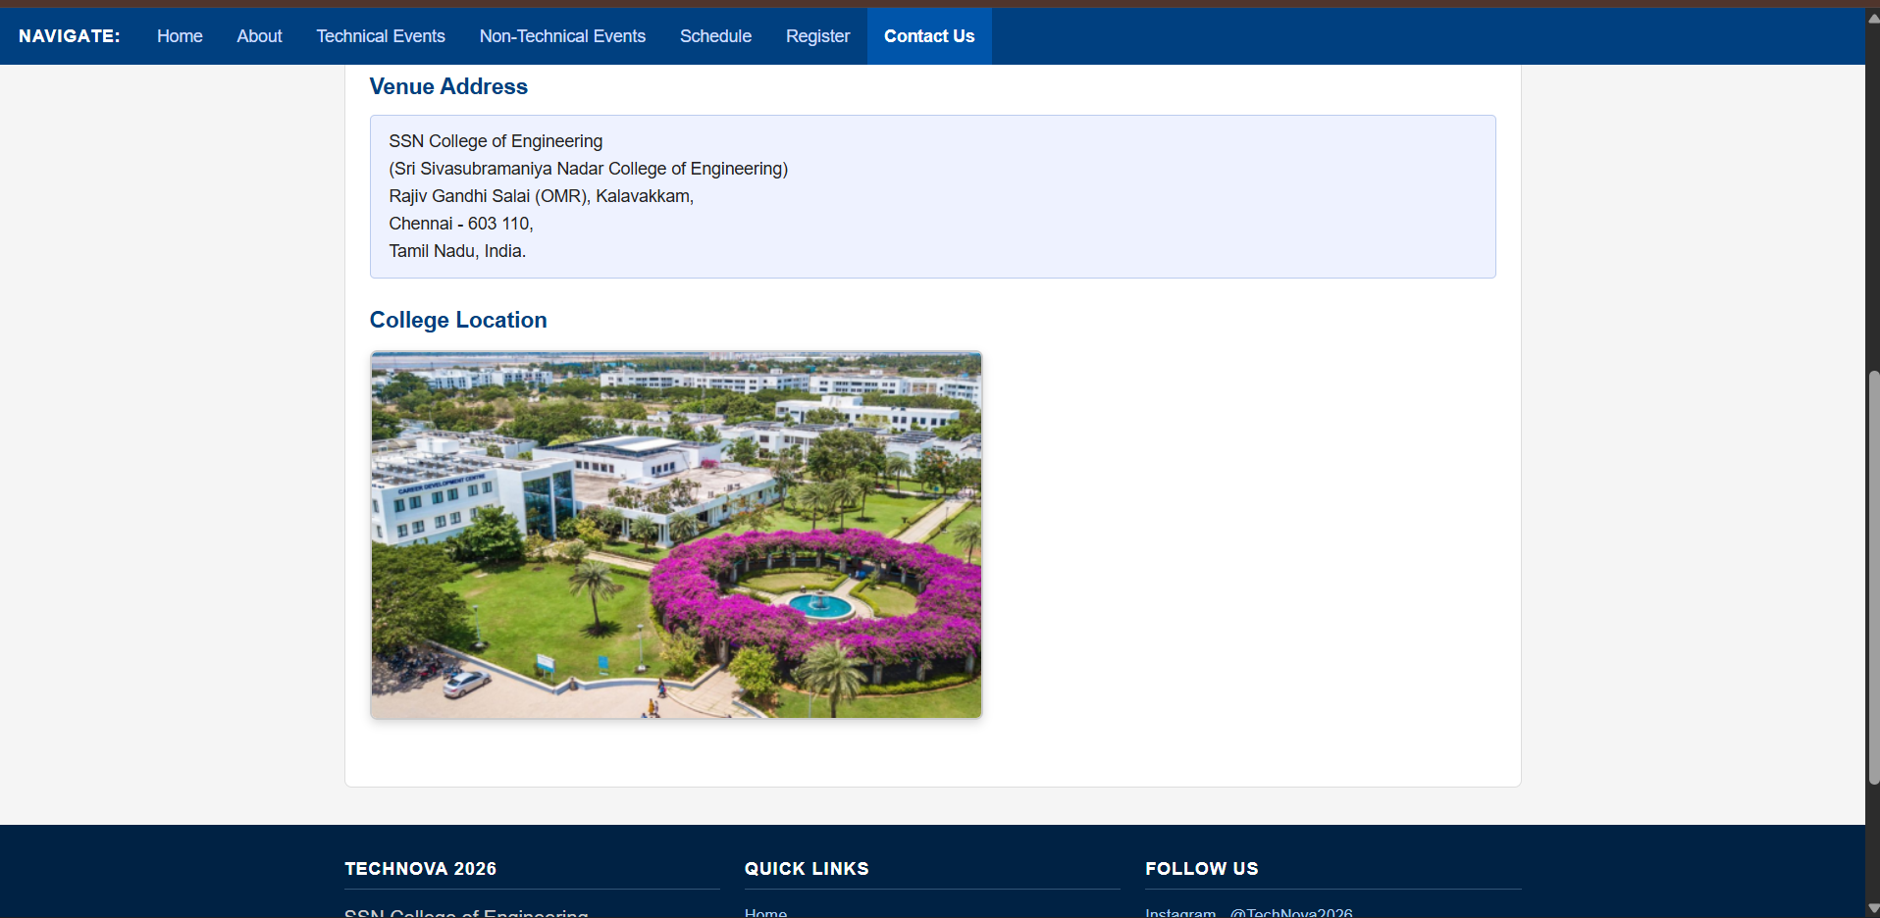

Keep the existing 7 pages exactly as they are and apply the following CSS concepts
- Home
- About
- Technical Events
- Non-Technical Events
- Event Schedule
- Registration
- Contact

CSS Requirements (Mandatory)

1. CSS Selectors
Use at least:
- Element selector
- Class selector
- ID selector
- Descendant selector
- Pseudo-class (:hover)
- Pseudo-element (::before or ::after)

2. Box Model
Demonstrate:
- Margin
- Padding
- Border
- Border-radius
- Box-sizing

3. Typography
Use:
- Font family
- Font size
- Font weight
- Text alignment
- Text transformation
- Letter spacing

4. Colors and Backgrounds
Use:
- Background colors
- Background images
- Gradient background (optional bonus)

5. Navigation Bar
Create a navigation menu with:
- Hover effects
- Active page highlighting

6. Layout using Flexbox
Use Flexbox for:
- Navigation menu
- Highlights section
- Event cards
- Contact section

7. CSS Grid
Use Grid layout for at least one section such as:
- Technical Events
- Non-Technical Events
- Gallery
- Highlights

8. Tables
Style the Event Schedule table with:
- Borders
- Alternate row colors
- Hover effect
- Header styling

9. Forms
Style the registration form using:
- Labels
- Input fields
- Radio buttons/Checkboxes (optional)
- Dropdown lists
- Focus effect
- Styled buttons

10. Positioning
Use at least one of:
- Relative
- Absolute
- Fixed
- Sticky
Example:
- Sticky navigation bar
- Fixed "Back to Top" button

11. Display Property
Use:
- Block
- Inline
- Inline-block

12. Responsive Design
Use Media Queries for:
- Mobile devices
- Tablet devices
- Desktop devices

13. Images
Apply:
- Rounded corners
- Shadows
- Responsive sizing

14. CSS Effects
Use at least three:
- Transition
- Transform
- Box-shadow
- Text-shadow
- Opacity

15. Footer
Create a common footer for every page containing:
- Copyright
- Quick links
- Social media icons/text links

Style.css

/* ============================================================
TechNova 2026 - Main Stylesheet
SSN College of Engineering
Department of Computer Science and Engineering
Web Development Lab - Assignment 02
============================================================ */

/* General Styles */
* {
box-sizing: border-box;
margin: 0;
padding: 0;
}

body {
font-family: Arial, sans-serif;
font-size: 16px;
background-color: #f5f5f5;
color: #222222;
line-height: 1.6;
}

/* Typography */
h1 {
font-size: 28px;
font-weight: bold;
text-align: center;
text-transform: uppercase;
letter-spacing: 2px;
color: #003366;
}

h2 {
font-size: 22px;
font-weight: bold;
color: #003366;
margin-bottom: 10px;
text-transform: capitalize;
}

h3 {
font-size: 18px;
font-weight: bold;
color: #004080;
margin-bottom: 8px;
}

h4 {
font-size: 15px;
font-weight: bold;
color: #333;
margin-bottom: 6px;
}

p {
margin-bottom: 10px;
}

/* Header */
header {
background-color: #003366;
color: white;
text-align: center;
padding: 20px 10px;
}

header h1 {
color: white;
font-size: 30px;
letter-spacing: 3px;
}

header h3 {
color: #ccddff;
font-size: 16px;
font-weight: normal;
letter-spacing: 1px;
margin-top: 5px;
}

.header-logo {
width: 80px;
height: 80px;
border-radius: 50%;
border: 3px solid white;
display: block;
margin: 0 auto 10px auto;
box-shadow: 0 0 8px rgba(0, 0, 0, 0.4);
}

/* Navigation */
nav {
background-color: #004080;
padding: 0;
position: sticky;
top: 0;
z-index: 100;
display: flex;
align-items: center;
flex-wrap: wrap;
}

.nav-label {
color: #ffffff;
font-weight: bold;
padding: 12px 15px;
font-size: 14px;
text-transform: uppercase;
letter-spacing: 1px;
display: inline-block;
}

nav a {
color: #ccddff;
text-decoration: none;
padding: 12px 14px;
font-size: 14px;
display: inline-block;
transition: background-color 0.3s, color 0.3s;
}

nav a:hover {
background-color: #0066cc;
color: #ffffff;
}

.active-link {
background-color: #0055aa;
color: #ffffff;
font-weight: bold;
}

/* Banner */
.banner-section {
text-align: center;
padding: 15px 0;
background-color: #e8eef5;
}

.banner-img {
width: 100%;
max-width: 860px;
height: auto;
border-radius: 8px;
box-shadow: 0 4px 10px rgba(0, 0, 0, 0.2);
display: block;
margin: 0 auto;
}

/* Main Content Area */
.main-content {
max-width: 960px;
margin: 20px auto;
padding: 20px;
background-color: #ffffff;
border: 1px solid #dddddd;
border-radius: 6px;
}

/* Section Styles */
.section-block {
margin-bottom: 20px;
padding-bottom: 15px;
border-bottom: 1px solid #eeeeee;
}

#symposium-overview {
background-color: #f0f4ff;
border-left: 4px solid #003366;
padding: 15px;
border-radius: 4px;
margin-bottom: 20px;
}

/* Event Highlights */
.highlights-container {
display: flex;
flex-wrap: wrap;
justify-content: center;
gap: 15px;
margin-top: 15px;
}

.highlight-card {
background-color: #003366;
color: white;
padding: 20px 25px;
text-align: center;
border-radius: 6px;
min-width: 150px;
flex: 1;
box-shadow: 0 2px 6px rgba(0, 0, 0, 0.2);
transition: transform 0.3s, box-shadow 0.3s;
}

.highlight-card:hover {
transform: translateY(-4px);
box-shadow: 0 6px 14px rgba(0, 0, 0, 0.3);
}

.highlight-card .highlight-number {
font-size: 26px;
font-weight: bold;
display: block;
}

.highlight-card .highlight-label {
font-size: 13px;
display: block;
margin-top: 5px;
letter-spacing: 1px;
text-transform: uppercase;
}

/* Event Cards */
.events-grid {
display: grid;
grid-template-columns: repeat(2, 1fr);
gap: 20px;
margin-top: 15px;
}

.event-card {
background-color: #ffffff;
border: 1px solid #cccccc;
border-radius: 6px;
padding: 15px;
box-shadow: 0 2px 5px rgba(0, 0, 0, 0.1);
transition: box-shadow 0.3s;
}

.event-card:hover {
box-shadow: 0 5px 12px rgba(0, 0, 0, 0.2);
}

.event-img {
width: 100%;
max-width: 300px;
height: auto;
border-radius: 6px;
box-shadow: 0 2px 6px rgba(0, 0, 0, 0.15);
margin-bottom: 10px;
display: block;
opacity: 0.95;
transition: opacity 0.3s;
}

.event-img:hover {
opacity: 1;
}

/* Tables */
.styled-table {
width: 100%;
border-collapse: collapse;
margin-top: 10px;
font-size: 14px;
}

.styled-table th,
.styled-table td {
border: 1px solid #aaaaaa;
padding: 10px 12px;
text-align: left;
}

.styled-table thead th {
background-color: #003366;
color: #ffffff;
font-weight: bold;
text-transform: uppercase;
letter-spacing: 1px;
font-size: 13px;
}

.styled-table tbody tr:nth-child(odd) {
background-color: #f5f8ff;
}

.styled-table tbody tr:nth-child(even) {
background-color: #ffffff;
}

.styled-table tbody tr:hover {
background-color: #ddeeff;
}

/* Registration Form */
.form-container {
max-width: 600px;
}

.form-group {
margin-bottom: 15px;
}

.form-container label {
display: block;
font-weight: bold;
margin-bottom: 5px;
font-size: 14px;
color: #333333;
}

.form-container input[type="text"],
.form-container input[type="email"],
.form-container input[type="tel"],
.form-container select,
.form-container textarea {
display: block;
width: 100%;
padding: 8px 10px;
border: 1px solid #aaaaaa;
border-radius: 4px;
font-size: 14px;
font-family: Arial, sans-serif;
background-color: #fafafa;
transition: border-color 0.3s, box-shadow 0.3s;
}

.form-container input:focus,
.form-container select:focus,
.form-container textarea:focus {
outline: none;
border-color: #003366;
box-shadow: 0 0 5px rgba(0, 51, 102, 0.3);
background-color: #ffffff;
}

.form-section-title {
font-size: 16px;
font-weight: bold;
color: #003366;
border-bottom: 2px solid #003366;
padding-bottom: 5px;
margin: 20px 0 12px 0;
text-transform: uppercase;
letter-spacing: 1px;
}

.btn-submit {
background-color: #003366;
color: #ffffff;
padding: 10px 22px;
border: none;
border-radius: 4px;
font-size: 15px;
font-weight: bold;
cursor: pointer;
transition: background-color 0.3s, transform 0.2s;
display: inline-block;
}

.btn-submit:hover {
background-color: #0055aa;
transform: scale(1.03);
}

.btn-reset {
background-color: #888888;
color: #ffffff;
padding: 10px 22px;
border: none;
border-radius: 4px;
font-size: 15px;
font-weight: bold;
cursor: pointer;
transition: background-color 0.3s;
display: inline-block;
margin-left: 10px;
}

.btn-reset:hover {
background-color: #555555;
}

/* Contact Page */
.contact-flex {
display: flex;
flex-wrap: wrap;
gap: 20px;
margin-top: 15px;
}

.contact-block {
flex: 1;
min-width: 220px;
background-color: #f0f4ff;
border: 1px solid #cccccc;
border-radius: 6px;
padding: 15px;
}

.contact-block h3 {
color: #003366;
margin-bottom: 8px;
border-bottom: 1px solid #aabbcc;
padding-bottom: 5px;
}

.map-img {
width: 100%;
max-width: 500px;
height: auto;
border-radius: 6px;
border: 2px solid #cccccc;
box-shadow: 0 3px 8px rgba(0, 0, 0, 0.15);
display: block;
margin-top: 10px;
}

/* Lists */
ul, ol {
margin-left: 20px;
margin-bottom: 10px;
}

li {
margin-bottom: 5px;
}

/* Horizontal Rule */
hr {
border: none;
border-top: 1px solid #cccccc;
margin: 15px 0;
}

/* Footer */
footer {
background-color: #002244;
color: #cccccc;
padding: 25px 20px;
margin-top: 30px;
}

.footer-content {
display: flex;
flex-wrap: wrap;
justify-content: space-between;
gap: 20px;
max-width: 960px;
margin: 0 auto;
}

.footer-col {
flex: 1;
min-width: 180px;
}

footer h4 {
color: #ffffff;
font-size: 14px;
text-transform: uppercase;
letter-spacing: 1px;
margin-bottom: 10px;
padding-bottom: 5px;
border-bottom: 1px solid #335577;
}

footer a {
color: #aaccee;
text-decoration: none;
display: block;
margin-bottom: 5px;
font-size: 13px;
transition: color 0.3s;
}

footer a:hover {
color: #ffffff;
}

.footer-bottom {
text-align: center;
margin-top: 20px;
padding-top: 15px;
border-top: 1px solid #335577;
font-size: 13px;
color: #aaaaaa;
}

.footer-bottom::before {
content: "© ";
}

/* About Page Styles */
.vision-block {
background-color: #f8f9ff;
border-left: 4px solid #0055aa;
padding: 12px 15px;
margin-bottom: 12px;
border-radius: 0 4px 4px 0;
}

/* Display Property Demos */
.badge {
display: inline-block;
background-color: #003366;
color: white;
padding: 3px 10px;
border-radius: 12px;
font-size: 12px;
font-weight: bold;
margin-right: 5px;
letter-spacing: 0.5px;
}

.info-bar {
display: block;
background-color: #eef2ff;
border: 1px solid #bbccee;
padding: 10px 15px;
border-radius: 4px;
margin-bottom: 15px;
font-size: 14px;
}

.text-inline {
display: inline;
font-weight: bold;
color: #003366;
}

/* Text Shadow and Box Shadow */
.page-heading {
font-size: 24px;
font-weight: bold;
color: #003366;
text-align: center;
text-shadow: 1px 1px 3px rgba(0, 0, 0, 0.15);
margin-bottom: 20px;
padding-bottom: 10px;
border-bottom: 2px solid #003366;
}

/* Responsive Design */
@media (max-width: 768px) {
body {
font-size: 15px;
}

h1 {
font-size: 22px;
letter-spacing: 1px;
}

nav {
flex-direction: column;
align-items: flex-start;
}

nav a {
padding: 10px 12px;
width: 100%;
}

.events-grid {
grid-template-columns: 1fr;
}

.highlights-container {
flex-direction: column;
align-items: center;
}

.highlight-card {
min-width: 200px;
width: 80%;
}

.contact-flex {
flex-direction: column;
}

.main-content {
margin: 10px;
padding: 15px;
}
}

@media (max-width: 480px) {
body {
font-size: 14px;
}

h1 {
font-size: 18px;
}

h2 {
font-size: 18px;
}

header {
padding: 15px 10px;
}

.header-logo {
width: 60px;
height: 60px;
}

.main-content {
margin: 5px;
padding: 10px;
}

.footer-content {
flex-direction: column;
}

.form-container {
max-width: 100%;
}

.styled-table {
font-size: 12px;
}

.btn-submit,
.btn-reset {
width: 100%;
margin: 5px 0;
}
}

@media (min-width: 769px) {
.events-grid {
grid-template-columns: repeat(2, 1fr);
}
}

Learning Outcomes
- Developed a responsive multi-page website using HTML and CSS.
- Applied CSS concepts such as Flexbox, Grid, Box Model, and Media Queries.
- Designed and styled navigation menus, tables, forms, images, and page layouts.
- Gained practical experience in creating user-friendly and visually appealing web pages using external CSS.

