LAB REPORT
Online Food Ordering Application using Vue JS Routing and State Management
Student Name | Sharruk S
Register Number | 3122247001061
Subject Code | ICS1511
Subject Name | Web Application Development Lab
Year / Semester | III Year / V Semester
Batch | 2024-2029
Exercise | Exercise 7

1. Aim
To design and develop a Vue.js Online Food Ordering application that demonstrates Vue Router (including nested routing) and Pinia for centralized state management.

2. Problem Statement
Develop a Vue.js Online Food Ordering application with Vue Router, nested routing, and Pinia for state management. The application should have a Home page, an Order section, and an About page. The Order section should use nested routing to provide separate pages for the Food Menu and Cart.

3. Objectives
- Implement multi-page navigation using Vue Router.
- Demonstrate nested (child) routes for the Food Menu and Cart under /order.
- Manage shared cart state centrally using Pinia (state, actions, getters).
- Practice reusable component design using props and emits.
- Build a clean, responsive UI using plain CSS.

4. Technologies Used
- Vue.js 3 (Composition API, <script setup>)
- Vite (build tool and dev server)
- Vue Router 4 (routing and nested routing)
- Pinia 2 (state management)
- Plain CSS (styling)

5. System Requirements
- Node.js (v18 or above) and npm
- A modern web browser
- Code editor (e.g., VS Code)

6. Project Structure
online-food-ordering/
├── package.json
├── vite.config.js
├── index.html
├── README.md
├── TESTING.md
└── src/
├── main.js
├── App.vue
├── style.css
├── router/index.js
├── stores/cartStore.js
├── views/
│ ├── Home.vue
│ ├── Order.vue
│ ├── FoodMenu.vue
│ ├── Cart.vue
│ └── About.vue
└── components/
└── FoodItem.vue

7. Route Structure
Path | Component | Description
/ | Home.vue | Landing page of the application
/order | Order.vue | Parent route; contains a <router-view> for its children
/order/menu | FoodMenu.vue | Nested child route showing the food menu
/order/cart | Cart.vue | Nested child route showing the cart
/about | About.vue | Static information page

Nested Routing Explanation
The /order route is registered with two children in router/index.js: menu and cart. Because they are declared as children of /order, Vue Router automatically resolves their full paths as /order/menu and /order/cart. Order.vue acts as the shared parent layout — it renders the page title and a sub-navigation bar, and places a <router-view> inside its own template. Whichever child route is currently active (FoodMenu.vue or Cart.vue) is rendered inside that inner <router-view>, which is the core demonstration of nested routing in this project.

8. Component Description
- main.js – Creates the Vue app, registers Pinia and the router, and mounts the app.
- App.vue – Top-level layout: navigation bar, footer, and the top-level <router-view>.
- router/index.js – Defines all routes, including the nested children under /order.
- stores/cartStore.js – Pinia store holding the cart state, actions, and getters.
- views/Home.vue – Landing page with a call-to-action button to the Food Menu.
- views/Order.vue – Parent route component with sub-navigation and a nested <router-view>.
- views/FoodMenu.vue – Displays the four food items using the FoodItem component.
- views/Cart.vue – Displays cart items and lets the user modify quantities or clear the cart.
- views/About.vue – Static page describing the application.
- components/FoodItem.vue – Reusable card that receives food details via props and emits an 'add-to-cart' event.

9. Pinia Store

State
items: an array of cart item objects, each with { id, name, price, emoji, quantity }.

Actions
- addToCart(food) – Adds a new item with quantity 1, or increases quantity by 1 if the item already exists in the cart.
- increaseQuantity(id) – Increases the specified item's quantity by 1.
- decreaseQuantity(id) – Decreases the specified item's quantity by 1, but never below 1.
- removeFromCart(id) – Removes the specified item from the cart completely.
- clearCart() – Empties the entire cart.

Getters
- totalItems – Sums the quantity field across all cart items.
- totalBill – Sums (price × quantity) across all cart items.

10. Implementation

Vue Router, RouterLink & RouterView
Navigation between Home, Order, and About is done using <RouterLink> instead of plain <a> tags, so the app never performs a full page reload. <RouterView> is used at two levels: once in App.vue for the top-level route, and once inside Order.vue for the nested child routes.

Nested Routing
{
path: '/order',
component: Order,
children: [
{ path: 'menu', component: FoodMenu },
{ path: 'cart', component: Cart }
]
}

Pinia Actions & Getters
Components call useCartStore() to get a reactive reference to the store, then read state/getters directly in the template (e.g. cart.totalBill) and call actions on click handlers (e.g. cart.increaseQuantity(item.id)).

Props & Emits
FoodItem.vue receives id, food, price, and emoji as props from FoodMenu.vue, and emits an 'add-to-cart' event with the item's details when its button is clicked. FoodMenu.vue listens for this event and forwards it to the Pinia store's addToCart action.

v-for & Conditional Rendering
v-for is used to render the list of food items in FoodMenu.vue and the list of cart items in Cart.vue. v-if / v-else is used in Cart.vue to switch between the empty-cart message and the populated cart view.

11. Screenshots
Screenshot 1 – Home Page
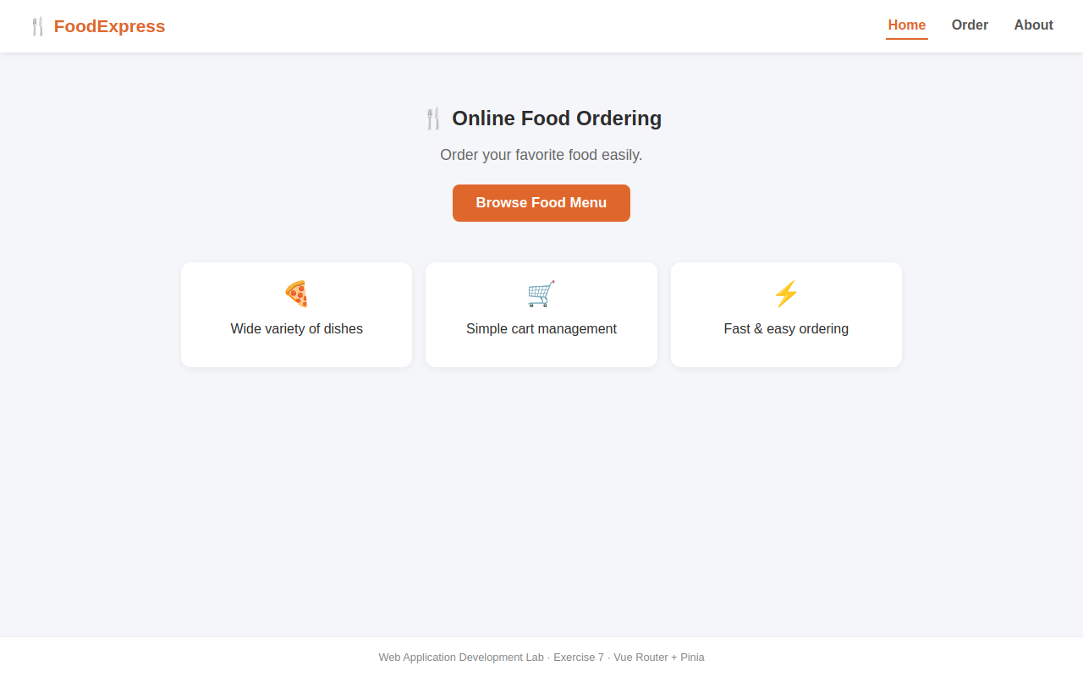
Screenshot 2 – Order Page with nested Food Menu
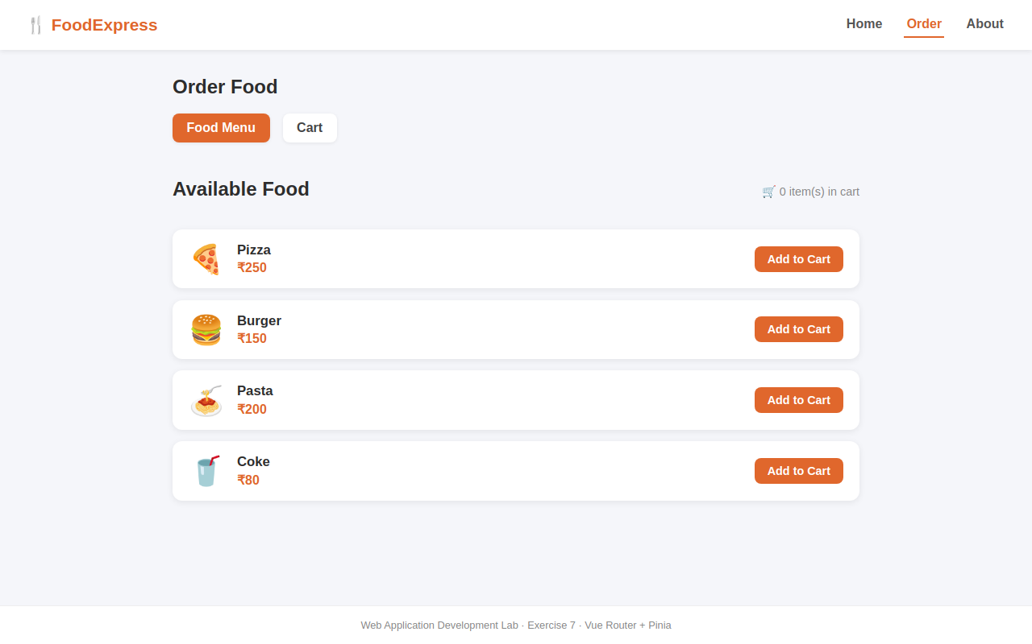
Screenshot 3 – Food Menu with food items
Screenshot 4 – Cart with items added (Pizza x2, Coke x1)
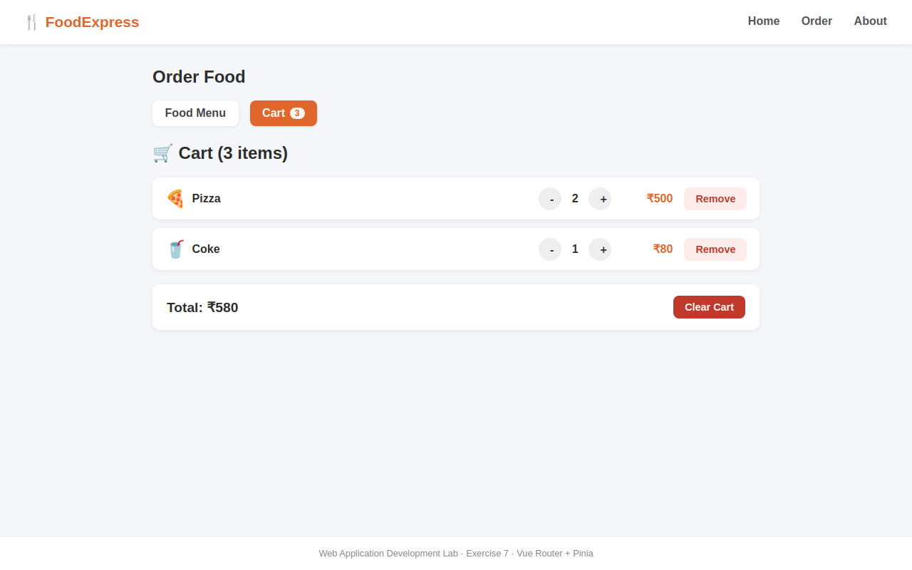
Screenshot 5 – Cart quantity modification
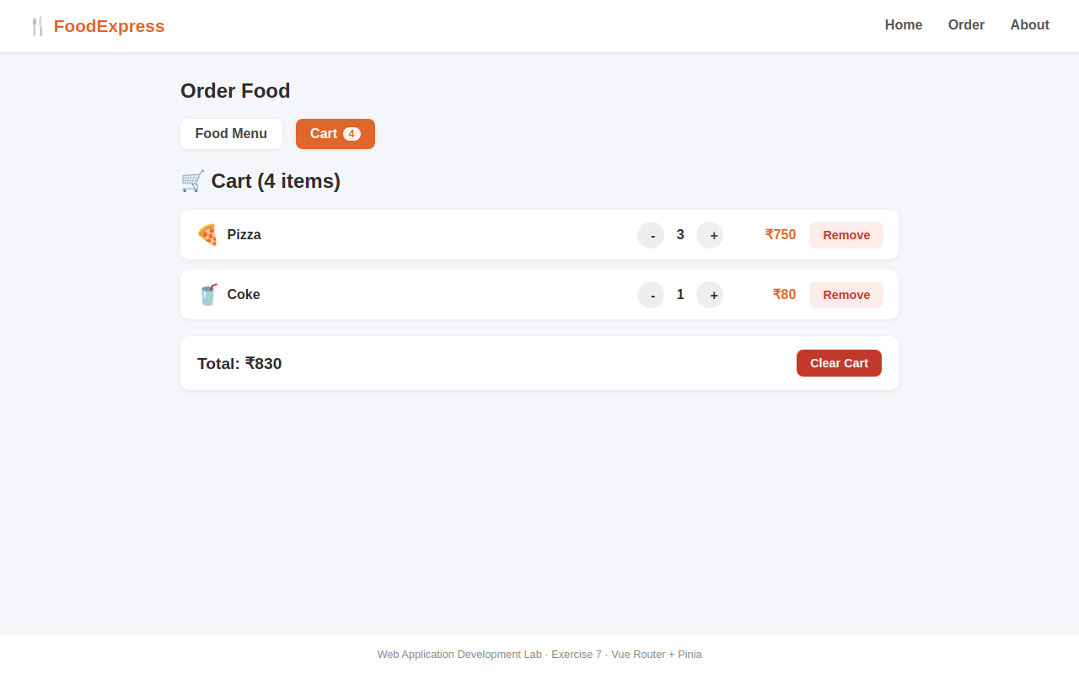
Screenshot 6 – Cart showing total bill
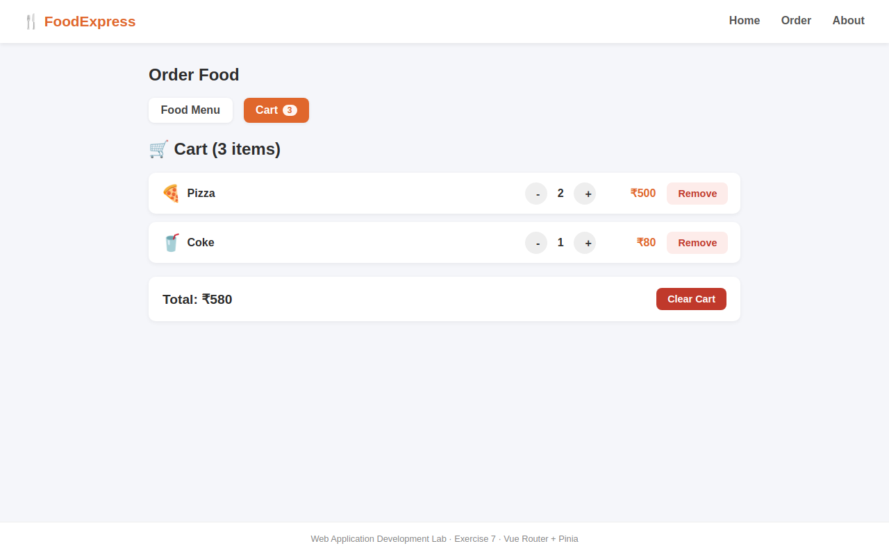
Screenshot 7 – Empty Cart
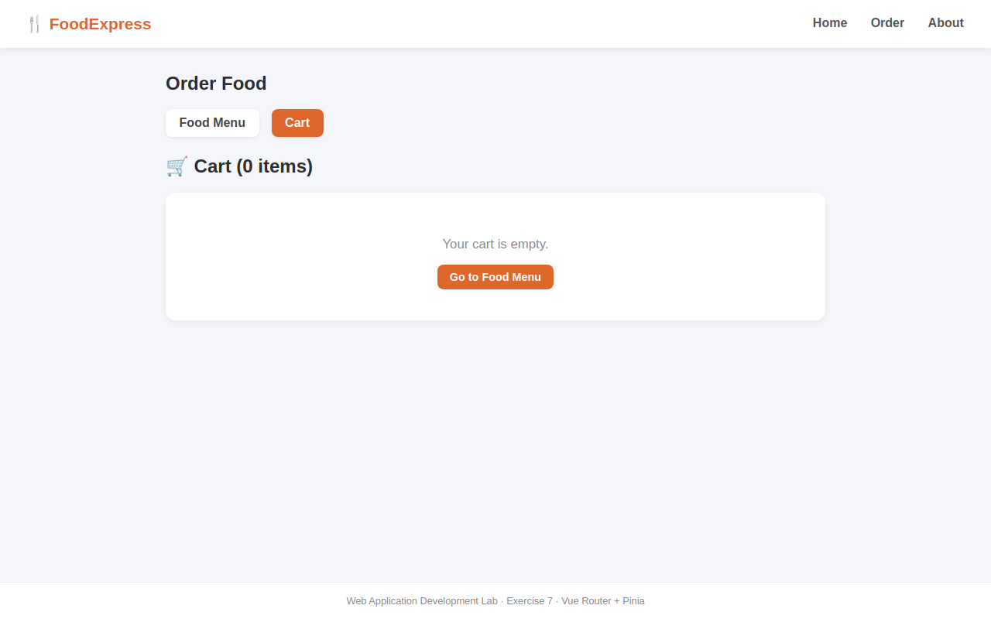
Screenshot 8 – About Page
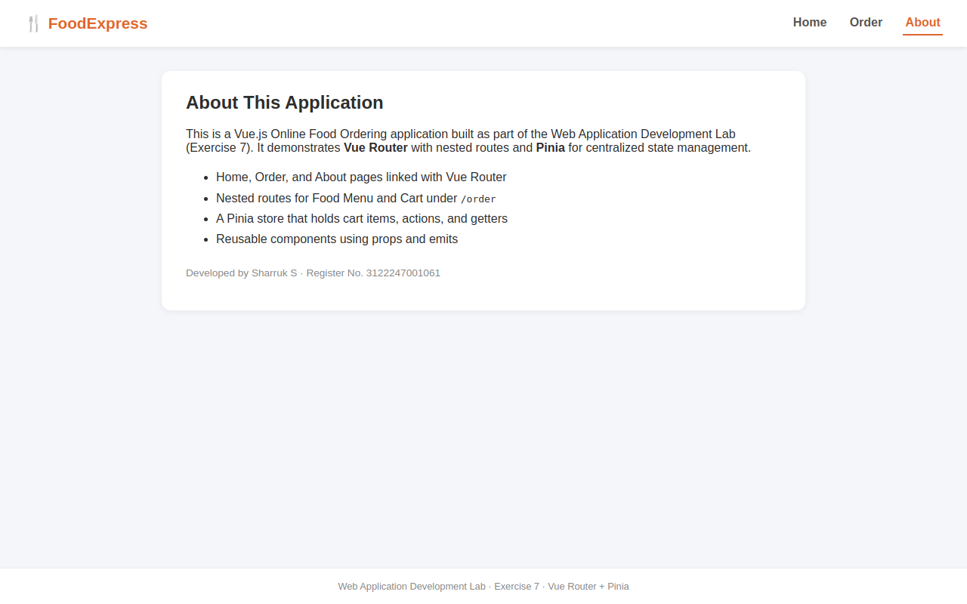

12. Expected Output
🛒 Cart (3 items)
--------------------------------
🍕 Pizza [-] 2 [+] ₹500
🥤 Coke [-] 1 [+] ₹80
Total: ₹580
[ Clear Cart ]
This exact scenario (Pizza quantity 2, Coke quantity 1, total items 3, total bill ₹580) was verified live in Screenshot 4 above.

13. Result
The Vue.js Online Food Ordering application was successfully developed and executed. All required routes (including the nested /order/menu and /order/cart routes), the Pinia store's actions and getters, and all cart operations (add, increase, decrease, remove, clear) were verified to work correctly.

14. Conclusion
This exercise provided hands-on experience with Vue Router's nested routing feature and Pinia's centralized state management. Implementing the cart using Pinia actions and getters made the state predictable and easy to reuse across the FoodMenu and Cart components, while props and emits demonstrated clean parent-child communication in the FoodItem component.

