Memory Card Game
CAT -1 ASSIGNMENT TEST

Name: Sundareswaran Rajaguru
Register Number: 3122247001048

1. Overview
A browser-based Memory Card Game built with plain HTML, CSS, and JavaScript - no frameworks or libraries. It renders a 4x4 grid of 16 face-down cards, each hiding one of 8 number text content s (each appears twice). The player clicks two cards at a time to find matching pairs. Matched pairs stay revealed in green; mismatched pairs flip back after a short delay.
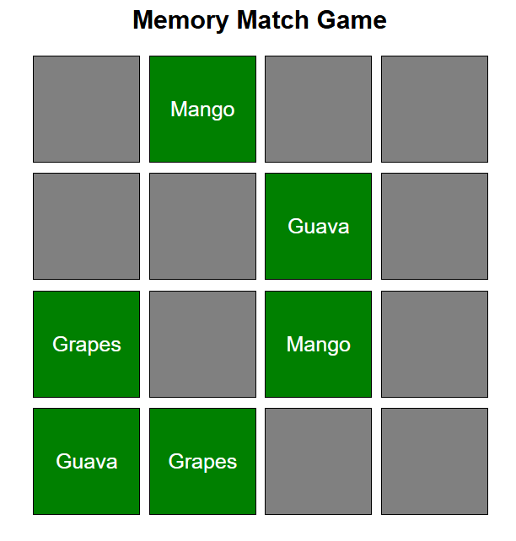

2. Technology Stack
- HTML5
- CSS
- JavaScript

3. Folder Structure
WAD_test/
├── index.html - Game markup, links CSS and JS
├── style.css - Layout, colors, card styling
└── script.js - Game logic (shuffle, click, match check)

4. Features Implemented
- 16 cards (8 matching pairs)
- 4 × 4 grid layout
- Cards are initially face down
- Random card shuffle at the beginning
- Only two cards can be selected at a time
- Matching cards remain face up
- Non-matching cards flip back after 1 second
- Winning message displayed after all pairs are matched

Game automatically restarts after completion

5. Styling Summary
- Cards have a gray background by default.
- CSS Grid is used to arrange the cards in a 4 × 4 layout.
- Flexbox centers the text content inside each card.
- Each card has a fixed size of 100px × 100px.
- Font size is 20px for clear text visibility.
- Pointer cursor indicates that the cards are clickable.
- A green background with white text is applied to matched cards.
- Equal spacing (10px gap) is maintained between cards.
- The page uses the Arial font with centered text for a clean appearance.

6. How to Run
- Keep index.html, style.css, and script.js in the same folder.
- Open index.html in any web browser.
- Click cards to reveal them and match all 8 pairs.

