MINI PROJECT REPORT
Shopping Cart Full Stack Web Application
using Vue.js, Spring Boot and MongoDB
Subject: Web Application Development Lab (ICS1511)
III Year / V Semester — Batch 2024-2029
Submitted by
Nathaniel Christian (3122247001037)
Shalini M (3122247001060)
Sharruk S (3122247001061)

1. Abstract
This project presents a full-stack Shopping Cart web application built using Vue.js for the frontend, Spring Boot for the backend REST API, and MongoDB as the NoSQL database. The application allows users to view a catalogue of products, add items to a cart, adjust item quantities, remove items, and view a running total. The frontend communicates with the backend through Axios-based HTTP calls to REST endpoints, and the backend persists both product and cart data as MongoDB documents. The project demonstrates a complete three-tier architecture (presentation, application, data) commonly used in modern e-commerce systems.

2. Introduction
E-commerce platforms rely on a shopping cart as a core feature that lets users collect products before checkout. This mini project implements a simplified but functionally complete shopping cart system covering product listing, cart management (add, increase, decrease, remove) and total price computation, built with a modern JavaScript frontend framework and a Java-based backend framework connected to a document-oriented database.

3. Problem Statement
Build a web application where users can browse available products and manage a shopping cart with real-time quantity and total updates, backed by a persistent database, without using a monolithic server-rendered architecture — instead using a decoupled REST API consumed by a single-page Vue.js application.

4. Objectives
- Design a REST API using Spring Boot to expose product and cart operations.
- Model products and cart items as MongoDB documents.
- Build a Vue.js single-page frontend to consume the REST API.
- Implement add-to-cart, quantity increase/decrease, remove-item and total calculation.
- Demonstrate frontend-backend-database integration end to end.

5. Scope of the Project
The project covers product listing and cart management for a single, shared cart (no user authentication or multi-user cart isolation). It focuses on core CRUD operations for cart items and read operations for products; it does not implement checkout, payment, or order history.

6. Technologies Used
Layer | Technology | Version (from project)
Frontend | Vue.js | 3.5.42
Frontend build tool | Vite | 8.3.0
HTTP client | Axios | 1.20.0
Backend | Spring Boot | 4.1.1
Backend language | Java | 21
Database | MongoDB | Local instance, port 27017
Build tool (backend) | Maven | via Maven Wrapper (mvnw)

7. System Requirements

7.1 Hardware
- Processor: Dual-core or above; RAM: 4 GB minimum (8 GB recommended)

7.2 Software
- Java Development Kit (JDK) 21
- Node.js and npm (for Vite/Vue)
- MongoDB Community Server, running on localhost:27017
- MongoDB Compass (for inspecting collections)
- IDE: IntelliJ IDEA / VS Code

8. System Architecture
The application follows a three-tier client-server architecture:
Vue.js (frontend, port 5173) | HTTP / REST (Axios, JSON) | Spring Boot (backend, port 8080) | Spring Data MongoDB | MongoDB (shopping_cart_db, port 27017)
The Vue.js frontend is a single-page application that renders two views — Products and Cart. Axios sends requests to the Spring Boot REST controllers, which use Spring Data MongoDB repositories to read and write documents in the shopping_cart_db database.

9. Frontend Layer
The frontend is implemented with Vue.js 3 (Options API) and Vite as the build tool. It contains three main pieces:
- App.vue — root component; holds cart state, toggles between Products and Cart views, and defines all cart-related methods (addToCart, increaseQuantity, decreaseQuantity, removeItem, loadCart).
- components/ProductList.vue — fetches and displays the product catalogue, emits an add-to-cart event.
- components/Cart.vue — displays cart items received as a prop, emits increase / decrease / remove events back to App.vue.
- services/api.js — a configured Axios instance with baseURL http://localhost:8080/api.
State is held in App.vue's data() as a single cart array; on every cart-modifying action, the backend's updated cart is written back into this array (source of truth is the server response, not local mutation), keeping frontend and database in sync.

10. Backend Layer
The backend is a Spring Boot 4.1.1 application (Java 21) using spring-boot-starter-data-mongodb and spring-boot-starter-webmvc. It exposes two REST controllers:

10.1 ProductController (/api/products)
- GET /api/products — returns all products (ProductRepository.findAll()).
- POST /api/products — saves a new product document.

10.2 CartController (/api/cart)
- GET /api/cart — returns the single shared cart, creating one if none exists.
- POST /api/cart/add — adds a CartItem; if the productId already exists in the cart, its quantity is incremented instead of duplicating the line item.
- PUT /api/cart/update/{productId}/{quantity} — sets the quantity for a given cart item directly.
- DELETE /api/cart/remove/{productId} — removes a cart item by productId.
Both controllers are annotated with @CrossOrigin(origins = "http://localhost:5173") to allow requests from the Vite dev server. There is no separate 'service' class in this project — controllers talk directly to Spring Data repositories (CartRepository, ProductRepository).

11. Database Layer
MongoDB is configured via application.properties: spring.data.mongodb.uri=mongodb://127.0.0.1:27017/shopping_cart_db and database name shopping_cart_db. Two collections are used:
Collection | Mapped class | Fields
products | Product | _id, name, price
cart | Cart | _id, items: [ { productId, productName, price, quantity } ]
The cart collection stores a single document holding the full list of CartItem sub-documents (embedded, not referenced) — a common MongoDB pattern for a cart-style aggregate.

12. Project Structure
Shopping-Cart-app/ frontend/ src/ components/ProductList.vue components/Cart.vue services/api.js App.vue main.js package.json vite.config.js shopping-cart-backend/ src/main/java/.../model/Product.java src/main/java/.../model/Cart.java src/main/java/.../model/CartItem.java src/main/java/.../repository/ProductRepository.java src/main/java/.../repository/CartRepository.java src/main/java/.../controller/ProductController.java src/main/java/.../controller/CartController.java src/main/resources/application.properties pom.xml

13. Key Code Snippets

13.1 Product model
@Document(collection = "products") public class Product { @Id private String id; private String name; private double price; // getters and setters }

13.2 Cart add endpoint (increments existing item)
@PostMapping("/add") public Cart addToCart(@RequestBody CartItem newItem) { Cart cart = getCart(); for (CartItem item : cart.getItems()) { if (item.getProductId().equals(newItem.getProductId())) { item.setQuantity(item.getQuantity() + newItem.getQuantity()); return cartRepository.save(cart); } } cart.getItems().add(newItem); return cartRepository.save(cart); }

13.3 Frontend Axios call (add to cart)
async addToCart(product) { const item = { productId: product.id, productName: product.name, price: product.price, quantity: 1 } const response = await api.post('/cart/add', item) this.cart = response.data.items }

14. API Documentation
Method | Endpoint | Purpose
GET | /api/products | Fetch all products
POST | /api/products | Add a new product
GET | /api/cart | Fetch current cart (auto-creates if empty)
POST | /api/cart/add | Add item to cart / increment quantity
PUT | /api/cart/update/{productId}/{quantity} | Set item quantity
DELETE | /api/cart/remove/{productId} | Remove item from cart

15. Application Workflow
User opens the app -> Vue.js loads product list via GET /api/products -> user clicks Add to Cart -> Vue.js sends POST /api/cart/add -> Spring Boot updates the Cart document in MongoDB -> Spring Boot returns the updated cart -> Vue.js re-renders the Cart view with the new items, quantities and computed total.

16. Main Features Implemented
- Product listing (name and price) fetched from MongoDB.
- Add to cart, with automatic quantity merge for repeat additions.
- Increase / decrease item quantity (decrease blocked below 1 on the frontend).
- Remove item from cart.
- Per-item subtotal and overall cart total, computed live.
- Cart state persisted server-side in MongoDB, so it survives a page refresh.

17. Testing
Testing was carried out on the running application (frontend on Vite dev server, backend on Spring Boot, database on local MongoDB) using the screenshots supplied for this report as verification evidence.
Test Case | Action | Expected Result | Status
Product display | Open app / Products tab | All products from DB shown with price | PASS
Add to cart | Click Add to Cart on a product | Item appears in cart, cart count increments | PASS
Add same product again | Add to Cart on same product repeatedly | Quantity increments instead of duplicate row | PASS
Cart display | Open Cart tab | All added items listed with subtotal | PASS
Increase quantity | Click + on a cart item | Quantity and subtotal increase | PASS
Decrease quantity | Click - on a cart item | Quantity and subtotal decrease | PASS
Total amount | View cart with multiple items | Total equals sum of subtotals | PASS
MongoDB persistence | Inspect products collection in Compass | Documents match products shown in UI | PASS
Remove product / clear cart | Not captured in supplied evidence | Item removed from cart | NOT VERIFIED

18. Screenshots

Figure 1: Product listing page
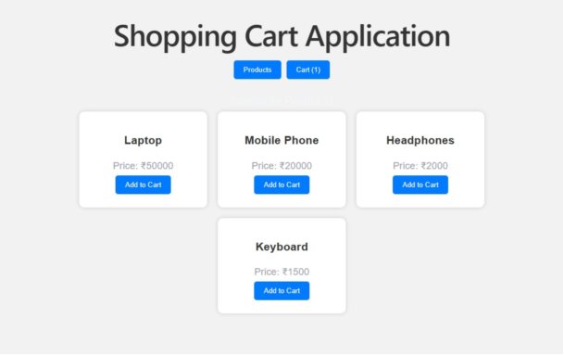
Figure 1 - Home / Product page showing Laptop, Mobile Phone, Headphones and Keyboard fetched from MongoDB

Figure 2: Shopping cart with items
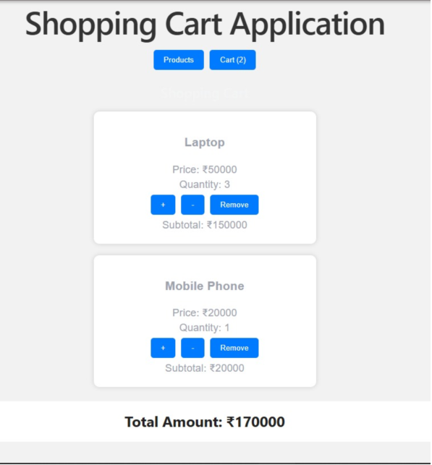
Figure 2 - Cart view: Laptop (qty 3) and Mobile Phone (qty 1) with subtotals and total amount Rs.170000

Figure 3: Cart view (responsive layout)
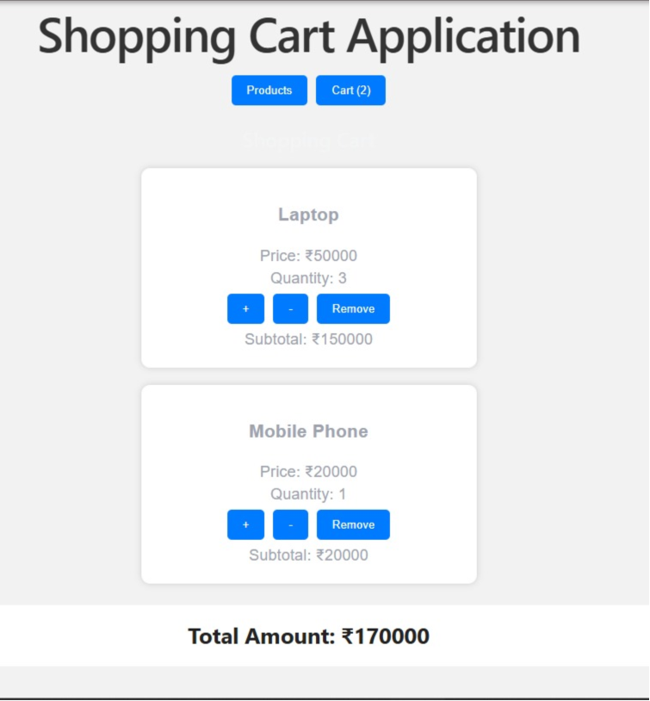
Figure 3 - Cart view rendered at a narrower width, showing the same live total

Figure 4: MongoDB products collection (Compass)
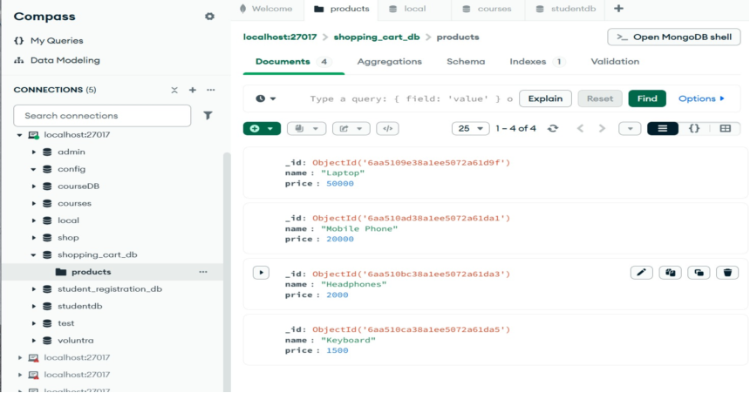
Figure 4 - MongoDB Compass view of shopping_cart_db.products containing the 4 product documents

19. Results
The application successfully demonstrates end-to-end integration: products stored in MongoDB are served through Spring Boot REST APIs and rendered by the Vue.js frontend; cart operations performed in the UI are persisted back to MongoDB and reflected immediately in the total amount shown, as confirmed in Figures 1-4.

20. Advantages
- Clear separation of concerns between frontend, backend and database.
- Stateless REST API that could support multiple frontend clients.
- MongoDB's document model maps naturally to a cart with embedded items.
- Lightweight stack, fast to develop and run locally.

21. Limitations
- Single shared cart — no per-user authentication or session isolation.
- No checkout, payment, or order-history functionality.
- No input validation or error handling UI for failed API calls beyond console logging.
- Remove-item and clear-cart flows were not captured in the available test evidence.

22. Future Enhancements
- Add user authentication and per-user carts.
- Add checkout and order persistence.
- Add product image, category and stock-quantity fields.
- Add form-level validation and user-facing error messages.

23. Conclusion
This mini project successfully implements a functional full-stack shopping cart application using Vue.js, Spring Boot, and MongoDB. It demonstrates the core principles of REST API design, document-based data modelling, and reactive frontend state management, fulfilling the objectives of the Web Application Development Lab.

24. References
- Vue.js Official Documentation — vuejs.org
- Spring Boot Reference Documentation — spring.io/projects/spring-boot
- MongoDB Documentation — mongodb.com/docs
- Axios Documentation — axios-http.com

