Unit 5

1. What is a run? (SAT 2025)
2. What is the Kendal tau correlation coefficient? (SAT 2025)
3. Write any two applications of the RUNS Test.(end sem 2024)

Unit 4

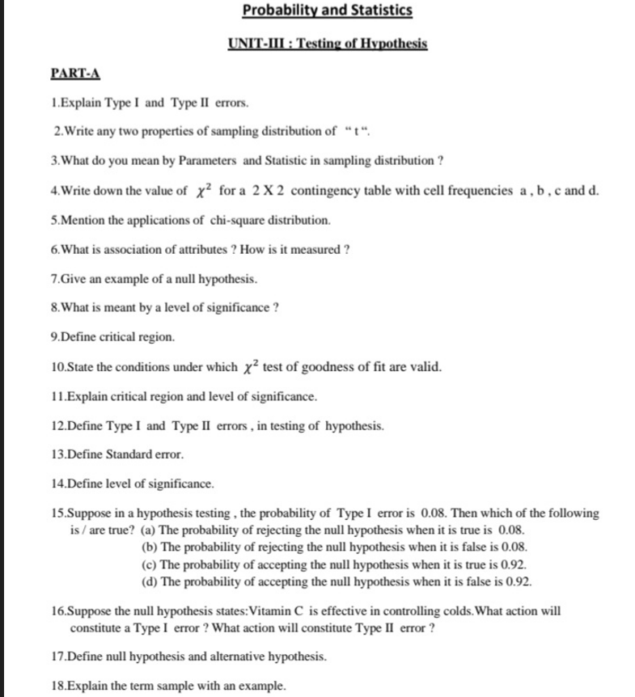

What is critical region? (end sem 2024)

Define level of significance(cat 2 2024)

Define Type I and Type II error((cat 2 2024)

What are the type 1 and type 2 error(cat 2 2025)

Give any two application of chi-square test

Unit 3

What is an unbiased estimator ? give an example( 2025 SAT)

Define unbiased estimator(cat 2 2024)