Development of scientific tamil

Pioneers who developed science tamil

Manicka Nayakar

Need for science tamil

Contribution of tamil scholars in science tamil

P.v appasamy

N.k veian

Dr.N. subbu Reddiar

Dondai MahadevenViswanathan

Development of science tamil in various field

Science tamil inn broadcasting

Work of journal in science tamil

Science tamil in agriculture

Science tamil in economics

Political science tamil

Computer tamil

Computer an d internet

Tamil websites

E tamil fonts

Online magazines

Global corporations

Web blogs

Internet sevices

Digitalization of tamil books

Creation and use of tamil e books

Types of files of tamil e texts

E pub

Modi

Pdf

Tamil software development

Keyboard

Encoding

Ascii

Tam

Tab

Unicode

Tace

Fonts

Tamil tying practice

Windows

Mac

Android

Linux

Floating keyboard

Tamil online keyboard

Google input tools

Tamil internet education corporation

Mission of tamil internet education corporation

E learning program

E library

Tamil software development fund

Computer tamil council

Tamil development movement , Singapore

Madurai tamil literary e synthesis project

Tamil wiki pedia

Function of online tamil dictionarie

Free

Easy access

Readable

Multi functional

***:entific Tamil & Tamil Computing***

***free Screen Setting***

***5.25***

The user can freely set the screen size for easy reading. The

system automatically performs word wrapping of the text.

***fiji) Fonts Change***

The user can change for example, the Japanese fonts to some

other fonts.

***(h>) Mail Function***

If the user finds an interesting explanation while reading, the

uSer can mail it.

***(y) Saving User's Properties***

Each user inherits various attributes. The user does not need

to reset the properties for each session.

**WORD CORPUS PLAN (SORKUVAI)**

The 'Sorkuvai' (Word Corpus) plan is a project to collate all

Tamil words, arrange them in alphabetical order, convert them

into proper words, arrange them into meaningful words and try to

preserve and develop the language.

Words are the basis of a language. Language can be preserved

and improved by saving the words. As the words multiply, the

language continues to grow. Certain words in the language are

subjected to change from time to time. Some words become

obsolete. Some words are newly formed. Compiling all these

and publishing them in alphabetic form will be a creative task for

development.

# Print Tamil Characters with their Unicode values in a tabular format

tamil_chars = "அஆஇஈஉஊஎஏஐஒஓஔ”

# Print header

print(f"{'Tamil Character':^15} | {'Unicode (Hex)':^15} | {'Unicode (Decimal)':^15}")

print("-" * 50)

# Print each character with proper alignment

for char in tamil_chars:

    print(f"{char:^15} | {hex(ord(char)).upper():^15} | {ord(char):^15}")

OUTPUT:

PS D:\Visual_Studio_Code> python tamil.py

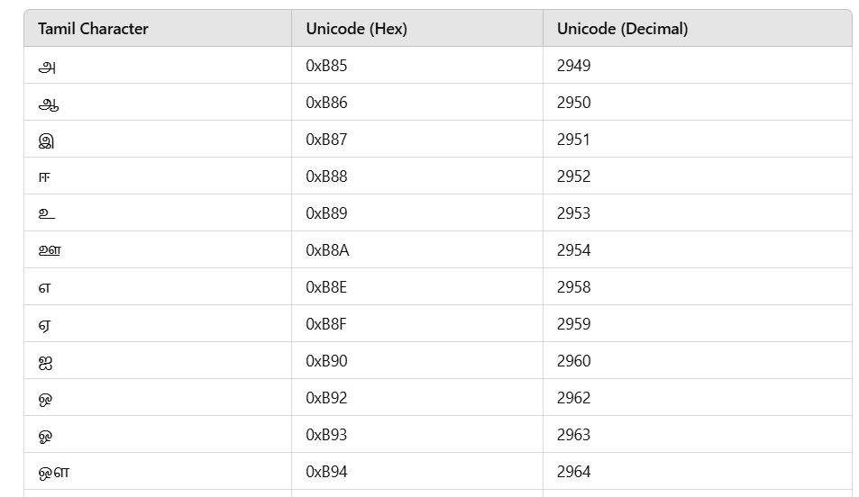

#print "HELLO WORLD"

முற்று "வணக்கம் உலகே!"

#addition

x = 15

y = 20

முற்று "மொத்தம்:", x + y

#if else

a = 10

இது a > 5 ஆகில்

    முற்று "a 5-க்கும் மேல்"

இல்லை

    முற்று "a 5-க்கும் குறைவு"

முடி

#for loop

எண்ணு i = 1 முதல் 5 வரை

    முற்று "எண்ணிக்கை:", i

முடி

OUTPUT:

