To,
The CSR Head / Managing Director
Herbalife
Bangalore-01

Subject: “Request for CSR Support :– Donation of computers and other Equipments to start Cyber Security lab under Department of Computer Science & Engineering”

Respected Sir,
Greetings from Shivasharane Akkamahadevi Government Women’s Polytechnic, Shiralakoppa, Shikaripura Taluk, Shivamogga District, Karnataka.

Our institution is a government women’s polytechnic dedicated to providing quality technical education to rural and economically disadvantaged women students. At present, around 600 students are pursuing diploma education in the following branches:

- Computer Science Engineering.
- Electronics and Communication Engineering.
- Civil Engineering.
- Cloud Computing.
- Mechanical Engineering.

While we are fortunate to have a well-established campus and infrastructure, we are facing a shortage of essential laboratory equipment, particularly in computing and electronics labs. Due to financial constraints of our students, upgrading lab facilities has become a challenge.
In this regard, we humbly request your esteemed organization to consider supporting our institution under your Corporate Social Responsibility (CSR) initiatives by donating the following equipment:

- Desktop computers (No.25)
- Laptops (No. 5)
- UPS systems (5kv)
- Computer accessories and peripherals.
- Networking equipment. (Access Point)
- And relevant laboratory hardware.

Such support will greatly enhance hands-on learning, improve technical skills, and help our students become industry-ready, thereby contributing to women empowerment and rural development.

We assure you that all donated equipment will be used responsibly for academic purposes and properly acknowledged as per CSR norms. We would be honored to provide any additional information or documentation required.

We sincerely hope for your positive consideration and look forward to the opportunity of partnering with your organization for this noble cause.

Thanking you in anticipation.
Enclosed: Yours sincerely,
- Institution profile.
Principal

INSTITUTION PROFILE

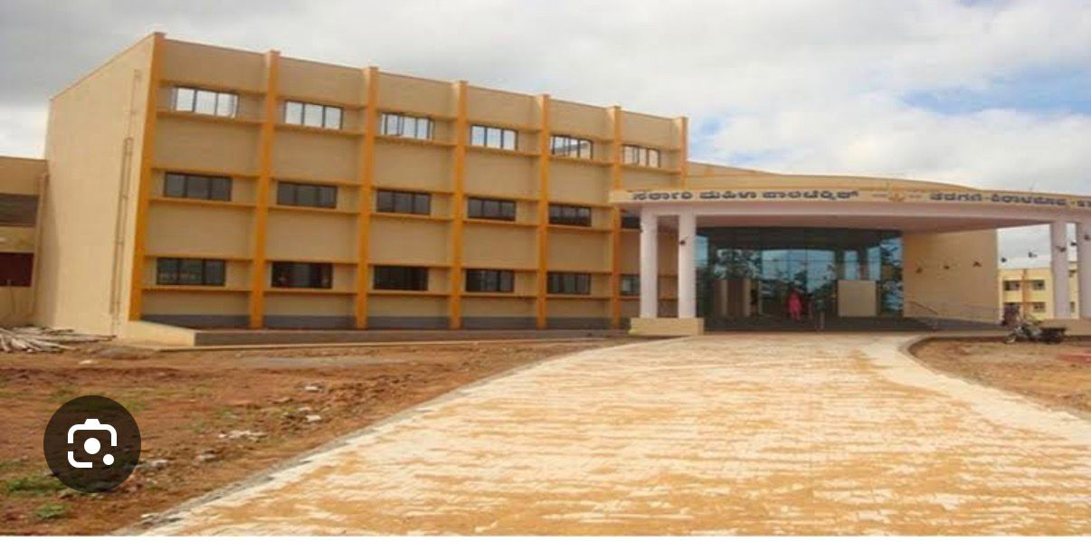

Shivasharane Akkamahadevi Government Women’s Polytechnic

- Institution Overview
The institution is dedicated to empowering rural and economically disadvantaged women through quality technical education and skill development.

• Name of Institution: Shivasharane Akkamahadevi Government Women’s Polytechnic
• Location: Shiralakoppa, Shikaripura Taluk, Shivamogga District, Karnataka
• Type: Government Polytechnic (Women)
• Affiliation: Department of Technical Education (DTE), Government of Karnataka
• Year of Establishment: 2008

- Academic Programs Offered

The polytechnic currently offers Diploma programs in the following branches:
1. Computer Science Engineering (CSE)
2. Electronics & Communication Engineering (ECE)
3. Civil Engineering (CE)
4. Cloud Computing (CC)
5. Mechanical Engineering (ME)

- Student Strength & Social Background

The institution plays a crucial role in women empowerment, employability, and regional development.

• Total Students: Approximately 600
Student Background:
• Majority from rural areas.
• Economically weaker sections.
• First-generation learners.

- Infrastructure Status
Despite having physical infrastructure, the institution faces shortage of modern lab equipment, especially for computing and electronics-related programs.

• Campus: Well-constructed government campus with adequate classrooms.
• Library: Available.
• Laboratories: Present but limited in equipment and capacity.
- Existing Challenges
Insufficient number of:
• Desktop computers
• Laptops
• UPS and power backup systems
• Networking and lab accessories
Difficulty in upgrading labs due to:
• Financial constraints of students
• Limited government funding for modernization

- Requirement for CSR Support
To improve practical learning in cyber security and industry readiness, the institution seeks CSR support in the form of donation:
• Desktop computers (No 25)
• Laptops (No 5)
• UPS systems (5Kv)
• Computer peripherals (keyboard, mouse, monitors)
• Networking equipment. (Access point)
• Relevant technical lab equipment.

- Impact of CSR Contribution
CSR support will help:
• Enhance hands-on technical training.
• Improve digital literacy.
• Increase employability of rural women students.
• Bridge the industry–academia gap.
• Support inclusive and sustainable development.
- Utilization & Transparency
Donated equipment will be:
• Used strictly for academic purposes.
• Properly recorded and maintained.
• Acknowledged as per CSR guidelines.
- Contact Details
- Ravishankar D S
Principal
9480057999
- Sharath M S
Sr.g Lecturer/CS&E
Coordinator

