**Autonomous Vehicles:**

**Terminologies:**

*Ego Vehicles:* In the context of autonomous vehicles and self-driving cars, the "ego vehicle" refers to the vehicle that is equipped with autonomous technology and is driving itself. It is called the "ego" vehicle because it is the vehicle that is making decisions and taking actions based on its perception of the environment and the goals it is programmed to achieve. Other vehicles on the road are referred to as "other vehicles”, and the autonomous system in the ego vehicle must be able to detect and track these vehicles to safely navigate the road.

**Maneuver modes:**

*Cruise control mode:* Move at the same pace on the same line.

*Lead car following mode:* This mode will follow the car in the lead without any maneuver

*Lane change mode:* All checks clear car can maneuver to change lane

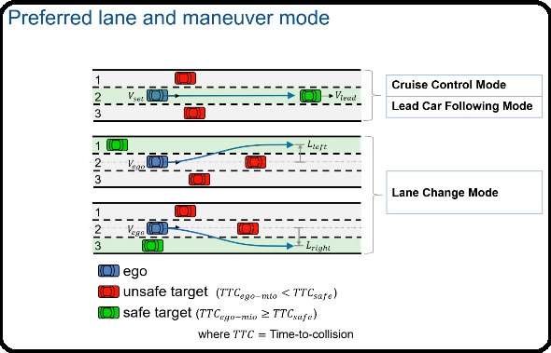

*Killed and seriously injured (KSI) accident:*

"Killed and seriously injured" (KSI) is a term commonly used in traffic safety to refer to the number of people who are either killed or suffer serious injuries in a road accident. KSI accident types can vary depending on the context and the classification system being used. However, some common KSI accident types include:

*Head-on collisions:* This is a type of accident where two vehicles collide with each other from the front, often resulting in severe injuries or fatalities.

*Pedestrian and bicycle accidents:* These are accidents involving pedestrians or cyclists being struck by a vehicle, which can often result in serious injuries or fatalities.

*Rollover accidents:* This is a type of accident where a vehicle rolls over, which can be caused by a variety of factors, including speeding, poor road conditions, and driver error.

*Intersection accidents:* These are accidents that occur at intersections, which can be particularly dangerous because they often involve multiple vehicles and high speeds.

*Rear-end collisions:* This is a type of accident where one vehicle collides with the back of another vehicle, often resulting in whiplash injuries, spinal injuries, or fatalities.

*Side-impact collisions:* This is a type of accident where one vehicle collides with the side of another vehicle, often resulting in serious injuries or fatalities.

*Run-off-road accidents:* These are accidents where a vehicle leaves the roadway and crashes into a stationary object or a natural feature, such as a tree or a ditch. These accidents can be particularly dangerous because they often involve high speeds and the potential for ejection from the vehicle.