**IBM- Naan Mudhalvan Data Analytics with Cognos**

**Phase 3**

**Development Part 1**

**Student Name :** Sharugesh.B

**Register Number :** 620821104107

**Branch :** B.E CSE

**Year :** 3rd Year

**Topic :** Data Analytics with Cognos

**Title :**Air Q Assessment TN

**College :** Gnanamani College of Technology

## Introduction

# In Tennessee, assessing air quality is vital to ensure the well-being of its residents and protect the environment. This assessment seeks to evaluate the state's air quality, identifying potential pollutants and their sources, as well as assessing the impact on public health and the environment. Understanding these factors is essential for maintaining a healthy and sustainable living environment in the state.

**Objectives**

Evaluate and monitor the state's air quality to ensure it meets or exceeds regulatory standards.

Identify sources of air pollution and their contribution to the overall air quality.

Assess the potential health and environmental impacts of air pollutants.

Provide data and insights for informed decision-making and actions to improve air quality in Tennessee.

**Data source**

A simple data source for an air quality assessment in Tennessee is the Tennessee Department of Environment and Conservation (TDEC) which collects and maintains air quality data through monitoring stations located throughout the state.

**Dataset link**: https://tn.data.gov.in/resource/location-wise-daily-ambient-air-quality-tamil-nadu-year-2014

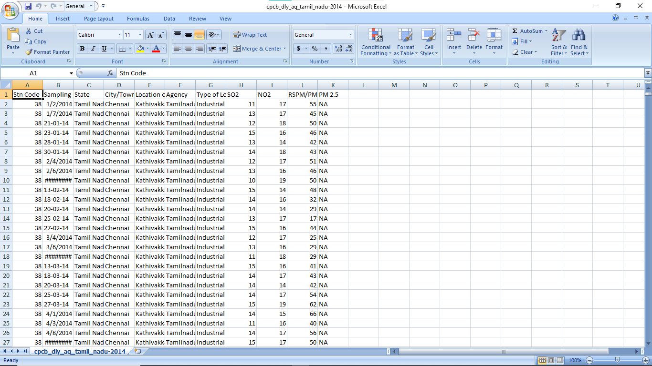

**Data Loading**

Steps Involved in data loading on IBM cognos.

1. Login to your IBM cognos
2. Click more menu from the left side
3. Select new tab

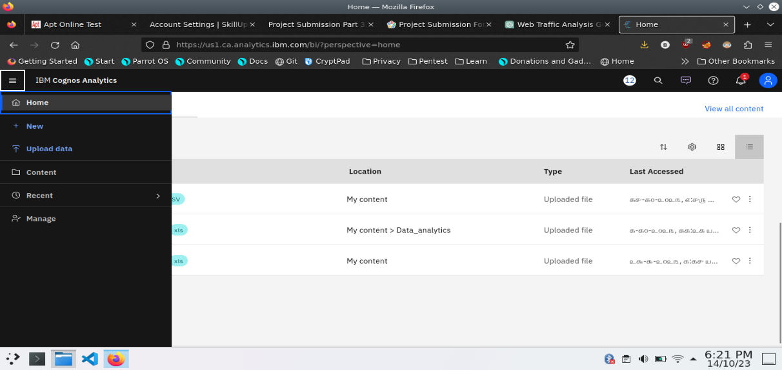

4. Click Data module tab

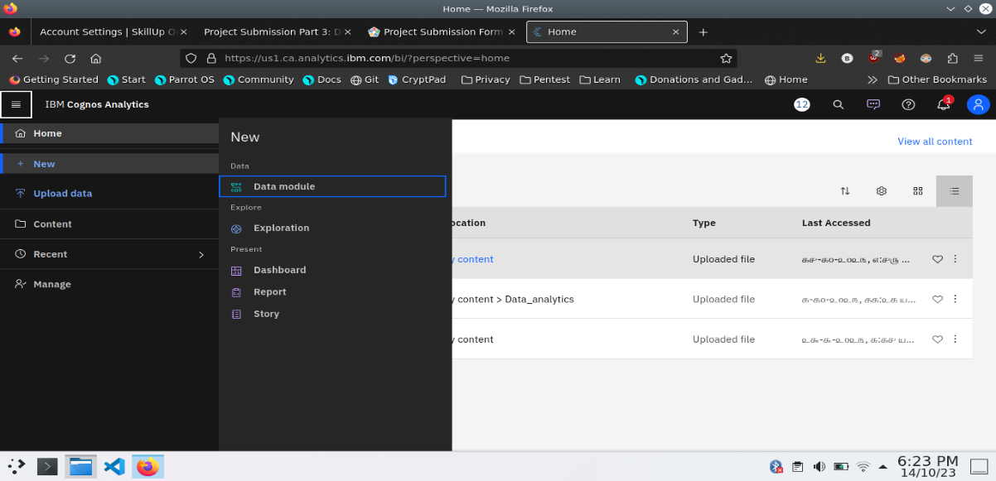

5.Upload the dataset for your project and select the Corresponding file

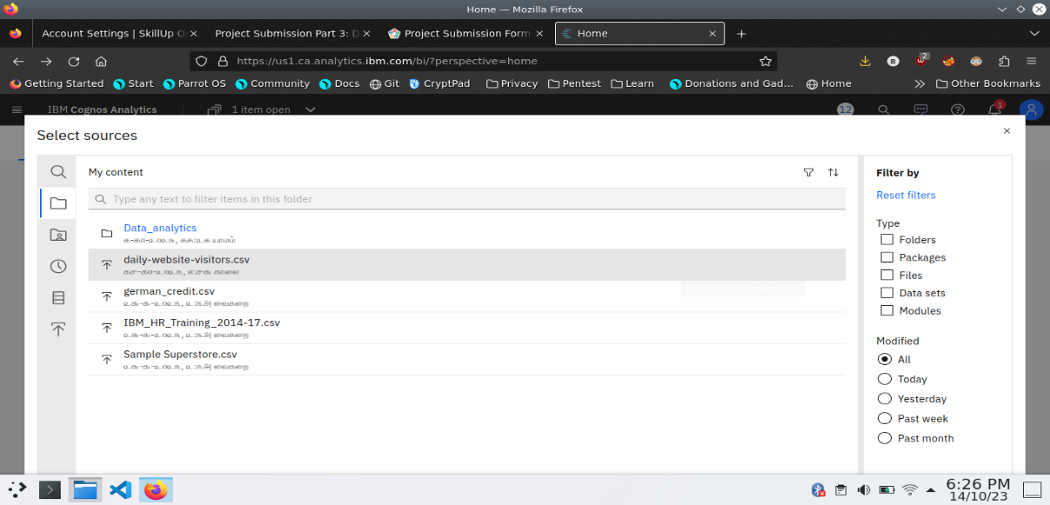

6. preview the data

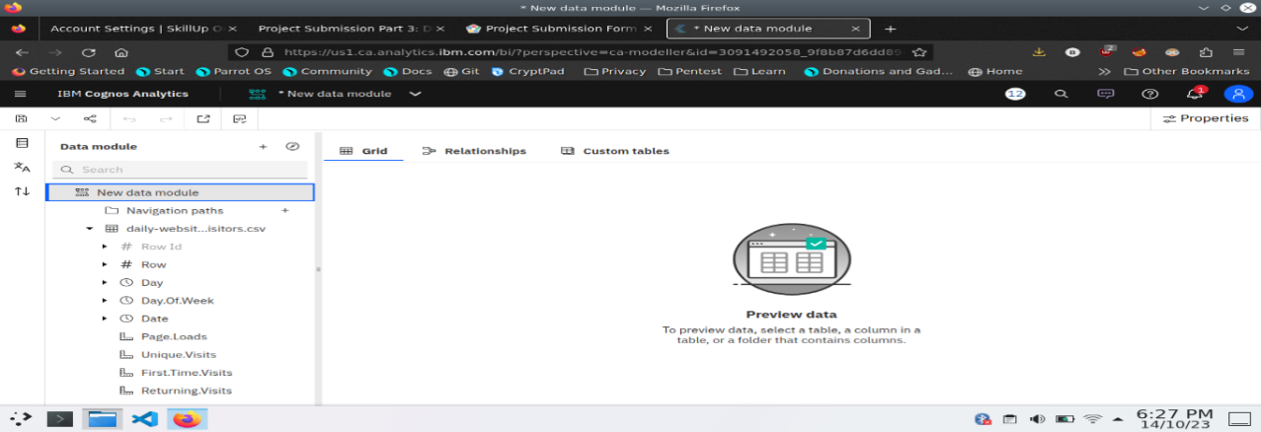

7.Explore the data

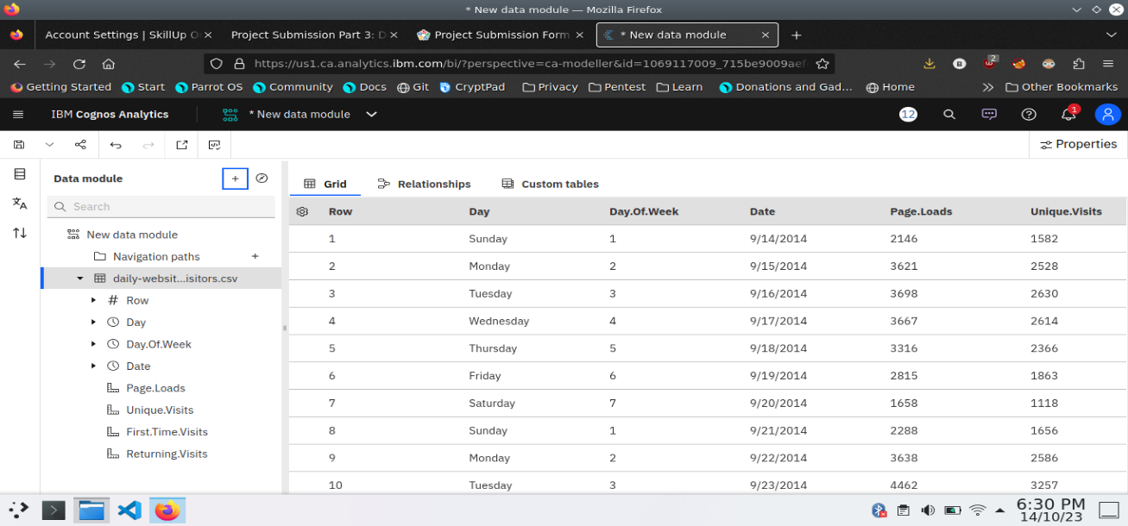

8. save the data module

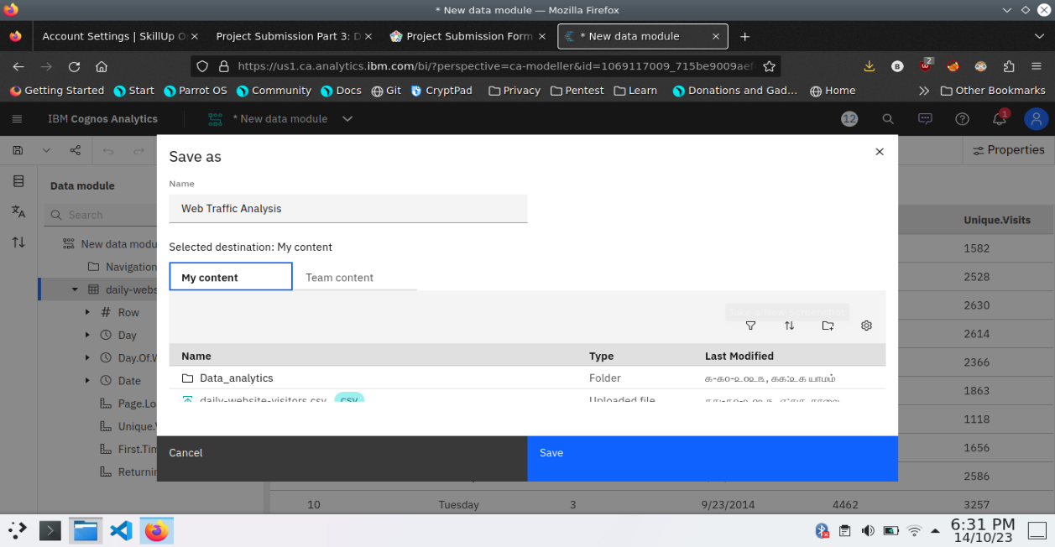

**Data Preprocessing and Cleaning**

In this phase the following steps will taken

* Handling missing data
* Data Transformation
* Data Type Conversion
* Removing Duplicates
* Dealing Outliers

Once you saved the data module. Click the corresponding dataset on IBM cognos and Preview the mosule

Right Click the row where you want to clean the data

It provides the UI to Clean the data and makes the task easy one, Now Updating and Replacing the Null values are simple

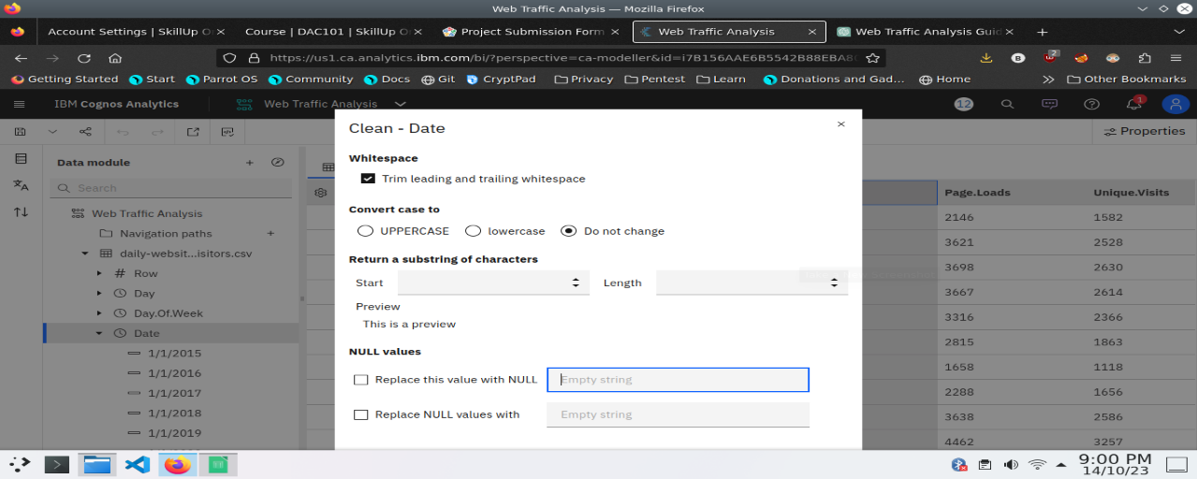

datamodule will be updated by doing the above process

after the completion ofprocess start creating the dashboard for Visualization

**Dashboard Creation**

Dashboard creation are helpful to visualizing the data

1. Goto Home menu
2. Select the new tab
3. Click dashboard

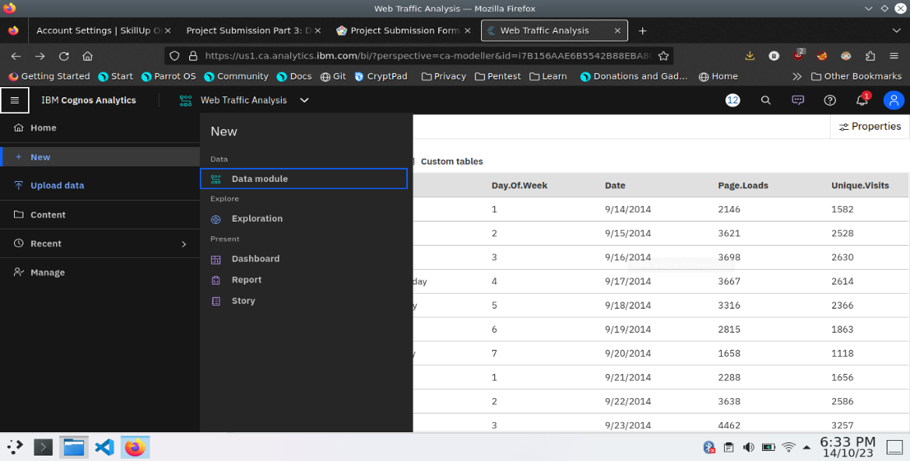

4. Choose the template for your project and click

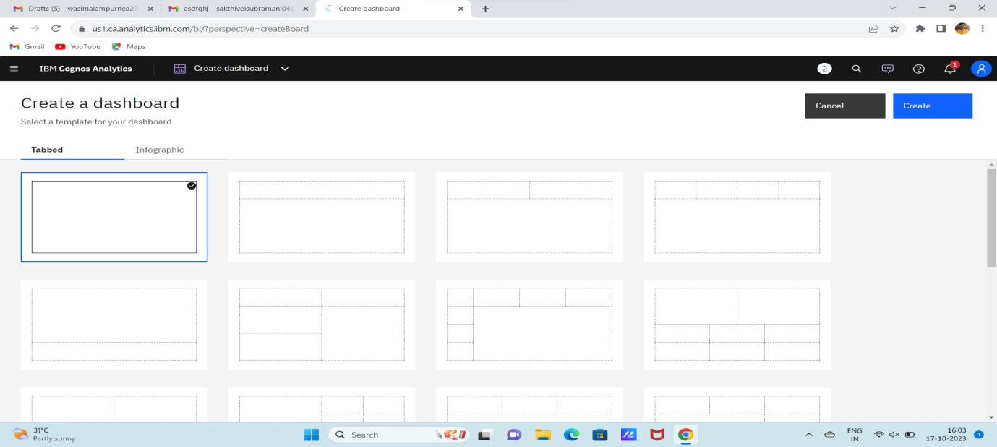

5.Now Dashboard is created

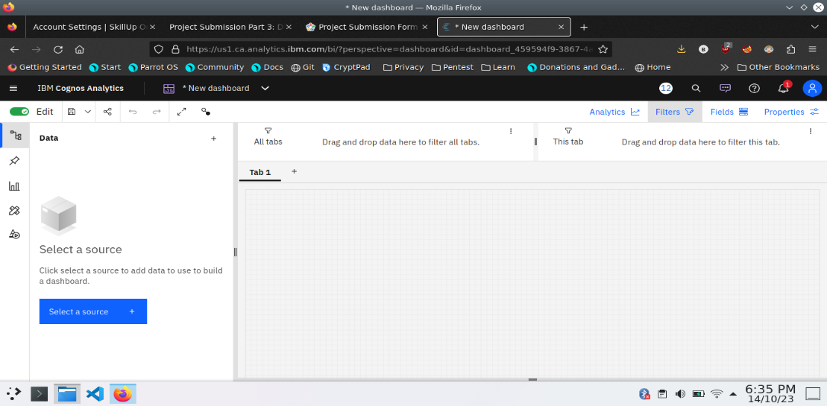

6. Select the data source

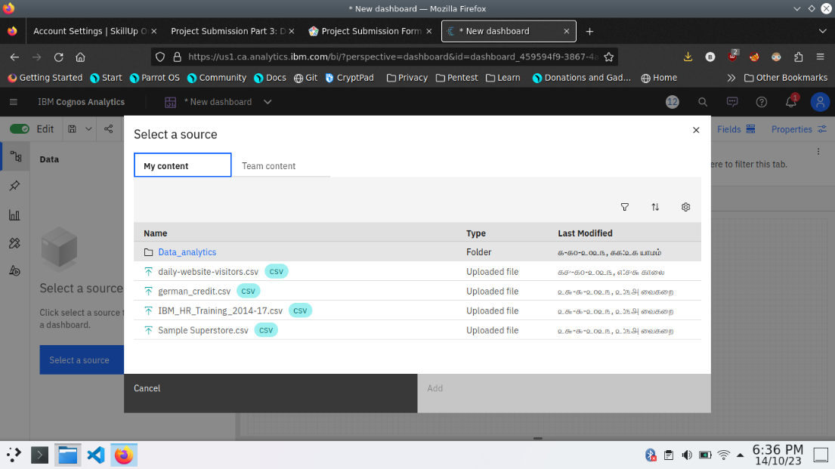

**Visualization**

After creating the dashboard, the next step is to visualize the data

In IBM Cognos

1. Goes to the Corresponding Dashboard

2. select the visualizations tab in the left side of title bar

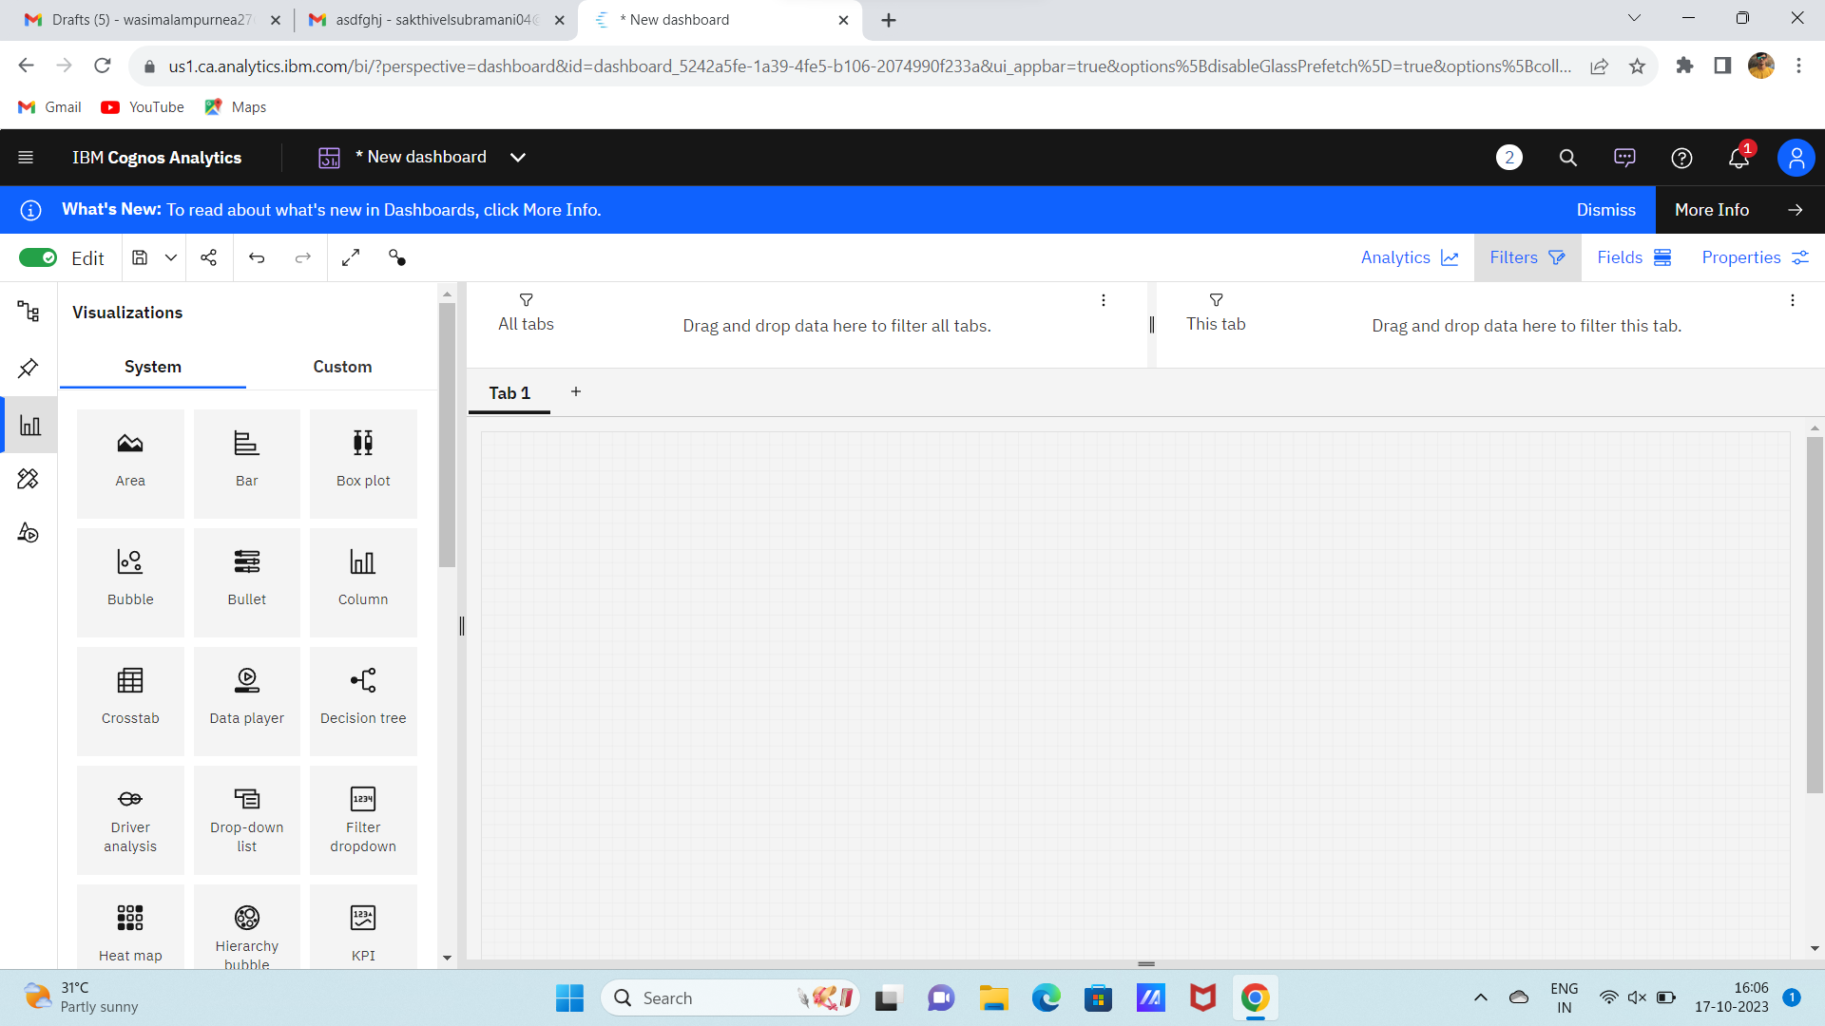

3.Choose the system as you want and put the data source for the required columns

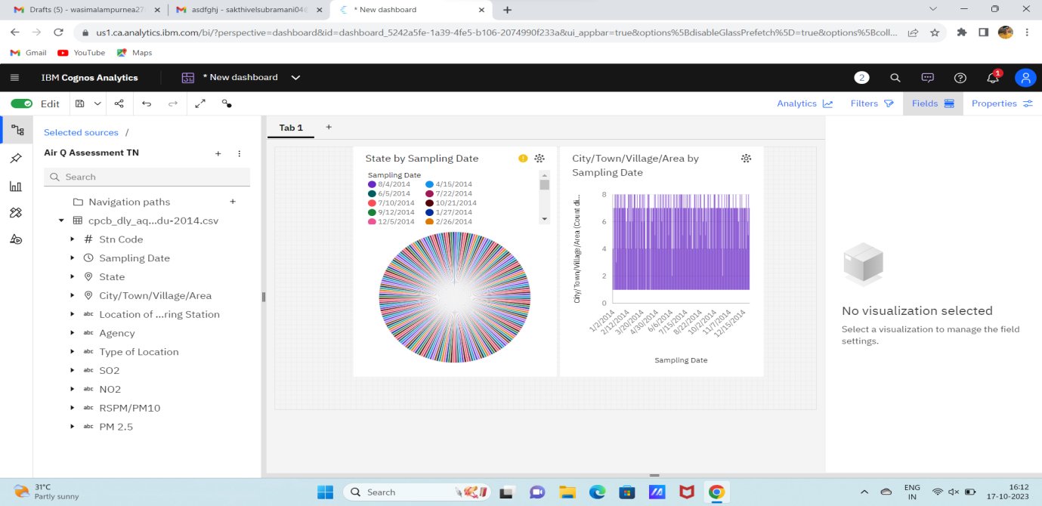

In the above screen shot displays the Line graph and model compares the “sampling date” and “city/town/village/area” from the time period of 2020

X-axis =sampling Dates

Y-axis = city/town/village/area

After performing these activities a comprehensive document will be created to demonstrate the ability to Communicate and share finding.

**Conclusion**

**"The air quality assessment in Tennessee reveals that the overall air quality is within acceptable limits, with only occasional minor fluctuations. Continued monitoring and maintenance are essential to ensure a healthy and safe environment for residents."**