RAJALAKSHMI ENGINEERING COLLEGE
RAJALAKSHMI NAGAR, THANDALAM 602 105





CS23531

–

WEB

PROGRAMMING

Laboratory

Record

Note

Book

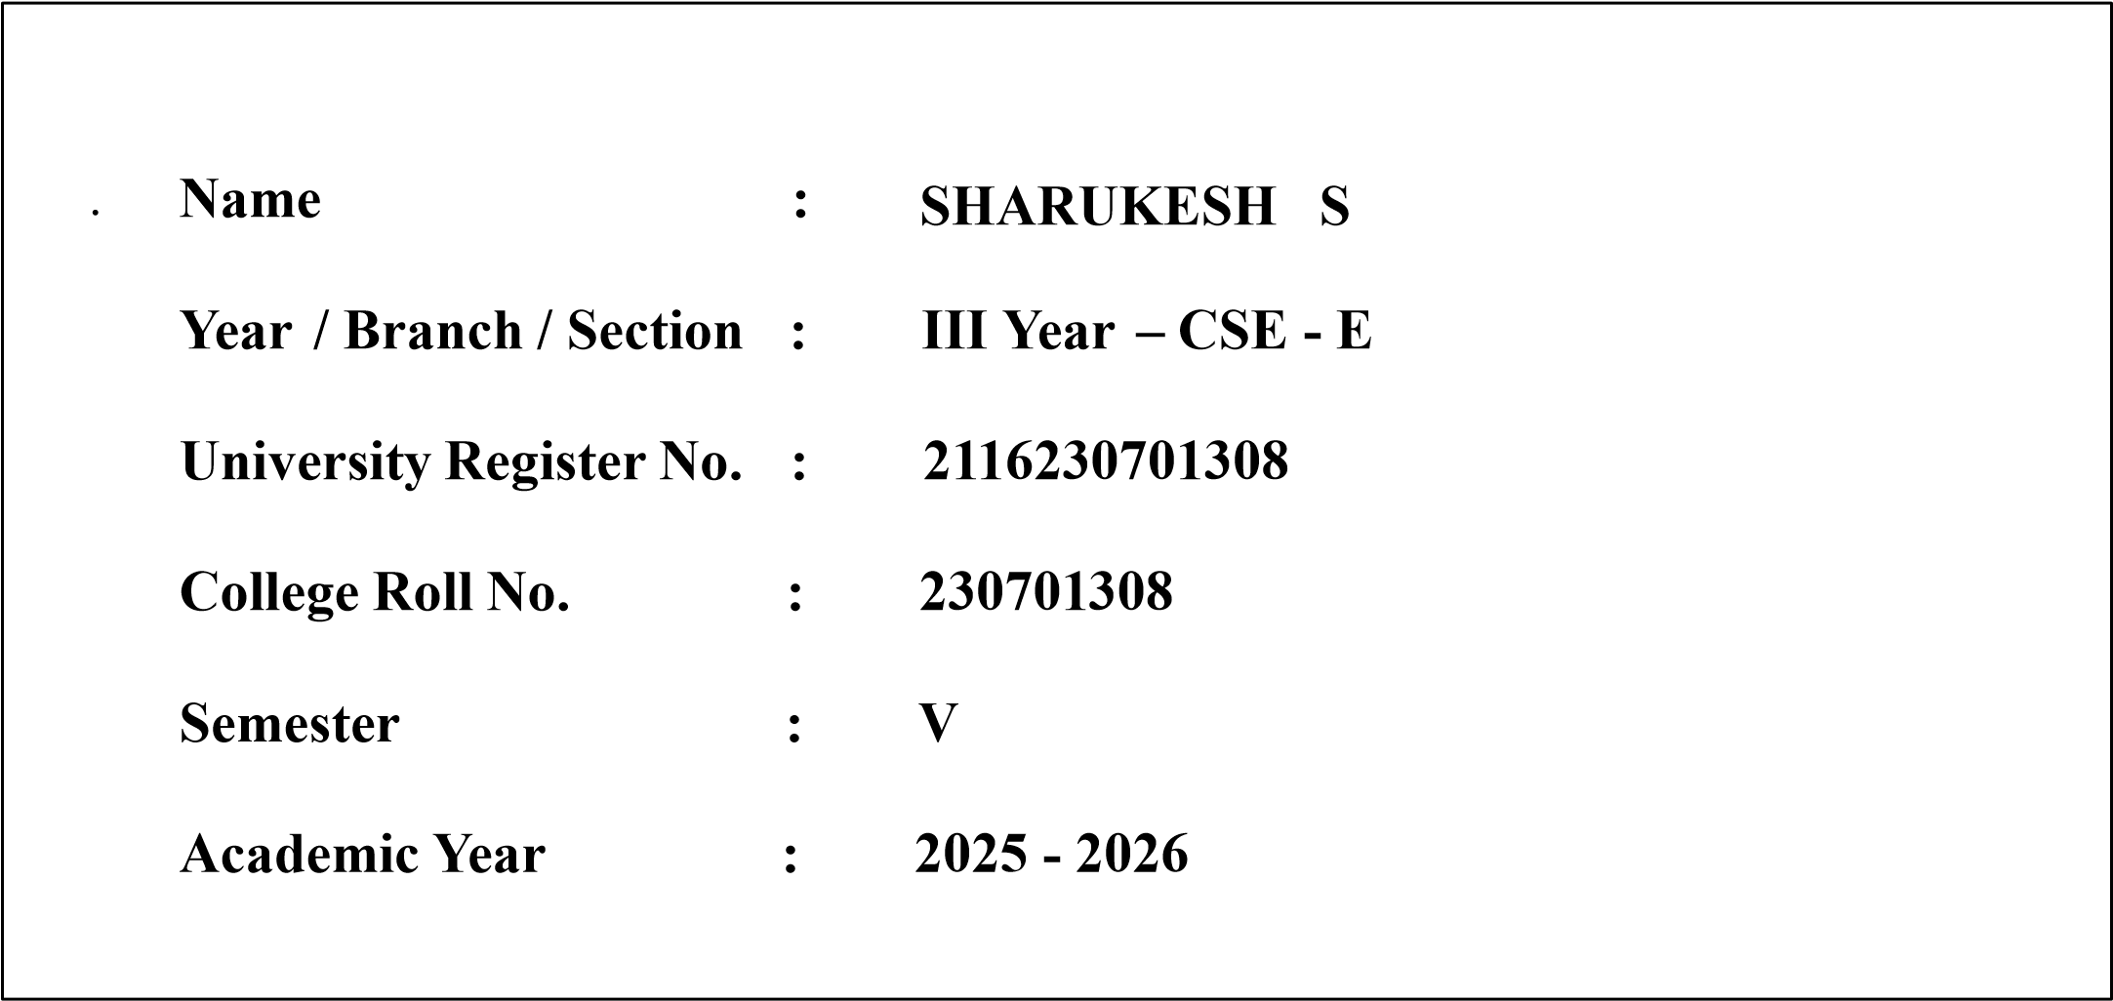
DEPARTMENT OF COMPUTER SCIENCE
AND ENGINEERING

CS23531 – WEB PROGRAMMING

REG NO | 2116230701308
NAME | SHARUKESH
YEAR | III - CSE
SEC | E


RAJALAKSHMI ENGINEERING COLLEGE
An Autonomous Institution

BONAFIDE CERTIFICATE

SHARUKESH S

Name: ……………………………………………………………………………

Academic Year: ………………… Semester: ……… Branch: …BE CSE…
2116230701308

Register No.

Certified that this is the bona fide record of work done by the above student in
the ....................................................................................................Laboratory
during the academic year 2025- 2026.

Signature of Faculty in-charge

06/11/2025
Submitted for the Practical Examination held on …………………………

Internal Examiner External Examiner

INDEX

EX. NO. | DATE | NAME OF THE EXPERIMENT | GITHUB QR CODE
1 | 23/07/25 | HTML Basics | 
2 | 27/07/25 | HTML – Elements
3 | 01/08/25 | Design With HTML & CSS
4 | 16/08/25 | Webpages With JavaScript
5 | 05/09/25 | Advanced Web Components
6 | 14/09/25 | NodeJS & Mongo DB
7 | 28/09/25 | React Setup & Components
8 | 30/09/25 | React Lifecycle & Tools
9 | 11/10/25 | React Dataflow &  Deployment
10 | 27/10/25 | Full Stack Project

