Ex.no:6b | DATA VISUALIZATION USING POWER BI

AIM

To visualize and analyze the Global Earthquake Dataset using Line Chart, Bar Chart, Pie Chart, Histogram, Scatter Plot, and Box Plot with Matplotlib to understand earthquake trends over time, magnitude-wise and depth-wise distributions, geographical patterns, and relationships between earthquake magnitude, depth, and location.

ALGORITHM

Step 1: Import Pandas and Matplotlib libraries.

Step 2: Load the Global Earthquake dataset into a DataFrame.

Step 3: Convert the Date column into a proper date format and extract the year from the date.

Step 4: Group the earthquake data according to Year and calculate the total number of earthquakes recorded in each year.

Step 5: Plot the yearly earthquake count using a Line Chart to observe earthquake activity and variations over time.

Step 6: Group the dataset according to Magnitude_Type and calculate the average earthquake magnitude for each magnitude type.

Step 7: Plot the magnitude-type-wise earthquake magnitude using a Bar Chart to compare the average magnitude across different magnitude types.

Step 8: Create magnitude categories such as Minor, Moderate, Strong, Major, and Great based on earthquake magnitude.

Step 9: Calculate the number of earthquakes in each magnitude category and plot the distribution using a Pie Chart.

Step 10: Plot the distribution of earthquake magnitudes using a Histogram to understand the frequency of different magnitude values.

Step 11: Plot a Scatter Plot between earthquake depth and magnitude to analyze the relationship between the depth and magnitude of earthquakes.

Step 12: Plot a Box Plot of earthquake magnitudes to identify the median, spread, and possible outliers in the earthquake magnitude data.

Step 13: Add suitable titles, axis labels, legends, grids, and formatting to the visualizations.

Step 14: Display all the visualizations.

CODE
import pandas as pd
import matplotlib.pyplot as plt

df = pd.read_csv(
"Global_Earthquake_Analysis.csv",
encoding="latin1",
low_memory=False
)
df["Date"] = pd.to_datetime(
df["Date"],
errors="coerce"
)

# Extract Year
df["Year"] = df["Date"].dt.year

yearly_earthquakes = df.groupby("Year").size()

plt.figure(figsize=(10, 5))

plt.plot(
yearly_earthquakes.index,
yearly_earthquakes.values,
marker="o"
)

plt.title("Global Earthquake Activity Over Time")
plt.xlabel("Year")
plt.ylabel("Number of Earthquakes")

plt.grid(True)

plt.tight_layout()
plt.show()

magnitude_type = df.groupby(
"Magnitude_Type"
)["Magnitude"].mean()

plt.figure(figsize=(10, 5))

plt.bar(
magnitude_type.index,
magnitude_type.values
)

plt.title("Average Earthquake Magnitude by Magnitude Type")
plt.xlabel("Magnitude Type")
plt.ylabel("Average Magnitude")

plt.xticks(rotation=45)

plt.tight_layout()
plt.show()

def magnitude_category(magnitude):

if magnitude < 4:
return "Minor"

elif magnitude < 5:
return "Moderate"

elif magnitude < 6:
return "Strong"

elif magnitude < 7:
return "Major"

else:
return "Great"

df["Magnitude_Category"] = df["Magnitude"].apply(
magnitude_category
)

magnitude_distribution = df[
"Magnitude_Category"
].value_counts()

plt.figure(figsize=(8, 8))

plt.pie(
magnitude_distribution.values,
labels=magnitude_distribution.index,
autopct="%1.1f%%"
)

plt.title("Earthquake Distribution by Magnitude Category")

plt.show()

plt.figure(figsize=(10, 5))

plt.hist(
df["Magnitude"].dropna(),
bins=20
)

plt.title("Distribution of Earthquake Magnitudes")
plt.xlabel("Magnitude")
plt.ylabel("Frequency")

plt.grid(True)

plt.tight_layout()
plt.show()

plt.figure(figsize=(10, 5))

plt.scatter(
df["Depth"],
df["Magnitude"],
alpha=0.5
)

plt.title("Relationship Between Earthquake Depth and Magnitude")
plt.xlabel("Depth (km)")
plt.ylabel("Magnitude")

plt.grid(True)

plt.tight_layout()
plt.show()
plt.figure(figsize=(8, 5))

plt.boxplot(
df["Magnitude"].dropna()
)

plt.title("Box Plot of Earthquake Magnitudes")
plt.ylabel("Magnitude")

plt.grid(True)

plt.tight_layout()
plt.show()

OUTPUT

LINE CHART
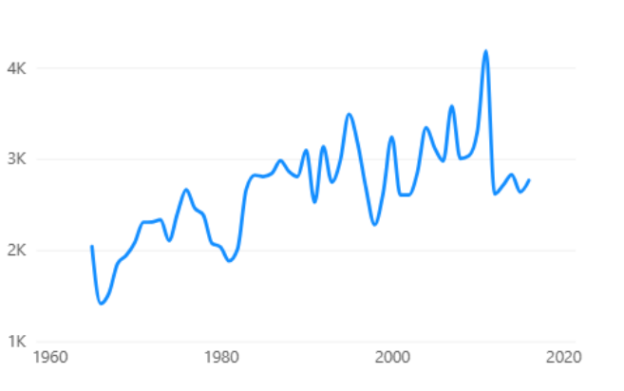

BAR CHART
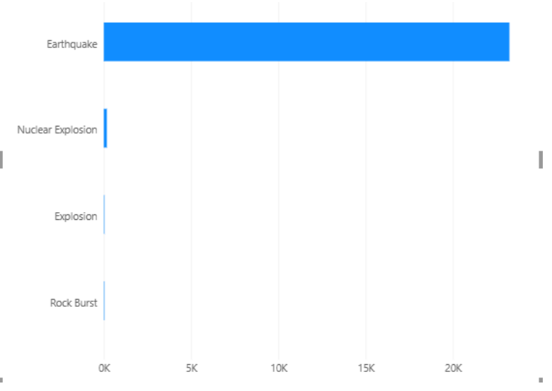
DONUT CHART
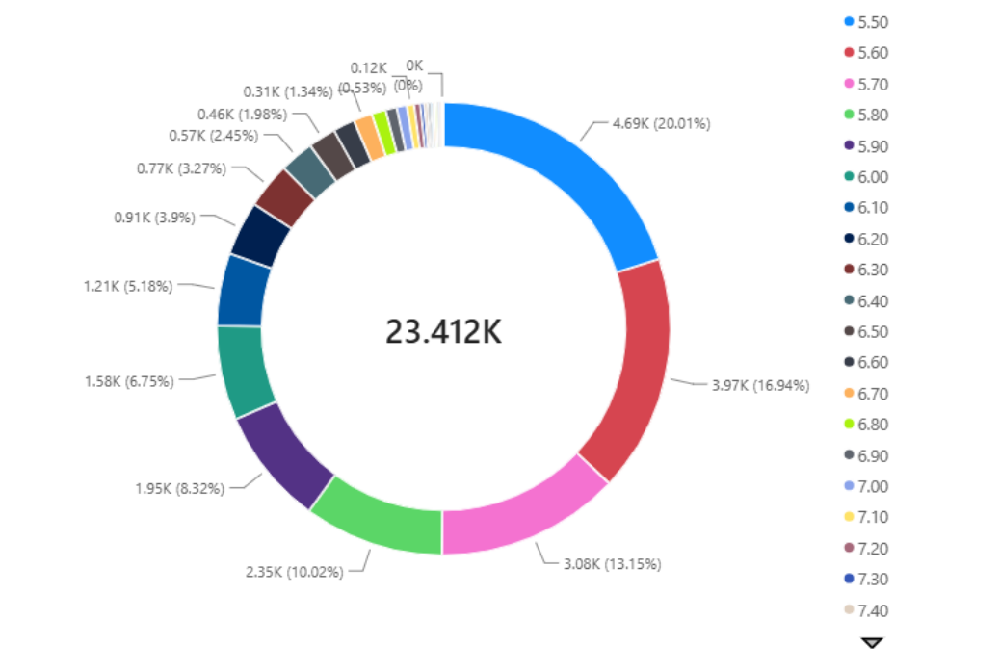

RESULT

