EX No:1b | EDA DATA CLEANING

AIM

To perform exploratory data analysis on the Food Waste Dataset by examining the dataset structure, dimensions, data types, statistical characteristics, missing values, restaurant-wise and city-wise waste distributions, food-item-wise waste patterns, temporal waste trends, waste percentage analysis, interactive filters, parameter-based analysis, and creating an interactive dashboard for effective food waste management and decision-making.

ALGORITHM
- Import the required libraries such as Pandas, NumPy, and Matplotlib.
- Load the Global Earthquake Dataset into a Pandas DataFrame.
- Display the first five and last five records of the dataset.
- Display the dataset information, shape, column names, and data types.
- Generate descriptive statistical information for numerical attributes.
- Identify the number of missing values in each column.
- Remove blank rows and duplicate records from the dataset.
- Perform data cleaning and standardization on the required categorical and numerical attributes.
- Convert the Date attribute into the appropriate datetime format and extract the required year and month information.
- Analyze the distribution of earthquake events across different years and event types.
- Analyze the distribution of earthquakes across different magnitude categories.
- Analyze the geographical distribution of earthquakes using Latitude and Longitude.
- Calculate and analyze earthquake depth categories based on the Depth attribute.
- Create interactive visualizations including bar charts, pie charts, line charts, geographical maps, Year Filter, Minimum Magnitude Parameter, and an interactive Global Earthquake Analysis Dashboard.
- Export the cleaned dataset into CSV format and display a confirmation message after successful file creation.

CODE
import os
import pandas as pd
import numpy as np
import matplotlib.pyplot as plt
path = "/content/Exp 6a.csv"
print("Dataset path:", path)
df = pd.read_csv(path)
print("\nFirst 5 rows:")
display(df.head())
print("\nLast 5 rows:")
display(df.tail())
print("\nDataset information:")
df.info()
print("\nShape:")
print(df.shape)
print("\nColumns:")
print(df.columns.tolist())
print("\nData types:")
print(df.dtypes)
print("\nStatistical description:")
display(df.describe())
print("\nMissing values:")
display(df.isnull().sum())
df = df.dropna(how="all")
df = df.drop_duplicates()
print("\nDataset after removing blank rows and duplicates:")
print(df.shape)
df["Date"] = pd.to_datetime(df["Date"], errors="coerce")
print("\nDate after conversion:")
display(df[["Date", "Year", "Month", "Month Name"]].head())
df["Depth Category"] = np.where(
df["Depth"] < 70,
"Shallow",
np.where(
df["Depth"] < 300,
"Intermediate",
"Deep"
)
)
print("\nDepth Category:")
display(
df[
[
"Depth",
"Depth Category"
]
].head()
)
print("\nEarthquake Event Type Distribution:")
display(
df.groupby("Type")
.size()
.sort_values(ascending=False)
)
print("\nYear-wise Earthquake Occurrences:")
display(
df.groupby("Year")
.size()
.sort_values(ascending=False)
)
print("\nMagnitude Category Distribution:")
display(
df.groupby("Magnitude Category")
.size()
.sort_values(ascending=False)
)
print("\nAverage Magnitude by Year:")
display(
df.groupby("Year")["Magnitude"]
.mean()
.sort_index()
)
print("\nMaximum Magnitude:")
print(df["Magnitude"].max())
print("\nMinimum Magnitude:")
print(df["Magnitude"].min())
print("\nAverage Magnitude:")
print(df["Magnitude"].mean())
print("\nAverage Depth:")
print(df["Depth"].mean())
print("\nGeographical Distribution:")
display(
df[
[
"Latitude",
"Longitude",
"Magnitude",
"Depth"
]
].head()
)
print("\nDepth Category Distribution:")
display(
df.groupby("Depth Category")
.size()
.sort_values(ascending=False)
)
print("\nMagnitude Statistics by Event Type:")
display(
df.groupby("Type")["Magnitude"]
.agg(["count", "mean", "max"])
)
print("\nCorrelation:")
display(
df.corr(numeric_only=True)
)
df.to_csv(
"Global_Earthquake_Cleaned.csv",
index=False
)
df.to_excel(
"Global_Earthquake_Cleaned.xlsx",
index=False
)
df.to_json(
"Global_Earthquake_Cleaned.json",
orient="records",
indent=4
)
print("\nCSV, Excel and JSON files created successfully.")

OUTPUT

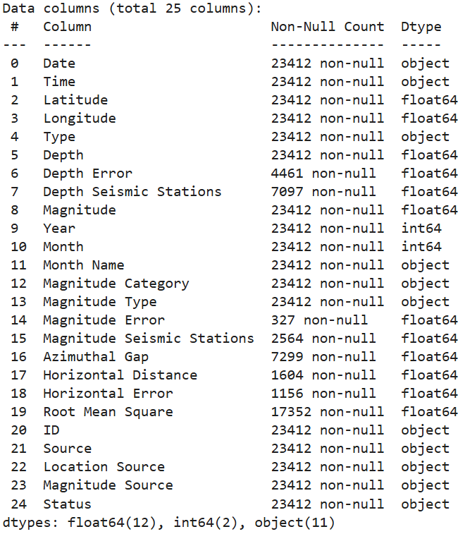

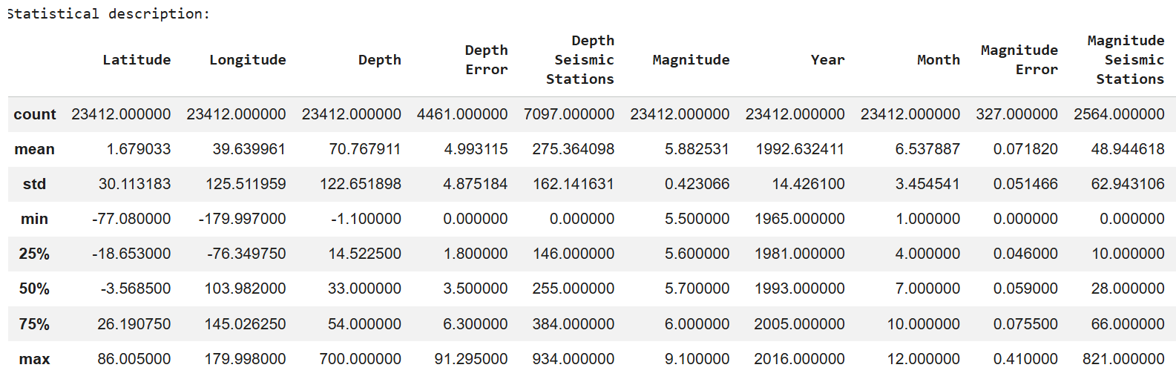

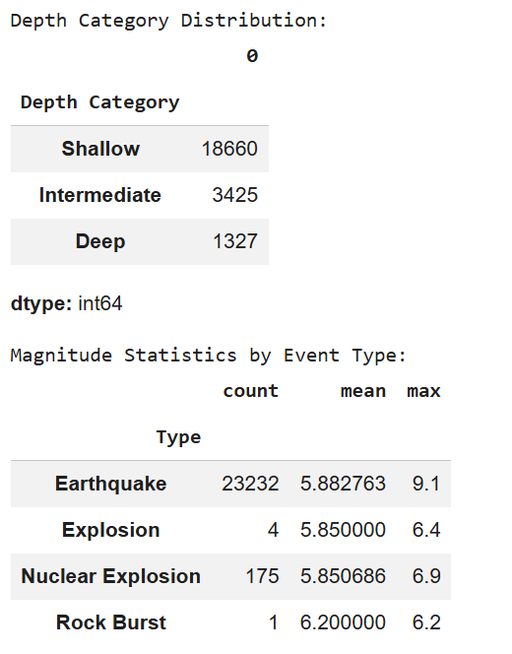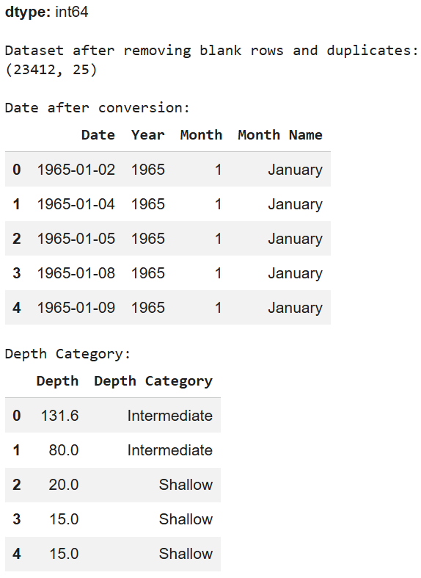
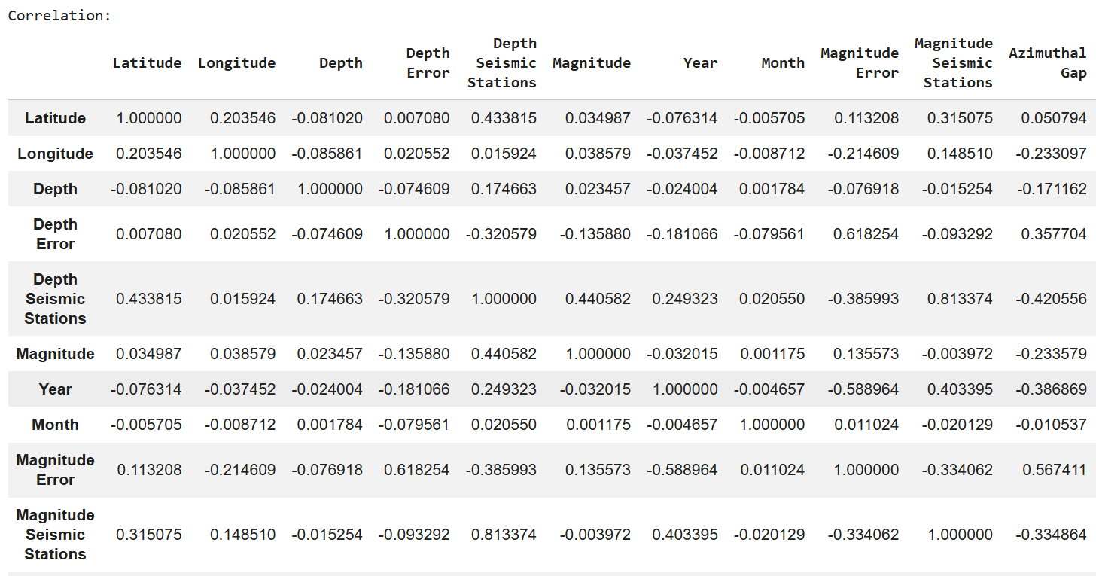

RESULT

