Ex.no:4b | EXPLORATORY DATA ANALYSIS (EDA) – DATA INSPECTION, FILTERING, STATISTICAL ANALYSIS AND CORRELATION

AIM

To perform data inspection, filtering, sorting, grouping, aggregation, descriptive statistical analysis, and correlation analysis on the Global Earthquake Analysis dataset using Pandas, and to visualize the analytical results using Matplotlib.

ALGORITHM
Algorithm 1: Dataset Inspection
- Import the Global Earthquake Analysis dataset.
- Display the first few records of the dataset.
- Check the dimensions of the dataset.
- Display the data types of the attributes.
- Generate a statistical summary of the numerical attributes.
Algorithm 2: Filtering Data
- Select the required attribute such as Magnitude or Depth.
- Specify a suitable filtering condition.
- Apply the condition to the dataset.
- Display the filtered records.
Algorithm 3: Sorting Data
- Select the attribute to be sorted such as Magnitude or Depth.
- Apply the sort_values() function.
- Specify the sorting order.
- Display the sorted dataset.
Algorithm 4: Statistical Analysis
- Select the required numerical attribute such as Magnitude.
- Calculate the mean.
- Calculate the median.
- Calculate the mode.
- Calculate the standard deviation.
- Display the calculated statistical measures.

Algorithm 5: Grouping and Aggregation
  - Select a categorical attribute such as Type, Magnitude Category, or Magnitude Type.
  - Apply the groupby() function.
  - Select the required numerical attribute such as Magnitude or Depth.
  - Calculate an aggregate measure such as mean or maximum.
  - Display the grouped results.
Algorithm 6: Correlation Analysis
- Select the required numerical attributes such as Latitude, Longitude, Depth, Magnitude, and Year.
- Apply the corr() function.
- Generate the correlation matrix.
- Analyze the correlation coefficient between the selected attributes.
- Visualize the relationship using an appropriate graph.

CODE
import kagglehub
import pandas as pd
import numpy as np
import matplotlib.pyplot as plt
import seaborn as sns
import os
# ============================================================
# LOAD DATASET
# ============================================================
path = "/content"
print("Dataset Path:")
print(path)
csv_files = [f for f in os.listdir(path) if f.endswith(".csv")]
print("\nCSV Files Found:")
print(csv_files)
csv_file = csv_files[0]
print("\nSelected CSV File:")
print(csv_file)
df = pd.read_csv(
os.path.join(path, csv_file),
encoding="latin1",
low_memory=False
)
print("\nDataset Loaded Successfully")
# ===========================================================
# PROGRAM 1 - DATA INSPECTION
# ============================================================
print("\nFirst 5 Records")
print(df.head())
print("\nLast 5 Records")
print(df.tail())
# ===========================================================
# PROGRAM 2 - SHAPE
# ============================================================
print("\nShape of Dataset")
print(df.shape)
print("\nRows =", df.shape[0])
print("Columns =", df.shape[1])
# ===========================================================
# PROGRAM 3 - DATA TYPE
# ============================================================
print("\nData Types")
print(df.dtypes)
print("\nDataset Info")
df.info()
# ===========================================================
# PROGRAM 4 - FILTERING
# ============================================================
# Earthquakes with Magnitude Greater Than 7
high_magnitude = df[df["Magnitude"] > 7]
print("\nRecords with Magnitude Greater Than 7")
print(
high_magnitude[
[
"Date",
"Latitude",
"Longitude",
"Depth",
"Magnitude",
"Type"
]
].head(10)
)
# ============================================================
# PROGRAM 5 - FILTER HIGH DEPTH
# ===========================================================
high_depth = df[df["Depth"] > 300
print("\nRecords with Depth Greater Than 300 km")
print(
high_depth[
[
"Date",
"Latitude",
"Longitude",
"Depth",
"Magnitude",
"Type"
]
].head(10)
)
# ============================================================
# PROGRAM 6 - SORTING
# ============================================================
# Sort by Magnitude
sorted_df = df.sort_values(
by="Magnitude",
ascending=False
)
print("\nTop Records by Earthquake Magnitude")
print(
sorted_df[
[
"Date",
"Latitude",
"Longitude",
"Depth",
"Magnitude",
"Type"
]
].head(10)
)
# ============================================================
# BAR CHART
# TOP 10 EARTHQUAKES BY MAGNITUDE
# ============================================================
top10 = sorted_df.head(10)
plt.figure(figsize=(10, 5))
plt.bar(
range(len(top10)),
top10["Magnitude"]
)
plt.xticks(
range(len(top10)),
top10["Date"].astype(str),
rotation=90
)
plt.xlabel("Date")
plt.ylabel("Magnitude")
plt.title("Top 10 Earthquakes by Magnitude")
plt.show()
# ============================================================
# PROGRAM 7 - STATISTICAL ANALYSIS
# ============================================================
print("\nMean Earthquake Magnitude =")
print(df["Magnitude"].mean())
print("\nMedian Earthquake Magnitude =")
print(df["Magnitude"].median())
print("\nMode Earthquake Magnitude =")
print(df["Magnitude"].mode())
print("\nStandard Deviation =")
print(df["Magnitude"].std())
print("\nMinimum Earthquake Magnitude =")
print(df["Magnitude"].min())
print("\nMaximum Earthquake Magnitude =")
print(df["Magnitude"].max())
# ============================================================
# PROGRAM 8 - DESCRIPTIVE STATISTICS
# ============================================================
print("\nDescriptive Statistics")
print(
df[
[
"Latitude",
"Longitude",
"Depth"
"Magnitude",
"Year",
"Month"
]
].describe()
)
# ============================================================
# PROGRAM 9 - GROUPING
# ============================================================
# Average Earthquake Magnitude by Type
group = df.groupby(
"Type"
)["Magnitude"].mean().sort_values(ascending=False)
print("\nAverage Earthquake Magnitude by Type")
print(group)
# Visualization
group.plot(
kind="bar",
figsize=(8, 5)
)
plt.xlabel("Earthquake Type")
plt.ylabel("Average Magnitude")
plt.title("Average Earthquake Magnitude by Type")
plt.xticks(rotation=45)
plt.show()
# ============================================================
# PROGRAM 10 - AGGREGATION
# ============================================================
summary = df.groupby("Magnitude Category").agg({
"Magnitude": "mean",
"Depth": "mean",
"Latitude": "mean",
"Longitude": "mean"
})
print("\nMagnitude Category-wise Aggregation")
print(summary)
# ============================================================
# PROGRAM 11 - CORRELATION
# ============================================================
numeric = df.select_dtypes(
include=np.number
)
corr = numeric.corr()
print("\nCorrelation Matrix")
print(corr)
plt.figure(figsize=(12, 8))
sns.heatmap(
corr,
annot=False,
cmap="coolwarm"
)
plt.title("Global Earthquake Dataset Correlation Heatmap")
plt.show()
# ============================================================
# PROGRAM 12 - SCATTER PLOT
# ============================================================
# Depth vs Magnitude
plt.figure(figsize=(7, 5))
plt.scatter(
df["Depth"],
df["Magnitude"]
)
plt.xlabel("Depth (km)")
plt.ylabel("Magnitude")
plt.title("Depth vs Earthquake Magnitude")
plt.show()
# ============================================================
# PROGRAM 13 - HISTOGRAM
# ============================================================
# Earthquake Magnitude Distribution
plt.figure(figsize=(7, 5))
plt.hist(
df["Magnitude"].dropna(),
bins=30
)
plt.xlabel("Magnitude")
plt.ylabel("Frequency")
plt.title("Distribution of Earthquake Magnitudes")
plt.show()
# ============================================================
# PROGRAM 14 - BOXPLOT
# ============================================================
plt.figure(figsize=(7, 5))
sns.boxplot(
x=df["Magnitude"].dropna()
)
plt.title("Earthquake Magnitude Boxplot")
plt.xlabel("Magnitude")
plt.show()
# ============================================================
# PROGRAM 15 - VALUE COUNTS
# ============================================================
print("\nEarthquake Type Counts")
print(
df["Type"].value_counts()
)
# ============================================================
# PROGRAM 16 - UNIQUE VALUES
# ============================================================
print("\nUnique Earthquake Types")
print(
df["Type"].unique()
)
print("\nUnique Magnitude Categories")
print(
df["Magnitude Category"].unique()
)
print("\nUnique Magnitude Types")
print(
df["Magnitude Type"].unique()
)
print("\nUnique Status Values")
print(
df["Status"].unique()
)
# ============================================================
# PROGRAM 17 - TOP 10 YEARS BY EARTHQUAKE OCCURRENCES
# ============================================================
print("\nTop 10 Years by Earthquake Occurrences")
year_count = (
df.groupby("Year")
.size()
.sort_values(ascending=False)
.head(10)
)
print(year_count)
# ============================================================
# PROGRAM 18 - EARTHQUAKE OCCURRENCES BY MAGNITUDE CATEGORY
# ============================================================
print("\nEarthquake Occurrences by Magnitude Category")
magnitude_category = (
df.groupby("Magnitude Category")
.size()
.sort_values(ascending=False)
)
print(magnitude_category)
# ============================================================
# PROGRAM 19 - TOP 10 EARTHQUAKES BY DEPTH
# ============================================================
print("\nTop 10 Earthquakes by Depth")
depth_data = (
df.sort_values(
by="Depth",
ascending=False
)
.head(10)
)
print(
depth_data[
[
"Date",
"Latitude",
"Longitude",
"Depth",
"Magnitude",
"Type"
]
]
)
# ============================================================
# PROGRAM 20 - MOST COMMON MAGNITUDE TYPES
# ============================================================
print("\nMost Common Magnitude Types")
magnitude_types = (
df["Magnitude Type"]
.value_counts()
.head(10)
)
print(magnitude_types)
# ============================================================
# PROGRAM 21 - EXPORT DATA
# ============================================================
df.to_csv(
"global_earthquake_data.csv",
index=False
)
df.to_excel(
"global_earthquake_data.xlsx",
index=False
)
df.to_json(
"global_earthquake_data.json",
orient="records",
indent=4
)
print("\nCSV, Excel and JSON files exported successfully.")

# ============================================================
# FINAL REPORT
# ============================================================
print("\n==============================================")
print("EXPERIMENT COMPLETED SUCCESSFULLY")
print("==============================================")
print("Dataset Shape :", df.shape)
print(
"Missing Values :",
df.isnull().sum().sum()
)
print(
"Total Records :",
len(df)
)
print(
"Average Magnitude :",
df["Magnitude"].mean()
)
print(
"Maximum Magnitude :",
df["Magnitude"].max()
)
print(
"Minimum Magnitude :",
df["Magnitude"].min()
)
print(
"Average Depth :",
df["Depth"].mean()
)
print(
"Number of Earthquake Types :",
df["Type"].nunique()
)
print(
"Number of Years :",
df["Year"].nunique()
)
print(
"Number of Magnitude Categories :",
df["Magnitude Category"].nunique()
)
print("Correlation Matrix Generated")
print("==============================================")
OUTPUT:
Dataset Path:
/content
CSV Files Found:
['Exp 6a (1).csv', 'global_earthquake_data.csv', 'Global_Earthquake_Cleaned.csv', 'Exp 6a.csv']
Selected CSV File:
Exp 6a (1).csv
Dataset Loaded Successfully
First 5 Records
Date Time Latitude Longitude Type Depth Depth Error
0 1965-01-02 13:44:18 19.246 145.616 Earthquake 131.6 NaN
1 1965-01-04 11:29:49 1.863 127.352 Earthquake 80.0 NaN
2 1965-01-05 18:05:58 -20.579 -173.972 Earthquake 20.0 NaN
3 1965-01-08 18:49:43 -59.076 -23.557 Earthquake 15.0 NaN
4 1965-01-09 13:32:50 11.938 126.427 Earthquake 15.0 NaN

Depth Seismic Stations Magnitude Year ... Magnitude Seismic Stations \
0 NaN 6.0 1965 ... NaN
1 NaN 5.8 1965 ... NaN
2 NaN 6.2 1965 ... NaN
3 NaN 5.8 1965 ... NaN
4 NaN 5.8 1965 ... NaN
Azimuthal Gap Horizontal Distance Horizontal Error Root Mean Square \
0 NaN NaN NaN NaN
1 NaN NaN NaN NaN
2 NaN NaN NaN NaN
3 NaN NaN NaN NaN
4 NaN NaN NaN NaN
ID Source Location Source Magnitude Source Status
0 ISCGEM860706 ISCGEM ISCGEM ISCGEM Automatic
1 ISCGEM860737 ISCGEM ISCGEM ISCGEM Automatic
2 ISCGEM860762 ISCGEM ISCGEM ISCGEM Automatic
3 ISCGEM860856 ISCGEM ISCGEM ISCGEM Automatic
4 ISCGEM860890 ISCGEM ISCGEM ISCGEM Automatic
Last 5 Records
Date Time Latitude Longitude Type Depth \
23407 2016-12-28 08:22:12 38.3917 -118.8941 Earthquake 12.30
23408 2016-12-28 09:13:47 38.3777 -118.8957 Earthquake 8.80
23409 2016-12-28 12:38:51 36.9179 140.4262 Earthquake 10.00
23410 2016-12-29 22:30:19 -9.0283 118.6639 Earthquake 79.00
23411 2016-12-30 20:08:28 37.3973 141.4103 Earthquake 11.94

Depth Error Depth Seismic Stations Magnitude Year ... \
23407 1.2 40.0 5.6 2016 ...
23408 2.0 33.0 5.5 2016 ...
23409 1.8 NaN 5.9 2016 ...
23410 1.8 NaN 6.3 2016 ...
23411 2.2 NaN 5.5 2016 ...

Magnitude Seismic Stations Azimuthal Gap Horizontal Distance \
23407 18.0 42.47 0.120
23408 18.0 48.58 0.129
23409 NaN 91.00 0.992
23410 NaN 26.00 3.553
23411 428.0 97.00 0.681
Horizontal Error Root Mean Square ID Source Location Source \
23407 NaN 0.1898 NN00570710 NN NN
23408 NaN 0.2187 NN00570744 NN NN
23409 4.8 1.5200 US10007NAF US US
23410 6.0 1.4300 US10007NL0 US US
23411 4.5 0.9100 US10007NTD US US
Shape of Dataset
(23412, 25)
Rows = 23412
Columns = 25

Data Types
Date object
Time object
Latitude float64
Longitude float64
Type object
Depth float64
Depth Error float64
Depth Seismic Stations float64
Magnitude float64
Year int64
Month int64
Month Name object
Magnitude Category object
Magnitude Type object
Magnitude Error float64
Magnitude Seismic Stations float64
Azimuthal Gap float64
Horizontal Distance float64
Horizontal Error float64
Root Mean Square float64
ID object
Source object
Location Source object
Magnitude Source object
Status object
dtype: object

Dataset Info
<class 'pandas.core.frame.DataFrame'>
RangeIndex: 23412 entries, 0 to 23411
Data columns (total 25 columns):
# Column Non-Null Count Dtype
--- ------ -------------- -----
0 Date 23412 non-null object
1 Time 23412 non-null object
2 Latitude 23412 non-null float64
3 Longitude 23412 non-null float64
4 Type 23412 non-null object
5 Depth 23412 non-null float64
6 Depth Error 4461 non-null float64
7 Depth Seismic Stations 7097 non-null float64
8 Magnitude 23412 non-null float64
9 Year 23412 non-null int64
10 Month 23412 non-null int64
11 Month Name 23412 non-null object
12 Magnitude Category 23412 non-null object
13 Magnitude Type 23412 non-null object
14 Magnitude Error 327 non-null float64
15 Magnitude Seismic Stations 2564 non-null float64
16 Azimuthal Gap 7299 non-null float64
17 Horizontal Distance 1604 non-null float64
18 Horizontal Error 1156 non-null float64
19 Root Mean Square 17352 non-null float64
20 ID 23412 non-null object
21 Source 23412 non-null object
22 Location Source 23412 non-null object
23 Magnitude Source 23412 non-null object
24 Status 23412 non-null object
dtypes: float64(12), int64(2), object(11)
memory usage: 4.5+ MB

Records with Magnitude Greater Than 7
Date Latitude Longitude Depth Magnitude Type
11 1965-01-24 -2.608 125.952 20.0 8.2 Earthquake
16 1965-02-04 51.251 178.715 30.3 8.7 Earthquake
26 1965-02-04 51.443 179.605 30.0 7.3 Earthquake
87 1965-03-14 36.405 70.724 207.8 7.4 Earthquake
100 1965-03-28 -32.522 -71.233 70.0 7.4 Earthquake
103 1965-03-30 50.282 177.959 20.0 7.6 Earthquake
152 1965-05-20 -14.921 167.340 120.0 7.7 Earthquake
165 1965-06-11 44.578 148.699 58.0 7.2 Earthquake
193 1965-07-02 52.990 -167.739 45.0 7.8 Earthquake
214 1965-08-02 -56.046 157.922 10.0 7.3 Earthquake
Records with Depth Greater Than 300 km
Date Latitude Longitude Depth Magnitude Type
9 1965-01-17 -24.563 178.487 565.0 5.8 Earthquake
13 1965-02-01 -18.697 -177.864 482.9 5.6 Earthquake
57 1965-02-17 21.527 143.081 340.0 5.6 Earthquake
80 1965-03-05 -27.027 -63.214 560.8 5.8 Earthquake
117 1965-04-10 -17.857 -178.646 543.7 6.5 Earthquake
118 1965-04-10 -13.409 170.376 635.0 6.3 Earthquake
120 1965-04-11 -26.168 178.628 570.0 5.7 Earthquake
121 1965-04-12 30.317 138.702 421.7 5.6 Earthquake
137 1965-04-29 -5.548 110.332 480.0 6.0 Earthquake
154 1965-05-22 -21.126 -178.537 553.8 6.1 Earthquake

Top Records by Earthquake Magnitude
Date Latitude Longitude Depth Magnitude Type
17083 2004-12-26 3.2950 95.9820 30.00 9.1 Earthquake
20501 2011-03-11 38.2970 142.3730 29.00 9.1 Earthquake
19928 2010-02-27 -36.1220 -72.8980 22.90 8.8 Earthquake
16 1965-02-04 51.2510 178.7150 30.30 8.7 Earthquake
21219 2012-04-11 2.3270 93.0630 20.00 8.6 Earthquake
17329 2005-03-28 2.0850 97.1080 30.00 8.6 Earthquake
18615 2007-09-12 -4.4380 101.3670 34.00 8.4 Earthquake
15440 2001-06-23 -16.2650 -73.6410 33.00 8.4 Earthquake
18111 2006-11-15 46.5920 153.2660 10.00 8.3 Earthquake
22791 2015-09-16 -31.5729 -71.6744 22.44 8.3 Earthquake 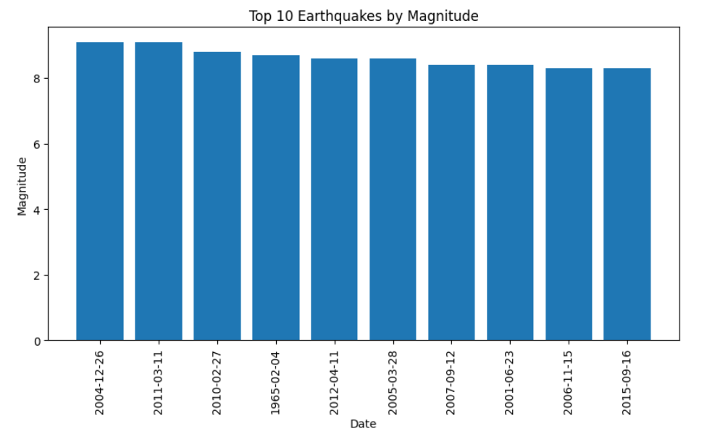

Mean Earthquake Magnitude =
5.882530753459764

Median Earthquake Magnitude =
5.7

Mode Earthquake Magnitude =
0 5.5
Name: Magnitude, dtype: float64

Standard Deviation =
0.4230656393157772

Minimum Earthquake Magnitude =
5.5

Maximum Earthquake Magnitude =
9.1

Descriptive Statistics
Latitude Longitude Depth Magnitude Year \
count 23412.000000 23412.000000 23412.000000 23412.000000 23412.000000
mean 1.679033 39.639961 70.767911 5.882531 1992.632411
std 30.113183 125.511959 122.651898 0.423066 14.426100
min -77.080000 -179.997000 -1.100000 5.500000 1965.000000
25% -18.653000 -76.349750 14.522500 5.600000 1981.000000
50% -3.568500 103.982000 33.000000 5.700000 1993.000000
75% 26.190750 145.026250 54.000000 6.000000 2005.000000
max 86.005000 179.998000 700.000000 9.100000 2016.000000

Month
count 23412.000000
mean 6.537887
std 3.454541
min 1.000000
25% 4.000000
50% 7.000000
75% 10.000000
max 12.000000
Average Earthquake Magnitude by Type
Type
Rock Burst 6.200000
Earthquake 5.882763
Nuclear Explosion 5.850686
Explosion 5.850000
Name: Magnitude, dtype: float64
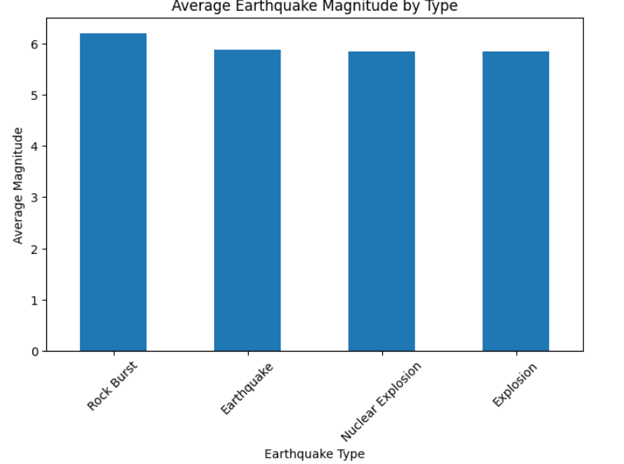
Magnitude Category-wise Aggregation
Magnitude Depth Latitude Longitude
Magnitude Category
5.5â5.9 5.655805 69.962793 1.119823 37.316436
6.0â6.9 6.270934 70.695878 2.769332 43.415529
7.0â7.9 7.282378 89.833139 4.309168 57.132763
8.0+ 8.232500 73.208500 -0.057190 42.690688
Correlation Matrix
Latitude Longitude Depth Depth Error \
Latitude 1.000000 0.203546 -0.081020 0.007080
Longitude 0.203546 1.000000 -0.085861 0.020552
Depth -0.081020 -0.085861 1.000000 -0.074609
Depth Error 0.007080 0.020552 -0.074609 1.000000
Depth Seismic Stations 0.433815 0.015924 0.174663 -0.320579
Magnitude 0.034987 0.038579 0.023457 -0.135880
Year -0.076314 -0.037452 -0.024004 -0.181066
Month -0.005705 -0.008712 0.001784 -0.079561
Magnitude Error 0.113208 -0.214609 -0.076918 0.618254
Magnitude Seismic Stations 0.315075 0.148510 -0.015254 -0.093292
Azimuthal Gap 0.050794 -0.233097 -0.171162 0.357704
Horizontal Distance -0.396768 -0.131313 -0.073832 -0.077423
Horizontal Error 0.015625 -0.093827 -0.016467 0.644593
Root Mean Square -0.214762 -0.028061 -0.134002 0.094398

Depth Seismic Stations Magnitude Year \
Latitude 0.433815 0.034987 -0.076314
Longitude 0.015924 0.038579 -0.037452
Depth 0.174663 0.023457 -0.024004
Depth Error -0.320579 -0.135880 -0.181066
Depth Seismic Stations 1.000000 0.440582 0.249323
Magnitude 0.440582 1.000000 -0.032015
Year 0.249323 -0.032015 1.000000
Month 0.020550 0.001175 -0.004657
Magnitude Error -0.385993 0.135573 -0.588964
Magnitude Seismic Stations 0.813374 -0.003972 0.403395
Azimuthal Gap -0.420556 -0.233579 -0.386869
Horizontal Distance 0.056619 -0.092609 0.109995
Horizontal Error -0.214959 -0.078406 -0.463956
Root Mean Square -0.158620 0.075865 -0.242516
Horizontal Distance Horizontal Error \
Latitude -0.396768 0.015625
Longitude -0.131313 -0.093827
Depth -0.073832 -0.016467
Depth Error -0.077423 0.644593
Depth Seismic Stations 0.056619 -0.214959
Magnitude -0.092609 -0.078406
Year 0.109995 -0.463956
Month -0.002546 -0.023784
Magnitude Error -0.076744 0.617721
Magnitude Seismic Stations -0.117606 -0.093143
Azimuthal Gap -0.033482 0.396450
Horizontal Distance 1.000000 0.126877
Horizontal Error 0.126877 1.000000
Root Mean Square 0.035778 0.157842
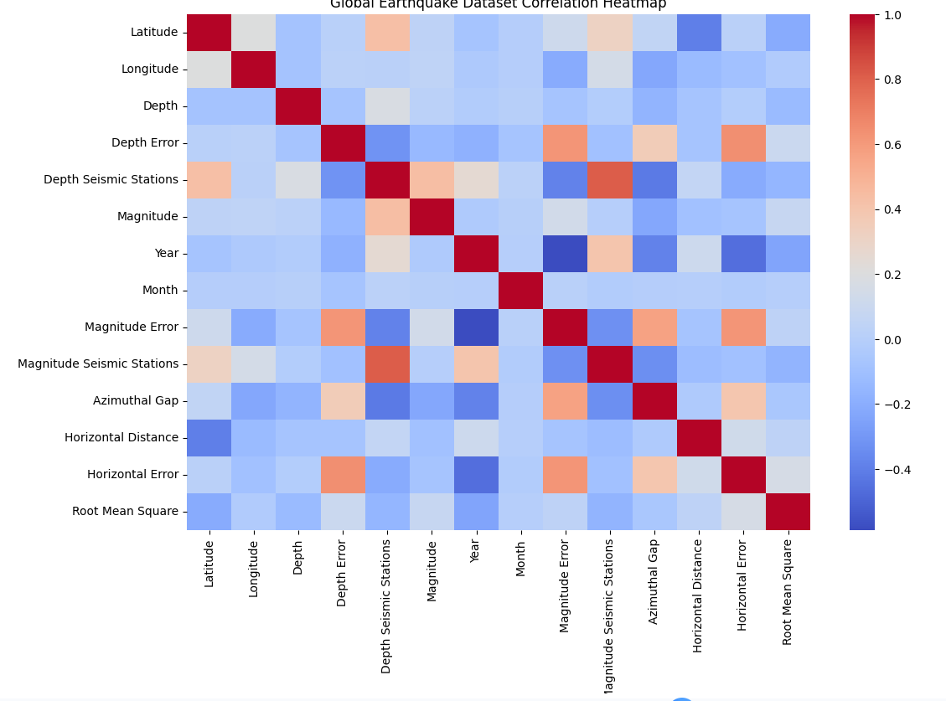
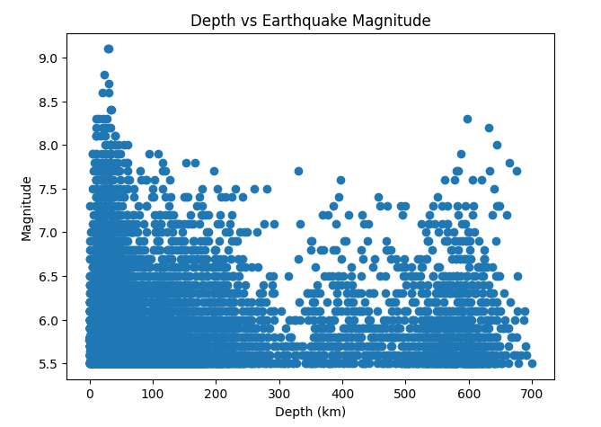
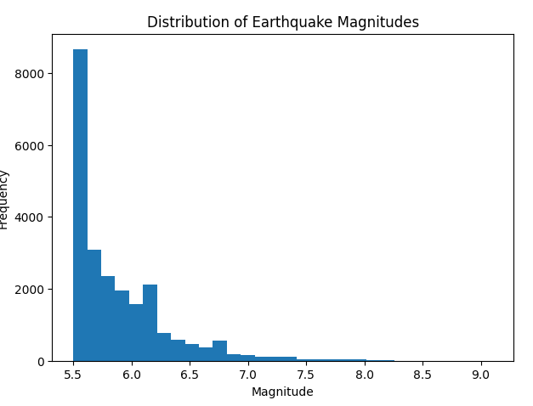
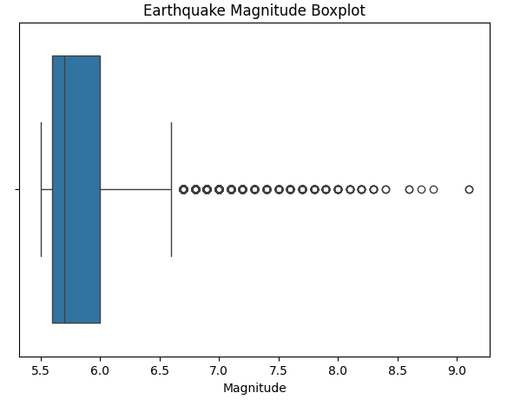
Earthquake Type Counts
Type
Earthquake 23232
Nuclear Explosion 175
Explosion 4
Rock Burst 1
Name: count, dtype: int64

Unique Earthquake Types
['Earthquake' 'Nuclear Explosion' 'Explosion' 'Rock Burst']

Unique Magnitude Categories
['6.0â\x80\x936.9' '5.5â\x80\x935.9' '8.0+' '7.0â\x80\x937.9']

Unique Magnitude Types
['MW' 'ML' 'MH' 'MS' 'MB' 'MWC' 'MD' 'Unknown' 'MWB' 'MWW' 'MWR']

Unique Status Values
['Automatic' 'Reviewed']

Top 10 Years by Earthquake Occurrences
Year
2011 713
2007 608
1995 591
2004 571
2010 560
2000 553
1996 541
1992 533
2005 533
1990 528
dtype: int64

Earthquake Occurrences by Magnitude Category
Magnitude Category
5.5â5.9 16058
6.0â6.9 6616
7.0â7.9 698
8.0+ 40
dtype: int64

Top 10 Earthquakes by Depth
Date Latitude Longitude Depth Magnitude Type
7734 1985-10-22 -20.158 -179.163 700.0 5.5 Earthquake
15933 2002-08-19 -24.871 178.566 691.6 5.6 Earthquake
4361 1977-06-17 -19.876 -179.098 690.0 5.7 Earthquake
18436 2007-05-06 -19.406 -179.315 688.0 6.1 Earthquake
14999 2000-09-02 -20.073 -179.135 687.6 6.0 Earthquake
18437 2007-05-07 -19.251 -179.362 682.2 5.6 Earthquake
13887 1998-02-09 51.550 149.639 678.9 5.5 Earthquake
15931 2002-08-19 -23.899 178.375 677.4 6.1 Earthquake
18435 2007-05-06 -19.401 -179.354 676.4 6.5 Earthquake
7218 1984-10-10 -20.147 -179.271 675.6 5.6 Earthquake

Most Common Magnitude Types
Magnitude Type
MW 7722
MWC 5669
MB 3761
MWB 2458
MWW 1983
MS 1702
ML 77
MWR 26
MD 6
MH 5
Name: count, dtype: int64

CSV, Excel and JSON files exported successfully.

==============================================
EXPERIMENT COMPLETED SUCCESSFULLY
==============================================
Dataset Shape : (23412, 25)
Missing Values : 145436
Total Records : 23412
Average Magnitude : 5.882530753459764
Maximum Magnitude : 9.1

RESULT

