Ex.no:5b | DATA VISUALIZATION USING MATPLOTLIB –  GLOBAL EARTHQUAKE DATASET

AIM

To visualize and analyze the Global Earthquake Analysis dataset using Line Chart, Bar Chart, and Pie Chart with Matplotlib to understand earthquake trends, earthquake-type comparisons, and magnitude-category distribution.

ALGORITHM

Step 1: Import Pandas and Matplotlib libraries.

Step 2: Load the Global Earthquake Analysis dataset into a DataFrame.

Step 3: Group the earthquake data according to year and calculate the total number of earthquake events for each year.

Step 4: Plot the yearly earthquake occurrences using a Line Chart to observe variations in earthquake activity over time.

Step 5: Group the dataset according to earthquake type and calculate the total number of events for each type.

Step 6: Plot the earthquake-type distribution using a Bar Chart to compare different earthquake event types.

Step 7: Select the major magnitude categories and calculate their earthquake event proportions.

Step 8: Plot the magnitude-category distribution using a Pie Chart.

Step 9: Add suitable titles, axis labels, legends, and display the visualizations.

CODE
import pandas as pd
import matplotlib.pyplot as plt
# Load Global Earthquake Analysis dataset
df = pd.read_csv(
"Exp 6a.csv",
encoding="latin1",
low_memory=False
)
# --------------------------------
# 1. Line Chart – Earthquakes by Year
# --------------------------------
yearly_earthquakes = df.groupby("Year").size()
plt.figure(figsize=(10, 5))
plt.plot(
yearly_earthquakes.index,
yearly_earthquakes.values,
marker="o"
)
plt.title("Earthquake Occurrences by Year")
plt.xlabel("Year")
plt.ylabel("Number of Earthquake Events")
plt.xticks(rotation=45)
plt.grid(True)
plt.tight_layout()
plt.show()
# --------------------------------
# 2. Bar Chart – Earthquakes by Type
# -------------------------------
earthquake_type = (
df.groupby("Type")
.size()
.sort_values(ascending=False)
)
plt.figure(figsize=(10, 6))
plt.bar(
earthquake_type.index,
earthquake_type.values
)
plt.title("Earthquake Events by Type")
plt.xlabel("Earthquake Type")
plt.ylabel("Number of Events")
plt.xticks(rotation=45, ha="right")
plt.tight_layout()
plt.show()
# --------------------------------
# 3. Pie Chart – Magnitude Category Distribution
# --------------------------------
magnitude_category = (
df.groupby("Magnitude Category")
.size()
.sort_values(ascending=False)
)
top_magnitude_categories = magnitude_category.head(6)
plt.figure(figsize=(8, 8))
plt.pie(
top_magnitude_categories.values,
labels=top_magnitude_categories.index,
autopct="%1.1f%%"
)
plt.title("Earthquake Magnitude Category Distribution")
plt.show()
OUTPUT
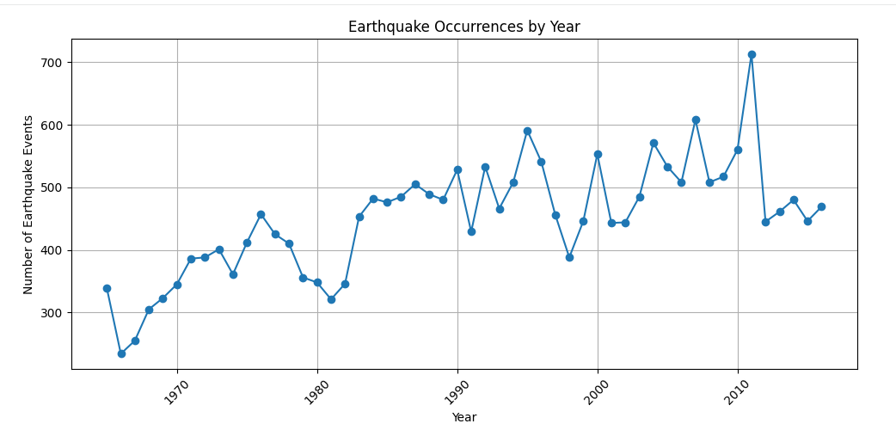

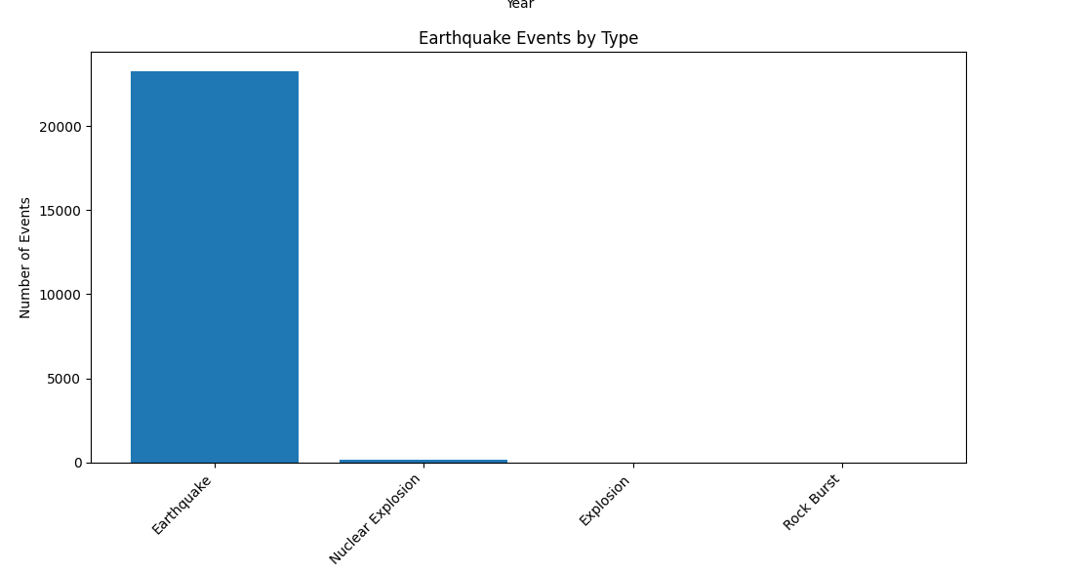
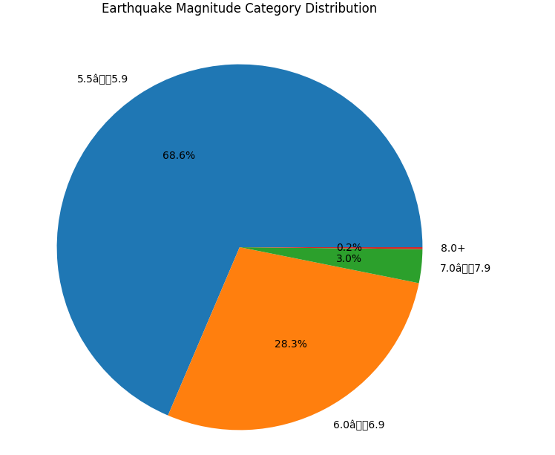

RESULT

