Name : M.Sharukhan
Reg no: 411625104064
Department : BE.CSE
Subject : Python
Batch : 5

Title : Employee Management System
Aim :
To develop an Employee Management System using Python that allows the user to add, view, search, update, and delete employee records using functions.
Procedure:
Start the program.
Create an empty dictionary to store employee details.
Display a menu with different options:
Add Employee
View Employees
Search Employee
Delete Employee
Exit
Ask the user to select an option.
If the user selects Add Employee, enter employee ID, name, and salary.
Store the employee details in the dictionary.
If the user selects View Employees, display all employee records.
If the user selects Search Employee, ask for employee ID and show details.
If the user selects Delete Employee, remove the employee record.
Repeat the menu until the user chooses Exit.
End the program.
Algorithm:
- Start
- Create empty dictionary employees
- Display menu options
- Read user choice
- If choice = 1 → Add employee details
- If choice = 2 → Display all employees
- If choice = 3 → Search employee by ID
- If choice = 4 → Delete employee
- If choice = 5 → Exit program
- Repeat steps 3–9 until exit
- Stop
Coding
employees = {}
def add_employee():
emp_id = input("Enter Employee ID: ")
name = input("Enter Employee Name: ")
salary = input("Enter Employee Salary: ")
employees[emp_id] = {"Name": name, "Salary": salary}
print("Employee added successfully!\n")
def view_employees():
if not employees:
print("No employee records found.\n")
else:
for emp_id, details in employees.items():
print("ID:", emp_id)
print("Name:", details["Name"])
print("Salary:", details["Salary"])
print("-------------------")
def search_employee():
emp_id = input("Enter Employee ID to search: ")
if emp_id in employees:
print("Employee Found")
print("Name:", employees[emp_id]["Name"])
print("Salary:", employees[emp_id]["Salary"])
else:
print("Employee not found.")
def delete_employee():
emp_id = input("Enter Employee ID to delete: ")
if emp_id in employees:
del employees[emp_id]
print("Employee deleted successfully.")
else:
print("Employee not found.")
while True:
print("\n--- Employee Management System ---")
print("1. Add Employee")
print("2. View Employees")
print("3. Search Employee")
print("4. Delete Employee")
print("5. Exit")
choice = input("Enter your choice: ")
if choice == "1":
add_employee()
elif choice == "2":
view_employees()
elif choice == "3":
search_employee()
elif choice == "4":
delete_employee()
elif choice == "5":
print("Exiting program...")
break
else:
print("Invalid choice! Try again.")

Output:

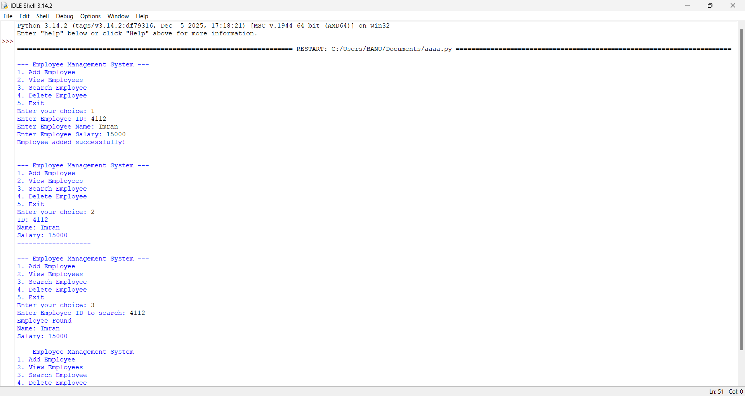

Result :
The Employee Management System project was successfully implemented using Python. The program allows the user to add, view, search, and delete employee records through a menu-driven interface. The system stores employee details using a dictionary and uses functions to perform different operations. The program executes correctly and displays the required output for each user option.

