Name: M.Sharukhan
Reg No: 411625104064
Department: BE.CSE
Subject: Python
Batch: 05

Mini Project: Library Management System

1. Project Title
Library Management System using python.

2. Problem Statement
To design and implement a Python program that manages library books using python. The system allows adding books, viewing books, issuing books to students, returning books, searching books, and calculating fines for late returns.

3. Objective
- To understand the use of functions in Python
- To manage book records using lists and dictionaries
- To perform issue and return operations
- To calculate fines for late book returns
- To create a menu-driven application

4. Tools Used
Python 3
VS Code / IDLE

5. Description
This project simulates a simple library management system. It allows the user to add books with a Book ID, view available books, issue books to students, return books, and search for books. The system also calculates fines if the book is returned late.

6. Algorithm
Step 1: Create an empty list to store books
Step 2: Display the menu
Step 3: Add book with Book ID and name
Step 4: Issue book to student with number of days
Step 5: Return book and calculate fine if late
Step 6: Search book by name
Step 7: Repeat until user exits

7. Program (Python Code)
books = []
def add_book():
book_id = input("Enter Book ID: ")
name = input("Enter Book Name: ")
books.append({
"id": book_id,
"name": name,
"issued": False,
"student": "",
"days": 0
})
print("Book added successfully!")
def view_books():
if len(books) == 0:
print("No books available.")
return
print("\nLibrary Books")
for book in books:
status = "Issued" if book["issued"] else "Available"
print(book["id"], "-", book["name"], "-", status)
def issue_book():
book_id = input("Enter Book ID to issue: ")
for book in books:
if book["id"] == book_id:
if book["issued"]:
print("Book already issued.")
return
student = input("Enter student name: ")
days = int(input("Enter number of days issued: "))
book["issued"] = True
book["student"] = student
book["days"] = days
print("Book issued successfully!")
return
print("Book not found.")
def return_book():
book_id = input("Enter Book ID to return: ")
for book in books:
if book["id"] == book_id:
if not book["issued"]:
print("Book was not issued.")
return
extra_days = int(input("Enter late days (0 if none): "))
fine = extra_days * 10
book["issued"] = False
book["student"] = ""
book["days"] = 0
print("Book returned successfully!")
if fine > 0:
print("Fine to pay: Rs.", fine)
return
print("Book not found.")
def search_book():
name = input("Enter book name to search: ")
for book in books:
if book["name"].lower() == name.lower():
status = "Issued" if book["issued"] else "Available"
print("\nBook Found")
print("Book ID:", book["id"])
print("Book Name:", book["name"])
print("Status:", status)
if book["issued"]:
print("Issued to:", book["student"])
return
print("Book not found.")
while True:
print("\n----- Library Management System -----")
print("1 Add Book")
print("2 View Books")
print("3 Issue Book")
print("4 Return Book")
print("5 Search Book")
print("6 Exit")
choice = input("Enter choice: ")
if choice == "1":
add_book()
elif choice == "2":
view_books()
elif choice == "3":
issue_book()
elif choice == "4":
return_book()
elif choice == "5":
search_book()
elif choice == "6":
print("Exiting system")
break
else:
print("Invalid choice")

9.Output

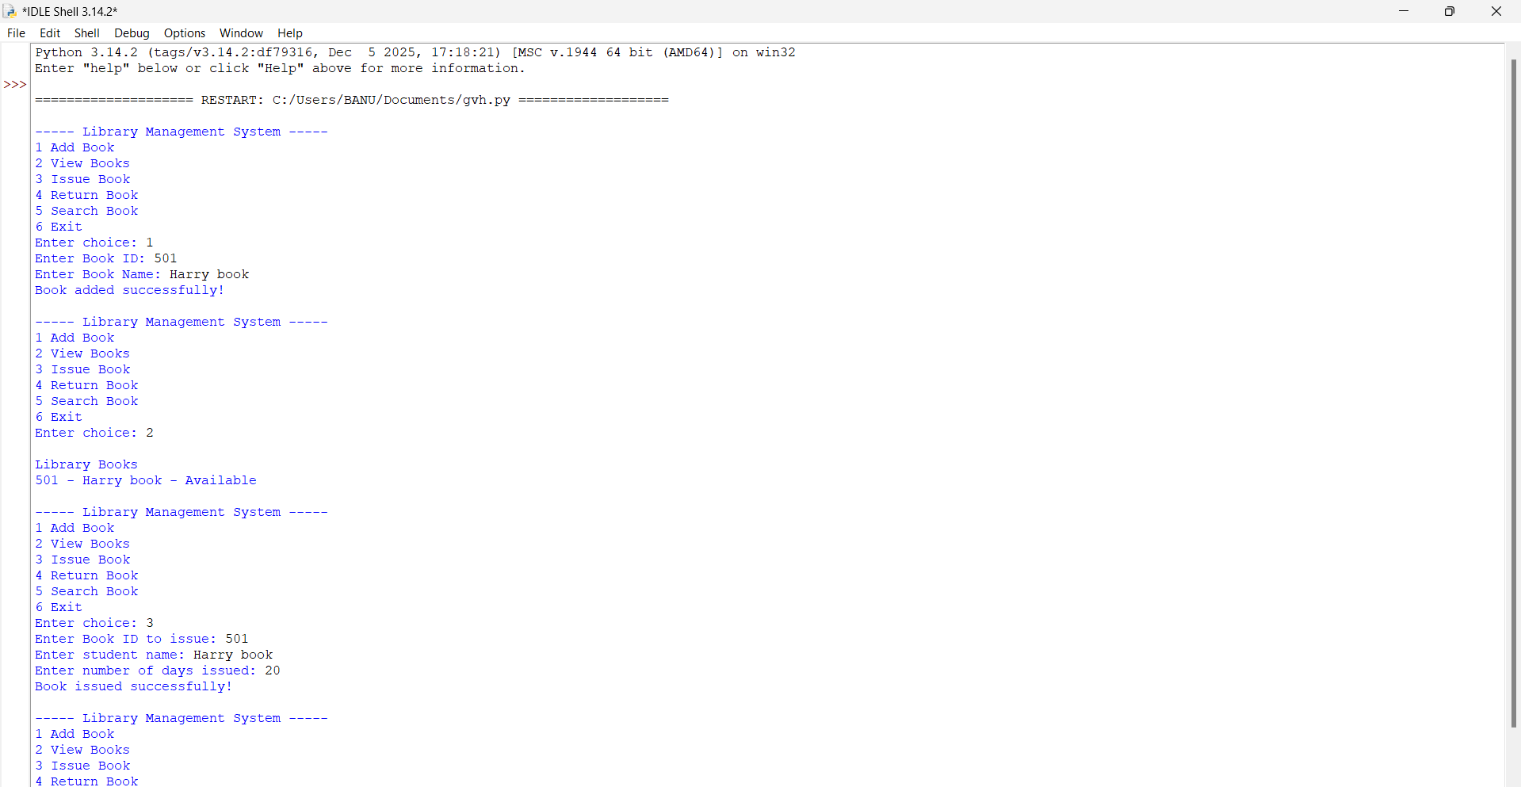

8. Result
The program successfully manages library books with Book ID, issuing to students, returning books, and calculating fines for late returns.

9. Conclusion
This project demonstrates how Python functions, lists, and dictionaries can be used to create a practical library management system.

