AcccountController.java
package com.cognizant.account.controller;
import org.springframework.web.bind.annotation.*;
import java.util.Map;

@RestController
public class AccountController {

@GetMapping("/accounts/{number}")
public Map<String, Object> getAccount(@PathVariable String number) {
return Map.of(
"number", number,
"type", "savings",
"balance", 234343
);
}
}

AccountApplication.java
package com.cognizant.account;

import org.springframework.boot.SpringApplication;
import org.springframework.boot.autoconfigure.SpringBootApplication;

@SpringBootApplication
public class AccountApplication {
public static void main(String[] args) {
SpringApplication.run(AccountApplication.class, args);
}
}

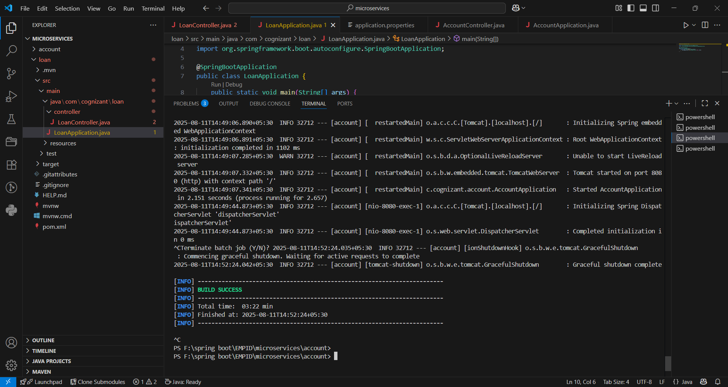

Output
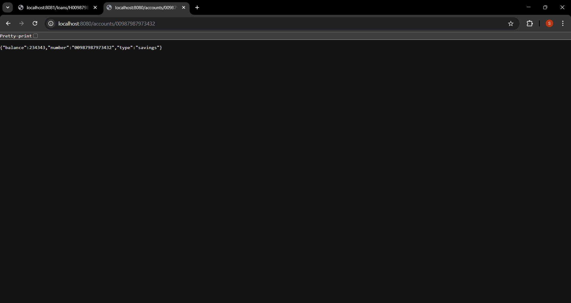

loanController.java
package com.cognizant.loan.controller;

import org.springframework.web.bind.annotation.*;
import java.util.Map;

@RestController
public class LoanController {
@GetMapping("/loans/{number}")
public Map<String, Object> getLoan(@PathVariable String number) {
return Map.of(
"number", number,
"type", "car",
"loan", 400000,
"emi", 3258,
"tenure", 18
);
}
}

loanApplication.java
package com.cognizant.loan;

import org.springframework.boot.SpringApplication;
import org.springframework.boot.autoconfigure.SpringBootApplication;

@SpringBootApplication
public class LoanApplication {
public static void main(String[] args) {
SpringApplication.run(LoanApplication.class, args);
}
}

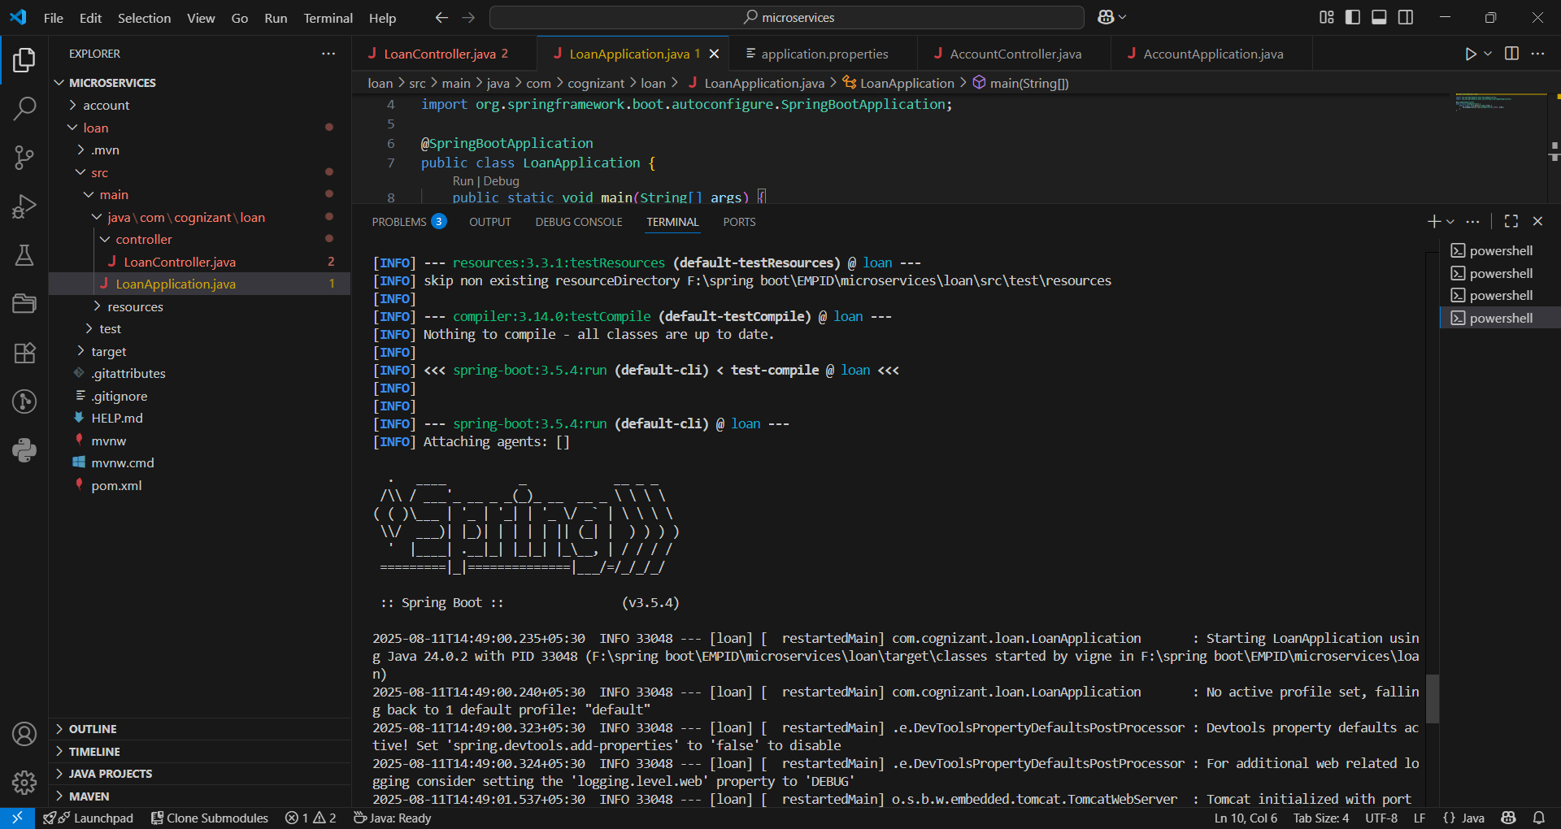

Output
