Players
Command
npx create-react-app Players
cd Players
npm start

App.js

import React from "react";
import ListofPlayers from "./components/nineth/ListofPlayers";
import Scorebelow70 from "./components/nineth/Scorebelow70";
import IndianPlayersComponent from './components/nineth/IndianPlayers';

function App() {
const players = [
{ name: "Rahul", score: 88 },
{ name: "Virat", score: 75 },
{ name: "Jadeja", score: 60 },
{ name: "Dhawan", score: 45 },
{ name: "Pant", score: 90 },
{ name: "Shami", score: 65 },
{ name: "Bumrah", score: 95 },
{ name: "Hardik", score: 35 },
{ name: "Ashwin", score: 70 },
{ name: "Kuldeep", score: 78 },
{ name: "Prithvi", score: 82 }
];

// Set flag to true/false to trigger UI condition
const flag = true; // Or false

if (flag === true) {
return (
<div>
<h1>List of Players</h1>
<ListofPlayers players={players} />
<hr />
<h1>List of Players having Scores Less than 70</h1>
<Scorebelow70 players={players} />
</div>
);
} else {
return (
<IndianPlayersComponent />
);
}
}

export default App;

/components/ ListofPlayers.js

import React from "react";

function ListofPlayers({ players }) {
return (
<ul>
{players.map((player, idx) => (
<li key={idx}>
{player.name} - {player.score}
</li>
))}
</ul>
);
}

export default ListofPlayers;

/components/ Scorebelow70.js
import React from "react";

const Scorebelow70 = ({ players }) => {
const filtered = players.filter(p => p.score < 70);
return (
<ul>
{filtered.map((player, idx) => (
<li key={idx}>{player.name} - {player.score}</li>
))}
</ul>
);
};

export default Scorebelow70;

component/IndianPlayers.js

import React from "react";
function OddPlayers({ team }) {
const oddTeam = team.filter((_, idx) => idx % 2 === 0);
return (
<ul>
{oddTeam.map((player, idx) => (
<li key={idx}>{player.name}</li>
))}
</ul>
);
}
function EvenPlayers({ team }) {
// Even: 1,3,5,7,9
const evenTeam = team.filter((_, idx) => idx % 2 !== 0);
return (
<ul>
{evenTeam.map((player, idx) => (
<li key={idx}>{player.name}</li>
))}
</ul>
);
}

function ListofIndianPlayers({ IndianPlayers }) {
return (
<ul>
{IndianPlayers.map((name, idx) => (
<li key={idx}>{name}</li>
))}
</ul>
);
}

function IndianPlayersComponent() {
const T20players = ["Rohit", "Hardik", "Bumrah", "Jadeja"];
const RanjiTrophyPlayers = ["Prithvi", "Shreyas", "Kuldeep"];
// Merge using spread operator (ES6)
const IndianPlayers = [...T20players, ...RanjiTrophyPlayers];
const IndianTeam = [
{ name: "Rohit" }, { name: "Virat" }, { name: "Jadeja" },
{ name: "Hardik" }, { name: "Kuldeep" }, { name: "Shreyas" },
{ name: "Bumrah" }, { name: "Prithvi" }
];

return (
<div>
<h1>Indian Team</h1>
<h1>Odd Players</h1>
<OddPlayers team={IndianTeam} />
<hr />
<h1>Even Players</h1>
<EvenPlayers team={IndianTeam} />
<hr />
<div>
<h1>List of Indian Players Merged:</h1>
<ListofIndianPlayers IndianPlayers={IndianPlayers} />
</div>
</div>
);
}

export default IndianPlayersComponent;

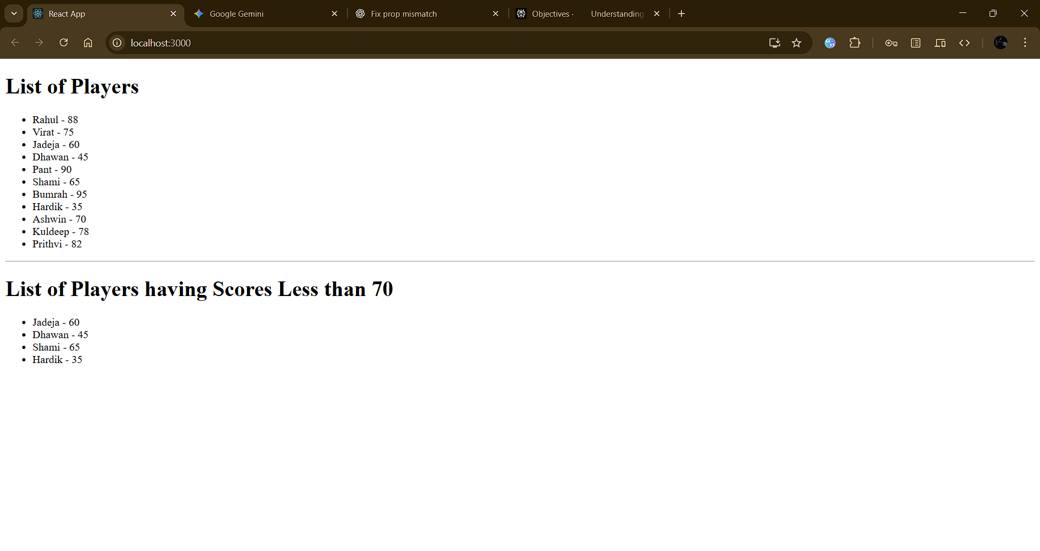
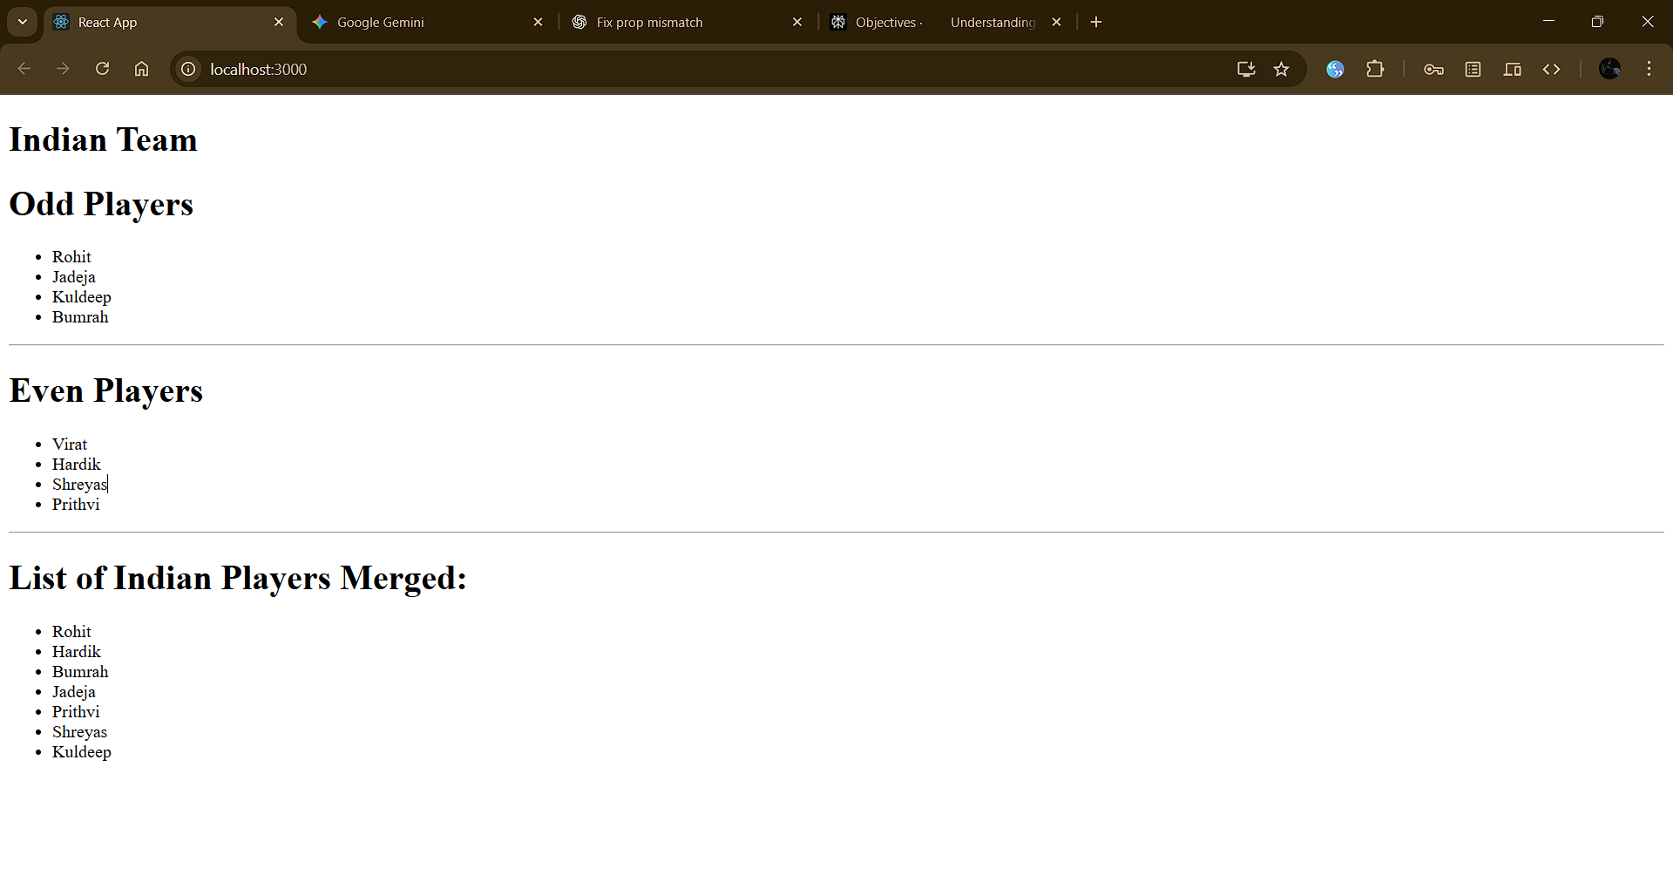

Office
Command
npx create-react-app office
cd office
npm start

App.js
import React from "react";
import image1 from "./assets/images/office1.jpg";
import image2 from "./assets/images/office2.jpeg";
import image3 from "./assets/images/office3.webp";

const offices = [
{ name: "DBS", rent: 50000, address: "Chennai", img: image1 },
{ name: "Regus", rent: 65000, address: "Bengaluru", img: image2 },
{ name: "WeWork", rent: 55000, address: "Mumbai", img: image3 }
];

function App() {
return (
<div>
<h1>Office Space, at Affordable Range</h1>
{offices.map((item, idx) => (
<div
key={idx}
style={{
margin: 24,
border: "1px solid #ccc",
borderRadius: "8px",
padding: "10px",
display: "inline-block",
width: 250
}}
>
<img src={item.img} alt={item.name} width="220" />
<h2>{item.name}</h2>
<span
style={{
color: item.rent <= 60000 ? "red" : "green",
fontWeight: "bold"
}}
>
Rent: Rs. {item.rent}
</span>
<p>Address: {item.address}</p>
</div>
))}
</div>
);
}

export default App;

Output

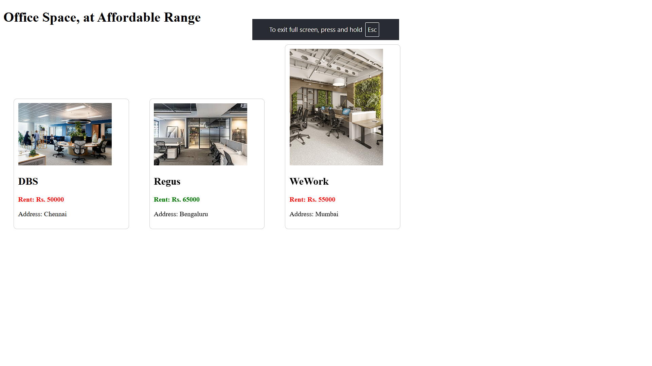

currencyconverter
Command
npx create-react-app currencyconverter
cd currencyconverter
npm start

App.js
import React, { Component } from "react";
import CurrencyConvertor from "./components/eleventh/CurrencyConvertor";

class App extends Component {
constructor(props) {
super(props);
this.state = { counter: 5 };

// Bind methods if not using arrow functions
this.increment = this.increment.bind(this);
this.sayHello = this.sayHello.bind(this);
this.incrementAndHello = this.incrementAndHello.bind(this);
}

increment() {
this.setState(prev => ({ counter: prev.counter + 1 }));
}

decrement = () => {
this.setState(prev => ({ counter: prev.counter - 1 }));
};

sayHello() {
alert("Hello! Member1");
}

incrementAndHello() {
this.increment();
this.sayHello();
}

sayWelcome = (msg) => {
alert(msg);
}

handleClick = (e) => {
// e is a synthetic event
alert("I was clicked");
}

render() {
return (
<div style={{ margin: 24 }}>
<div>{this.state.counter}</div>
<button onClick={this.incrementAndHello}>Increment</button>
<button onClick={this.decrement}>Decrement</button>
<button onClick={() => this.sayWelcome("welcome")}>Say welcome</button>
<button onClick={this.handleClick}>Click on me</button>
<CurrencyConvertor />
</div>
);
}
}

export default App;

./components/CurrencyConverter.js
import React, { Component } from "react";

class CurrencyConvertor extends Component {
constructor(props) {
super(props);
this.state = { amount: "", currency: "", converted: null };
}

handleAmountChange = (e) => {
this.setState({ amount: e.target.value });
};

handleCurrencyChange = (e) => {
this.setState({ currency: e.target.value });
};

handleSubmit = (e) => {
e.preventDefault();
// Example conversion: Assume 1 Euro = 80 INR
const euroRate = 80;
const euroAmount = this.state.amount / euroRate;
alert(`Converting to ${this.state.currency} Amount is ${euroAmount * euroRate}`);
};

render() {
return (
<div>
<h1 style={{ color: "green" }}>Currency Convertor!!!</h1>
<form onSubmit={this.handleSubmit}>
<label>
Amount:
<input type="number" value={this.state.amount} onChange={this.handleAmountChange} />
</label>
<br/>
<label>
Currency:
<input type="text" value={this.state.currency} onChange={this.handleCurrencyChange} />
</label>
<br/>
<button type="submit">Submit</button>
</form>
</div>
);
}
}

export default CurrencyConvertor;

Output

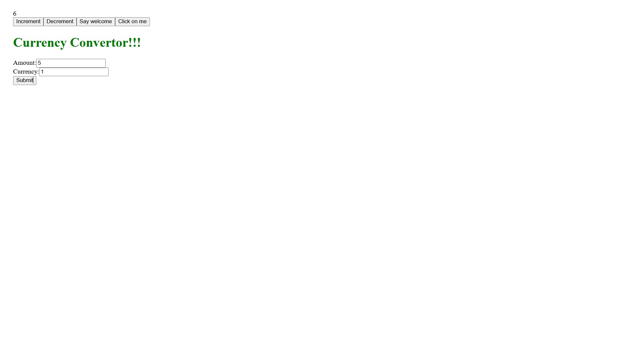

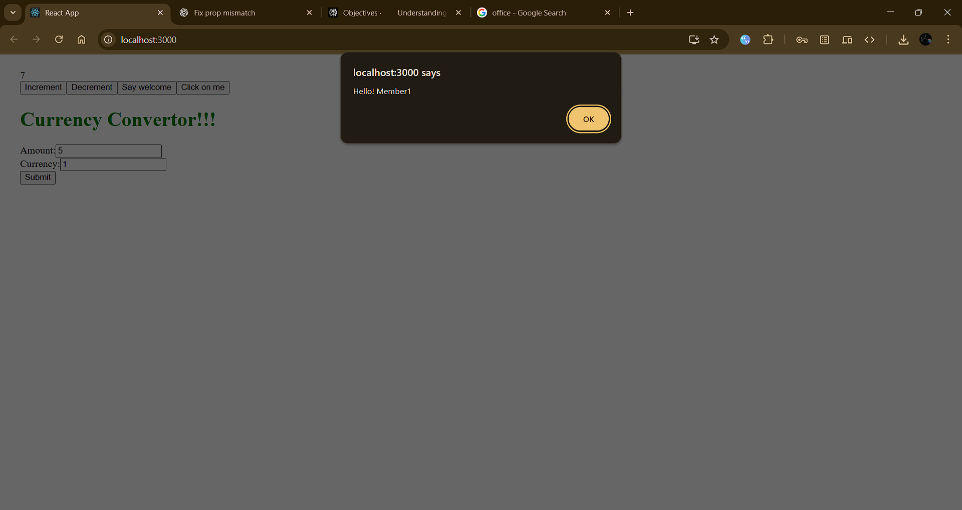

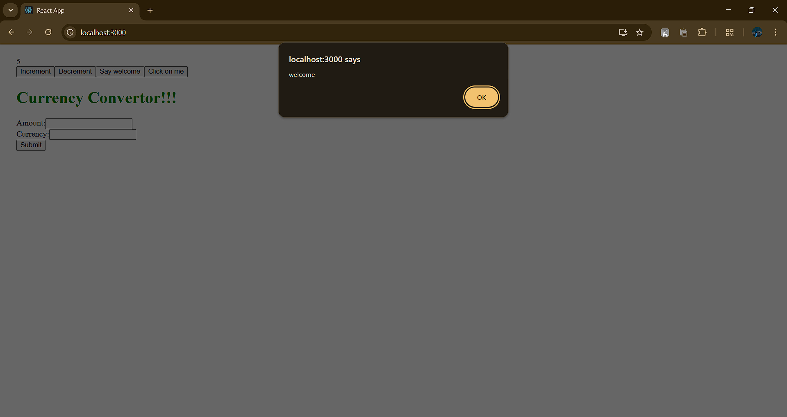

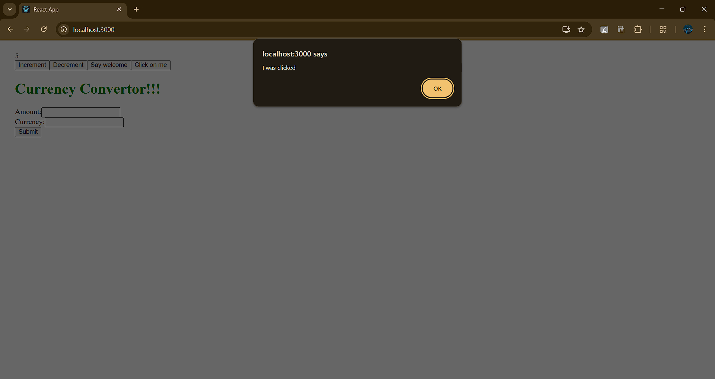

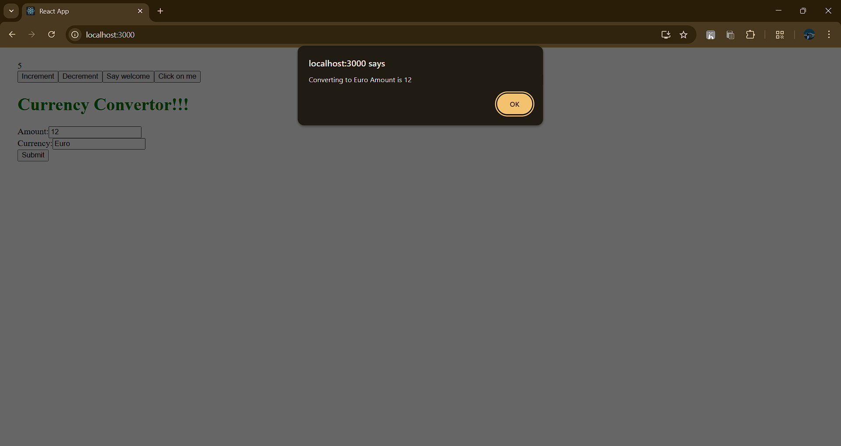

Ticket Booking App
Command
npx create-react-app ticketbookingapp
cd ticketbookingapp
npm start

App.js
import React, { useState } from "react";
function GuestPage({ onLogin }) {
return (
<div>
<h2>Welcome, Guest</h2>
<FlightDetails />
<button onClick={onLogin}>Login</button>
</div>
);
}

function UserPage({ onLogout }) {
return (
<div>
<h2>Welcome, User</h2>
<FlightDetails />
<button>Book Ticket</button>
<button onClick={onLogout}>Logout</button>
</div>
);
}
function FlightDetails() {
return (
<div>
<h3>Flight Details</h3>
<ul>
<li>Flight: AI-202, Chennai → Delhi</li>
<li>Departure: 9:30 AM</li>
<li>Arrival: 12:00 PM</li>
</ul>
</div>
);
}

function App() {
const [isLoggedIn, setIsLoggedIn] = useState(false); // flag variable

// Use element variable:
let page;
if (isLoggedIn) {
page = <UserPage onLogout={() => setIsLoggedIn(false)} />;
} else {
page = <GuestPage onLogin={() => setIsLoggedIn(true)} />;
}

return (
<div style={{ margin: 40 }}>
<h1>Ticket Booking App</h1>
{page}
</div>
);
}

export default App;

Output 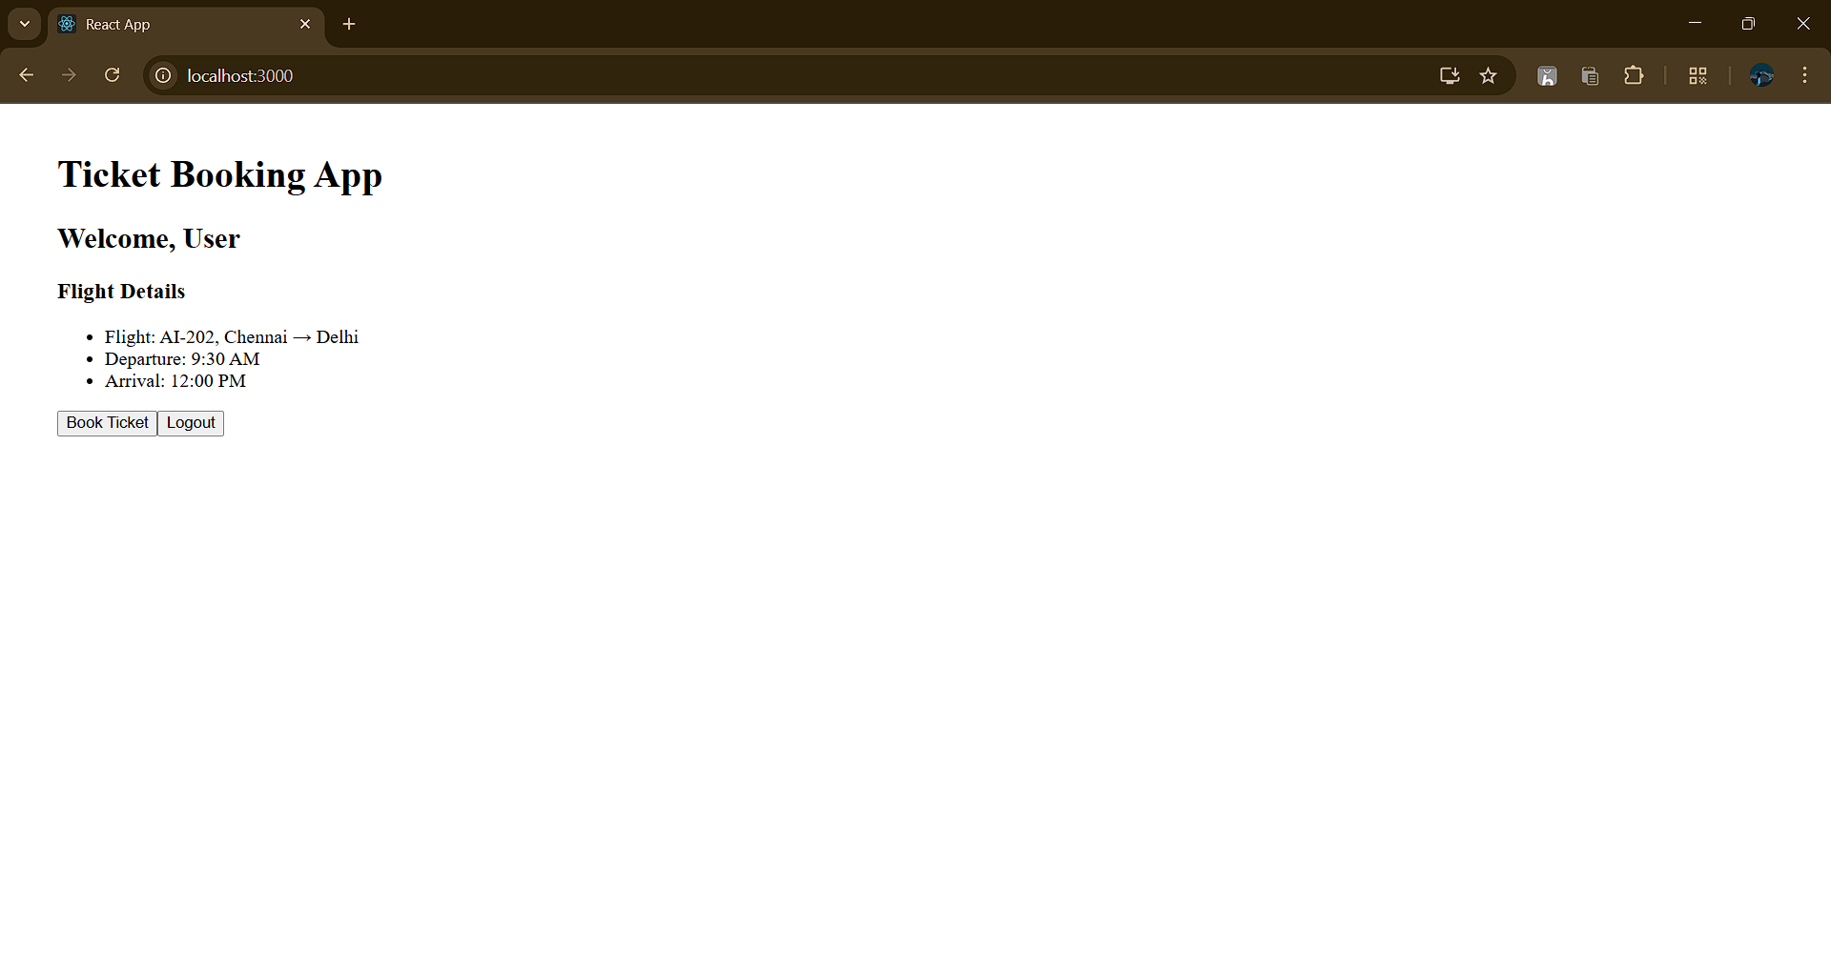

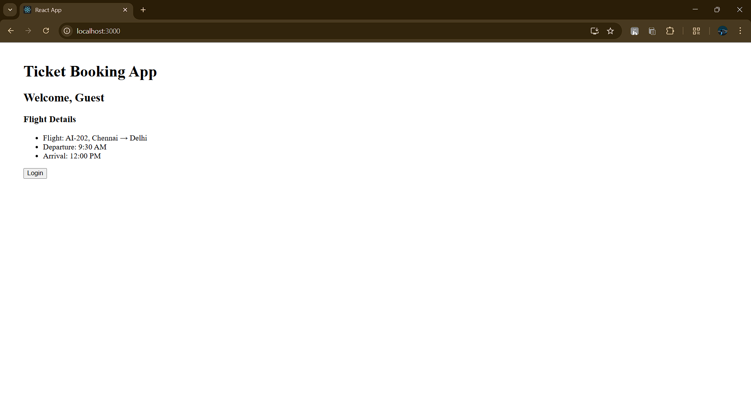

Blogger App
Command
npx create-react-app bloggerapp
cd bloggerapp
npm start

App.js
import React, { useState } from "react";
import { BookDetails, BlogDetails, CourseDetails } from "./components/thirteenth/BookDetails";

function App() {
const [showBooks, setShowBooks] = useState(true);
const [showBlogs, setShowBlogs] = useState(true);
const [isCoursesVisible, setCoursesVisible] = useState(true);

const books = [
{ id: 1, name: "React Basics", price: "₹500" },
{ id: 2, name: "JavaScript Essentials", price: "₹400" },
{ id: 3, name: "CSS Mastery", price: "₹350" }
];

const blogs = [
{ id: 1, title: "Understanding React useState" },
{ id: 2, title: "Mastering Conditional Rendering" },
{ id: 3, title: "Why Keys Are Important in Lists" }
];

const courses = [
{ code: "CR101", name: "React Bootcamp", date: "12-Aug-2025" },
{ code: "CR102", name: "Advanced JavaScript", date: "20-Aug-2025" },
{ code: "CR103", name: "UI/UX Foundations", date: "25-Aug-2025" }
];

return (
<div>
<h1>Blogger App</h1>
<button onClick={() => setShowBooks(b => !b)}>Toggle Books</button>
<button onClick={() => setShowBlogs(b => !b)}>Toggle Blogs</button>
<button onClick={() => setCoursesVisible(b => !b)}>Toggle Courses</button>

<BookDetails books={books} show={showBooks} />
<BlogDetails blogs={blogs} show={showBlogs} />
<CourseDetails courses={courses} isVisible={isCoursesVisible} />
</div>
);
}

export default App;

Output
