1. **Alert handling in version 9.3.2 and above**

May get issue of handling alert . In webbrowser alert could open and shut suddenly so unable to capture the alert . To overcome this

Go to project -> settings->Desired capabilties -> webui -> chrome or firefox browser( which browser you working) . Add the below prompt and alert behaviour to handle the alert in browser

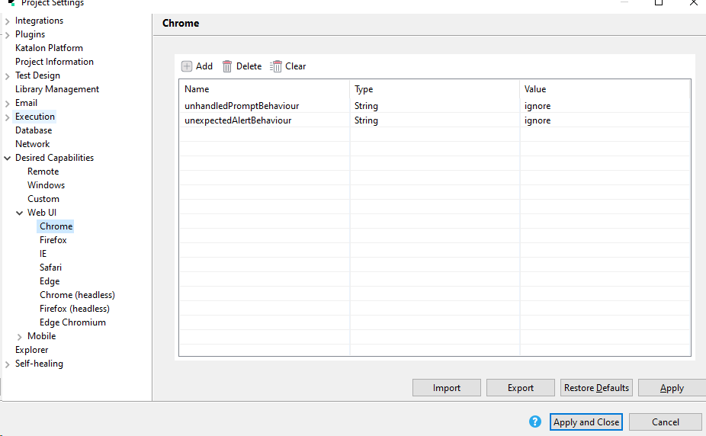

1. **Run feature file:**

Where you can run the only one feature file

Eg: CucumberKW.*runFeatureFile*('Include/features/ReadDataFromExcel_Login.feature')

You need to specify this in your testcase

With the recent version of 9.3.2 it got fail . In hooks mention the below code to glue the feature file

CucumberGlueGenerator.*addDefaultPackages*();

1. **Run Feature folder:**

Where we can run entire feature file

Eg : CucumberKW.*runFeatureFolder*('Include/features')

**4.Run Cucumber Options:**

Using runner class ,We can run specific feature file and also we can get report in a html manner

Create a runner class and specify below cucumber options

@RunWith(Cucumber.**class**)

@CucumberOptions(features="Include/features",glue="",plugin=["pretty","html:Reports"])