LOGS & REPORT FOR KATALON

We have different type of report : LOGS and REPORT

1 . Logs we get generated for :

Testcase level

TestSuite

TestSuite collection



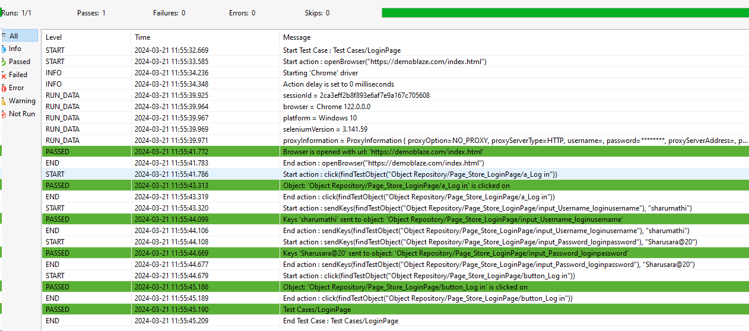

After executing the testcase we can find the logs for those case . It involves step of actions performed in testcase. It will show for both failed and passed testcases.

1. Report we get generated for :

TestSuite level

TestSuite Collection

TestSuite - Nothing but collection of testcase . We can group the testcase and execute

Step 1 : For the report : we have plugin in katalon .

Goto : <https://store.katalon.com/>

Under Utilities Section you can find Basic Report plugin

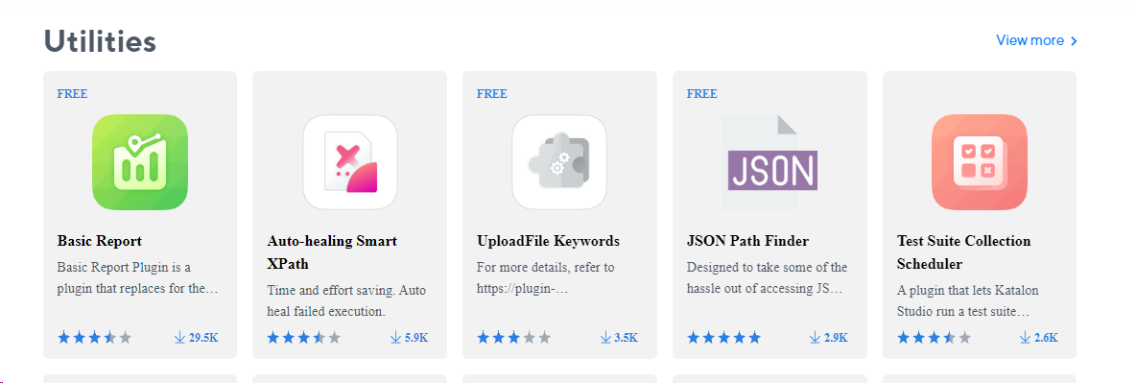

Install theplugin , it will ask you to login your katalon account . Login and Install

Step 2 :

Goto : <https://store.katalon.com/product/59/Basic-Report/change-logs>

Download this changelog , where it will support HTML and PDF report

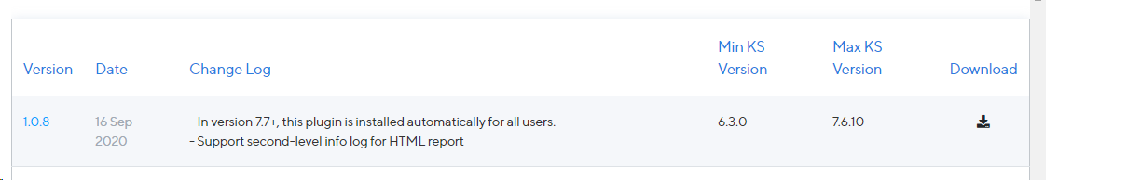

Step 3 : Once you have downloaded , unzip the file and you need to add into your katalon studio

Click on Tools -> Plugin -> Install plugin and add the unzipped file

Step 4 : To crosscheck the plugin is loaded in katalon studio

Go to Project-> Settings->Plugins -> You can view the report

Step 5 :

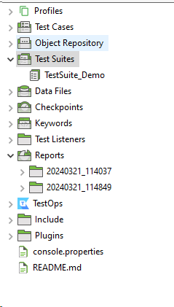

In Test Suite -> create one Testsuite folder

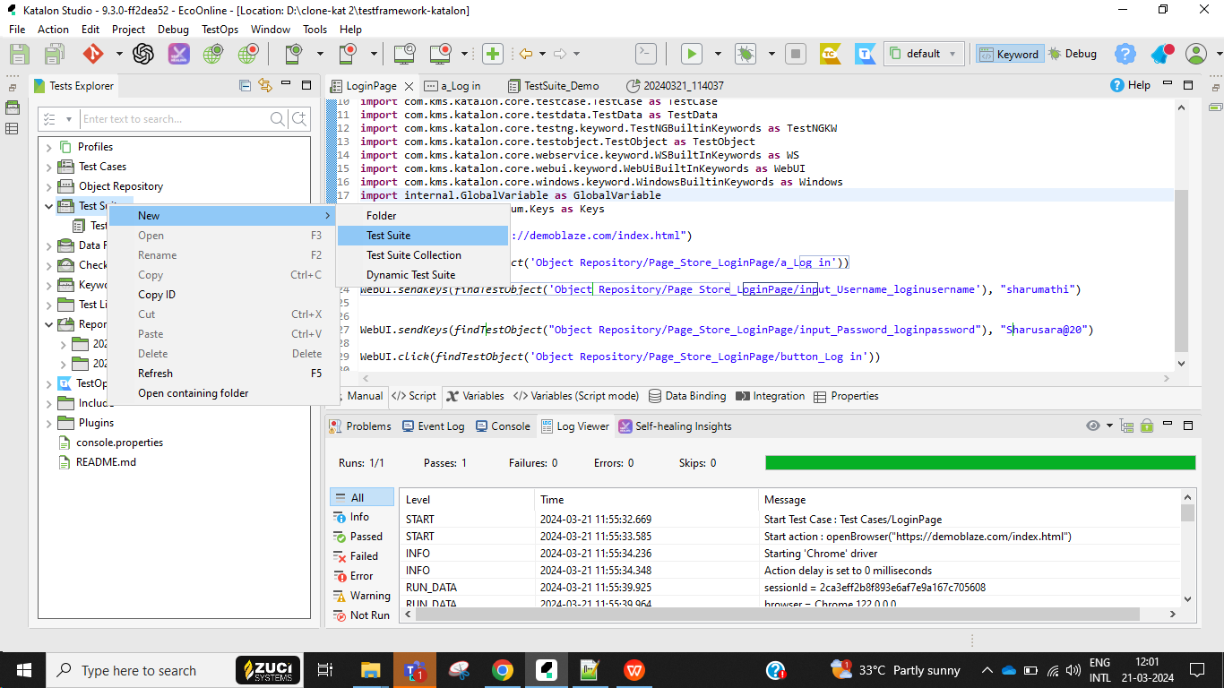

Step 6 :

Click on ADD button to add the testcase you want to setup in testsuite

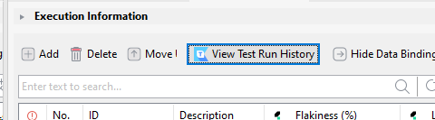

Step 7: You will get this popup to select the testcase file, select checkbox and click add & continue or OK button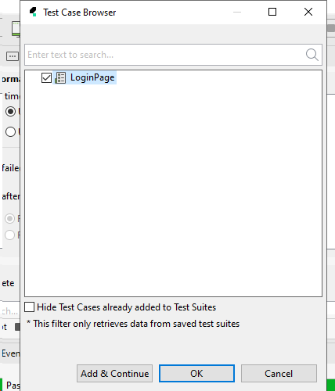

In the above screenshot it is showing only one testcase . I have only one testcase in my project .

If you have multiple testcase to setup in suite level you can select all the cases and Ok button

Step 4 :

You can find the testcase name over here

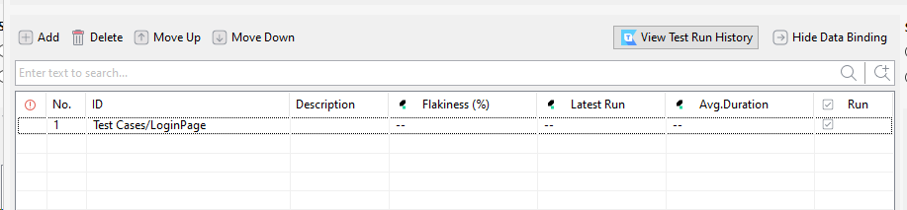

Step 5 : Then run your project

Step 6: Refresh your project and click on reports in project folder, you can find the testsuite name and report

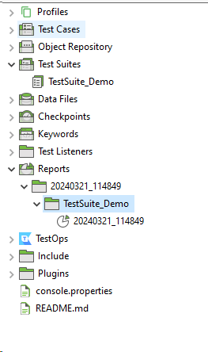

Step 7 :

You can find the TestSuite name in summary , TestCase Name

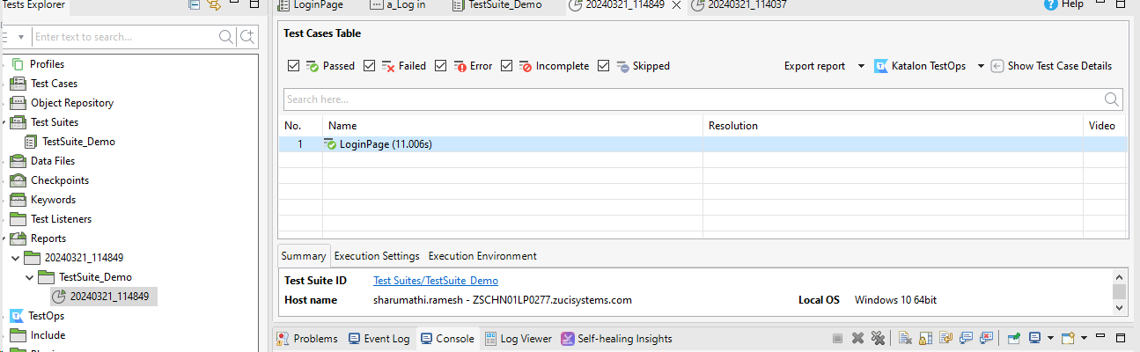

Step 8 : Click on Show testCase details on the right corner , where you can view logs of passed , failed testcases

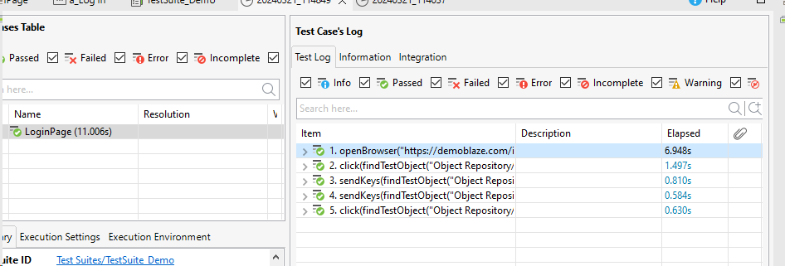

Step 9 : Also we have option to export the report as HTML, CSV , PDF format

Select the particular , right click -> export As -> and you can choose the format you need

For Html report :

It will ask you to open in any folder or else you can create a new folder

And you can view the report in HTML report .

It shows the execution env , Test Case name , passed case . If any failed cases you can view .

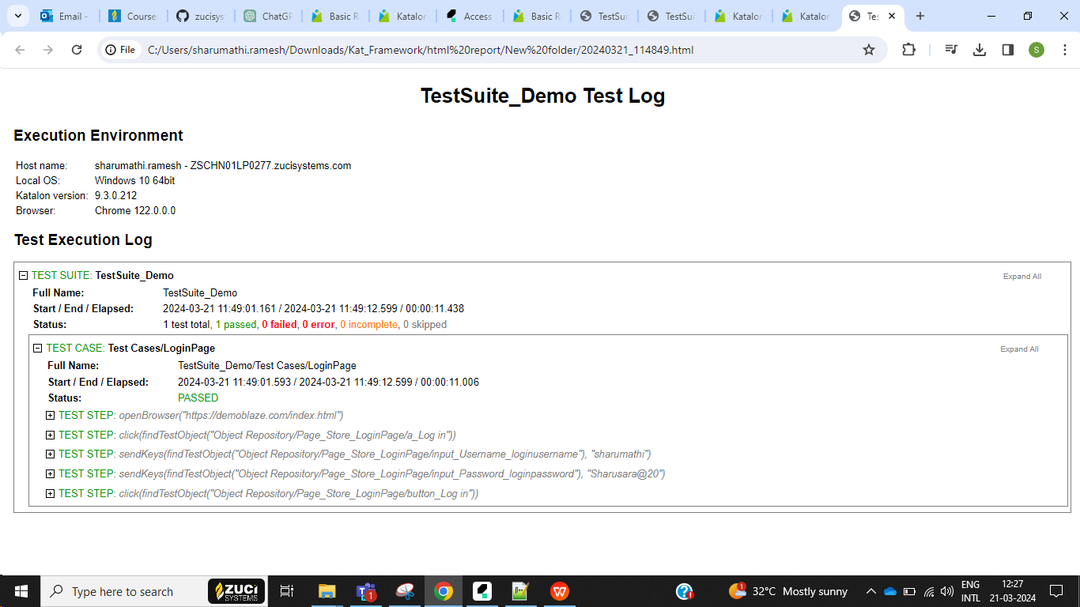

If you export as PDF format you can view in pdf format of passed and failed testcase details and the actions.

KATALON - TESTOPS

Features: we can integrate for

TestManagement

Test Execution

Reporting

CI/CD

Step 1 : Go to <https://analytics.katalon.com/> login your katalon account

Step 2 : Create a new organization and then create a new project

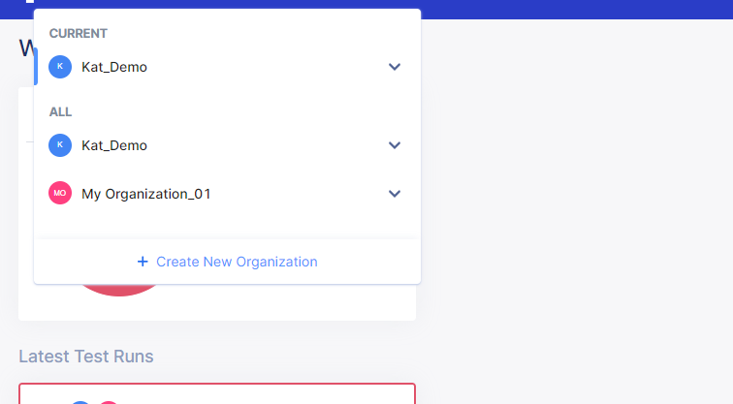

Step : Under project settings do the configuration and fetch the project you created in katalon testops

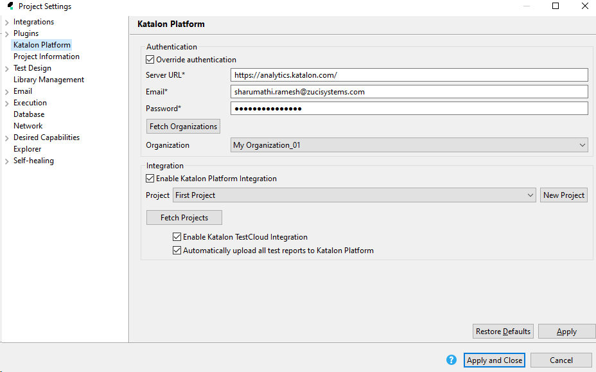

Once you executed the testcase or testsuite you can view the latestrun

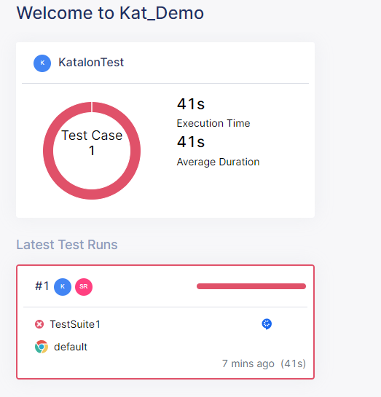

Inside the latest test run you can view the test run details

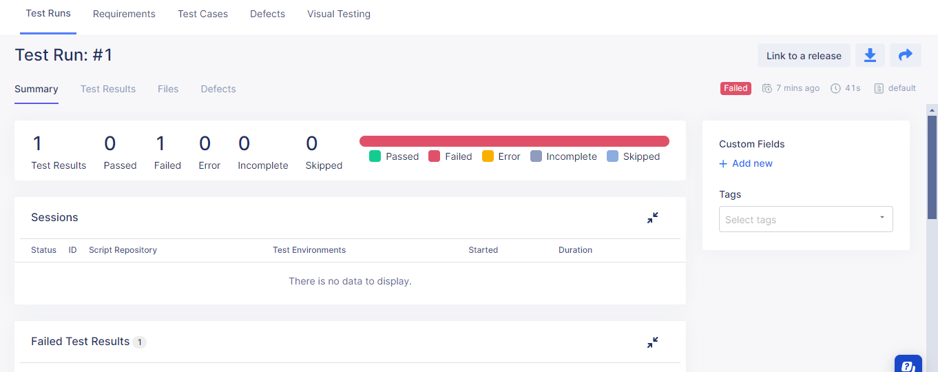

And also we can schedule the run

