WAP to Implement Single Link List with following
operations: Sort the linked list, Reverse the linked list,
Concatenation of two linked lists.
5
b) WAP to Implement Single Link List to simulate Stack &
Queue Operations.
6a)
#include<stdio.h>
#include<stdlib.h>

struct node {
int info;
struct node *next;
};

struct node *start1 = NULL;
struct node *start2 = NULL;

struct node* create(struct node *start) {
int n, item;
printf("Enter number of nodes: ");
scanf("%d", &n);

for(int i = 0; i < n; i++) {
printf("Enter item: ");
scanf("%d", &item);

struct node *p = malloc(sizeof(struct node));
p->info = item;
p->next = NULL;

if(start == NULL)
start = p;
else {
struct node *temp = start;
while(temp->next != NULL) temp = temp->next;
temp->next = p;
}
}
return start;
}

void display(struct node *start) {
if(start == NULL) {
printf("List empty");
return;
}
while(start != NULL) {
printf("%d ", start->info);
start = start->next;
}
}

void sort(struct node *start) {
struct node *p, *q;
for(p = start; p != NULL; p = p->next)
for(q = p->next; q != NULL; q = q->next)
if(p->info > q->info) {
int t = p->info;
p->info = q->info;
q->info = t;
}
}

void reverse() {
struct node *prev = NULL, *next = NULL, *curr = start1;
while(curr != NULL) {
next = curr->next;
curr->next = prev;
prev = curr;
curr = next;
}
start1 = prev;
}

void concat() {
if(start1 == NULL)
start1 = start2;
else {
struct node *temp = start1;
while(temp->next != NULL)
temp = temp->next;
temp->next = start2;
}
}

int main() {
int ch;

while(1) {
printf("\n1.Create List1\n2.Create List2\n3.Sort List1\n4.Reverse List1\n5.Concat L1 & L2\n6.Display List1\n7.Exit\n");
scanf("%d", &ch);

switch(ch) {
case 1: start1 = create(start1); break;
case 2: start2 = create(start2); break;
case 3: sort(start1); break;
case 4: reverse(); break;
case 5: concat(); break;
case 6: display(start1); break;
case 7: return 0;
default: printf("Invalid choice");
}
}
}

Output:
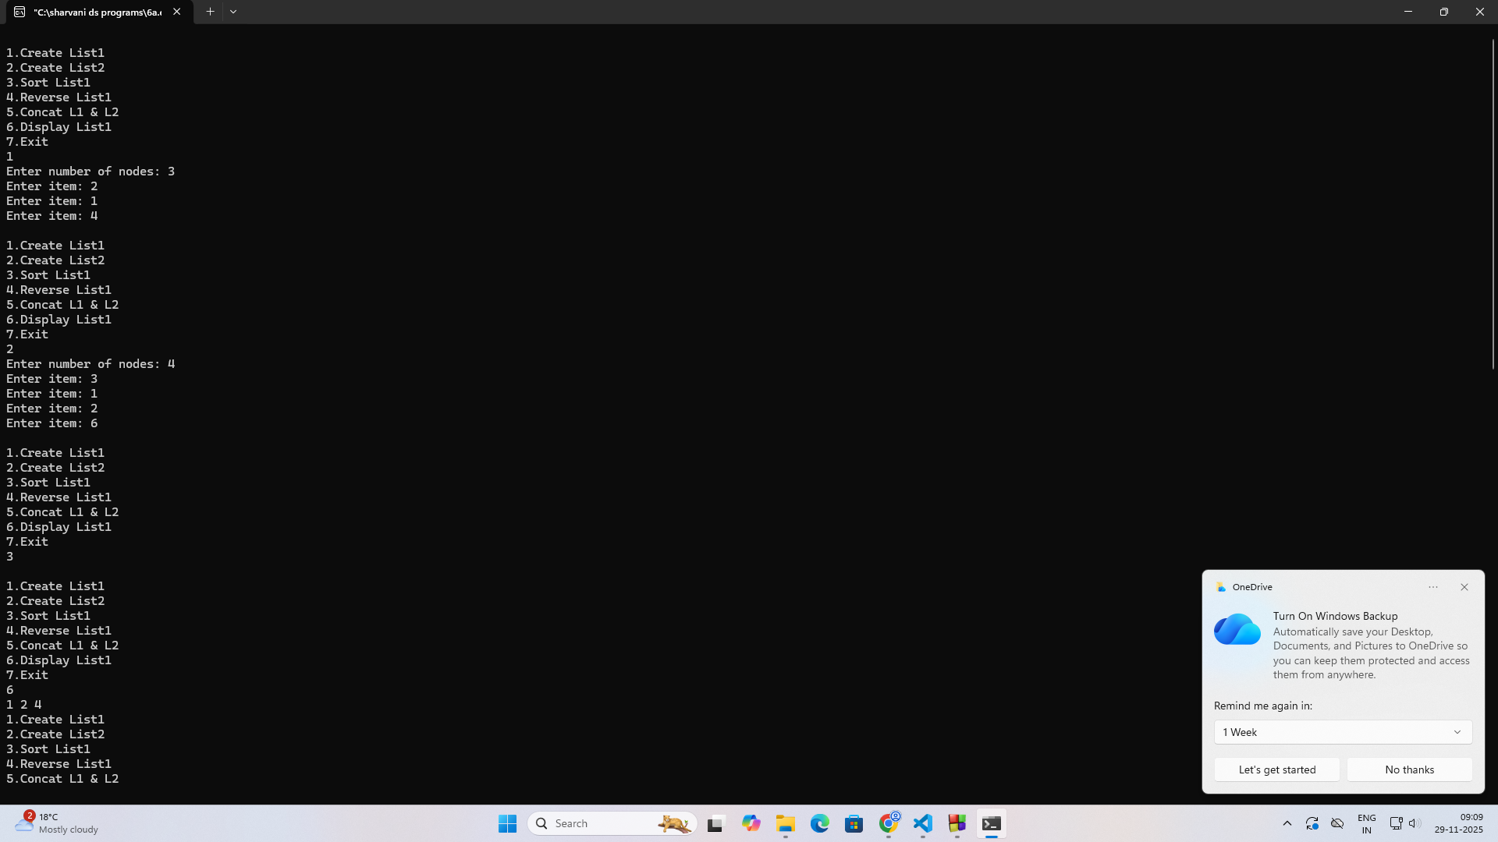
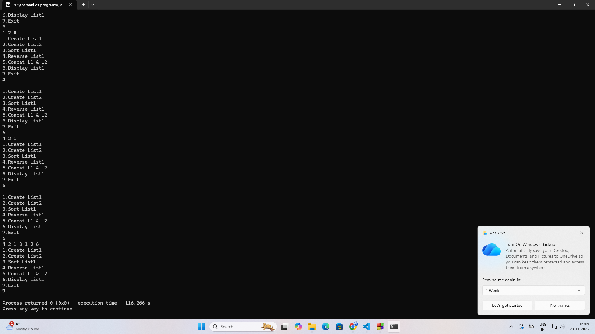
6b:program
#include<stdio.h>
#include<stdlib.h>

struct node {
int info;
struct node *next;
};

struct node *top = NULL; // stack
struct node *front = NULL; // queue
struct node *rear = NULL;

void push() {
int item;
printf("Enter item: ");
scanf("%d", &item);

struct node *p = malloc(sizeof(struct node));
p->info = item;
p->next = top;
top = p;
}

void pop() {
if(top == NULL)
printf("Stack empty");
else {
struct node *temp = top;
top = top->next;
free(temp);
}
}

void enqueue() {
int item;
printf("Enter item: ");
scanf("%d", &item);

struct node *p = malloc(sizeof(struct node));
p->info = item;
p->next = NULL;

if(front == NULL)
front = rear = p;
else {
rear->next = p;
rear = p;
}
}

void dequeue() {
if(front == NULL)
printf("Queue empty");
else {
struct node *temp = front;
front = front->next;
free(temp);
}
}

void display_stack() {
struct node *temp = top;
printf("Stack: ");
while(temp != NULL) {
printf("%d ", temp->info);
temp = temp->next;
}
}

void display_queue() {
struct node *temp = front;
printf("Queue: ");
while(temp != NULL) {
printf("%d ", temp->info);
temp = temp->next;
}
}

int main() {
int ch;

while(1) {
printf("\n1.Push\n2.Pop\n3.Display Stack\n4.Enqueue\n5.Dequeue\n6.Display Queue\n7.Exit\n");
scanf("%d", &ch);

switch(ch) {
case 1: push(); break;
case 2: pop(); break;
case 3: display_stack(); break;
case 4: enqueue(); break;
case 5: dequeue(); break;
case 6: display_queue(); break;
case 7: return 0;
default: printf("Invalid");
}
}
}

Output:
