WEATHER TREND FORECASTING
Global Weather Repository — Data Science, Forecasting & Environmental Analysis
PM Accelerator – AI Engineer Technical Assessment

Prepared by:
Sharvani Kadarla

Technology:
Python | Pandas | NumPy | Scikit-learn | Matplotlib | Seaborn | Jupyter Notebook

Dataset:
Global Weather Repository

Analysis Period:
May 2024 – October 2026

PM Accelerator AI Engineer Technical Assessment

1. Executive Summary
This project presents an end-to-end analysis of the Global Weather Repository dataset to identify weather trends, environmental relationships, geographic patterns, and short-term forecasting performance.

The analysis begins with data cleaning and validation, followed by exploratory data analysis (EDA), temporal feature engineering, weather and air-quality analysis, time-series forecasting, feature importance analysis, anomaly detection, climate variability analysis, and spatial analysis.

The dataset contains 168,591 weather observations covering 211 countries. After preprocessing, the dataset was validated for missing values, duplicate records, invalid physical measurements, and inconsistent values. Physically implausible observations were corrected using location-level median imputation, while potentially legitimate extreme weather and pollution observations were retained for further analysis.

For forecasting, Kyiv, Ukraine was selected as a focused case study. Three machine-learning models—Ridge Regression, Random Forest, and HistGradientBoosting—were evaluated alongside a previous-day naive baseline. An ensemble model was also developed. On the final test period, Ridge achieved the lowest MAE of 2.355°C, while the ensemble achieved the lowest RMSE of 3.505°C and the highest R² of 0.434.

Feature-importance analysis showed that recent temperature history, particularly the previous day's temperature and the seven-day rolling average, provided the strongest predictive signals. Advanced anomaly detection using Isolation Forest identified approximately 1% of observations as multivariate anomalies, with flagged observations showing substantially higher particulate pollution on average.

The project also examined geographic temperature patterns, climate variability within the available observation period, relationships between weather conditions and air quality, and geographic pollution hotspots. Because the dataset covers only approximately 2.4 years, the climate analysis is interpreted as descriptive climate variability rather than evidence of long-term climate change.

2. Project Objective & PM Accelerator Mission

2.1 Project Objective

The objective of this project is to analyze the Global Weather Repository dataset and use data science and machine-learning techniques to identify weather trends, forecast future weather conditions, analyze anomalies, investigate environmental relationships, and identify geographic patterns.

The project was designed to demonstrate an end-to-end data science workflow, including data preprocessing, exploratory data analysis, forecasting, model evaluation, advanced analysis, visualization, and documentation.

2.2 PM Accelerator Mission

I’m on a mission to help launch 1,000+ AI products and empower professionals like you to become the next generation of AI product leaders — impacting millions of lives through real-world innovation.

Source: PM Accelerator official website
https://www.pmaccelerator.io/

3. Dataset Overview

The analysis uses the Global Weather Repository dataset available through Kaggle. The dataset contains weather observations collected across locations worldwide along with geographic information and air-quality measurements.

The dataset includes variables related to temperature, precipitation, humidity, wind, atmospheric pressure, visibility, UV index, and multiple air-quality indicators including carbon monoxide (CO), ozone, nitrogen dioxide (NO₂), sulphur dioxide (SO₂), PM2.5, and PM10.

The original dataset contained 168,591 observations and 41 columns. The observation timestamps ranged from May 16, 2024 to October 1, 2026 and covered 211 countries.

Table 1
Metric | Value
Observations | 168,591
Original columns | 41
Final columns | 49
Countries | 211
Raw locations | 268
Earliest observation | May 16, 2024
Latest observation | October 1, 2026
Duplicate rows | 0
Initial missing values | 0

4. Data Cleaning & Preprocessing

4.1 Initial Data Quality Assessment

The initial data-quality assessment was performed to understand the structure, completeness, consistency, and reliability of the Global Weather Repository dataset before conducting exploratory analysis and forecasting.

The original dataset contained 168,591 observations and 41 columns. The dataset included weather measurements, geographic information, timestamps, and air-quality indicators.

Missing Values:
An initial missing-value check showed 0 missing values across all 41 columns. Therefore, no general missing-value imputation was required at the initial stage. However, additional validation was performed to identify physically invalid or sentinel values that may not be represented as conventional missing values.

Duplicate Records:
A duplicate-row check identified 0 duplicate records. This indicated that each row represented a unique observation in the original dataset.

Data Types:
The data types of all variables were inspected to ensure that numerical measurements were stored as numeric values and categorical fields were treated appropriately. The last_updated field was converted from its original representation into a proper datetime format to support temporal analysis and forecasting.

Timestamp Validation:
After conversion, the last_updated variable ranged from May 16, 2024 to October 1, 2026. This timestamp was subsequently used to create temporal features such as year, month, day, day of year, day of week, ISO week number, and season.

Invalid and Physically Implausible Values:
Although the dataset contained no conventional missing values, validation checks identified several values that were physically implausible or inconsistent with the expected measurement ranges. Examples included an extreme temperature reading of 79.3°C, several unusually high wind-speed measurements, pressure values above a reasonable atmospheric range, and negative air-quality measurements including sentinel-style -9999 values.

These observations were not automatically removed. Values determined to be physically invalid were converted to missing values and subsequently imputed using the median value for the corresponding location. Potentially legitimate extreme weather and pollution observations were retained for further analysis.

Outlier Assessment:
Outlier analysis was performed separately from basic data cleaning. This distinction was important because an extreme observation is not necessarily an erroneous observation. Potentially legitimate extremes, such as unusually high precipitation or pollution measurements, were preserved and later examined using statistical anomaly-detection techniques.

Overall, the initial assessment confirmed that the dataset was structurally complete, contained no duplicate rows, and required targeted validation of physical measurement ranges before further analysis.

Table 2
Data Quality Check | Result
Initial observations | 168,591
Initial variables | 41
Missing values | 0
Duplicate rows | 0
Timestamp converted | Yes
Earliest timestamp | May 16, 2024
Latest timestamp | October 1, 2026
Physical-value validation | Performed
Outlier/anomaly analysis | Performed separately

4.2 Handling Invalid Values

Table 3
Variable | Issue Identified | Action
Temperature | 79.3°C extreme/implausible value | Location median imputation
Wind | Extreme wind/gust values | Location median imputation
Pressure | Values >1100 mb | Location median imputation
CO/SO₂ | -9999 sentinel values | Converted to missing and imputed
PM10/PM2.5 | Negative values | Converted to missing and imputed
Precipitation | Extreme but potentially legitimate values | Retained

Extreme values were not automatically removed. Physically impossible observations were corrected, while potentially legitimate extreme weather and pollution observations were retained for subsequent anomaly analysis.

4.3 Temporal Feature Engineering

Because weather patterns vary over time, the `last_updated` timestamp was transformed into multiple temporal features to support exploratory analysis, seasonal pattern identification, and forecasting.

The `last_updated` column was first converted into a datetime format. The resulting timestamp range covered observations from **May 16, 2024 through October 1, 2026**. Several calendar-based features were then extracted from this timestamp.

Table 4 - Temporal Feature Engineering
Feature | Description
Year | Extracted year from the timestamp
Month | Extracted month (1–12) from the timestamp
Day | Extracted day of the month
Day of Week | Day of the week represented numerically
Day of Year | Position of the day within the year
Week of Year | Calendar week number
Quarter | Quarter of the year (1–4)
Season | Winter, Spring, Summer, or Fall
Is Weekend | Binary indicator for Saturday/Sunday
Is Month Start | Indicates whether the date is the first day of a month
Is Month End | Indicates whether the date is the last day of a month
Lag Features | Previous observations used to capture temporal dependency
Rolling Mean | Moving average used to smooth short-term fluctuations
Rolling Standard Deviation | Measures variability over a moving time window
Cyclic Sine Feature | Encodes the cyclical nature of time using a sine transformation
Cyclic Cosine Feature | Encodes the cyclical nature of time using a cosine transformation

Table 5 - Season Definitions
Season | Months
Winter | December – February
Spring | March – May
Summer | June – August
Fall | September – November

Table 6 - Forecasting-Specific Features
Feature | Purpose
Lag 1 | Previous day's weather value
Lag 7 | Weather value from the previous week
Rolling Mean (7-day) | Captures recent average weather conditions
Rolling Std (7-day) | Captures recent weather variability
Temperature Trend | Identifies increasing or decreasing temperature trends
Precipitation Trend | Captures recent precipitation behavior

The seasons were defined using the following calendar grouping:

- Winter: December, January, February
- Spring: March, April, May
- Summer: June, July, August
- Fall: September, October, November

The dataset was also sorted chronologically by `location_name` and `last_updated`. This ordering was important for the forecasting stage because lag and rolling features must be generated from observations that occurred earlier in time.

Importance for Forecasting

The temporal features provided information about the seasonal and calendar context of each observation. In particular, `day_of_year`, `month`, and the seasonal representation helped the forecasting models capture recurring annual weather patterns.

For the Kyiv forecasting case study, additional time-series features were created from the daily temperature series, including:

- Previous-day temperature (`lag_1`)
- Two-day lag (`lag_2`)
- Seven-day lag (`lag_7`)
- Fourteen-day lag (`lag_14`)
- Seven-day rolling temperature average (`rolling_7`)
- Fourteen-day rolling temperature average (`rolling_14`)
- Sine and cosine transformations of `day_of_year`

The cyclic sine and cosine transformations were used to represent the cyclical nature of the annual calendar. This allows the models to recognize that the end and beginning of a year are temporally close, rather than treating December and January as distant numerical values.

Overall, temporal feature engineering transformed the raw timestamp into meaningful calendar and time-series variables that could be used for exploratory analysis, seasonal comparisons, and weather forecasting.

4.4 Final Data Quality Validation

After correcting physically invalid values and creating the required temporal features, a final data-quality validation was performed to confirm that the cleaned dataset was suitable for exploratory analysis, statistical analysis, and forecasting.

The cleaning process preserved the original number of observations while correcting invalid measurements. The final dataset contained 168,591 observations and 49 variables. The increase from 41 to 49 variables resulted from the temporal features created during preprocessing.

The final validation focused on duplicate records, missing values, invalid weather measurements, and negative environmental measurements.

Final Data Quality Checks

Table 7 - Final Data Quality Validation Results
Data Quality Check | Result
Final observations | 168,591
Final variables | 49
Duplicate rows | 0
Missing values | 0
Invalid humidity values | 0
Invalid cloud values | 0
Negative precipitation values | 0
Negative wind values | 0
Negative air-quality values | 0
Timestamp validation | Passed
Temperature unit consistency | Passed
Wind-speed unit consistency | Passed

The final validation confirmed that no duplicate rows remained and that all missing values introduced during the correction of invalid measurements were successfully imputed using location-level median values.

Humidity and cloud-cover values were also checked against their expected ranges. No remaining invalid values were identified. Precipitation and wind-speed measurements were checked to ensure that no negative values remained. Air-quality variables were similarly validated to ensure that invalid negative measurements and sentinel values had been addressed.

Unit Consistency Checks

Additional validation was performed to confirm consistency between weather variables reported in different units.

Temperature was available in both Celsius and Fahrenheit. The Celsius-to-Fahrenheit relationship was checked across the dataset. The maximum absolute difference between the reported Fahrenheit value and the value calculated from Celsius was approximately 0.12°F, which is within an acceptable rounding difference.

Wind speed was also available in miles per hour and kilometers per hour. The reported values were compared against the expected conversion relationship. The maximum observed conversion difference was approximately 0.12 km/h, indicating that the two representations were consistent within rounding precision.

These checks reduced the risk of using inconsistent unit representations during exploratory analysis and forecasting.

Treatment of Extreme but Potentially Valid Observations

The cleaning process distinguished between invalid measurements and legitimate extreme observations.

Physically implausible values, such as the 79.3°C temperature record and extreme wind-speed values, were corrected because they were inconsistent with realistic weather measurements. In contrast, observations such as the 74.52 mm precipitation measurement recorded in Nassau, Bahamas were retained because extreme precipitation can occur during severe weather events and the value could not be identified as invalid based solely on its magnitude.

Similarly, unusually high particulate-matter concentrations were not automatically removed. These observations were investigated separately through statistical anomaly detection and geographic analysis.

This approach prevented the preprocessing stage from artificially reducing genuine weather and environmental variability.

Final Cleaned Dataset

The resulting cleaned dataset was saved as: `data/processed/weather_cleaned.csv`

The cleaned dataset was then used as the primary input for all subsequent exploratory analysis, anomaly detection, climate variability analysis, environmental impact analysis, spatial analysis, and forecasting.

Overall, the final validation confirmed that the dataset was structurally consistent, free of duplicate records and remaining invalid values, and suitable for the next stages of the project.

5. Exploratory Data Analysis

After completing the preprocessing and final validation, exploratory data analysis (EDA) was conducted to understand the overall distribution of weather variables, identify seasonal patterns, examine relationships between variables, and detect important patterns in precipitation and temperature.

The EDA focused primarily on temperature, precipitation, humidity, wind speed, atmospheric pressure, visibility, UV index, and air-quality variables.

5.1 Descriptive Statistics

The cleaned dataset was first summarized using descriptive statistics including the mean, median, standard deviation, minimum, and maximum values.

Table 8 - Descriptive Statistics of Key Weather and Environmental Variables
Variable | Mean | Median | Minimum | Maximum
Temperature (°C) | 21.46 | 23.60 | -29.80 | 49.20
Precipitation (mm) | 0.13 | 0.00 | 0.00 | 74.52
Humidity (%) | 67.03 | 72.00 | 2.00 | 100.00
Wind Speed (km/h) | 12.68 | 10.40 | — | 205.90
Pressure (mb) | 1013.99 | 1014.00 | 771.00 | 1080.00
Visibility (km) | 9.50 | 10.00 | 0.00 | 32.00
UV Index | 3.07 | 1.40 | — | 16.30
PM2.5 | 22.58 | 13.02 | — | 1614.10
PM10 | 45.25 | 18.50 | — | 6037.29

The descriptive statistics show substantial variability across the global dataset. The mean temperature was approximately 21.46°C, while the observed range extended from -29.8°C to 49.2°C. Precipitation had a highly skewed distribution, with a median of zero and a maximum of 74.52 mm, indicating that many observations contained little or no precipitation while a smaller number represented heavier rainfall events.

Humidity had a mean of approximately 67%, while wind speed averaged approximately 12.68 km/h. Air-quality variables, particularly PM2.5 and PM10, displayed substantial ranges, reflecting differences in environmental conditions across geographic locations.

5.2 Monthly Temperature Trends

Monthly average temperatures were calculated to identify broad seasonal patterns within the dataset.

Figure 1 - temperature_by_latitude_band.png
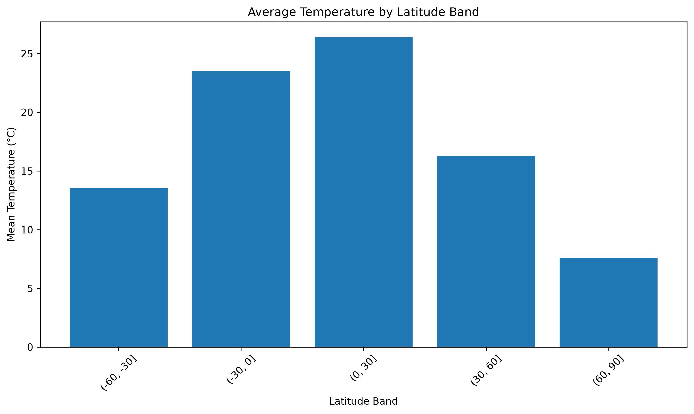

Table 9 - Average Temperature by Month
Month | Mean Temperature (°C)
January | 16.07
February | 16.71
March | 18.70
April | 20.71
May | 22.96
June | 24.79
July | 25.05
August | 24.79
September | 23.40
October | 21.59
November | 18.89
December | 17.00

The monthly results show a clear seasonal pattern in the global dataset. Average temperatures increased from winter into spring and reached their highest monthly average in July at approximately 25.05°C. Temperatures then decreased through the fall and returned to lower levels during December and January.

Because the dataset contains observations from locations across both hemispheres, these monthly averages should be interpreted as global descriptive statistics rather than as a representation of a single geographic region.

5.3 Seasonal Temperature Analysis

Seasonal averages were also calculated to provide a broader view of temperature variation.

Table 10 - Average Temperature by Season
Season | Mean Temperature (°C)
Winter | 16.60
Spring | 20.98
Summer | 24.88
Fall | 21.60

The results show that Summer had the highest average temperature at approximately 24.88°C, followed by Fall and Spring. Winter had the lowest average temperature at approximately 16.60°C.

These differences demonstrate the importance of temporal features in modeling weather patterns.

5.4 Precipitation Analysis
Precipitation was analyzed using monthly and seasonal averages to identify periods with relatively higher rainfall activity.

Table 11 - Average Precipitation by Month
Month | Mean Precipitation (mm)
January | 0.122
February | 0.106
March | 0.122
April | 0.114
May | 0.133
June | 0.132
July | 0.151
August | 0.144
September | 0.158
October | 0.128
November | 0.136
December | 0.111

September had the highest average precipitation at approximately 0.158 mm, followed by July and August. February had the lowest monthly average at approximately 0.106 mm.

The relatively low overall precipitation mean and median indicate that the dataset contains many observations with little or no rainfall, while a smaller number of observations contain substantially higher precipitation values.

5.5 Correlation Analysis

A correlation analysis was performed to identify linear relationships among weather and environmental variables.

Figure 2 - Correlation Matrix of Weather and Air-Quality Variables
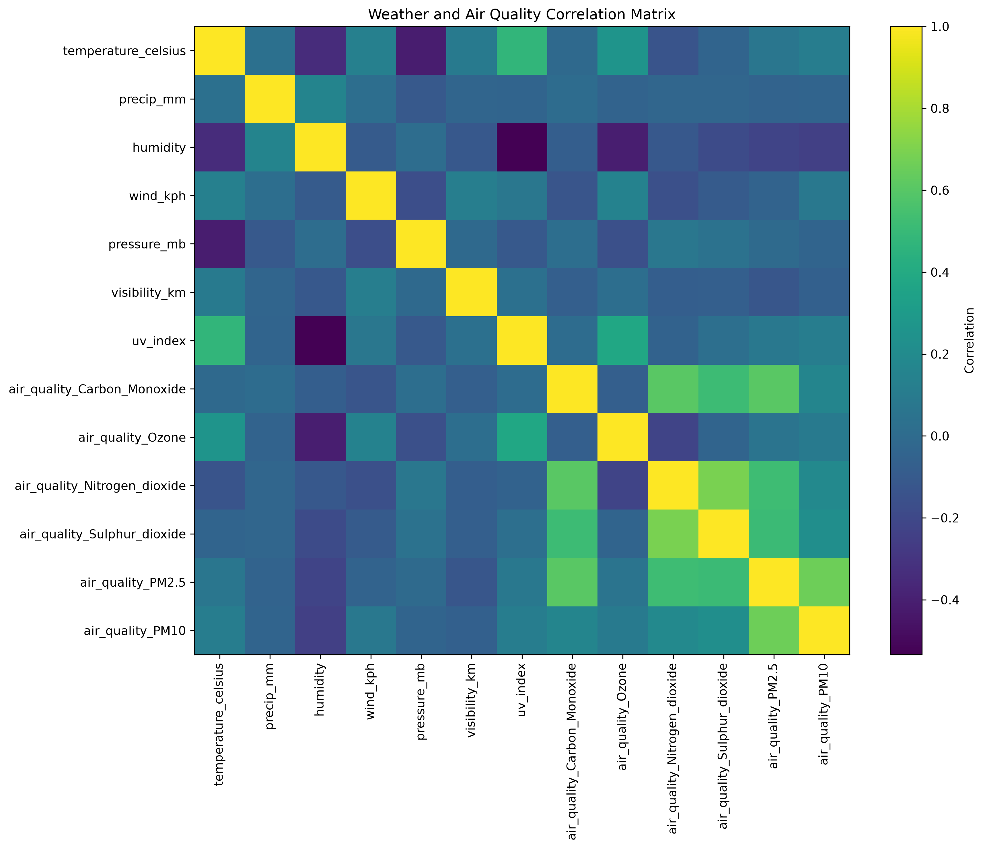
The correlation analysis identified several notable relationships.

Temperature showed a positive correlation with UV index of approximately 0.48 and a negative correlation with atmospheric pressure of approximately -0.41. Temperature also showed a negative relationship with humidity of approximately -0.34.

Among the air-quality variables, NO₂ and SO₂ showed a relatively strong positive correlation of approximately 0.69. PM2.5 and PM10 were also positively correlated at approximately 0.66. CO and PM2.5 showed a correlation of approximately 0.61.

Humidity showed a negative relationship with UV index of approximately -0.53 and with ozone of approximately -0.41.

These correlations represent statistical associations within the pooled global dataset. They should not be interpreted as evidence of direct causal relationships because geographic differences, local climate conditions, seasonality, and other unobserved factors may influence these relationships.

6. Weather and Air-Quality Analysis

The relationship between weather conditions and air quality was examined to understand how environmental variables varied under different temperature, humidity, and wind conditions.

6.1 Temperature and Air Quality
Temperature observations were grouped into four categories:
- Cold: below 10°C
- Mild: 10–20°C
- Warm: 20–30°C
- Hot: above 30°C

Table 12 - Air-Quality Statistics by Temperature Category
Temperature Category | PM2.5 | PM10 | Ozone | NO2 | SO2 | CO
Cold | 24.32 | 29.51 | 45.65 | 23.19 | 13.74 | 501.25
Mild | 19.72 | 35.08 | 53.10 | 17.25 | 10.88 | 403.49
Warm | 19.51 | 39.78 | 56.71 | 8.68 | 6.37 | 358.58
Hot | 36.95 | 96.44 | 80.89 | 19.38 | 15.64 | 576.31

The hot-temperature category had higher average PM2.5, PM10, ozone, SO2, and CO concentrations than the warm category. However, these differences should be interpreted as associations in the dataset rather than direct causal effects of temperature.

6.2 Humidity and Air Quality
Humidity was divided into four categories:
- Low: below 40%
- Moderate: 40–60%
- High: 60–80%
- Very High: above 80%

Figure 3 - PM2.5 Concentration by Humidity Category
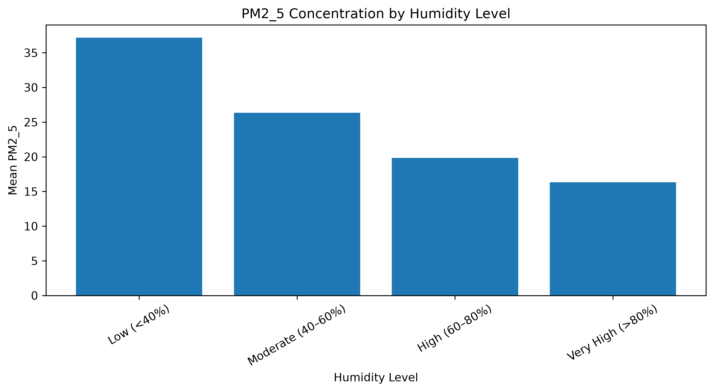
The average PM2.5 concentration decreased across the humidity categories, from approximately 37.17 in the low-humidity group to approximately 16.33 in the very-high-humidity group.

Figure 4 - PM10 Concentration by Humidity Category
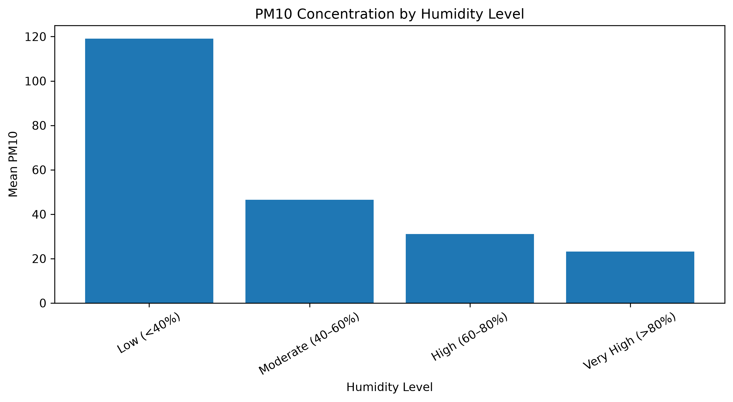
PM10 showed a similar pattern, with the highest average concentration occurring in the low-humidity category.

Additional humidity-related visualizations were generated for CO, NO2, ozone, and SO2.

Figure 5 - CO Concentration by Humidity Category
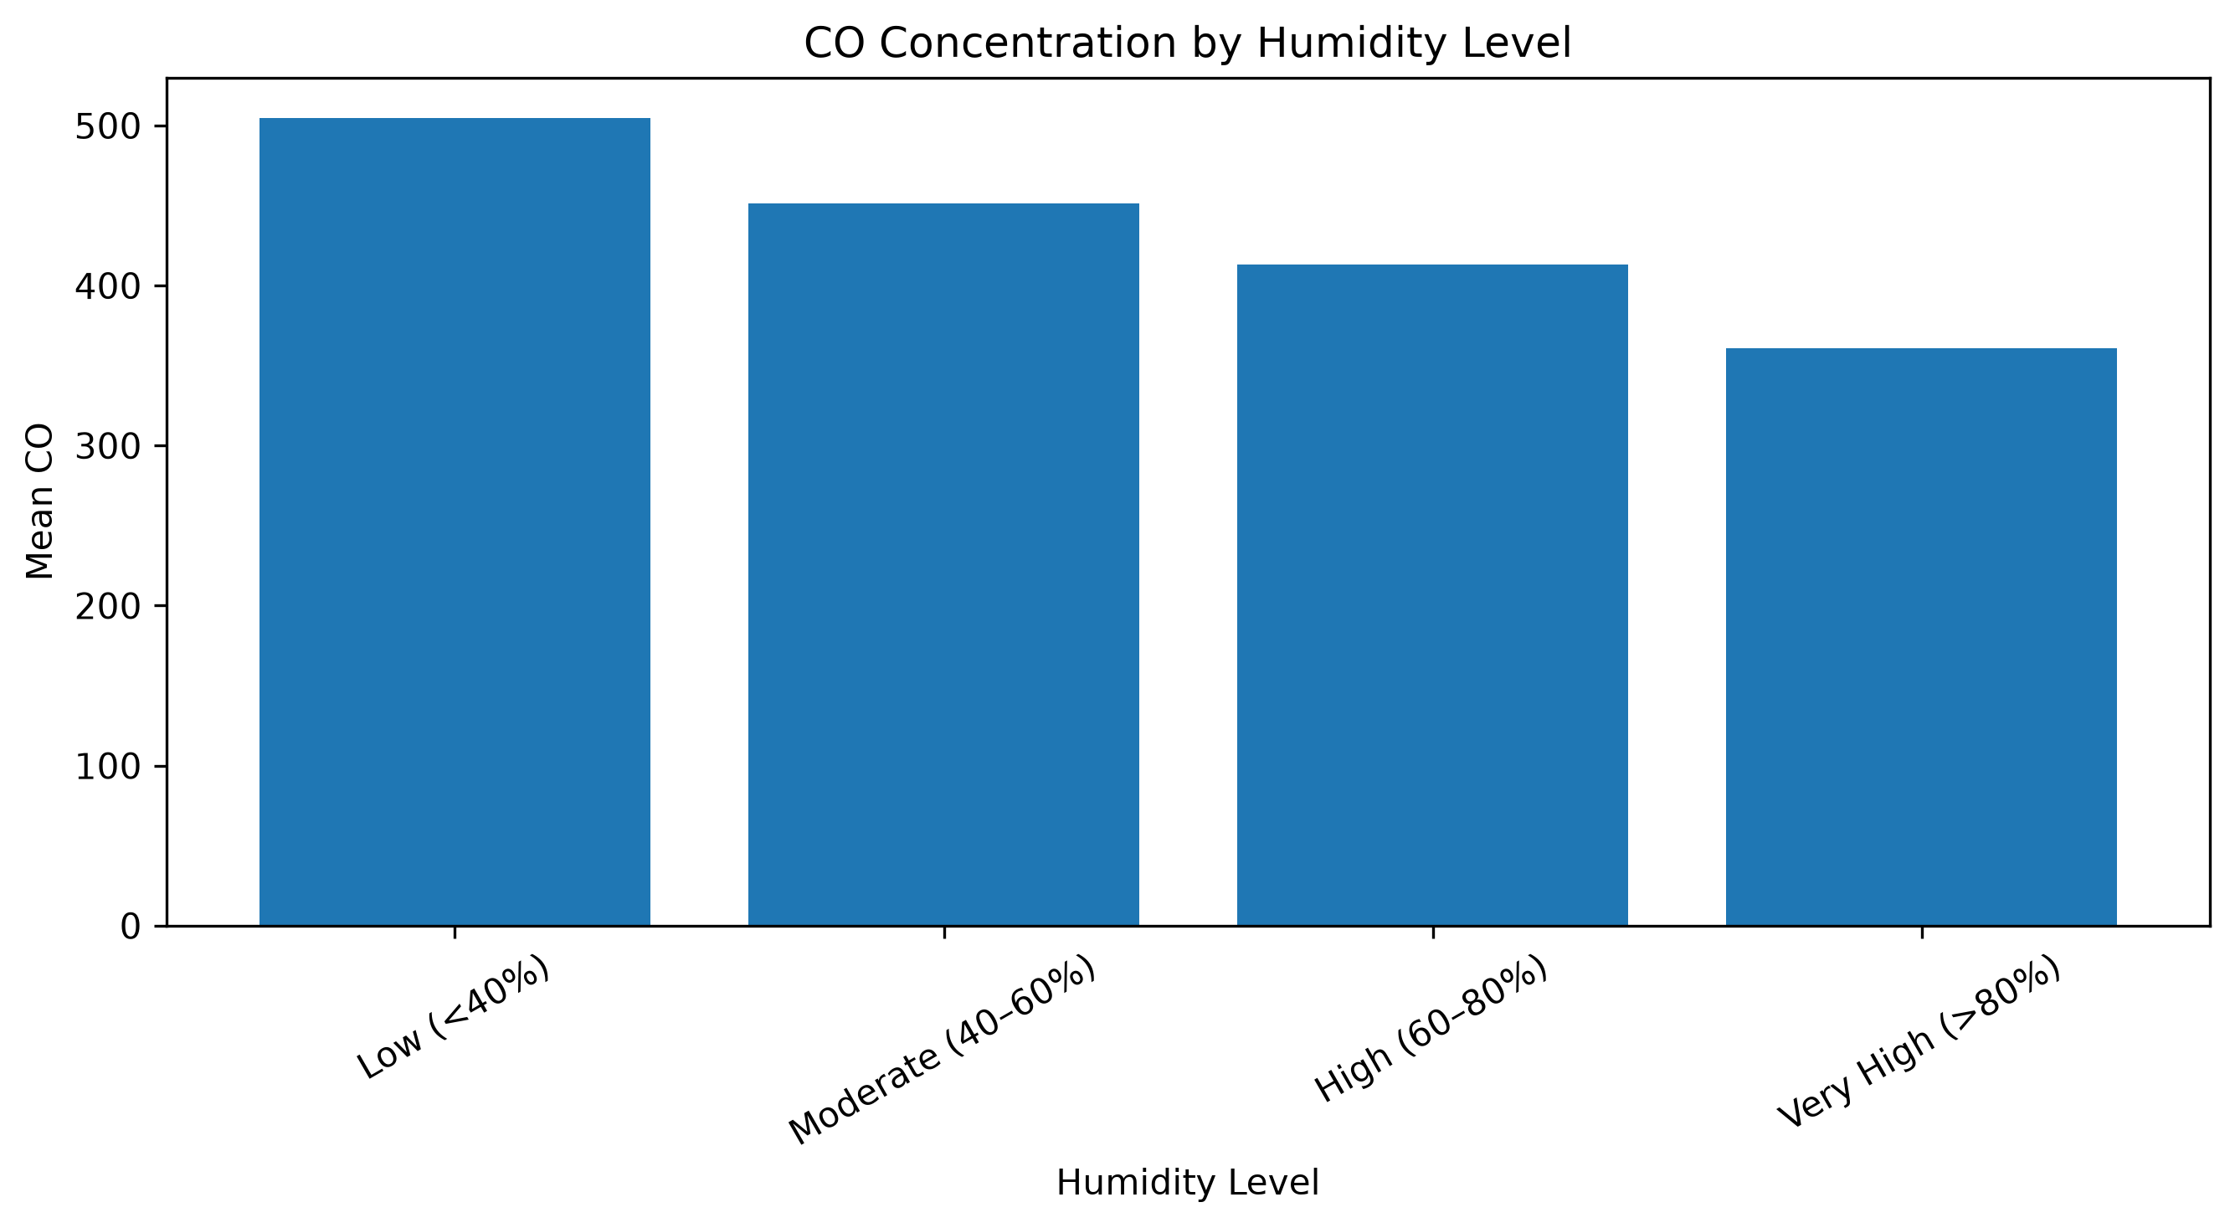

Figure 6 - NO2 Concentration by Humidity Category
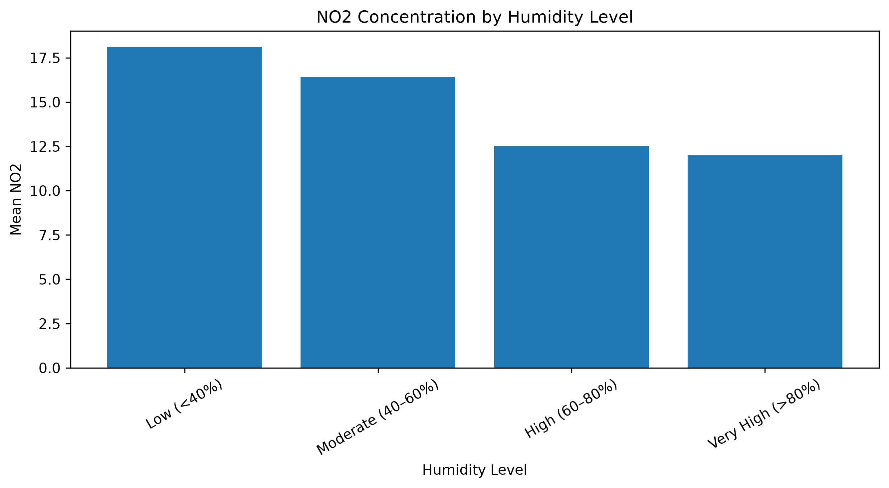

Figure 7 - Ozone Concentration by Humidity Category
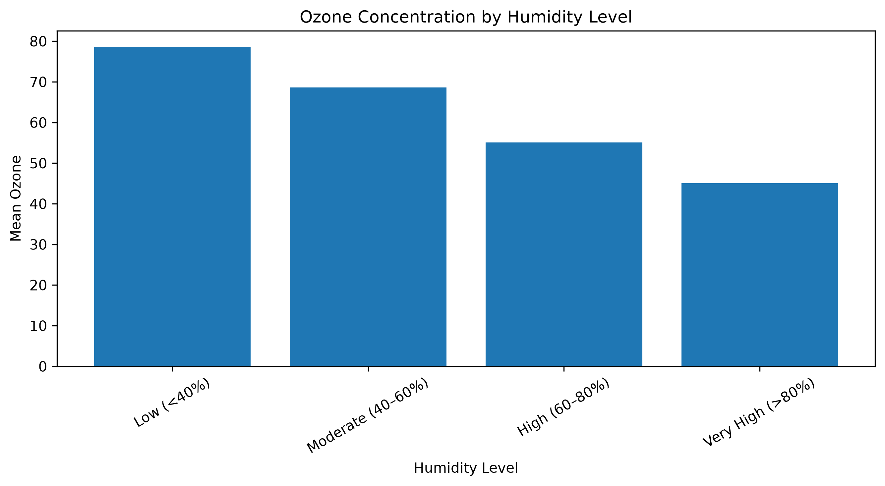

Figure 8 - SO2 Concentration by Humidity Category
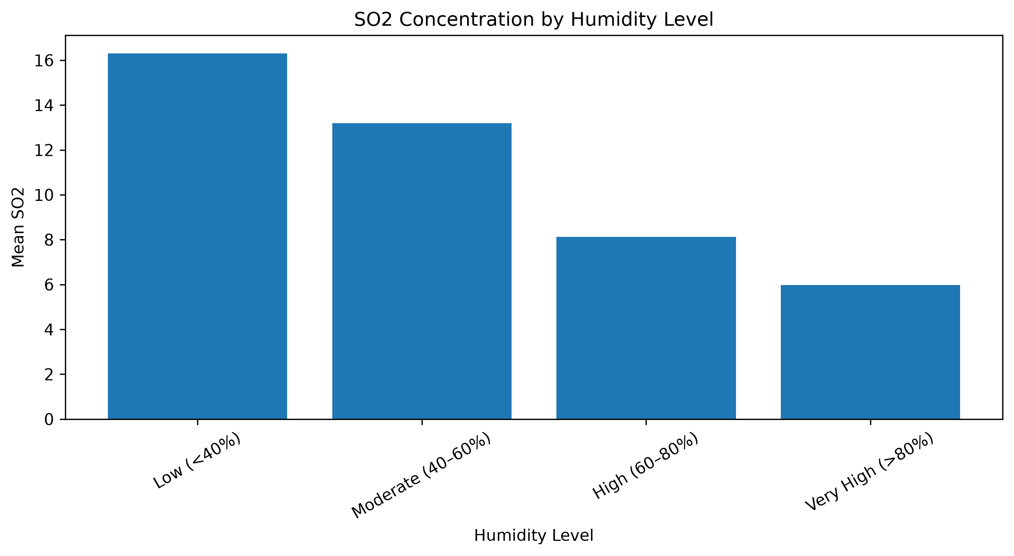

Overall, the humidity analysis indicates that several air-quality measurements varied across humidity categories. However, these patterns may also reflect geographic and seasonal differences represented in the global dataset.

7. Forecasting Methodology

A forecasting case study was developed using Kyiv, Ukraine to demonstrate time-series forecasting at an individual location.

Kyiv was selected as the primary case study because it contained a sufficiently long sequence of observations for constructing daily time-series features and evaluating forecasting models.
The Kyiv subset contained 867 observations, covering approximately May 16, 2024 through October 1, 2026.

Because the original observations were timestamped at different times, the data were aggregated to daily frequency. Daily temperature was calculated using the daily mean, while precipitation was aggregated using the daily sum. Other weather and air-quality variables were aggregated using daily means.

The resulting daily dataset contained 869 calendar dates.

7.1 Forecasting Features
The forecasting model used historical temperature and calendar information as predictors.

The main features included:
- Month
- Day of year
- Day of week
- Previous-day temperature
- Two-day lag
- Seven-day lag
- Fourteen-day lag
- Seven-day rolling temperature average
- Fourteen-day rolling temperature average
- Sine of day of year
- Cosine of day of year

Lag variables allowed the models to use previous temperature observations as predictors. Rolling averages provided information about recent temperature trends, while sine and cosine transformations represented the cyclical nature of annual seasonality.

7.2 Chronological Data Split
To avoid using future information when predicting earlier observations, the data were divided chronologically rather than randomly.

Table 13 - Chronological Forecasting Data Split
Dataset | Rows | Period
Training | 589 | May 30, 2024 – January 16, 2026
Validation | 126 | January 17, 2026 – May 27, 2026
Test | 127 | May 28, 2026 – October 1, 2026

The training set was used to fit the models, the validation set was used for model comparison and ensemble weighting, and the final test set was kept for evaluating performance on unseen future observations.

8. Forecasting Models

Four forecasting approaches were evaluated:
- Previous-day naive baseline
- Ridge Regression
- Random Forest Regression
- HistGradientBoosting Regression

An ensemble model combining the three machine-learning models was also evaluated.

8.1 Naive Baseline
The previous-day temperature was used as a simple baseline. Under this approach, the predicted temperature for a given day was equal to the temperature observed on the previous available day.

The baseline provides a reference point for determining whether machine-learning models provide meaningful improvement.

8.2 Ridge Regression
Ridge Regression was used as a regularized linear model. Feature scaling was applied because the predictor variables have different numerical ranges.

Ridge Regression provided a relatively strong forecasting result, particularly during validation.

8.3 Random Forest Regression
Random Forest Regression was used to capture nonlinear relationships between historical temperatures, rolling averages, and calendar features.

Random Forest does not require feature normalization in the same way as linear models because it uses decision-tree-based splitting.

8.4 HistGradientBoosting Regression
HistGradientBoosting Regression was included as another tree-based nonlinear model capable of learning complex relationships between the engineered forecasting features and temperature.

8.5 Ensemble Model
An ensemble was created by combining the predictions of Ridge Regression, Random Forest, and HistGradientBoosting.

The model weights were determined using inverse validation MAE, giving greater weight to models that performed better on the validation set.

The resulting weights were approximately:

Table 14
Model | Ensemble Weight
Ridge Regression | 0.387
Random Forest | 0.296
HistGradientBoosting | 0.317

The purpose of the ensemble was to combine predictions from models with different learning characteristics rather than relying on a single forecasting approach.

9. Forecasting Model Evaluation

Model performance was evaluated using three metrics:
- MAE (Mean Absolute Error): average absolute prediction error in degrees Celsius.
- RMSE (Root Mean Squared Error): penalizes larger prediction errors more heavily.
- R²: measures the proportion of variance explained by the model.

Table 15 - Forecasting Model Performance
Model | Validation MAE | Validation RMSE | Validation R² | Test MAE | Test RMSE | Test R²
Naive Baseline | — | — | — | 2.695 | 4.078 | 0.234
Ridge Regression | 2.291 | 3.099 | 0.893 | 2.355 | 3.527 | 0.427
Random Forest | 2.989 | 4.281 | 0.795 | 2.592 | 3.572 | 0.413
HistGradientBoosting | 2.794 | 3.781 | 0.840 | 2.735 | 3.746 | 0.354
Ensemble | 2.475 | 3.303 | 0.878 | 2.424 | 3.505 | 0.434

The test results show that all three machine-learning models improved upon the previous-day naive baseline in terms of MAE and RMSE, while also achieving higher R² values.

Ridge Regression achieved the lowest test MAE at 2.355°C. The ensemble achieved the lowest test RMSE at 3.505°C and the highest test R² at 0.434 among the evaluated models.

The difference between validation and test performance is also important. For example, Ridge Regression achieved a validation R² of 0.893 but a test R² of 0.427. This indicates that performance varied across the forecasting period and suggests that seasonal or distributional changes affected generalization.

Figure 9 - Kyiv Actual vs. Predicted Temperature
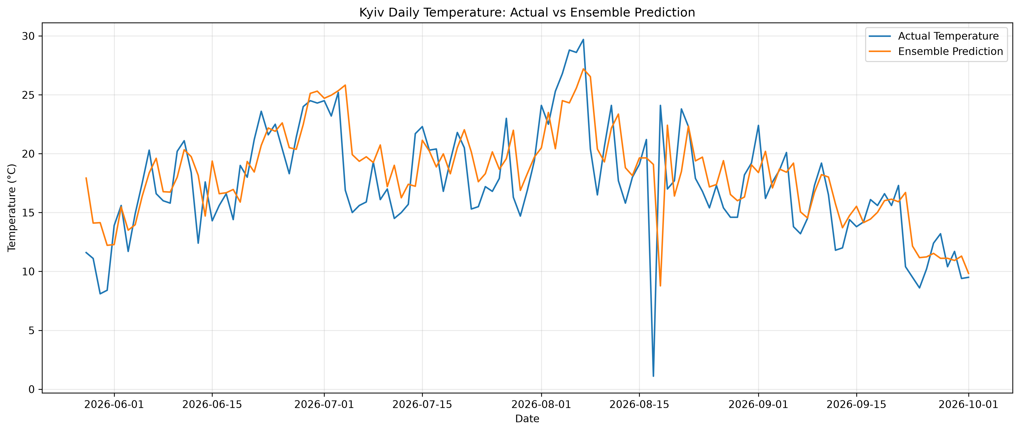

The actual-versus-predicted visualization shows how the forecasting models tracked the observed temperature series during the test period. The predictions generally followed the broad movement of the observed temperatures while showing some deviations during larger temperature changes.

10. Feature Importance Analysis

Feature importance analysis was conducted to determine which engineered variables contributed most strongly to the Random Forest forecasting model.

Two approaches were used:
- Random Forest impurity-based feature importance.
- Permutation feature importance.

Figure 10 - Random Forest Feature Importance
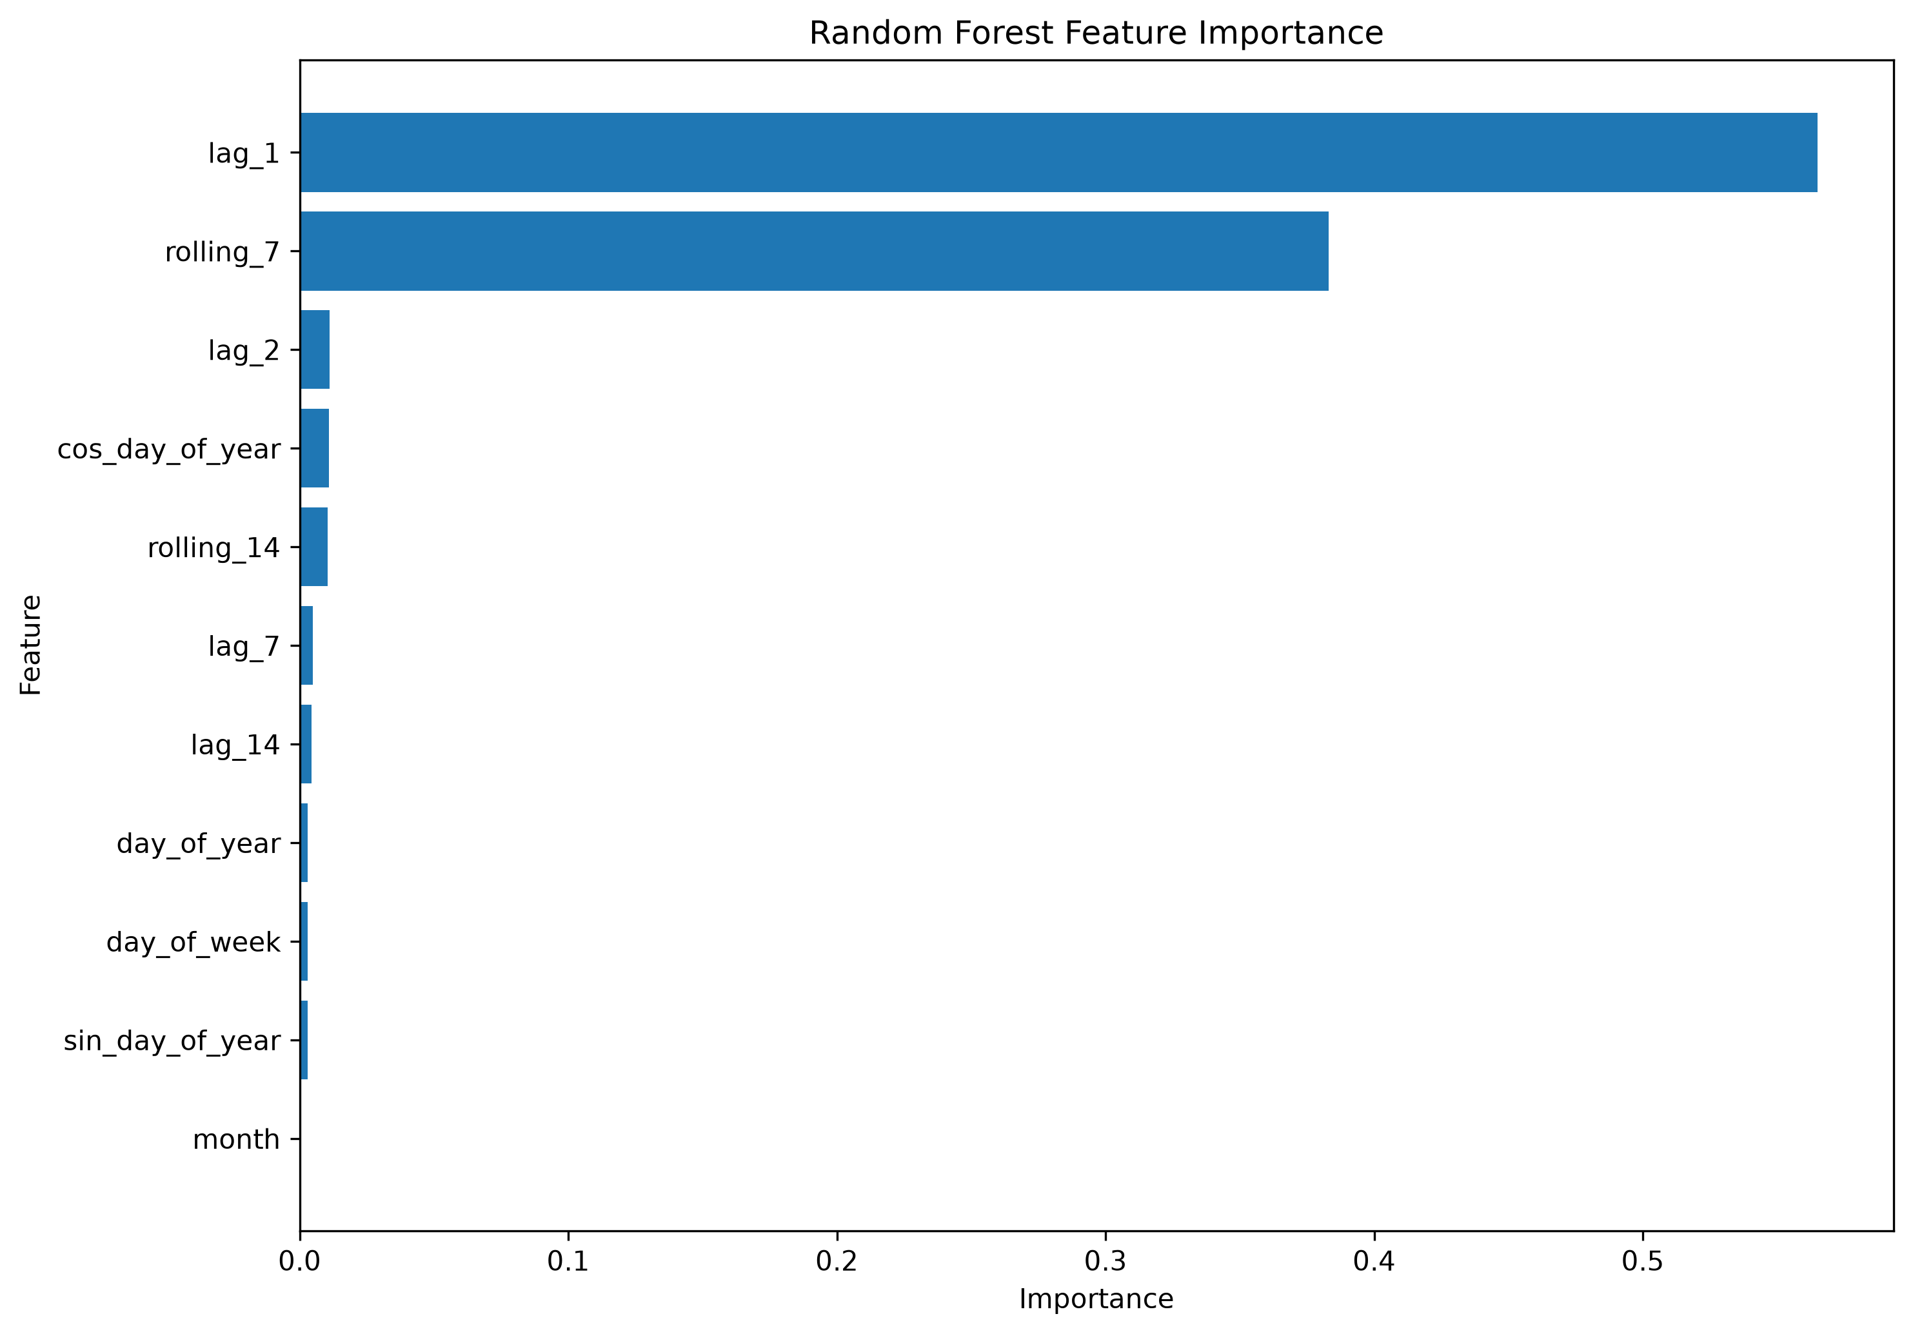

The results showed that recent temperature history was the dominant predictive signal.
The previous-day temperature (lag_1) had the highest importance, followed by the seven-day rolling temperature average (rolling_7). The remaining variables had substantially smaller importance values.

The Random Forest impurity-based importance assigned approximately 56.5% importance to lag_1 and approximately 38.3% to rolling_7.

Permutation importance produced a similar ranking, with lag_1 and rolling_7 clearly above the remaining features.

Table 16 - Top Forecasting Feature Importance
Feature | Random Forest Importance | Permutation Importance
lag_1 | 0.5651 | 1.0066
rolling_7 | 0.3831 | 0.3503
lag_2 | 0.0112 | -0.0126
cos_day_of_year | 0.0110 | -0.0269
rolling_14 | 0.0105 | -0.0375
lag_7 | 0.0050 | 0.0215
lag_14 | 0.0044 | -0.0271

The agreement between the two approaches indicates that short-term temporal persistence was substantially more informative than most of the calendar variables included in the model.

Feature importance represents predictive association within the model and should not be interpreted as evidence of causation.

11. Advanced Anomaly Detection

To identify unusual combinations of weather and environmental conditions, an Isolation Forest anomaly-detection model was applied to the cleaned dataset.

The analysis used the following variables:
- Temperature
- Precipitation
- Humidity
- Wind speed
- Atmospheric pressure
- Visibility
- UV index
- PM2.5
- PM10

The Isolation Forest model was configured with 200 trees and a contamination rate of 1%.

The model classified:
- 166,905 observations as normal
- 1,686 observations as anomalies

Thus, approximately 1% of observations were identified as multivariate anomalies

Figure 11 - Countries with the Highest Number of Detected Anomalies
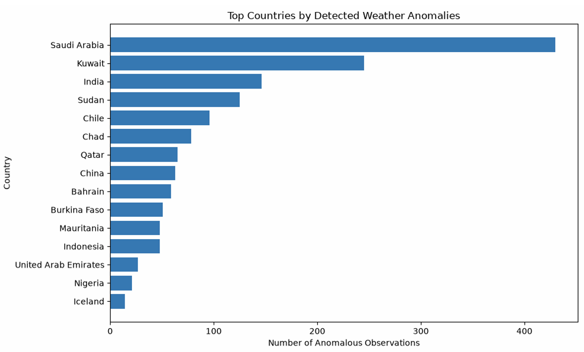

The largest numbers of detected anomalies occurred in countries including Saudi Arabia, Kuwait, India, Sudan, Chile, Chad, and Qatar.

However, the anomaly count should not be interpreted as evidence that weather conditions in a particular country are inherently abnormal. Countries with more observations can naturally produce more detected anomalies.

The anomaly observations also showed different average environmental characteristics compared with normal observations.

Table 17 - Average Conditions: Normal vs. Anomalous Observations
Variable | Normal | Anomaly
Temperature (°C) | 21.39 | 28.67
Precipitation (mm) | 0.13 | 0.37
Humidity (%) | 67.39 | 31.65
Wind Speed (km/h) | 12.60 | 20.63
Pressure (mb) | 1014.04 | 1009.44
Visibility (km) | 9.52 | 7.81
UV Index | 3.04 | 6.22
PM2.5 | 20.85 | 192.95
PM10 | 36.21 | 940.67

Compared with normal observations, flagged anomalies had higher average temperature, wind speed, UV index, PM2.5, and PM10, while humidity and visibility were lower.

The strongest differences were observed in particulate pollution. These results describe statistical differences in the dataset and do not establish causal relationships.

12. Climate Variability Analysis

The geographic and temporal coverage of the dataset was used to examine descriptive climate variability patterns.

Because the available dataset covers approximately 2024–2026, this analysis should not be interpreted as a long-term climate-change study. Instead, it describes geographic and seasonal variability observed during the available observation period.

12.1 Country-Level Temperature Analysis

Country-level average temperatures were calculated for countries with at least 100 observations to reduce the influence of locations represented by very small numbers of records.

Figure 12 - Warmest Represented Countries by Mean Temperature
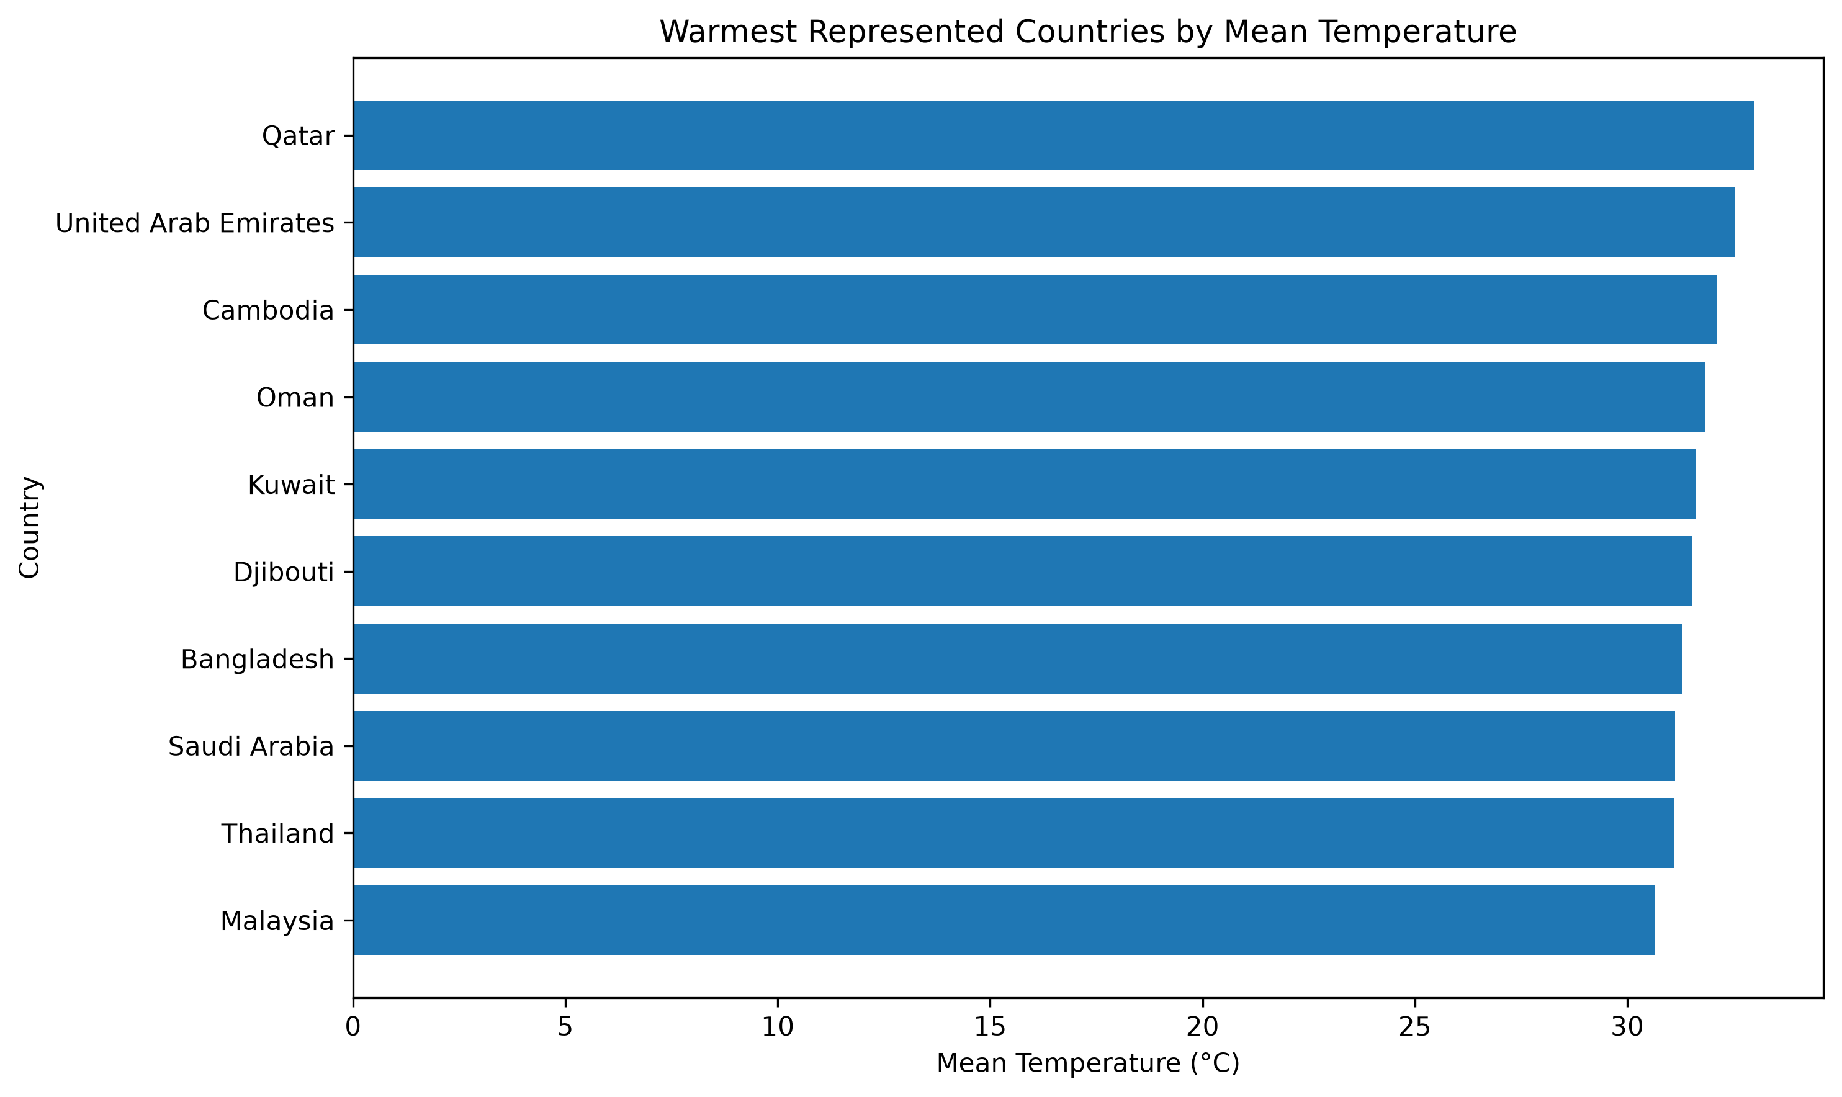

Countries with the highest mean temperatures included Qatar, the United Arab Emirates, Cambodia, Oman, Kuwait, Djibouti, Bangladesh, Saudi Arabia, Thailand, and Malaysia.

Figure 13 - Coolest Represented Countries by Mean Temperature

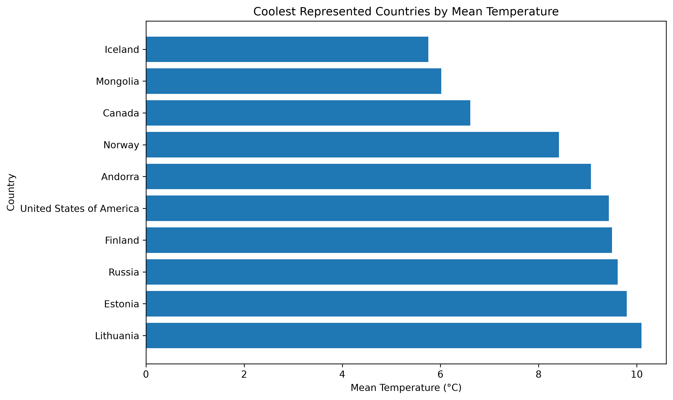

Countries with lower mean temperatures included Iceland, Mongolia, Canada, Norway, Andorra, the United States, Finland, Russia, Estonia, and Lithuania.

These results demonstrate strong geographic differences in observed temperatures across the dataset.

12.2 Latitude-Band Analysis

Temperature, precipitation, and humidity were also summarized by latitude bands.

Figure 14 - Weather Patterns by Latitude Band

Table 18 - Weather Statistics by Latitude Band
Latitude Band | Mean Temperature (°C) | Mean Precipitation (mm) | Mean Humidity (%)
-60 to -30 | 13.55 | 0.105 | 77.12
-30 to 0 | 23.52 | 0.158 | 68.91
0 to 30 | 26.40 | 0.180 | 69.92
30 to 60 | 16.29 | 0.073 | 62.16
60 to 90 | 7.62 | 0.122 | 77.72

The latitude analysis shows substantial differences in average temperature across geographic bands. The 0–30° latitude band had the highest mean temperature, while the 60–90° band had the lowest.

These results are descriptive of the locations represented in the dataset and should not be interpreted as a complete representation of global climate behavior.

13. Spatial and Geographic Analysis

Spatial analysis was performed using latitude, longitude, country, and location information to investigate geographic differences in temperature, precipitation, and air pollution.

The dataset covered approximately 211 countries and 268 raw location names.

Location-level aggregation was used to calculate average weather and air-quality measurements.

13.1 Global Temperature Distribution

Figure 15 - Global Spatial Distribution of Mean Temperature
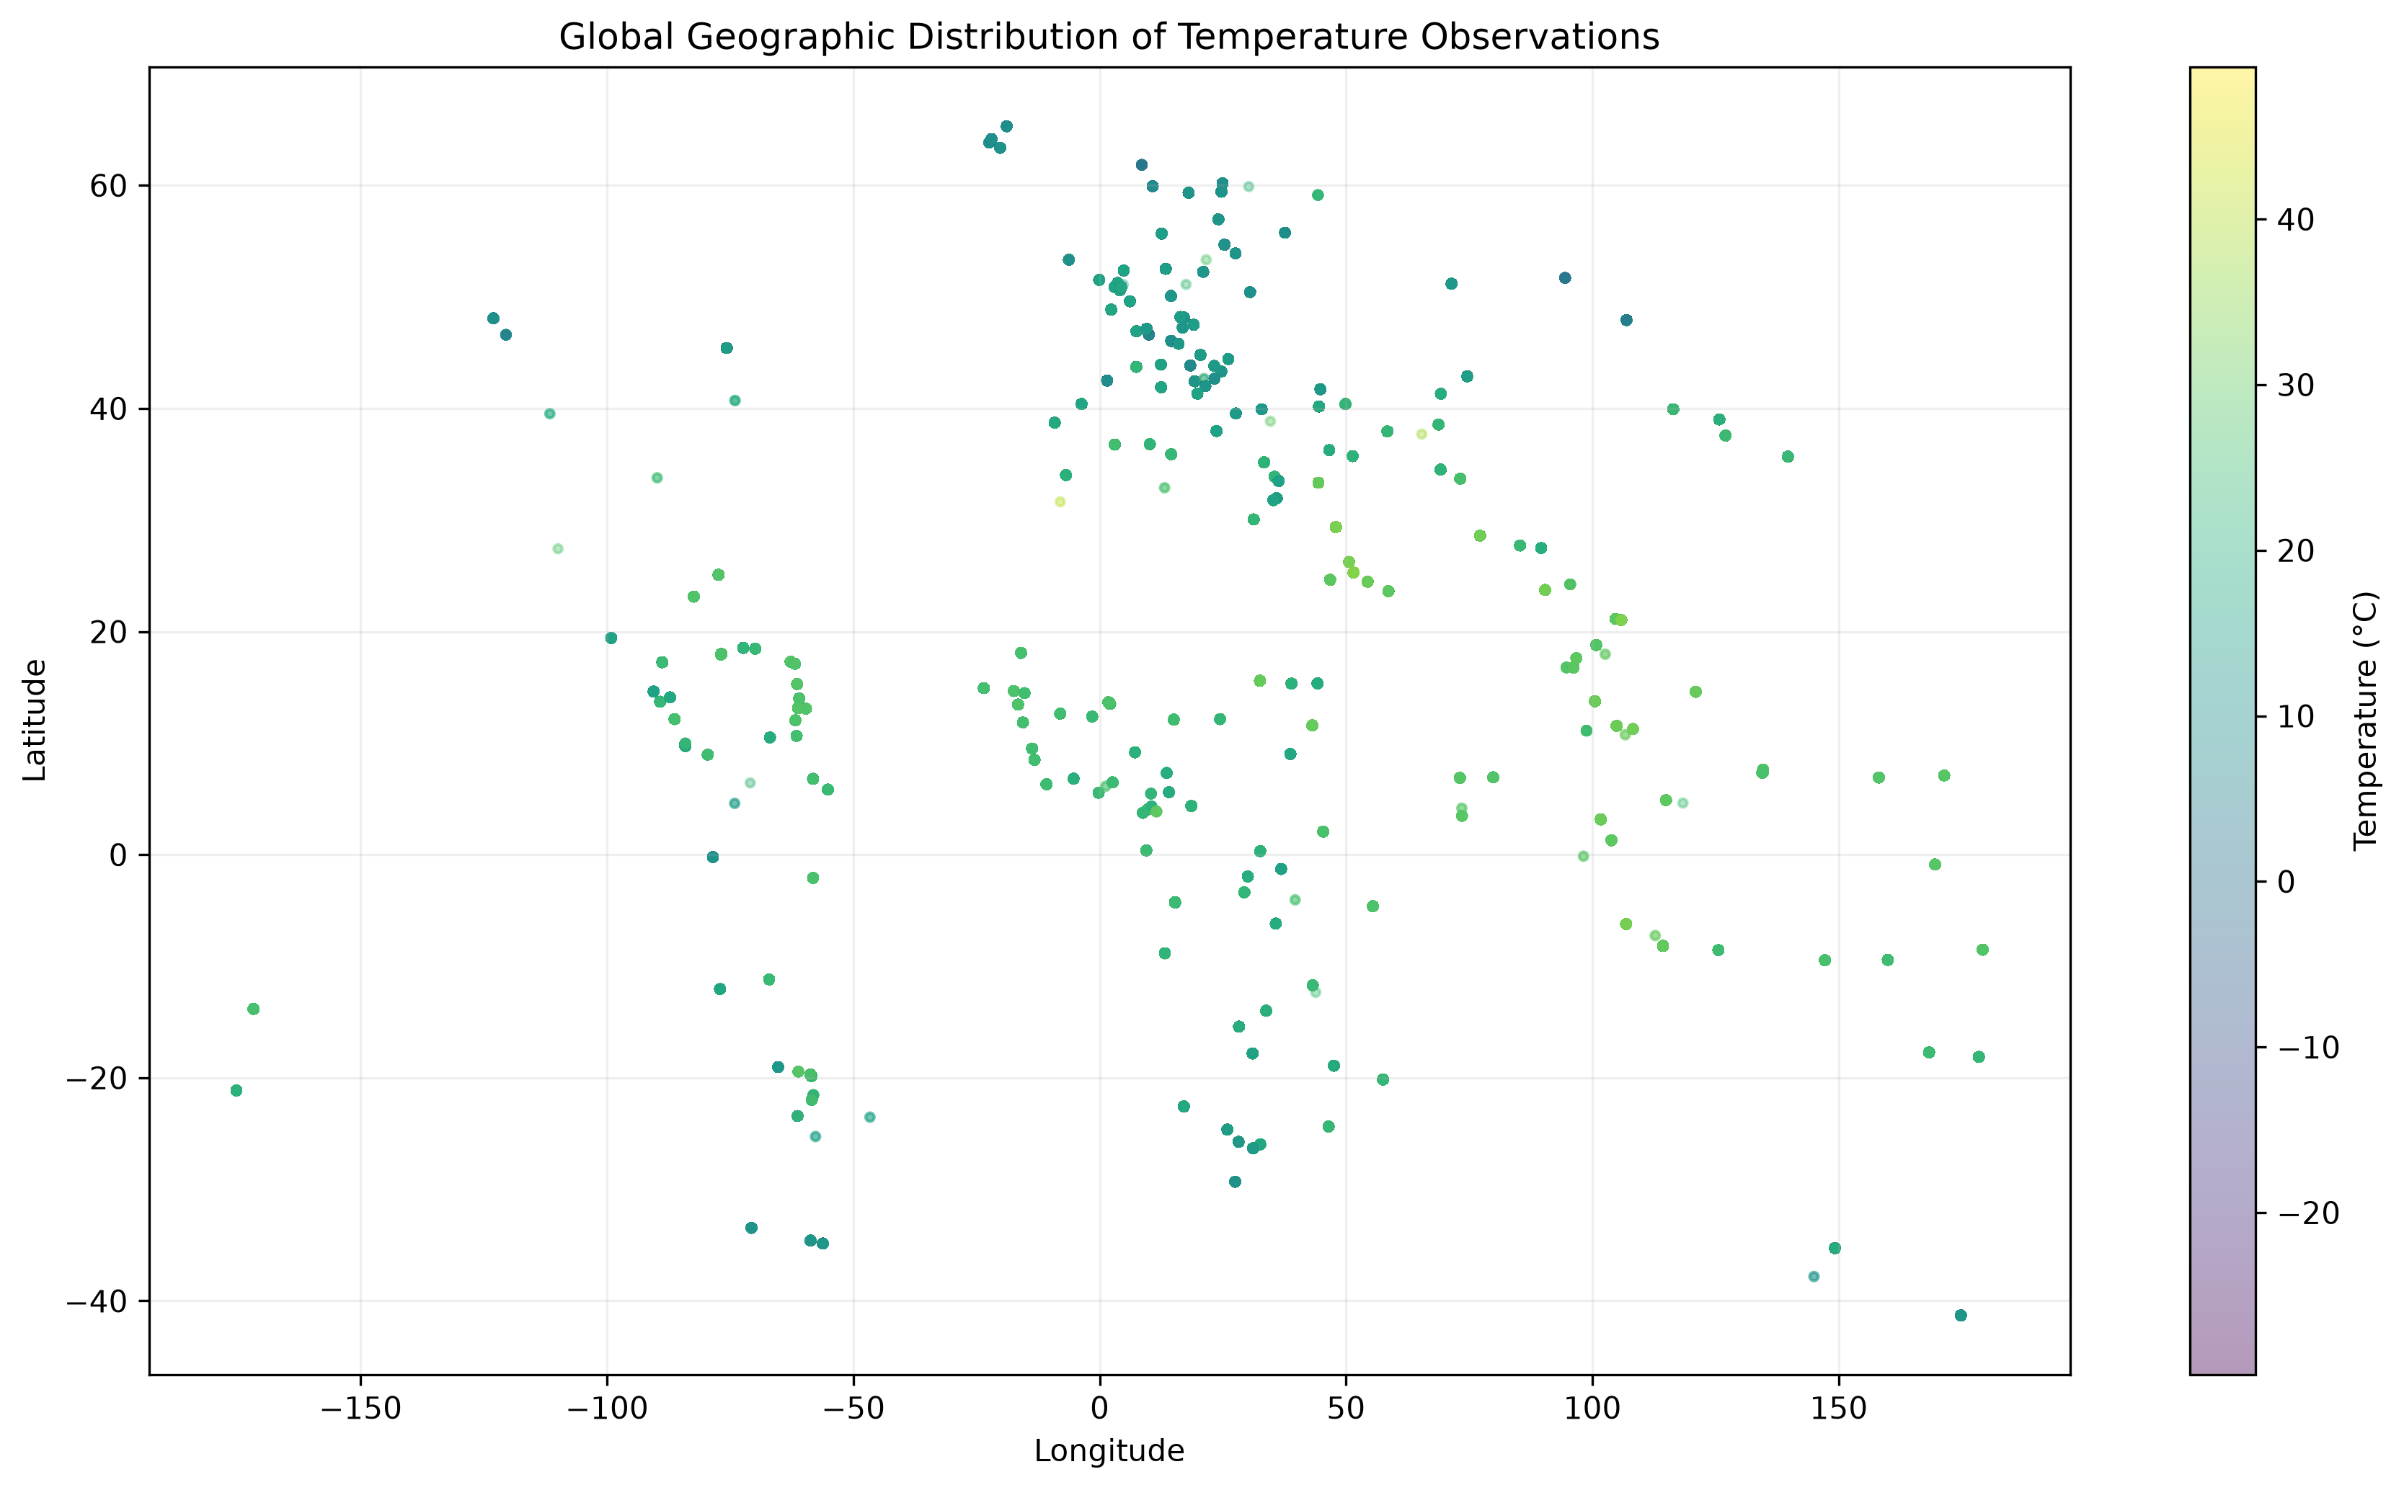

The spatial distribution demonstrates clear geographic variation in mean temperature across the locations represented in the dataset.

13.2 Global Precipitation Distribution

Figure 16 - Global Spatial Distribution of Mean Precipitation
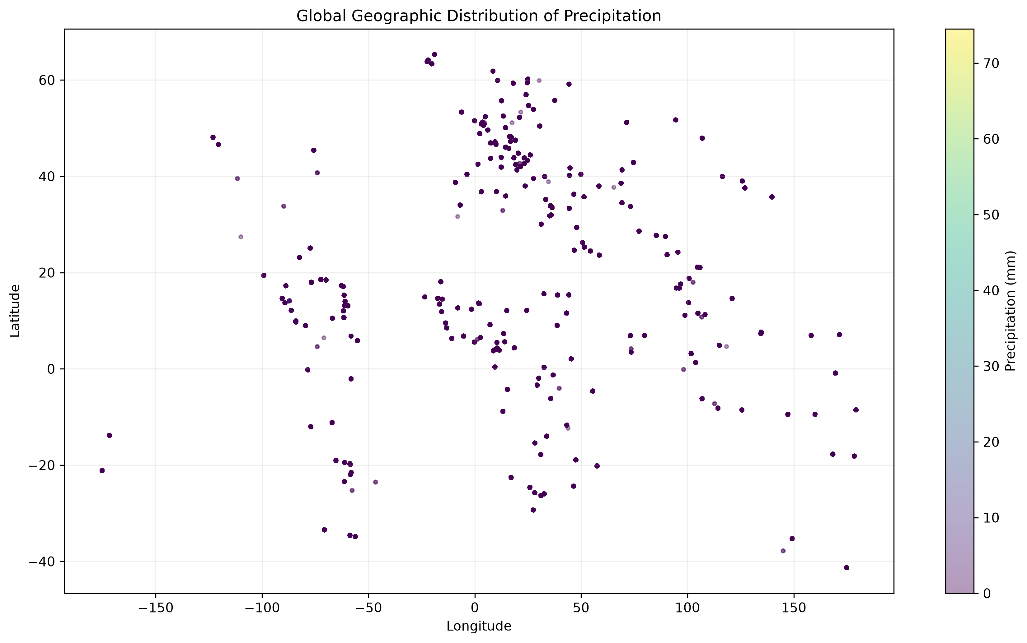

The precipitation map shows geographic differences in average precipitation across the observed locations.

13.3 Geographic Pollution Patterns

PM2.5 and PM10 were analyzed at the location level to identify locations with relatively high average particulate concentrations.

Figure 17 - Geographic Distribution of Mean PM2.5
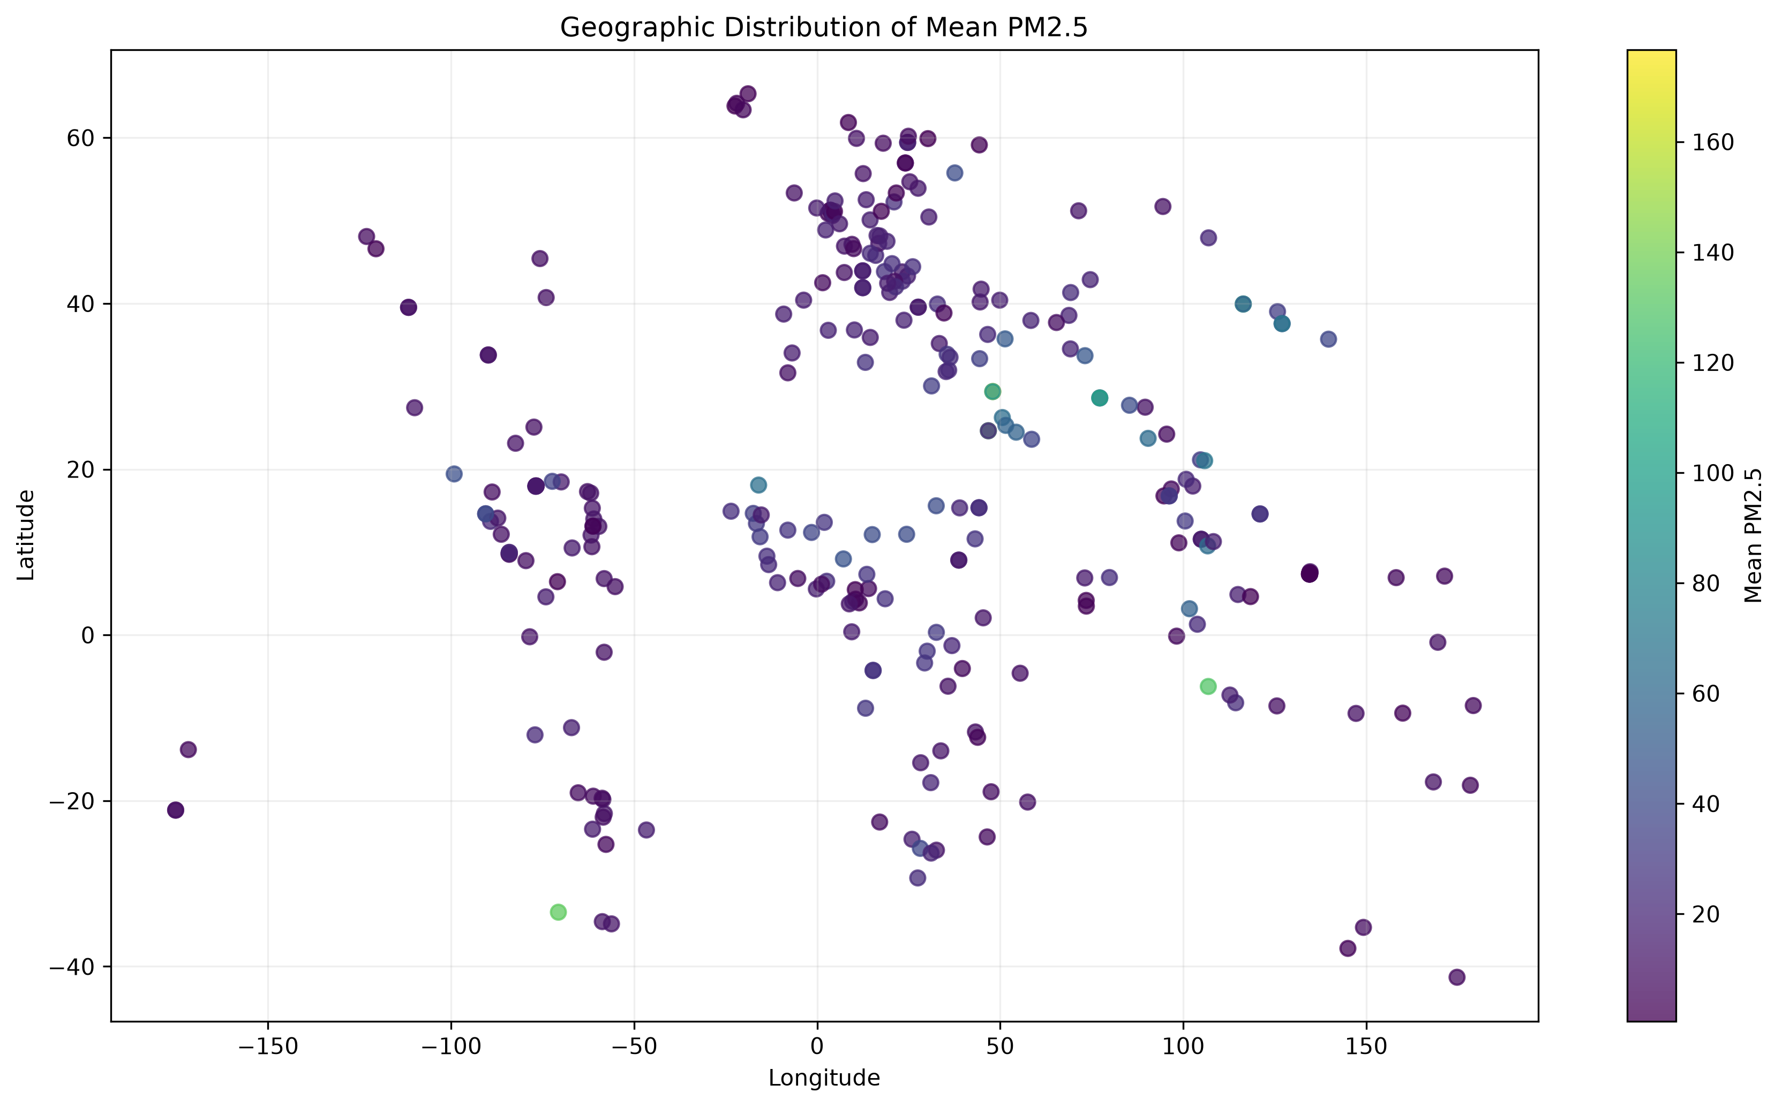

Figure 18 - Geographic Distribution of Mean PM10
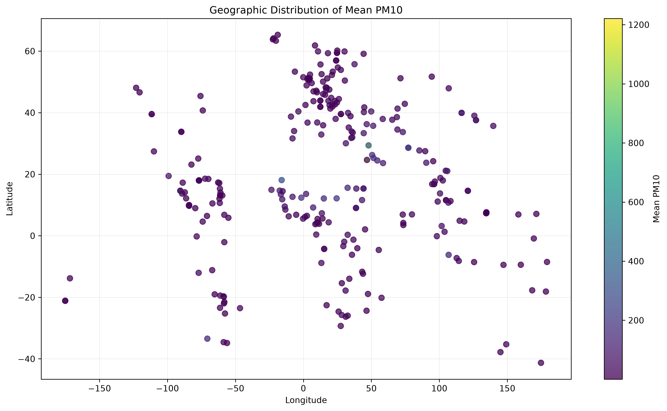

Locations with high mean PM2.5 included Riyadh, Santiago, Jakarta, Beijing, New Delhi, Kuwait City, Hanoi, and Nouakchott.

For PM10, Riyadh had the highest average value in the location-level analysis, followed by Kuwait City, Nouakchott, New Delhi, Juba, and Ouagadougou.

These results identify geographic pollution patterns within the dataset but should not be interpreted as rankings of overall air quality because measurements can be influenced by local monitoring conditions, seasonal variation, and the structure of the source dataset.

13.4 Temperature and Latitude

Figure 19 - Relationship Between Temperature and Latitude
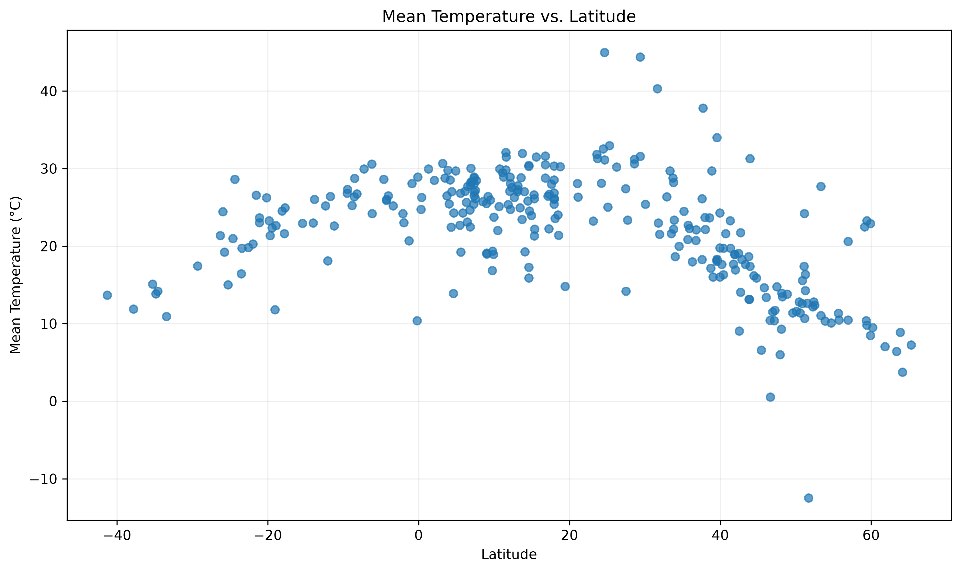

The temperature-versus-latitude analysis provides an additional visualization of the geographic relationship between latitude and observed temperature.

14. Key Findings

The analysis produced several important findings across data quality, weather patterns, forecasting, air quality, anomalies, and geographic variation.

Data Quality
The original dataset contained 168,591 observations with no duplicate rows and no conventional missing values. Targeted validation identified several physically invalid measurements, including extreme temperature, wind-speed, pressure, and negative air-quality values. These were corrected using location-level median imputation where appropriate.

Weather Patterns
Temperature demonstrated strong seasonal variation, with the highest average monthly temperature occurring in July. Precipitation was highly skewed, with many observations recording zero precipitation and a smaller number of substantially larger rainfall measurements.

Weather and Air Quality
Several weather and air-quality variables showed measurable statistical associations. Humidity, UV index, temperature, and wind speed were associated with different air-quality patterns. However, the correlations are observational and do not establish causal relationships.

Forecasting
The Kyiv case study demonstrated that historical temperature information can provide useful predictive information. The previous-day temperature and seven-day rolling temperature average were the most important forecasting features.

All machine-learning forecasting models improved upon the previous-day naive baseline on the final test set. Ridge Regression achieved the lowest test MAE, while the ensemble achieved the lowest test RMSE and highest test R² among the evaluated models.

Anomaly Detection
Isolation Forest identified approximately 1% of observations as multivariate anomalies. These observations generally showed higher particulate pollution, higher temperature and wind speed, and lower humidity and visibility than normal observations.

Climate and Geographic Variability
The dataset showed substantial geographic differences in temperature across countries and latitude bands. Tropical and subtropical locations generally showed higher observed temperatures, while higher-latitude locations showed lower average temperatures.

Spatial Pollution Patterns
Several locations displayed relatively high average PM2.5 and PM10 concentrations. These patterns demonstrate the value of combining weather data with geographic and environmental information.

15. Limitations

Several limitations should be considered when interpreting the results.

Limited Historical Period
The dataset covers approximately 2024–2026. Therefore, the climate analysis represents short-term descriptive variability rather than long-term climate-change trends.

Geographic Representation
The number of observations varies across countries and locations. Consequently, global averages
and country-level comparisons may be influenced by differences in geographic representation.

Forecasting Case Study
The forecasting model was developed using Kyiv as a case study. Its performance should not be assumed to represent all cities or climates.

Missing Calendar Dates
The Kyiv daily time series contained several missing calendar dates. These gaps were preserved rather than artificially filled with fabricated weather observations.

Model Generalization
The difference between validation and test performance demonstrates that forecasting performance can vary over time. Additional historical data and evaluation across multiple cities would provide a stronger assessment of generalization.

Correlation Does Not Imply Causation
Observed relationships between weather and air-quality variables represent statistical associations. They may be influenced by geography, seasonality, emissions, urbanization, and other factors not explicitly modeled.

Extreme Values
Some extreme pollution and weather measurements were retained because they may represent genuine environmental conditions. While anomaly detection was used to identify unusual observations, statistical anomaly status does not automatically mean that an observation is erroneous.

16. Conclusion

This project developed an end-to-end weather trend forecasting workflow using the Global Weather Repository dataset.

The analysis began with systematic data-quality assessment and preprocessing. Physically invalid measurements were identified and corrected while potentially legitimate extreme observations were retained for further analysis. Temporal features were then created from the last_updated timestamp to support seasonal analysis and forecasting.

Exploratory analysis revealed substantial variation in temperature, precipitation, humidity, and air quality across time and geographic locations. Correlation analysis identified several relationships among weather and environmental variables, while additional environmental analysis demonstrated differences in air-quality measurements across temperature, humidity, and wind categories.

For forecasting, a Kyiv-based daily temperature case study was developed using lag features, rolling averages, and seasonal transformations. Ridge Regression, Random Forest, and HistGradientBoosting models were compared against a previous-day baseline. The ensemble approach provided competitive performance, while feature-importance analysis demonstrated that recent temperature history was the strongest predictive signal.

Advanced analysis using Isolation Forest identified multivariate anomalies, while climate and spatial analyses revealed substantial geographic differences in temperature, precipitation, and particulate pollution.

Overall, the project demonstrates an end-to-end data science workflow covering data cleaning, exploratory analysis, time-series feature engineering, forecasting, model evaluation, feature importance, anomaly detection, environmental analysis, climate variability, and spatial analysis.

The results also highlight the importance of responsible interpretation. Extreme observations should not automatically be removed, correlations should not be interpreted as causal relationships, and short-term weather datasets should not be used to make unsupported claims about long-term climate change.

17. Project Deliverables

The completed project includes the following deliverables:

Source Code and Analysis
The project repository contains the complete analysis notebook, preprocessing workflow, forecasting models, and supporting files.

Cleaned Dataset
The processed dataset is stored as:
data/processed/weather_cleaned.csv

Forecasting Models
The trained forecasting models are stored in:
outputs/models/

These include:
- Ridge Regression model
- Random Forest model
- HistGradientBoosting model
- Ensemble weights

Analysis Tables
The generated analysis tables are stored in:
outputs/tables/

These include:
- forecasting_model_comparison.csv
- feature_importance_comparison.csv
- anomaly_country_summary.csv
- climate_country_summary.csv
- environmental_impact_summary.csv
- location_spatial_analysis.csv
- pollution_hotspots.csv

Visualizations
All generated figures are stored in:
outputs/figures/

These include forecasting, feature-importance, anomaly, climate, environmental, and spatial visualizations.

Documentation
The project also includes a detailed README containing project objectives, methodology, setup instructions, analysis results, limitations, and reproducibility information.

Demo Video
A short demonstration video was created to show the project workflow, code, analysis outputs, and forecasting results.

18. References

- Nelgiriyewithana. Global Weather Repository. Kaggle.
https://www.kaggle.com/datasets/nelgiriyewithana/global-weather-repository
- PM Accelerator. PM Accelerator — AI Product Management and Innovation.
https://www.pmaccelerator.io/
- Scikit-learn Documentation. Machine Learning in Python.
https://scikit-learn.org/
- Pandas Documentation. Python Data Analysis Library.
https://pandas.pydata.org/
- NumPy Documentation. Numerical Computing with Python.
https://numpy.org/
- Matplotlib Documentation. Visualization with Python.
https://matplotlib.org/

