**OOPS-JAVA ASSESMENT – 1**

**NAME : S V SHARVANI**

**ROLL NO : CH.EN.U4CCE22036**

**Program 1: Input and Output using Scanner – Bank Account Setup**

**CODE**

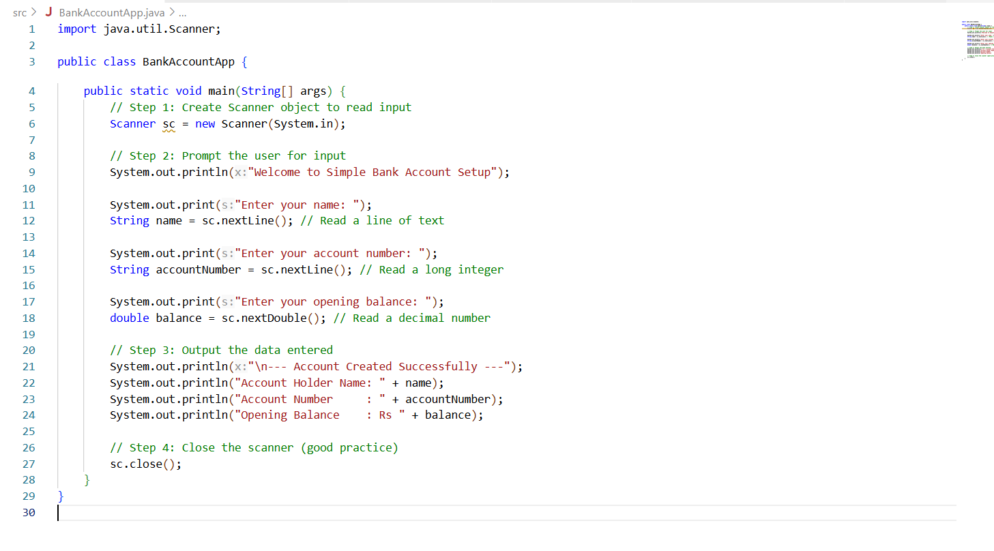

**OUTPUT**

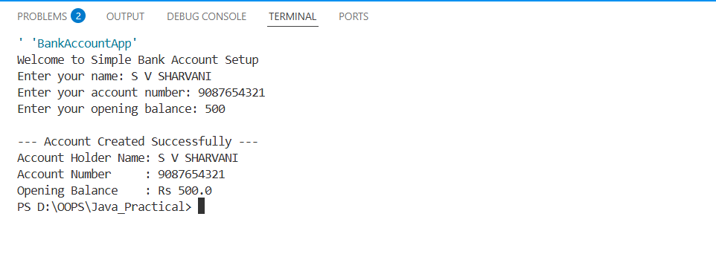

**Program 2: Input and Output without using Scanner – Bank Account Setup**

**CODE**

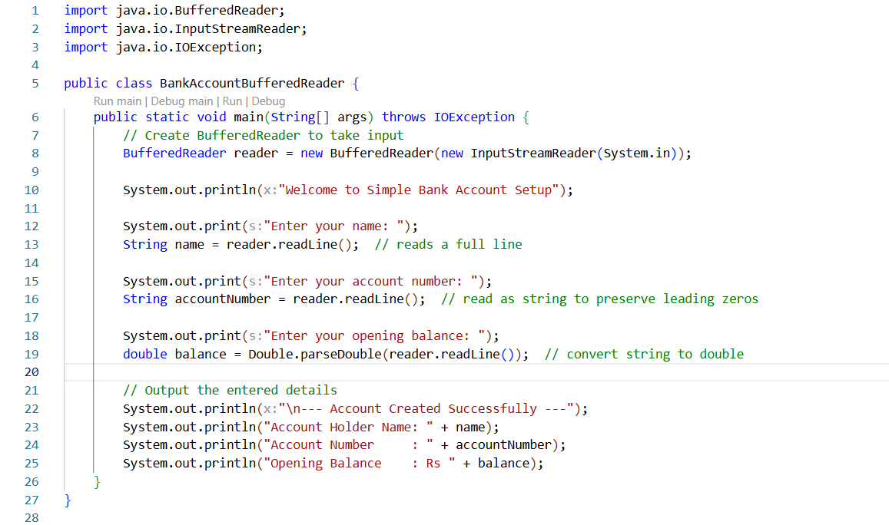

**OUTPUT**

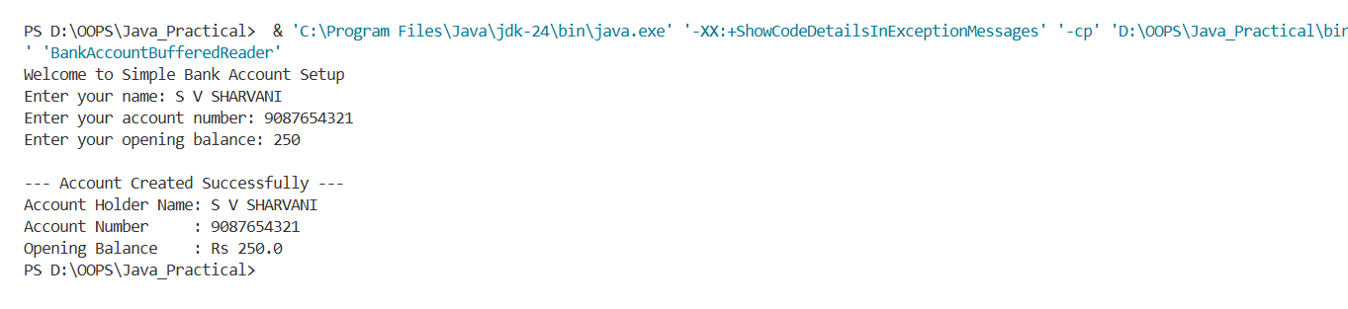

**Program 3: Arithmetic Operations using all Operators – Calculator**

**CODE**

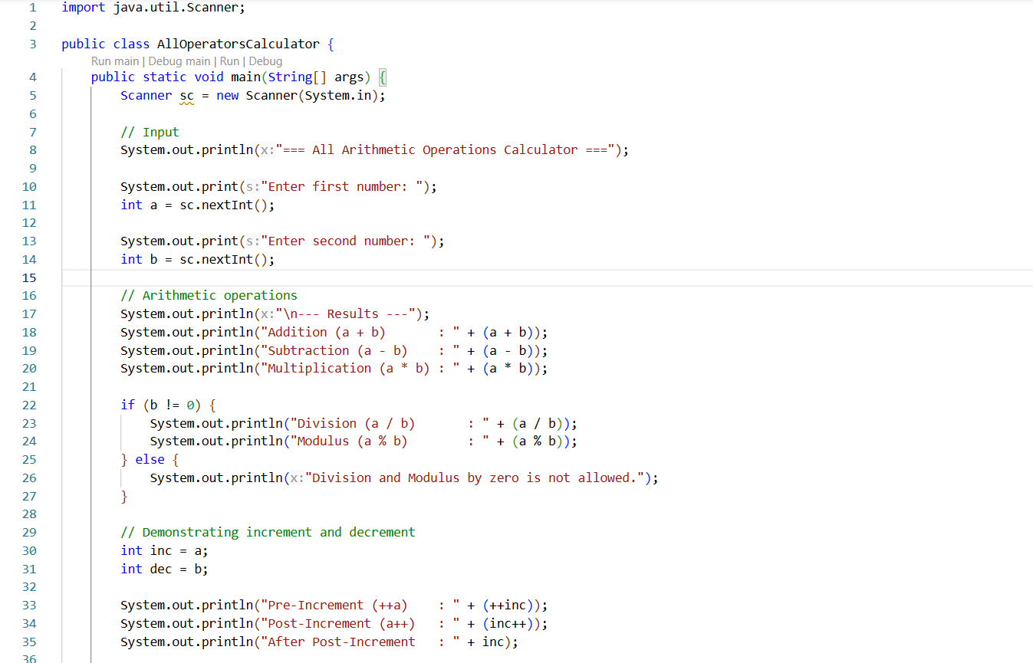

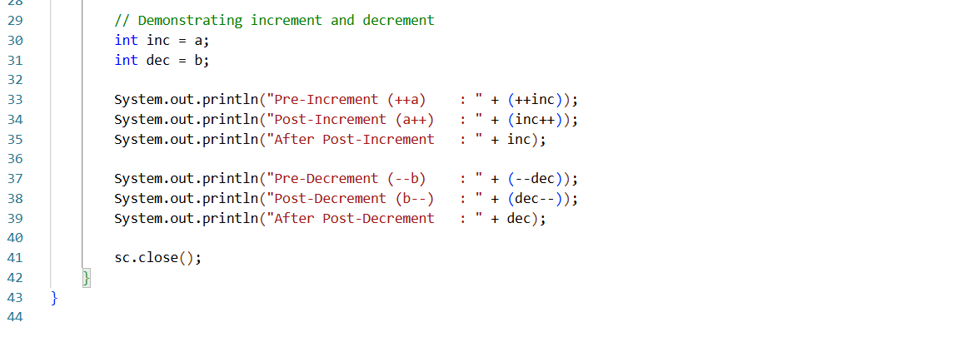

**OUTPUT**

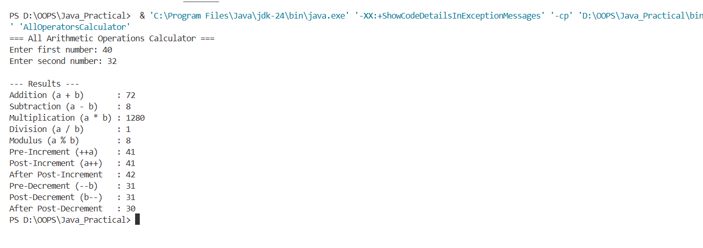

**Program 4: Data Types in Java – Student Profile Display**

**CODE**

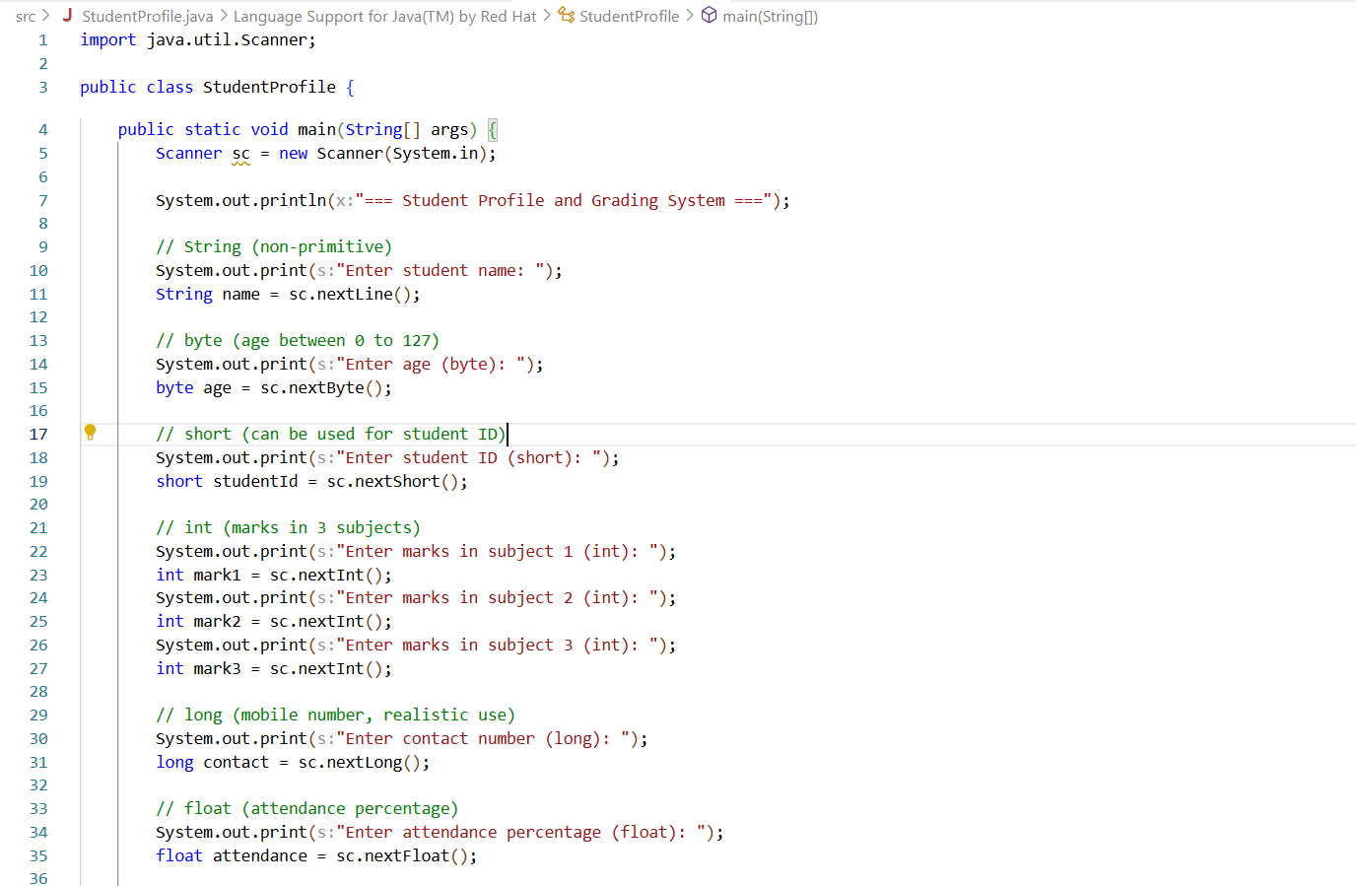

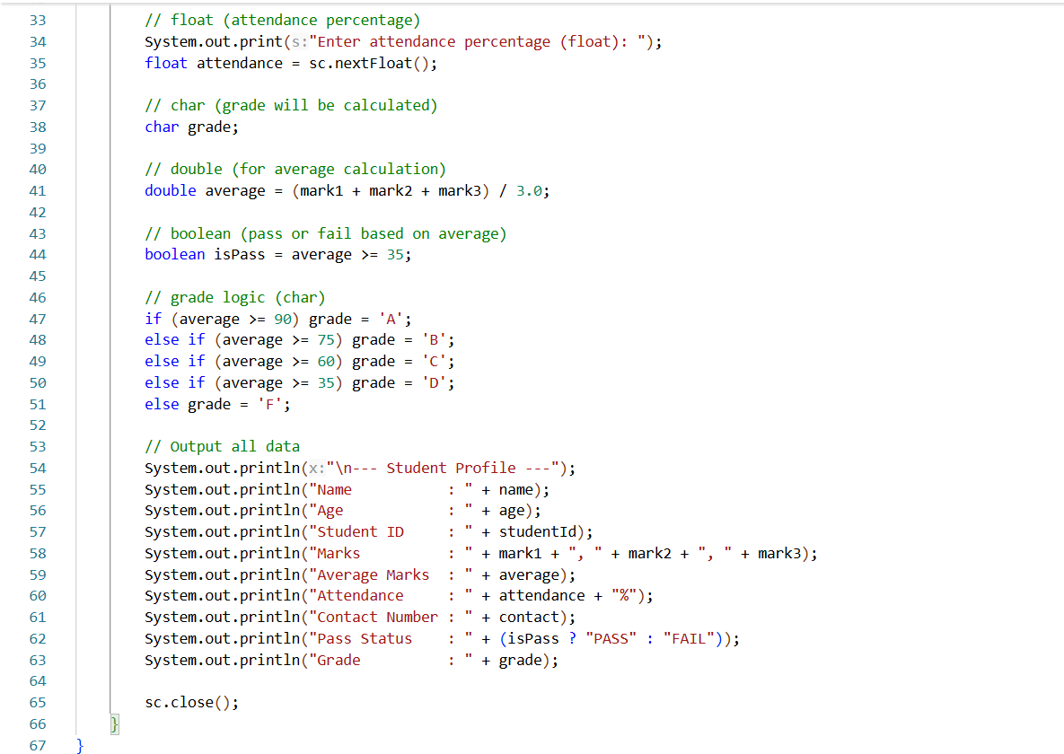

**OUTPUT**

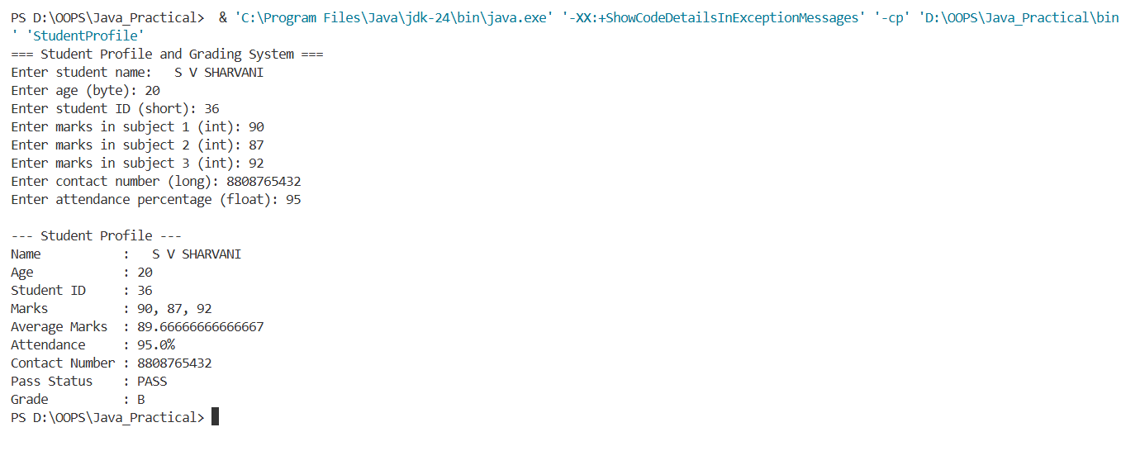

**Program 5: Access Modifiers in Java – Student Profile Display**

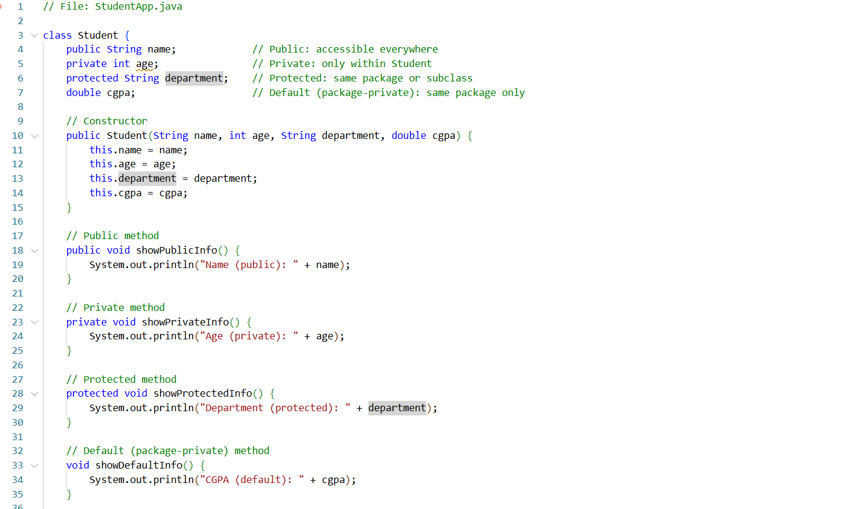

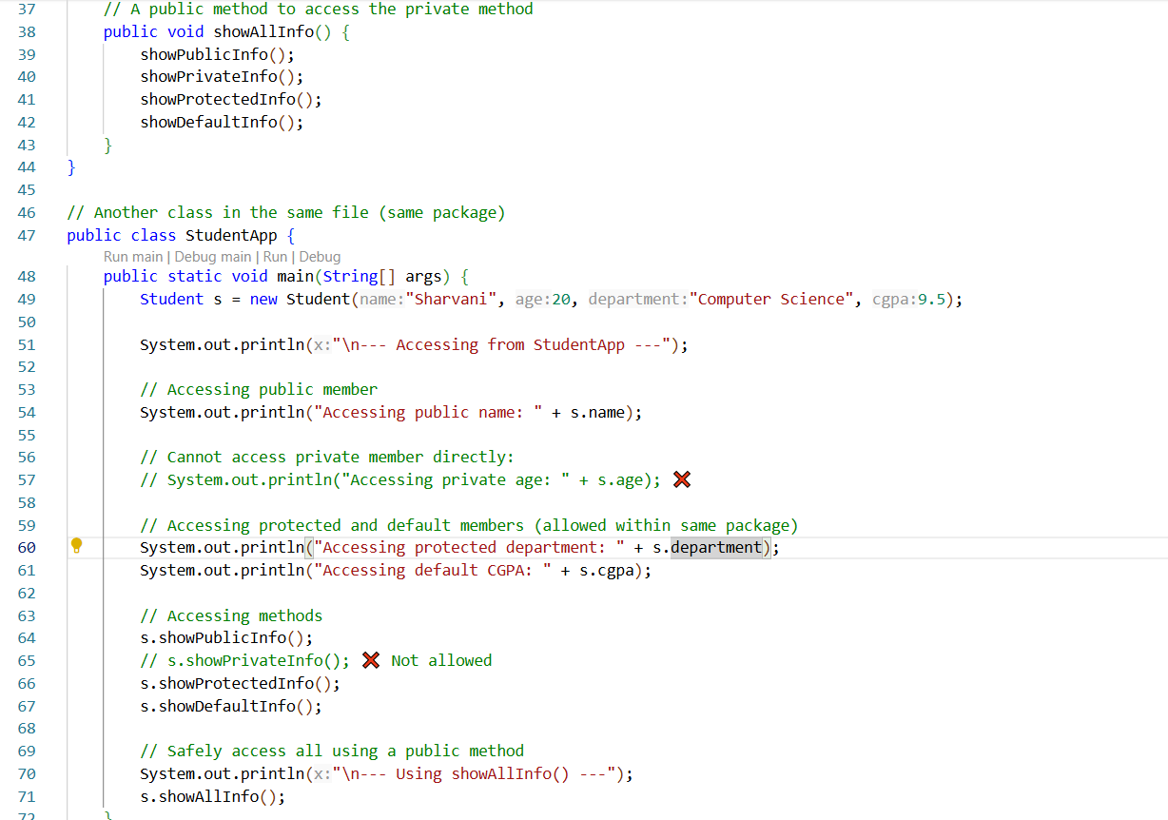

**OUTPUT**

