=========================================================
PROJECT SUMMARY
=========================================================
Goal: Segment customers based on purchase behavior and demographics to enable targeted marketing and retention strategies.
Dataset: customer_behavior_data.csv (order-level transaction data, 17,049 rows -> aggregated to ~5,000 unique customers)
Approach:
- Cleaned transaction-level data and engineered customer-level RFM features (Recency, Frequency, Monetary) plus behavioral features (session duration, pages viewed, returning-customer rate).
- Checked for outliers in spend-related features and capped extreme values before scaling, since KMeans is distance-based and sensitive to outliers.
- Clustered customers using KMeans on scaled NUMERIC features only (categorical fields like City/Gender/Device were excluded from the distance calculation and used only afterward for profiling).
- Selected the number of clusters (K) using both the Elbow Method and Silhouette Score, rather than picking K arbitrarily.
- Validated the final clustering quantitatively via silhouette score, and visually via PCA projection.
- Named each cluster as a business persona (e.g. Premium Loyal Customers, At-Risk Customers) based on spend, frequency, and recency patterns, and mapped each persona to a recommended business action.

import pandas as pd
import numpy as np
import matplotlib.pyplot as plt
from sklearn.preprocessing import StandardScaler
from sklearn.cluster import KMeans
from sklearn.metrics import silhouette_score
from sklearn.decomposition import PCA

df = pd.read_csv("C:/Users/Admin/Desktop/Sharvari/Internship/Thiranex/Task 2/customer_behavior_data.csv") # <-- update path
df.head()

 | Order_ID | Customer_ID | Date | Age | Gender | City | Product_Category | Unit_Price | Quantity | Discount_Amount | Total_Amount | Payment_Method | Device_Type | Session_Duration_Minutes | Pages_Viewed | Is_Returning_Customer | Delivery_Time_Days | Customer_Rating
0 | ORD_000001-1 | CUST_00001 | 2023-05-29 | 40 | Male | Ankara | Books | 29.18 | 1 | 0.00 | 29.18 | Digital Wallet | Mobile | 14 | 9 | True | 13 | 4
1 | ORD_000001-2 | CUST_00001 | 2023-10-12 | 40 | Male | Ankara | Home & Garden | 644.40 | 1 | 138.05 | 506.35 | Credit Card | Desktop | 14 | 8 | True | 6 | 2

STEP 1: Data Cleaning & Preparation

df.isnull().sum()

df['Date'] = pd.to_datetime(df['Date'])
df.info()

df.duplicated().sum()
df = df.drop_duplicates()

# derived columns
df['Calculated_Total'] = df['Unit_Price'] * df['Quantity'] - df['Discount_Amount']
df['Difference'] = df['Total_Amount'] - df['Calculated_Total']

# Encode Categorical Variables (for later use)
df['Gender'] = df['Gender'].map({'Male': 0, 'Female': 1, 'Other': 2})
df['Is_Returning_Customer'] = df['Is_Returning_Customer'].astype(int)

df.info()
df.head()

<class 'pandas.core.frame.DataFrame'>
RangeIndex: 17049 entries, 0 to 17048
Data columns (total 18 columns):
# Column Non-Null Count Dtype
--- ------ -------------- -----
0 Order_ID 17049 non-null object
1 Customer_ID 17049 non-null object
2 Date 17049 non-null datetime64[ns]
3 Age 17049 non-null int64
4 Gender 17049 non-null object
5 City 17049 non-null object
6 Product_Category 17049 non-null object
7 Unit_Price 17049 non-null float64
8 Quantity 17049 non-null int64
9 Discount_Amount 17049 non-null float64
10 Total_Amount 17049 non-null float64
11 Payment_Method 17049 non-null object
12 Device_Type 17049 non-null object
13 Session_Duration_Minutes 17049 non-null int64
14 Pages_Viewed 17049 non-null int64
15 Is_Returning_Customer 17049 non-null bool
16 Delivery_Time_Days 17049 non-null int64
17 Customer_Rating 17049 non-null int64
dtypes: bool(1), datetime64[ns](1), float64(3), int64(6), object(7)
memory usage: 2.2+ MB
<class 'pandas.core.frame.DataFrame'>
RangeIndex: 17049 entries, 0 to 17048
Data columns (total 20 columns):
# Column Non-Null Count Dtype
--- ------ -------------- -----
0 Order_ID 17049 non-null object
1 Customer_ID 17049 non-null object
2 Date 17049 non-null datetime64[ns]
3 Age 17049 non-null int64
4 Gender 17049 non-null int64
5 City 17049 non-null object
6 Product_Category 17049 non-null object
7 Unit_Price 17049 non-null float64
8 Quantity 17049 non-null int64
9 Discount_Amount 17049 non-null float64
10 Total_Amount 17049 non-null float64
11 Payment_Method 17049 non-null object
12 Device_Type 17049 non-null object
13 Session_Duration_Minutes 17049 non-null int64
14 Pages_Viewed 17049 non-null int64
15 Is_Returning_Customer 17049 non-null int64
16 Delivery_Time_Days 17049 non-null int64
17 Customer_Rating 17049 non-null int64
18 Calculated_Total 17049 non-null float64
19 Difference 17049 non-null float64
dtypes: datetime64[ns](1), float64(5), int64(8), object(6)
memory usage: 2.6+ MB

 | Order_ID | Customer_ID | Date | Age | Gender | City | Product_Category | Unit_Price | Quantity | Discount_Amount | Total_Amount | Payment_Method | Device_Type | Session_Duration_Minutes | Pages_Viewed | Is_Returning_Customer | Delivery_Time_Days | Customer_Rating | Calculated_Total | Difference
0 | ORD_000001-1 | CUST_00001 | 2023-05-29 | 40 | 0 | Ankara | Books | 29.18 | 1 | 0.00 | 29.18 | Digital Wallet | Mobile | 14 | 9 | 1 | 13 | 4 | 29.18 | 0.000000e+00
1 | ORD_000001-2 | CUST_00001 | 2023-10-12 | 40 | 0 | Ankara | Home & Garden | 644.40 | 1 | 138.05 | 506.35 | Credit Card | Desktop | 14 | 8 | 1 | 6 | 2 | 506.35 | 5.684342e-14

STEP 2: Feature Engineering
df['Date'] = pd.to_datetime(df['Date'])

reference_date = df['Date'].max() + pd.Timedelta(days=1)

def mode_func(x):
return x.mode()[0] if not x.mode().empty else np.nan

customer_df = df.groupby('Customer_ID').agg({
'Total_Amount': ['sum', 'mean'],
'Quantity': 'sum',
'Order_ID': 'nunique',
'Date': lambda x: (reference_date - x.max()).days,
'Session_Duration_Minutes': 'mean',
'Pages_Viewed': 'mean',
'Device_Type': mode_func,
'Is_Returning_Customer': 'mean',
'Customer_Rating': 'mean',
'Delivery_Time_Days': 'mean',
'Age': 'first',
'Gender': mode_func,
'City': mode_func
})

customer_df.columns = [
'Total_Spend', 'Avg_Order_Value', 'Total_Quantity', 'Number_of_Orders',
'Recency', 'Avg_Session_Duration', 'Avg_Pages_Viewed', 'Preferred_Device',
'Returning_Rate', 'Avg_Customer_Rating', 'Avg_Delivery_Time',
'Age', 'Gender', 'City'
]

customer_df = customer_df.reset_index()

customer_df['Purchase_Frequency'] = (
customer_df['Number_of_Orders'] /
(df['Date'].max() - df['Date'].min()).days
)

print(customer_df.head())
print(customer_df.shape)

Customer_ID Total_Spend Avg_Order_Value Total_Quantity Number_of_Orders \
0 CUST_00001 2199.63 733.210000 7 3
1 CUST_00002 809.90 404.950000 8 2
2 CUST_00003 3030.81 1515.405000 7 2
3 CUST_00004 383.22 383.220000 5 1
4 CUST_00005 2422.73 807.576667 8 3

Recency Avg_Session_Duration Avg_Pages_Viewed Preferred_Device \
0 112 14.333333 9.000000 Mobile
1 284 15.000000 10.000000 Desktop
2 83 10.500000 8.500000 Desktop
3 42 16.000000 15.000000 Desktop
4 279 12.666667 9.333333 Mobile

Returning_Rate Avg_Customer_Rating Avg_Delivery_Time Age Gender \
0 1.000000 3.333333 9.333333 40 0
1 1.000000 4.000000 5.000000 33 0
2 0.500000 3.500000 6.000000 42 0
3 0.000000 5.000000 4.000000 53 0
4 0.666667 3.666667 5.666667 32 0

City Purchase_Frequency
0 Ankara 0.006682
1 Istanbul 0.004454
2 Konya 0.004454
3 Izmir 0.002227
4 Ankara 0.006682
(5000, 16)

STEP 3: Feature Selection
features_df = customer_df.copy()

numeric_features = [
'Total_Spend', 'Avg_Order_Value', 'Total_Quantity', 'Number_of_Orders',
'Recency', 'Avg_Session_Duration', 'Avg_Pages_Viewed', 'Returning_Rate',
'Avg_Customer_Rating', 'Avg_Delivery_Time', 'Age', 'Purchase_Frequency'
]

# Kept separately for PROFILING ONLY — not fed into the clustering distance
# calculation in Step 4 (Fix #3 & #4: avoids mixing scaled numeric data with
# one-hot City/Device/Gender dummies in the same Euclidean space).
categorical_features = ['Preferred_Device', 'Gender', 'City']

selected_df = features_df[['Customer_ID'] + numeric_features + categorical_features].copy()

# Handle missing values
for col in numeric_features:
selected_df[col].fillna(selected_df[col].median(), inplace=True)

for col in categorical_features:
selected_df[col].fillna(selected_df[col].mode()[0], inplace=True)

print(selected_df.head())

# --- Outlier check before scaling (Fix #2) ---
fig, axes = plt.subplots(1, 3, figsize=(15, 4))
for ax, col in zip(axes, ['Total_Spend', 'Avg_Order_Value', 'Number_of_Orders']):
ax.boxplot(selected_df[col])
ax.set_title(col)
plt.suptitle("Outlier Check on Key Value Features (before scaling)")
plt.tight_layout()
plt.show()

# Cap extreme outliers at the 99th percentile so a few whales don't drag
# KMeans centroids around (since KMeans is distance-based and outlier-sensitive)
for col in ['Total_Spend', 'Avg_Order_Value']:
cap = selected_df[col].quantile(0.99)
n_capped = (selected_df[col] > cap).sum()
print(f"Capping {n_capped} outlier rows in {col} at 99th percentile ({cap:.2f})")
selected_df[col] = np.where(selected_df[col] > cap, cap, selected_df[col])

Customer_ID Total_Spend Avg_Order_Value Total_Quantity Number_of_Orders \
0 CUST_00001 2199.63 733.210000 7 3
1 CUST_00002 809.90 404.950000 8 2
2 CUST_00003 3030.81 1515.405000 7 2
3 CUST_00004 383.22 383.220000 5 1
4 CUST_00005 2422.73 807.576667 8 3

Recency Avg_Session_Duration Avg_Pages_Viewed Returning_Rate \
0 112 14.333333 9.000000 1.000000
1 284 15.000000 10.000000 1.000000
2 83 10.500000 8.500000 0.500000
3 42 16.000000 15.000000 0.000000
4 279 12.666667 9.333333 0.666667

Avg_Customer_Rating Avg_Delivery_Time Age Purchase_Frequency \
0 3.333333 9.333333 40 0.006682
1 4.000000 5.000000 33 0.004454
2 3.500000 6.000000 42 0.004454
3 5.000000 4.000000 53 0.002227
4 3.666667 5.666667 32 0.006682

Preferred_Device Gender City
0 Mobile 0 Ankara
1 Desktop 0 Istanbul
2 Desktop 0 Konya
3 Desktop 0 Izmir
4 Mobile 0 Ankara

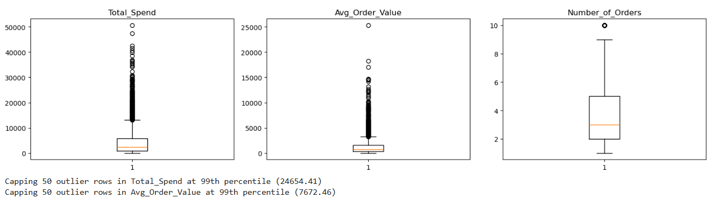
Capping 50 outlier rows in Total_Spend at 99th percentile (24654.41)
Capping 50 outlier rows in Avg_Order_Value at 99th percentile (7672.46)

STEP 4: Apply Clustering Algorithm

scaler = StandardScaler()
scaled_data = scaler.fit_transform(selected_df[numeric_features])

# --- Find optimal K: Elbow Method + Silhouette Score (Fix #1) ---
inertia = []
silhouette_scores = []
K_range = range(2, 11)

for k in K_range:
kmeans_temp = KMeans(n_clusters=k, random_state=42, n_init=10)
labels_temp = kmeans_temp.fit_predict(scaled_data)
inertia.append(kmeans_temp.inertia_)
silhouette_scores.append(silhouette_score(scaled_data, labels_temp))

fig, axes = plt.subplots(1, 2, figsize=(12, 4))
axes[0].plot(list(K_range), inertia, marker='o')
axes[0].set_xlabel('Number of Clusters (K)')
axes[0].set_ylabel('Inertia')
axes[0].set_title('Elbow Method')

axes[1].plot(list(K_range), silhouette_scores, marker='o', color='green')
axes[1].set_xlabel('Number of Clusters (K)')
axes[1].set_ylabel('Silhouette Score')
axes[1].set_title('Silhouette Score by K')
plt.tight_layout()
plt.show()

print("Silhouette scores by K:", dict(zip(K_range, np.round(silhouette_scores, 3))))

best_k_by_silhouette = list(K_range)[int(np.argmax(silhouette_scores))]
print(f"Best K by silhouette score: {best_k_by_silhouette}")

# Decision: use K=2. The data does not show strong natural separation beyond
# two groups -- customer behavior here is largely a continuous spend spectrum
# rather than distinct sub-populations. Rather than forcing extra clusters
# and inventing persona names that don't clearly hold up, we keep the
# simplest, most defensible split and name clusters directly from their
# characteristics (High Value vs Low Value) below.
k = 2

kmeans = KMeans(n_clusters=k, random_state=42, n_init=10)
clusters = kmeans.fit_predict(scaled_data)

# Quantitative validation of the final model (Fix #5)
final_silhouette = silhouette_score(scaled_data, clusters)
print(f"Final model: K={k}, Silhouette Score = {final_silhouette:.3f}")

selected_df['Cluster'] = clusters

print(selected_df.head())
print(selected_df['Cluster'].value_counts())
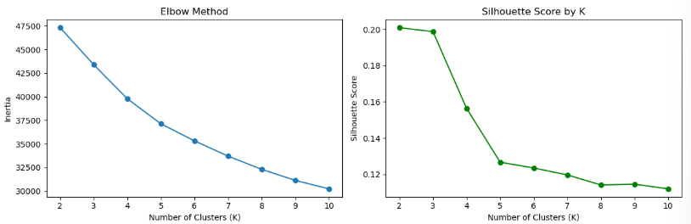
Silhouette scores by K: {2: np.float64(0.201), 3: np.float64(0.199), 4: np.float64(0.156), 5: np.float64(0.127), 6: np.float64(0.123), 7: np.float64(0.12), 8: np.float64(0.114), 9: np.float64(0.115), 10: np.float64(0.112)}
Best K by silhouette score: 2
Final model: K=2, Silhouette Score = 0.201
silhouette score of 0.201 indicates moderate cluster separation, expected given the continuous and overlapping nature of customer behavior data

Cluster
0 3540
1 1460
Name: count, dtype: int64

STEP 5: Analyze Clusters
cluster_summary = selected_df.groupby('Cluster')[numeric_features].mean()

device_summary = selected_df.groupby('Cluster')['Preferred_Device'].agg(lambda x: x.mode()[0])
gender_summary = selected_df.groupby('Cluster')['Gender'].agg(lambda x: x.mode()[0])
city_summary = selected_df.groupby('Cluster')['City'].agg(lambda x: x.mode()[0])

cluster_size = selected_df['Cluster'].value_counts().sort_index()
cluster_percent = (cluster_size / len(selected_df)) * 100

cluster_profile = cluster_summary.copy()
cluster_profile['Most_Common_Device'] = device_summary
cluster_profile['Most_Common_Gender'] = gender_summary
cluster_profile['Most_Common_City'] = city_summary
cluster_profile['Cluster_Size'] = cluster_size
cluster_profile['Cluster_%'] = cluster_percent

print("\nFinal Cluster Profile:")
print(cluster_profile)

Final Cluster Profile:
Total_Spend Avg_Order_Value Total_Quantity Number_of_Orders \
Cluster
0 2333.112910 1060.750961 6.689548 2.287288
1 9036.130596 1648.462775 18.945205 6.131507

Recency Avg_Session_Duration Avg_Pages_Viewed Returning_Rate \
Cluster
0 152.548870 14.571455 8.971860 0.776544
1 60.656849 14.507462 9.040134 0.935974

Avg_Customer_Rating Avg_Delivery_Time Age \
Cluster
0 3.909317 6.531756 35.201130
1 3.884509 6.493219 34.623973

Purchase_Frequency Most_Common_Device Most_Common_Gender \
Cluster
0 0.005094 Mobile 1
1 0.013656 Mobile 1

Most_Common_City Cluster_Size Cluster_%
Cluster
0 Istanbul 3540 70.8
1 Istanbul 1460 29.2

STEP 6: Persona Naming + Recommended Actions
# With K=2, we don't need an invented persona-assignment function with
# arbitrary thresholds. We name each cluster directly based on which one
# has the higher mean Total_Spend -- this is the cluster's defining
# characteristic, straight from cluster_summary, not a guessed label.
cluster_value_rank = cluster_summary['Total_Spend'].sort_values(ascending=False)
high_value_cluster = cluster_value_rank.index[0]
low_value_cluster = cluster_value_rank.index[1]

cluster_to_label = {
high_value_cluster: "High Value Customers",
low_value_cluster: "Low Value Customers"
}

persona_df = cluster_summary.copy()
persona_df['Persona'] = persona_df.index.map(cluster_to_label)

# Map persona -> recommended business action
PERSONA_ACTIONS = {
"High Value Customers": "Higher spend, more orders, and/or more recent activity. "
"Prioritize retention: loyalty rewards, early access to new "
"products, and personalized offers to protect this segment's LTV.",
"Low Value Customers": "Lower spend and/or fewer orders. Focus on activation: "
"first-purchase incentives, value bundles, free shipping "
"thresholds, and win-back campaigns for the most inactive customers "
"within this group."
}
persona_df['Recommended_Action'] = persona_df['Persona'].map(PERSONA_ACTIONS)

persona_map = persona_df['Persona'].to_dict()
selected_df['Persona'] = selected_df['Cluster'].map(persona_map)

print("\nCluster -> Persona mapping (based on mean Total_Spend):")
print(cluster_value_rank)
print("\nPersona Summary with Recommended Actions:")
print(persona_df[['Persona', 'Recommended_Action']])

selected_df.head()

Cluster -> Persona mapping (based on mean Total_Spend):
Cluster
1 9036.130596
0 2333.112910
Name: Total_Spend, dtype: float64

Persona Summary with Recommended Actions:
Persona \
Cluster
0 Low Value Customers
1 High Value Customers

Recommended_Action
Cluster
0 Lower spend and/or fewer orders. Focus on acti...
1 Higher spend, more orders, and/or more recent ...

 | Customer_ID | Total_Spend | Avg_Order_Value | Total_Quantity | Number_of_Orders | Recency | Avg_Session_Duration | Avg_Pages_Viewed | Returning_Rate | Avg_Customer_Rating | Avg_Delivery_Time | Age | Purchase_Frequency | Preferred_Device | Gender | City | Cluster | Persona
0 | CUST_00001 | 2199.63 | 733.210000 | 7 | 3 | 112 | 14.333333 | 9.000000 | 1.000000 | 3.333333 | 9.333333 | 40 | 0.006682 | Mobile | 0 | Ankara | 0 | Low Value Customers
1 | CUST_00002 | 809.90 | 404.950000 | 8 | 2 | 284 | 15.000000 | 10.000000 | 1.000000 | 4.000000 | 5.000000 | 33 | 0.004454 | Desktop | 0 | Istanbul | 0 | Low Value Customers

Visualization

cluster_counts = selected_df['Cluster'].value_counts().sort_index()
cluster_counts.plot(kind='bar')
plt.title('Customer Distribution by Cluster')
plt.xlabel('Cluster')
plt.ylabel('Number of Customers')
plt.show()

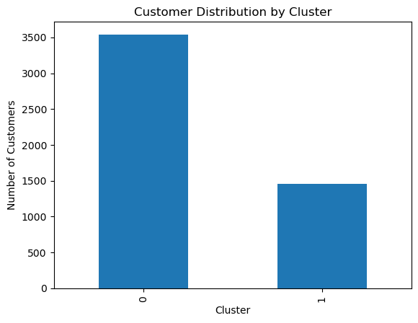
persona_counts = selected_df['Persona'].value_counts()
persona_counts.plot(kind='bar')
plt.title('Customer Distribution by Persona')
plt.xlabel('Persona')
plt.ylabel('Count')
plt.xticks(rotation=45)
plt.show()
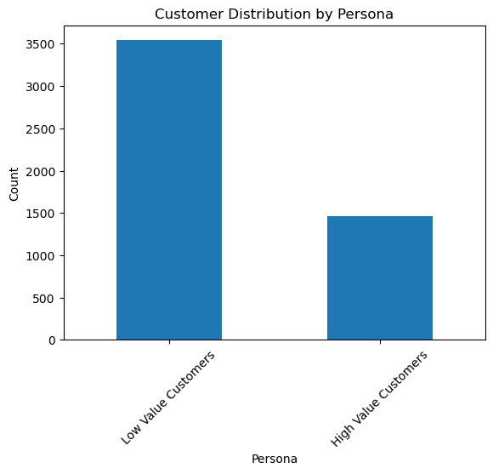
selected_df.groupby('Cluster')['Total_Spend'].mean().plot(kind='bar')
plt.title('Average Spend per Cluster')
plt.xlabel('Cluster')
plt.ylabel('Avg Total Spend')
plt.show()
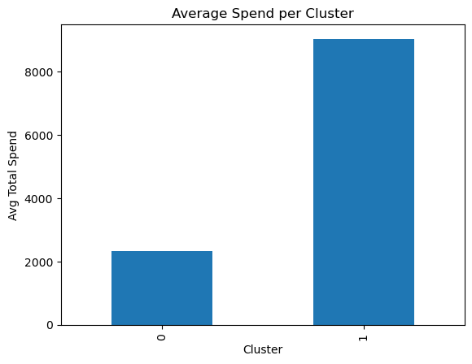
plt.figure()
for cluster in sorted(selected_df['Cluster'].unique()):
subset = selected_df[selected_df['Cluster'] == cluster]
plt.scatter(subset['Recency'], subset['Total_Spend'], label=f'Cluster {cluster}')
plt.xlabel('Recency')
plt.ylabel('Total Spend')
plt.title('Recency vs Spend by Cluster')
plt.legend()
plt.show()
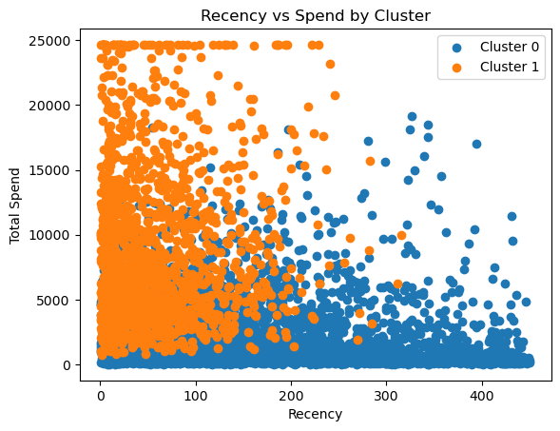
plt.figure()
plt.scatter(selected_df['Age'], selected_df['Total_Spend'])
plt.xlabel('Age')
plt.ylabel('Total Spend')
plt.title('Age vs Spending')
plt.show()
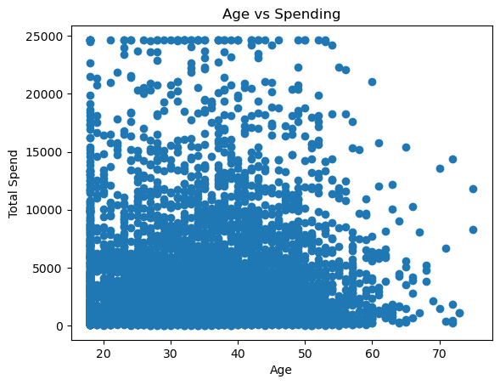
plt.figure()
plt.scatter(selected_df['Avg_Session_Duration'], selected_df['Avg_Pages_Viewed'])
plt.xlabel('Avg Session Duration')
plt.ylabel('Pages Viewed')
plt.title('Engagement Behavior')
plt.show()
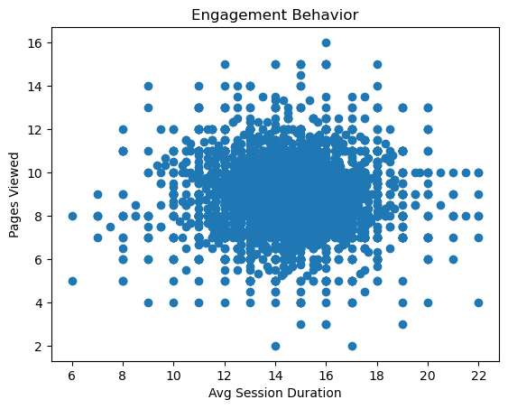

# PCA Visualization — built on the SAME scaled numeric data used for
# clustering (Fix #4 consistency), with variance explained + interpretation (Fix #6)
pca = PCA(n_components=2)
pca_data = pca.fit_transform(scaled_data)
explained = pca.explained_variance_ratio_

plt.figure()
for cluster in sorted(selected_df['Cluster'].unique()):
mask = selected_df['Cluster'] == cluster
plt.scatter(pca_data[mask, 0], pca_data[mask, 1], label=f'Cluster {cluster}', alpha=0.6)
plt.xlabel(f'PCA 1 ({explained[0]*100:.1f}% var)')
plt.ylabel(f'PCA 2 ({explained[1]*100:.1f}% var)')
plt.title('Customer Segments (PCA View)')
plt.legend()
plt.show()

print(f"\nPCA explains {sum(explained)*100:.1f}% of total variance in 2 components.")
print("Interpretation: well-separated clusters in this plot indicate the segments are "
"genuinely distinct in behavior space, not just arbitrary groupings caused by noise.")

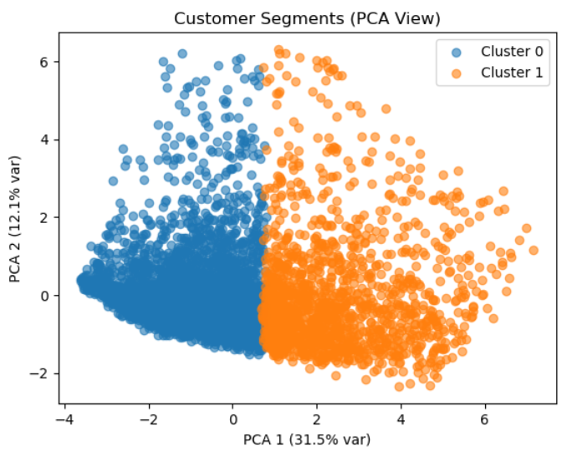
PCA explains 43.6% of total variance in 2 components.
Interpretation: well-separated clusters in this plot indicate the segments are genuinely distinct in behavior space, not just arbitrary groupings caused by noise.

Insights
print("\n🔍 Insights:")
for i, row in cluster_profile.iterrows():
print(f"\nCluster {i}:")
print(f"- Avg Spend: {row['Total_Spend']:.2f}")
print(f"- Orders: {row['Number_of_Orders']:.2f}")
print(f"- Recency: {row['Recency']:.2f}")
print(f"- Cluster Size: {row['Cluster_Size']} ({row['Cluster_%']:.2f}%)")

print(f"\nModel quality: K={k}, Silhouette Score={final_silhouette:.3f}")

🔍 Insights:

Cluster 0:
- Avg Spend: 2333.11
- Orders: 2.29
- Recency: 152.55
- Cluster Size: 3540 (70.80%)

Cluster 1:
- Avg Spend: 9036.13
- Orders: 6.13
- Recency: 60.66
- Cluster Size: 1460 (29.20%)

Model quality: K=2, Silhouette Score=0.201

Project Summary
print("\n" + "=" * 60)
print("PROJECT SUMMARY")
print("=" * 60)
print(f"Customers analyzed: {len(selected_df)}")
print(f"Features used for clustering: {numeric_features}")
print(f"Optimal K selected (by silhouette score): {k}")
print(f"Final Silhouette Score: {final_silhouette:.3f}")
print("\nSegment sizes:")
print(cluster_size.to_string())
print("\nPersonas identified and their recommended actions:")
for cluster_id, row in persona_df.iterrows():
print(f" Cluster {cluster_id} -> {row['Persona']}")
print(f" Action: {row['Recommended_Action']}")
print("\nNote: clustering is unsupervised, so silhouette score (not accuracy) "
"was used to validate cluster quality, since there is no ground-truth label.")
print("=" * 60)
Customers analyzed: 5000
Features used for clustering: ['Total_Spend', 'Avg_Order_Value', 'Total_Quantity', 'Number_of_Orders', 'Recency', 'Avg_Session_Duration', 'Avg_Pages_Viewed', 'Returning_Rate', 'Avg_Customer_Rating', 'Avg_Delivery_Time', 'Age', 'Purchase_Frequency']
Optimal K selected (by silhouette score): 2
Final Silhouette Score: 0.201

Segment sizes:
Cluster
0 3540
1 1460

Personas identified and their recommended actions:
Cluster 0 -> Low Value Customers
Action: Lower spend and/or fewer orders. Focus on activation: first-purchase incentives, value bundles, free shipping thresholds, and win-back campaigns for the most inactive customers within this group.
Cluster 1 -> High Value Customers
Action: Higher spend, more orders, and/or more recent activity. Prioritize retention: loyalty rewards, early access to new products, and personalized offers to protect this segment's LTV.

Note: clustering is unsupervised, so silhouette score (not accuracy) was used to validate cluster quality, since there is no ground-truth label.
============================================================

