**Software Engineering Tools Lab**

**Assignment No-1**

**(Module 1- Introduction to FOSS)**

1. Differentiate in between free software, Open source software and proprietary software with respect to its properties.

**Free Software:**

Free Software refers to freedom, not price. It guarantees its users the essential four freedoms. The absence of at least one of these freedoms means an application is proprietary, so non‐Free Software.

Use

Free Software can be used for any purpose and is free of restrictions such as licence expiry or geographic limitations.

Study

Free Software and its code can be studied by anyone, without non‐disclosure agreements or similar restrictions.

Share

Free Software can be shared and copied at virtually no cost

**Open-Source Software:**

It all started with Richard Stallman who developed the GNU project in 1983 which fueled the free software movement which eventually led to the revolutionary open-source software movement. The idea is to release the software under the open licenses category so that anyone could see, modify, and distribute the source code as deemed necessary. Any software under the open source license is intended to be shared openly among users and redistributed by others as long as the distribution terms are compliant with the OSI’s open source definition. Programmers with access to a program’s source code are allowed to manipulate parts of code by adding or modifying features that would not have worked otherwise.

**Proprietary Software:**

Unlike open source, there are some software the source code of which can only be modified by the individual or organization who created it. The owner or publisher of the software holds intellectual property rights of the source code exclusively. We call this type of software “proprietary software” because only the original owner(s) of the software are legally allowed to inspect and modify the source code. Unlike open source software, the internal structure of proprietary software is not exposed and the restrictions are imposed upon the users by the End User License Agreement. Examples of proprietary software include iTunes, Windows, macOS, Google Earth, Unix, Adobe Flash Player, Microsoft Word, etc.

2. Enlist some examples along with its purpose and properties (at least 10) of FOSS and

proprietary software with respect to database.

**FOSS:**

FOSS means Free and Open Source Software. It doesn’t mean the software is free of cost. It means that the software's source code is open for all and anyone is free to use, study and modify the code. This principle allows others to contribute to developing and improving a software like a community.

1 PostgreSQL

PostgreSQL is an object-relational database management system, founded on July 8, 1996. Developed by the PostgreSQL Global Development Group, it is written in C and works in most UNIX-like operating systems and Windows.

Features

* PostgreSQL works with every significant language and middleware.
* It bolsters simultaneous control.
* Its server-side programming usefulness is extremely full-grown.
* It has support for JSON licences.

2 MariaDB

MariaDB is a network created relational database management software system, written in C, C++, Bash and Perl. The stable version 10.3.12 of this free and open source database management software has the date January 7, 2019. MariaDB Corporation AB and MariaDB Foundation are the developers of this database.

Features

* MariaDB is comparable to MySQL, with some additional features. It can be viewed as an evolved variant of MySQL.
* Programming in MariaDB is covered by BSD, GPL, and LGPL licences.
* The framework uses a rearranged and standard questioning language.
* It supports an assortment of working frameworks and programming dialects.
* It offers special help for PHP.

3 SQLite

SQLite is a C programming library. The word ‘lite’ in the name indicates that the organisation, arrangement, and basic source of the database is lightweight. Created by D. Richard Hipp on August 17, 2000, the stable version of SQLite 3.26.0 was released on December 1, 2018.

Features

a. SQLite programming enhances cross-stage document design.

b. It needs less programming. The whole library is under 500 KiB in size.

c. It has a static composing group, which is usable in most SQL database motors.

d. SQLite utilises variable-length records.

e. The SQL explanations are compiled into virtual machine code.

4 Neo4j

Neo4j is a graph database management system. Its stable version 3.5.1 was released on December 20, 2018.

Features

* It is ACID (atomicity, consistency, isolation, and durability) compliant.
* It encourages versatility.
* Replicates information with quality and security.
* It works with Web applications for recovering chart information.
* It bolsters enquiry information sent out to JSON and XLS design.

5 CouchDB

CouchDB has been developed by the Apache Software Foundation, and is written in Erlang language. The stable version 2.3.0 was released on December 6, 2018.

Features

* It is ACID compliant.
* Has a distributed design with replication.
* CouchDB gives accessibility such as parcel resilience, ensuring competency.
* The information in the CouchDB framework is stored as ‘records’.

6 RethinkDB

RethinkDB is an open source database that, in contrast to customary database frameworks, stores data in the JSON (JavaScript Object Notation) group. It’s viewed as a NoSQL (Not only SQL) database, just like MongoDB, Cassandra, and CouchDB.

Features

* No mapping or table structure is required for putting away the data.
* Distributed engineering helps it to scale (in groups).

Consistency (similar information can be viewed by all the customers of the framework)

Availability

Partition tolerance

7 Redis

Redis is an open source (BSD authorised), in-memory information structure store, used as a database, reserve and message dealer. It enhances information structures — for example, strings, hashes, records, sets, arranged sets with extend enquiries, bitmaps, hyperlogs, and geospatial files.

Features

a. In-memory data store

b. Flexible data structures

c. Simplicity and ease-of-use

d. Replication and persistence

e. High availability and scalability

8 CockroachDB

CockroachDB is a distributed SQL (newSQL) database built on a transactional and strongly-consistent key-value store. It’s heavily inspired by Google’s Spanner and has many similarities with it.

Features

a. Distributed or replicated OLTP

b. Multi-data centre deployments

c. Multi-region deployments

9 Cassandra

Cassandra comes from the stable of the Apache Software Foundation, and is a free and open source DBMS written in Java. Authorised under Apache License 2.0, its stable version 3.11.3 was released on August 1, 2018.

Features

a. Apache Cassandra is a NoSQL database.

b. It supports replication and multi-server farm replication.

c. It is adaptable and reliable.

d. A distributed database, its conveyance plan relies on Amazon DynamoDB and information model on Google Cloud Bigtable.

e. Cassandra can run on sensitive equipment and perform quick writes to store a lot of information.

10 Timescale

New technologies require new sorts of databases. One of the best open source databases for the Internet of Things is Timescale.

Features

a. Hypertable abstraction layer

b. Automatic partitioning

c. Optimised time based constraint exclusion

d. Works across time-series and relational tables

e. Built-in flexible time bucketing

3. Enlist some examples of free open source exam software for online assessment.

* TCExam
* VirtualX
* Moodle
* TAO
* Kaldin
* Papershala
* Edbase
* Mettl
* FlexiQuiz
* Eklavvya
* Think Exam

4. Demonstrate any one exam software which is open source and freely available.

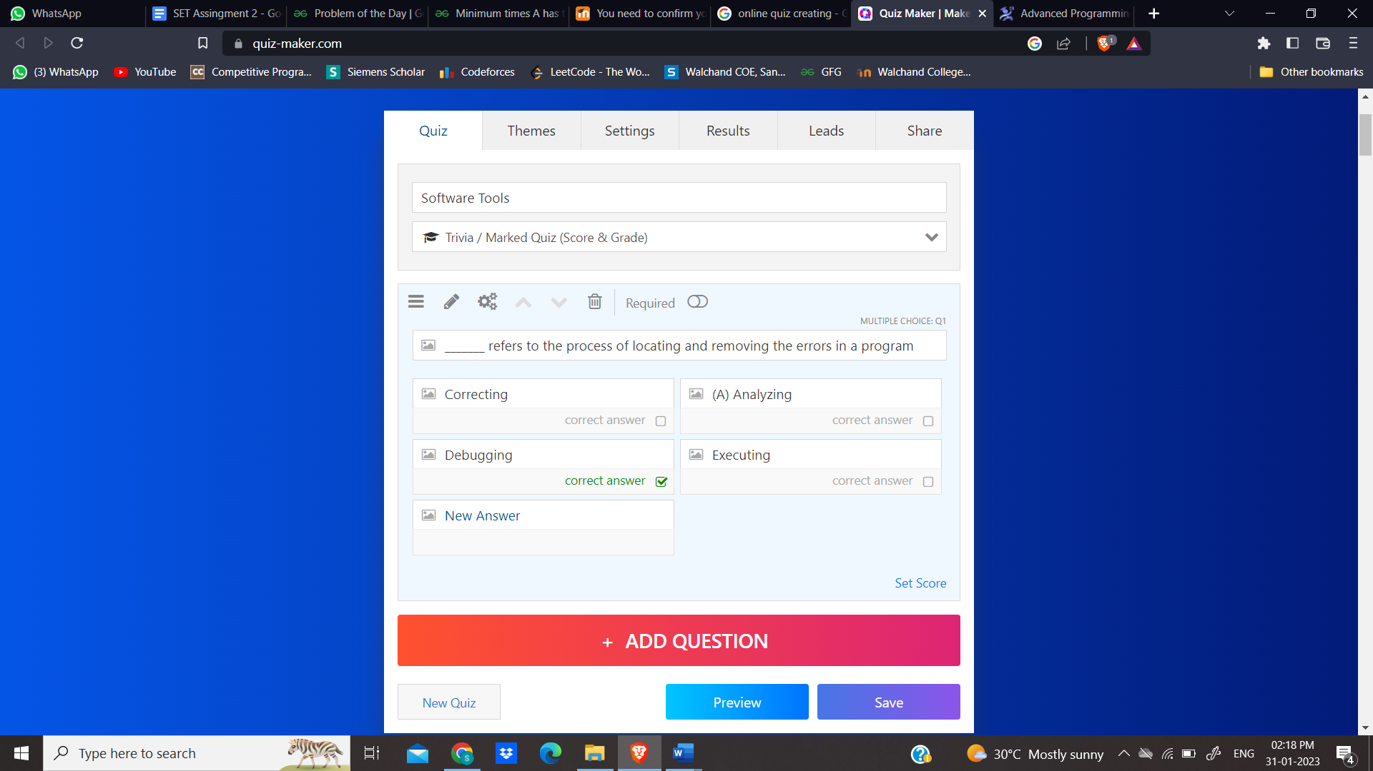

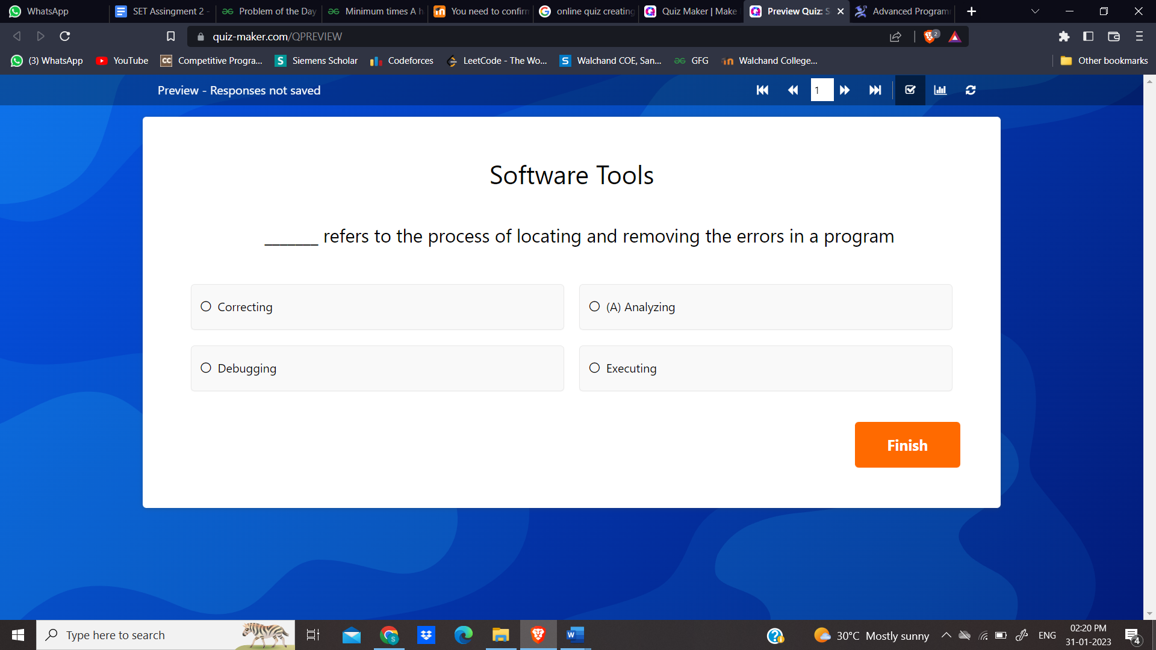

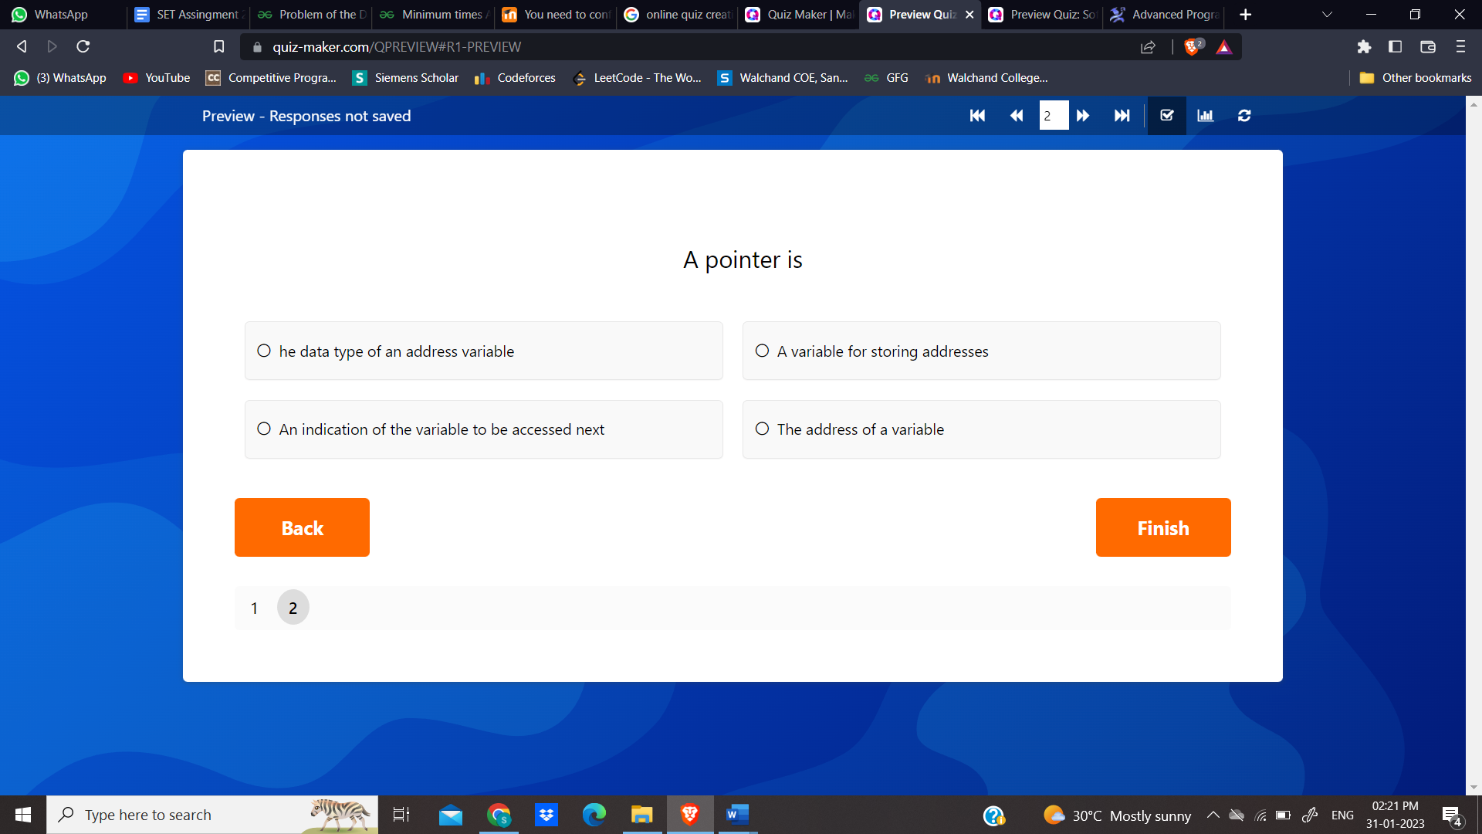

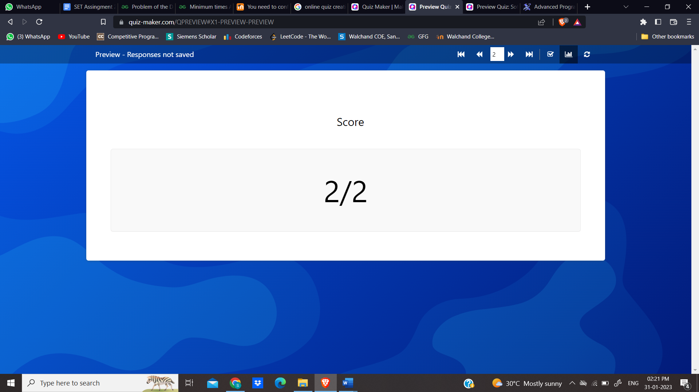

5. Demonstrate FOSS software related to database.

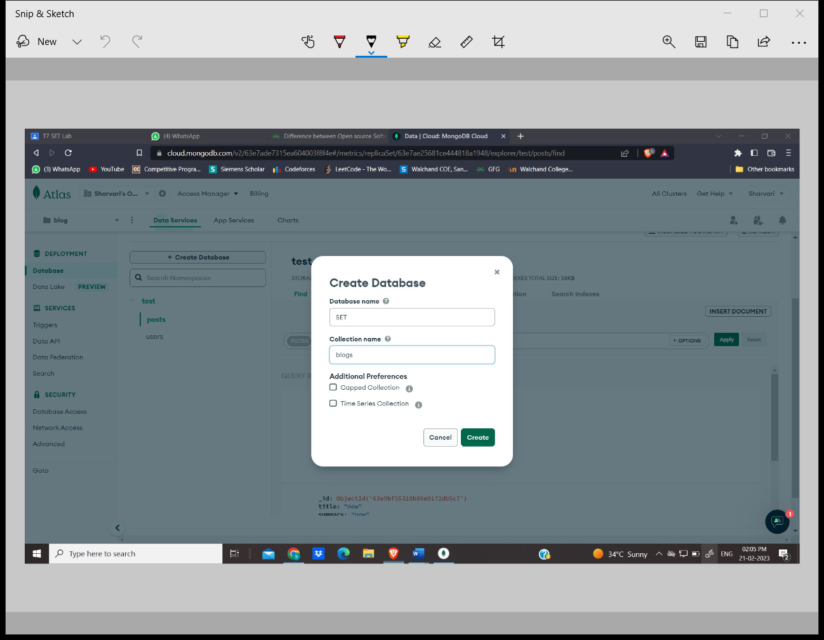

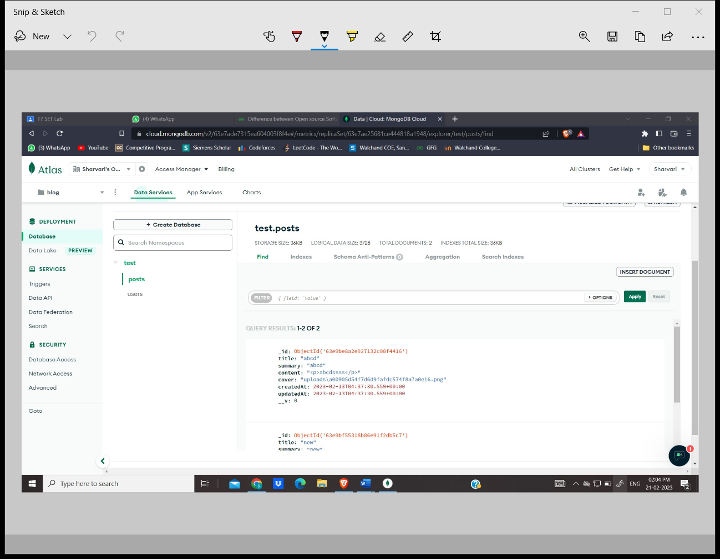

6. How does the Exam software work?

The best online examination software helps with the following procedures:

* **Students’ Registration**

Online exam software helps with the registration process of students and generates unique IDs for them.

* **Test Paper Creation**

You can create a subjective, objective, multiple-choice, and other types of questions online and ensure zero spam.

* **Take Tests Anytime, Anywhere**

Students can take tests from anywhere with a stable internet connection and a system. Similarly, teachers can invigilate directly through the system.

* **Automated Evaluation**

Teachers don’t need to evaluate answers manually, as the exam software helps analyze students’ performance digitally.

* **Track Students’ Progress**

YouTube broadcast software enables users to list their live streams as videos on their channels. This way the live stream can be seen even after it ended.

* **Data analysis**

The performance reports include detailed info about the strengths and weaknesses of every student. Accordingly, teachers can make the improvement plan.