

Case Study No.: 6
1. Case Study Title: To demonstrate JavaScript string operations using substring(), indexOf(), split(), replace(), string reversal, and vowel counting based on user input.

Case Study Program Code:
<!
function performOperations() {

let str = document.getElementById("str").value;

let start = Number(document.getElementById("start").value);
let end = Number(document.getElementById("end").value);

let search = document.getElementById("search").value;
let separator = document.getElementById("separator").value;

let oldText = document.getElementById("oldText").value;
let newText = document.getElementById("newText").value;

let output = "";

output += "<div class='result-title'>Results</div>";

// substring()
output += "Substring: " +
str.substring(start, end) + "<br>";

// indexOf()
output += "Index of '" + search + "': " +
str.indexOf(search) + "<br>";

// split()
if (separator.toLowerCase() == "space") {
output += "Split: " +
str.split(" ") + "<br>";
} else {
output += "Split: " +
str.split(separator) + "<br>";
}

// replace()
output += "Replace: " +
str.replace(oldText, newText) + "<br>";

// Reverse string
let reversed = str.split("").reverse().join("");

output += "Reversed String: " +
reversed + "<br>";

// Count vowels
let count = 0;

for (let i = 0; i < str.length; i++) {

let ch = str[i].toLowerCase();

if (
ch == "a" ||
ch == "e" ||
ch == "i" ||
ch == "o" ||
ch == "u"
) {
count++;
}
}

output += "Number of Vowels: " + count;

document.getElementById("output").innerHTML = output;
}

</style>

</head>
<body>
<h2>Shreya's JavaScript String Operations</h2>
<label>Enter String:</label><br>
<textarea id="str" placeholder="Enter your string or paragraph"></textarea>
<br>
<label>Substring Start:</label>
<input type="number" id="start" placeholder="Enter start index">
<br>
<label>Substring End:</label>
<input type="number" id="end" placeholder="Enter end index">
<br>
<label>IndexOf - Enter text to search:</label>
<input type="text" id="search" placeholder="Enter character or word">
<br>
<label>Split - Enter separator:</label>
<input type="text" id="separator" placeholder="Example: space">
<br>
<label>Replace - Text to replace:</label>
<input type="text" id="oldText" placeholder="Enter text to replace">
<br>
<label>Replace - New text:</label>
<input type="text" id="newText" placeholder="Enter new text">
<br>
<button onclick="performOperations()">Perform Operations</button>
<div id="output"></div>
<script src="shreya_case6.js"></script>
</body>
</html>
function performOperations() {

let str = document.getElementById("str").value;

let start = Number(document.getElementById("start").value); let end = Number(document.getElementById("end").value);

let search = document.getElementById("search").value;
let separator = document.getElementById("separator").value;

let oldText = document.getElementById("oldText").value; let newText = document.getElementById("newText").value; let output = "";
// Substring
output += "Substring: " + str.substring(start, end) + "<br>";
// IndexOf
output += "Index of '" + search + "': " + str.indexOf(search) + "<br>";
// Split
if (separator === "space") {
output += "Split: " + str.split(" ") + "<br>";
} else {
output += "Split: " + str.split(separator) + "<br>";
}
// Replace
output += "Replace: " + str.replace(oldText, newText) + "<br>";

// Reverse
let reverse = str.split("").reverse().join(""); output += "Reversed String: " + reverse + "<br>";
// Count Vowels let count = 0;
for (let i = 0; i < str.length; i++) { let ch = str[i].toLowerCase();
if (ch == "a" || ch == "e" || ch == "i" || ch == "o" || ch == "u") {
count++;
}
}
output += "Number of Vowels: " + count; document.getElementById("output").innerHTML = output;
}

3. Output:
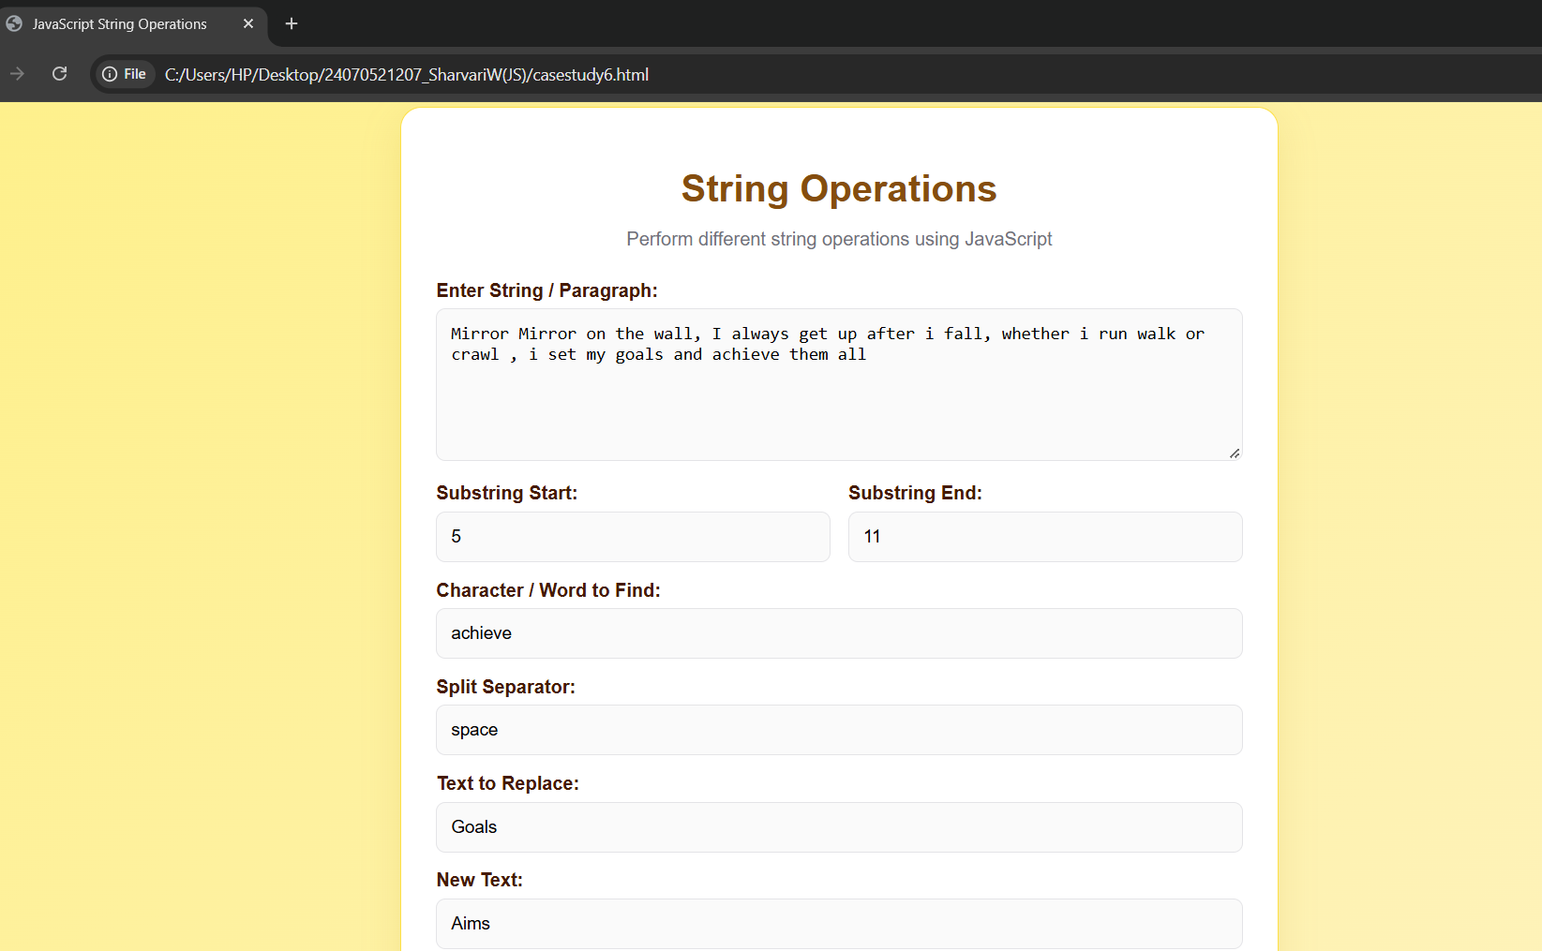
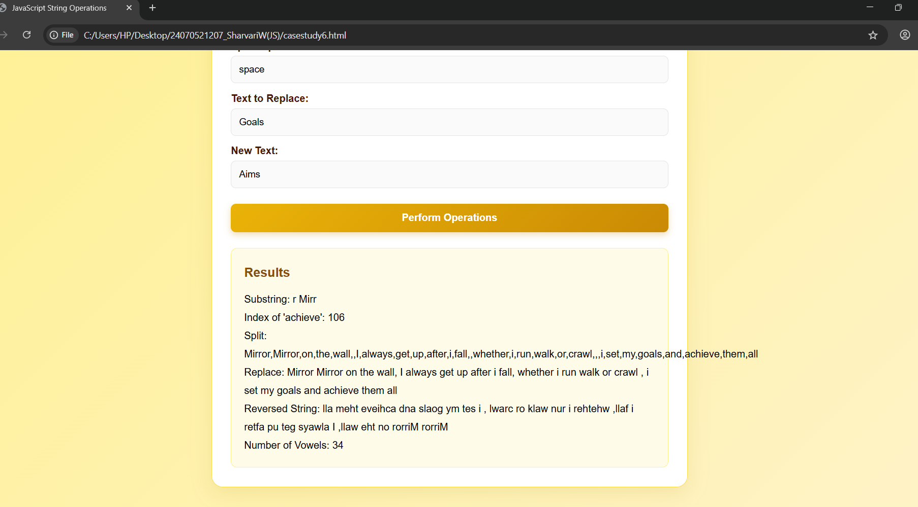

4. Result/Conclusion:
Thus, various JavaScript string operations were successfully performed, including substring extraction, text searching, splitting, replacing, reversing, and vowel counting, and the results were displayed dynamically on the webpage.

