

Case Study No.: 7
1. Case Study Title: To demonstrate events handling in javascript, a) access and manipulate from elements using javascript. b) validate user input (eg. email,empty,fields) c) use various form events (submit,change,focus).

Case Study Program Code:

<!DOCTYPE html>
<html lang="en">
<head>
<meta charset="UTF-8">
<meta name="viewport" content="width=device-width, initial-scale=1.0">
<title>SharvariWakde 1207 - SIT</title>
<style>
body {
font-family: 'Times New Roman', Times, serif;
background-color: #FFB6C1;
text-align: center;
padding: 20px;
}
h1 {
color: brown;
}
.info-card {
background-color: white;
max-width: 400px;
margin: 30px auto;
padding: 20px;
border-radius: 8px;
box-shadow: 0px 4px 8px rgba(0,0,0,0.1);
text-align: left;
}
.info-item {
margin-bottom: 15px;
font-size: 1.1rem;
}
.label {
font-weight: bold;
color: brown;
}



label {
display: block; margin-top: 15px; font-weight: bold;
}
input, select { width: 100%; padding: 10px; margin-top:
5px;
box-sizing: border-box;
}
input:focus, select:focus
{ border: 2px solid blue; outline: none;
}
.error {
color: red;
font-size: 13px;
}
button {
width: 100%; margin-top:
20px; padding:
10px;
background-color: #2563eb; color: white;
border: none;

#message {
text-align: center;
font-weight: bold; margin-top: 15px;
}
</style>
</head>
<body>
<div class="form-box">
<h2>Shreya's student Registration Form</h2>
<form id="studentForm">
<label>Name:</label>
<input type="text" id="name">
<div id="nameError" class="error"></div>
<label>Email:</label>
<input type="text" id="email">
<div id="emailError" class="error"></div>
<label>Course:</label>
<select id="course">
<option value="">Select Course</option>
<option value="CSE">Computer Science</option>
<option value="IT">Information Technology</option>
<option value="ECE">Electronics</option>
</select>
<div id="courseError" class="error"></div>
<button type="submit">Submit</button>
</form>

</div>
<script>
// Access form elements let form =
document.getElementById("studentForm");
let name = document.getElementById("name"); let email = document.getElementById("email");
let course = document.getElementById("course");
// Focus event name.addEventListener("focus", function() {
name.style.backgroundColor = "#eef4ff";
});
email.addEventListener("focus", function() { email.style.backgroundColor = "#eef4ff";
});
// Change event course.addEventListener("change", function() {

document.getElementById("courseError").innerText = "Selected Course: " + course.value;
});

// Submit event
form.addEventListener("submit", function(event)
{
event.preventDefault()
; let valid = true;
// Name validation
if (name.value.trim() === "") { document.getElementById("nameError").innerText

=
"Name cannot be empty"; valid = false;
} else {
document.getElementById("nameError").innerText = "";
}
// Email validation let emailPattern =
/^[^\s@]+@[^\s@]+\.[^\s@]+$/;
if (email.value.trim() === "") { document.getElementById("emailError").innerText =
"Email cannot be empty"; valid = false;
}
else if (!emailPattern.test(email.value)) { document.getElementById("emailError").innerText =
"Enter a valid email"; valid = false;
}
else {

document.getElementById("emailError").innerText = "";
}
// Course validation
if (course.value === "") {



document.getElementById("courseError").innerText = "Please select a course";
valid = false;
}
// Final result if (valid) {
document.getElementById("message").innerText =
"Registration submitted successfully!";

document.getElementById("message").style.color = "green";
}
else {

document.getElementById("message").innerText =
"Please correct the errors."; document.getElementById("message").style.color = "red";
}
});
</script>
</body>
</html>

Output:

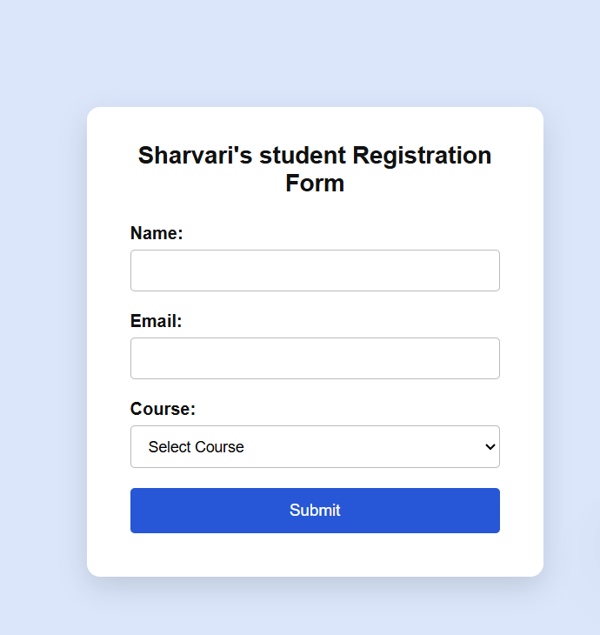

Result/Conclusion:
Thus, JavaScript events were successfully handled using focus, change, and submit, and form elements were accessed, manipulated, and validated using JavaScript.

