Experiment No.: 3
- Title: Implement control structures and form validation;create a grading system based on user-entered marks.
- Software/Tools Required: VS Code, web browser, HTML, JavaScript.
- Theory: Control structures (if, else if, and else) are used to make decisions based on the marks entered by the user.
Form validation checks whether the input is empty or outside the valid range (0–100) before processing.
The getElementById() method is used to access the value entered in the input box.
The Number() function converts the entered value from text to a numeric value.A function (calculateGrade()) is called when the Submit button is clicked to validate the input and calculate the grade.
The calculated grade is displayed on the webpage using the
innerHTML property.

Output :

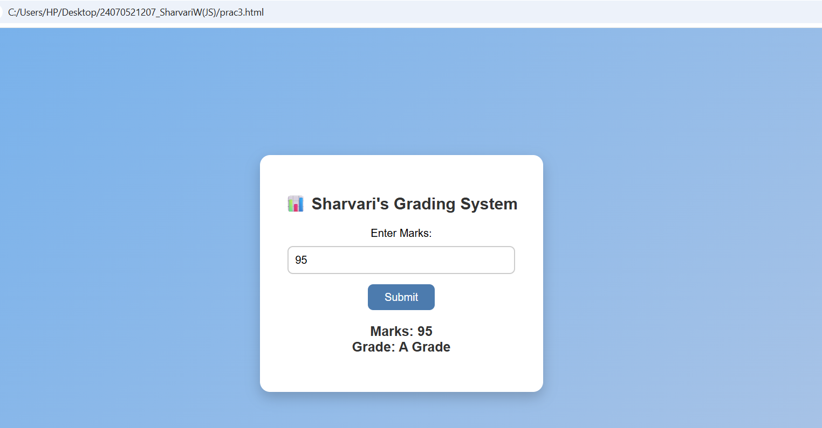

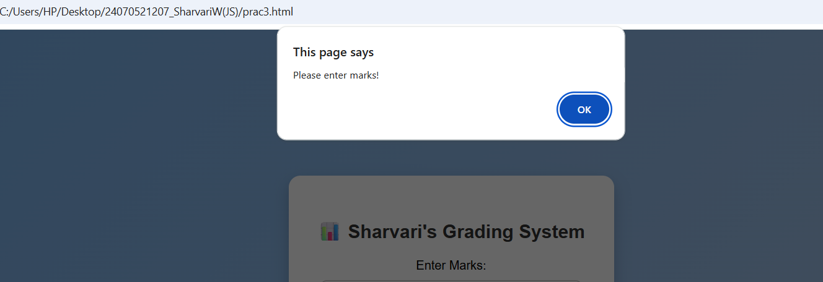
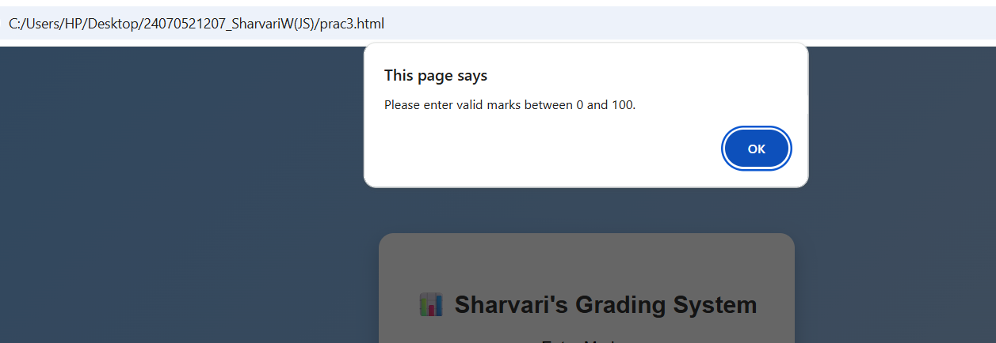

- Result/Conclusion:The grading system was successfully implemented using JavaScript. The program validated the user input, assigned grades using if-else control structures, and displayed the correct grade based on the entered marks. It effectively demonstrated the use of control structures and form validation in web development.

Case Study No.: 3
1. Case Study Title: Scholarship Eligibility,A college awards scholarships based on marks. Below 50-Not Eligible,
50-69-Bronze,70-84-Silver,85-94-Gold,95-100-Platinum.
Write a JavaScript program that accepts student marks and display the Scholarship category.

Case Study Program Code:

<!DOCTYPE html>

<html>

<head>

<title>Scholarship Eligibility</title>

<style>

body {

margin: 0;

font-family: Arial, sans-serif;

background: linear-gradient(135deg, hsl(21, 75%, 69%), hsl(39, 52%, 79%));

display: flex;

justify-content: center;

align-items: center;

height: 100vh;

}

.container {

background: white;

padding: 35px;

border-radius: 15px;

box-shadow: 0 8px 20px rgba(0,0,0,0.2);

text-align: center;

width: 350px;

}

h2 {

color: #333;

margin-bottom: 20px;

}

input {

width: 90%;

padding: 10px;

margin-top: 10px;

border: 2px solid #ccc;

border-radius: 8px;

font-size: 16px;

}

button {

margin-top: 15px;

padding: 10px 25px;

background: hsl(32, 39%, 49%);

color: white;

border: none;

border-radius: 8px;

font-size: 16px;

cursor: pointer;

transition: 0.3s;

}

button:hover {

background: hsl(60, 100%, 41%);

}

#result {

margin-top: 20px;

font-size: 20px;

font-weight: bold;

color: #333;

}

</style>

</head>

<body>

<div class="container">

<h2>🎓 Sharvari's Scholarship Eligibility System [24070521207] </h2>

<label>Enter Marks:</label><br>

<input type="number" id="marks" placeholder="Enter marks (0-100)">

<br>

<button onclick="checkGrade()">Submit</button>

<p id="result"></p>

</div>

<script>

function checkGrade() {

var marks = Number(document.getElementById("marks").value);

var input = document.getElementById("marks").value;

if (input === "") {

alert("Please enter marks!");

return;

}

if (marks < 0 || marks > 100) {

alert("Please enter valid marks between 0 and 100.");

return;

}

// Declared the scholarship variable properly

var scholarship = "";

if (marks >= 95) {

scholarship = "Platinum Scholarship";

} else if (marks >= 85) {

scholarship = "Gold Scholarship";

} else if (marks >= 70) {

scholarship = "Silver Scholarship";

} else if (marks >= 50) {

scholarship = "Bronze Scholarship";

} else {

// Simplified the final fallback case

scholarship = "Not Eligible for Scholarship";

}

// Now variables match perfectly

document.getElementById("result").innerHTML = "Marks: " + marks + "<br>Scholarship: " + scholarship;

}

</script>

</body>

</html>

marks = Number(marks); if(marks < 0 || marks > 100)
{
alert("Enter Valid Marks for Eligibility"); return;
}
let grade; if(marks >= 95)
grade = "Platinum Scholarship"; else if(marks >= 85)
grade = "Gold Scholarship"; else if(marks >= 70)
grade = "Silver Scholarship"; else if(marks >=50)
grade = "Bronze Scholarship"; else if(marks <= 50)
grade = "Not Eligible for Scholarship"; document.getElementById("result").innerHTML =
"Marks: " + marks + "<br>Grade: " + grade;
}
</script>
</body>
</html>

Output:

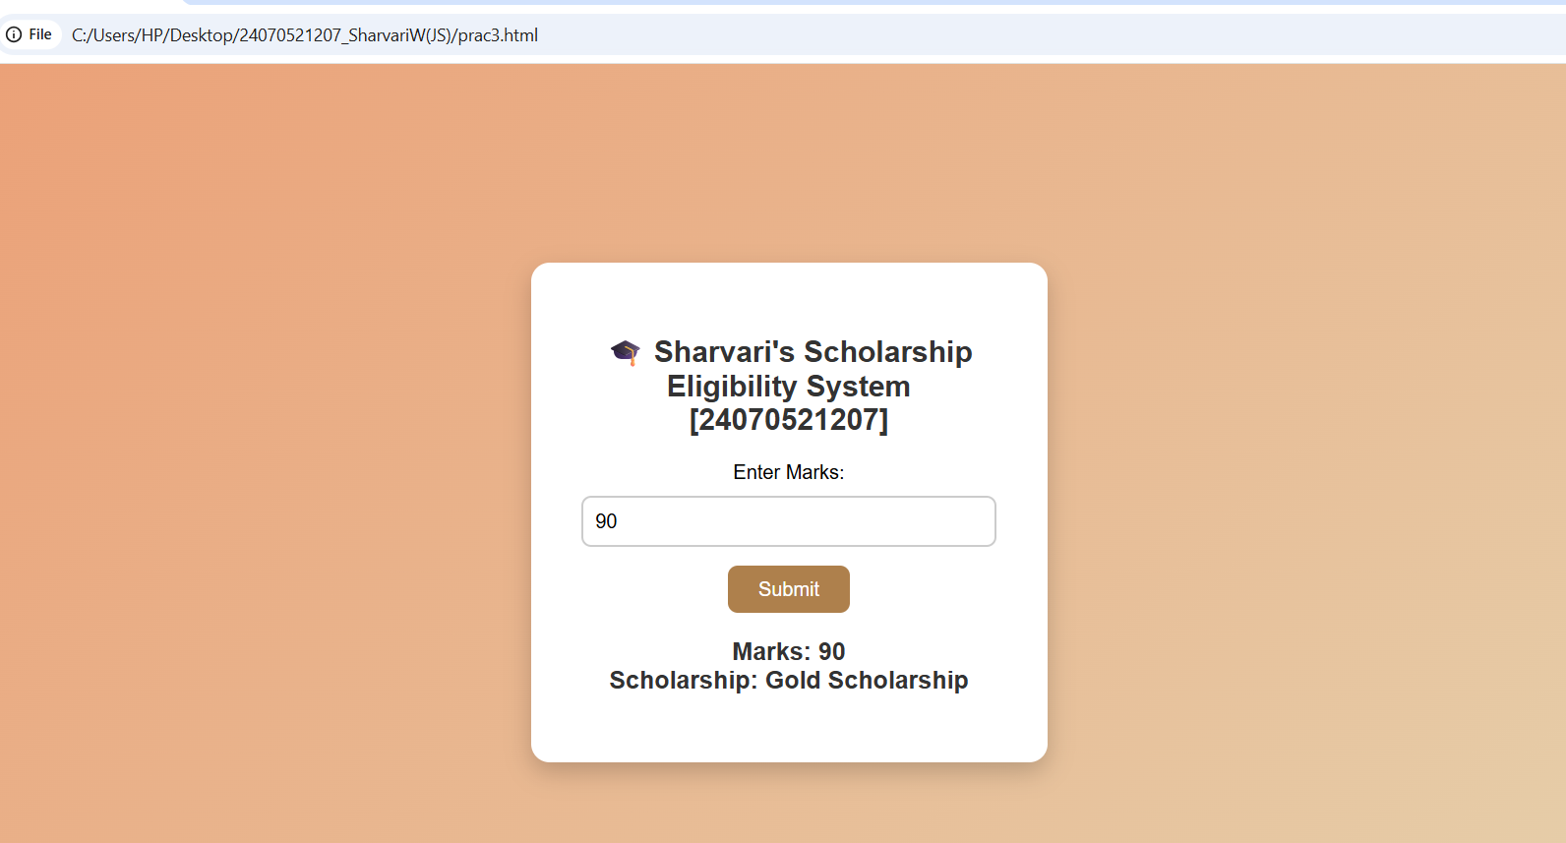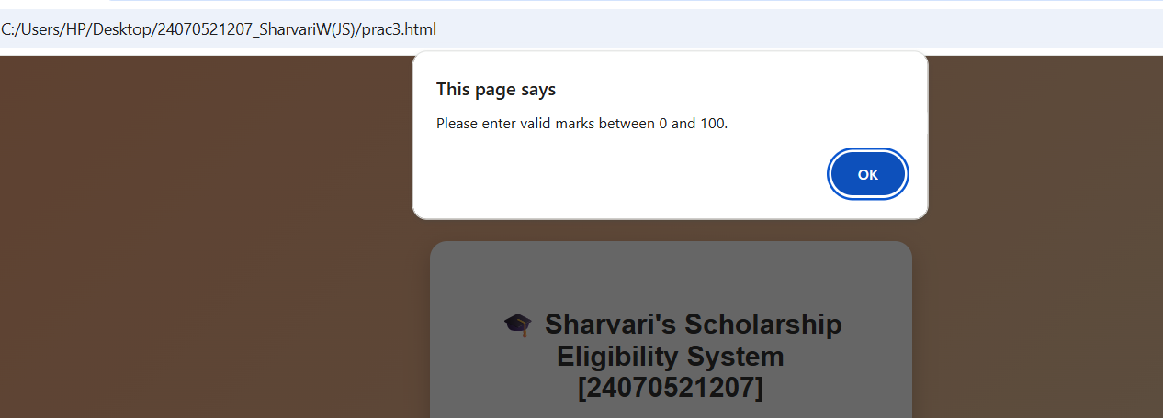

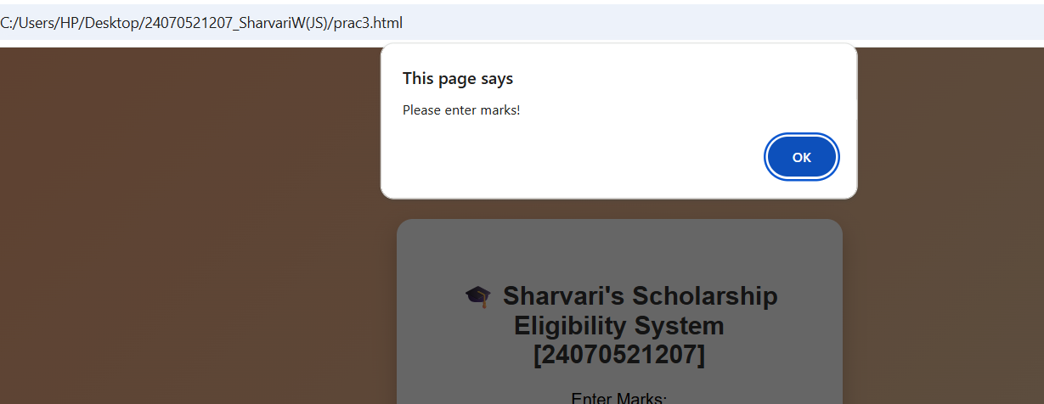

Result/Conclusion: The Scholarship Eligibility was successfully implemented using JavaScript. The program validated the user input, assigned eligibility marks using if-else control structures, and displayed the correct Eligibility awards based on the entered marks. It effectively demonstrated the use of control structures and form validation in web developmen

