Experiment No.: 4
- Title:
- Software/Tools Required: VS Code, web browser, HTML, JavaScript.
- Theory:
1. Regular Function
A regular function is a reusable block of code that performs a specific task. It can accept parameters, return values, and is invoked whenever needed. Functions improve code reusability and organization.
2. Function Declaration
A function declaration defines a function using the function keyword and a function name. It is hoisted, meaning it can be called before its declaration in the code.
3. Function Expression
A function expression stores a function inside a variable. Unlike function declarations, it is not fully hoisted and can only be called after it is defined.
4. Anonymous Function
An anonymous function is a function without a name. It is commonly used as a callback function or assigned to a variable for one-time or temporary operations.
5. Arrow Function
An arrow function is a shorter syntax for writing functions using the => operator. It is concise, easier to read, and automatically inherits the this value from its surrounding scope.
6. Variable Scope
Variable scope determines where a variable can be accessed in a program. JavaScript provides global scope, function scope, and block scope (using let and const).
7. Scope Closure (Closure)
A closure is created when an inner function remembers and accesses variables from its outer function even after the outer function has finished executing. Closures help preserve data and create private variables.
8. TryCatch
The trycatch statement is used for exception handling in JavaScript. The try block contains code that may cause an error, while the catch block handles the error, preventing the program from crashing.

Output :

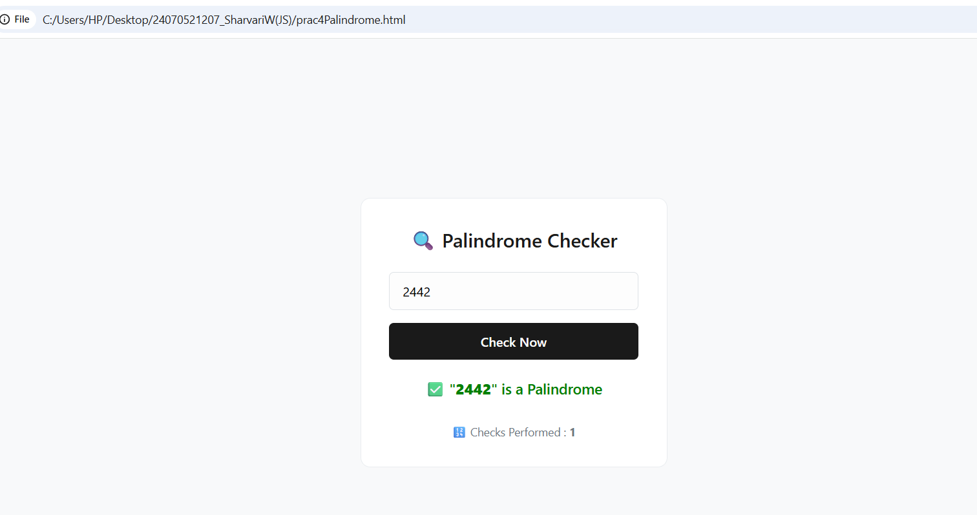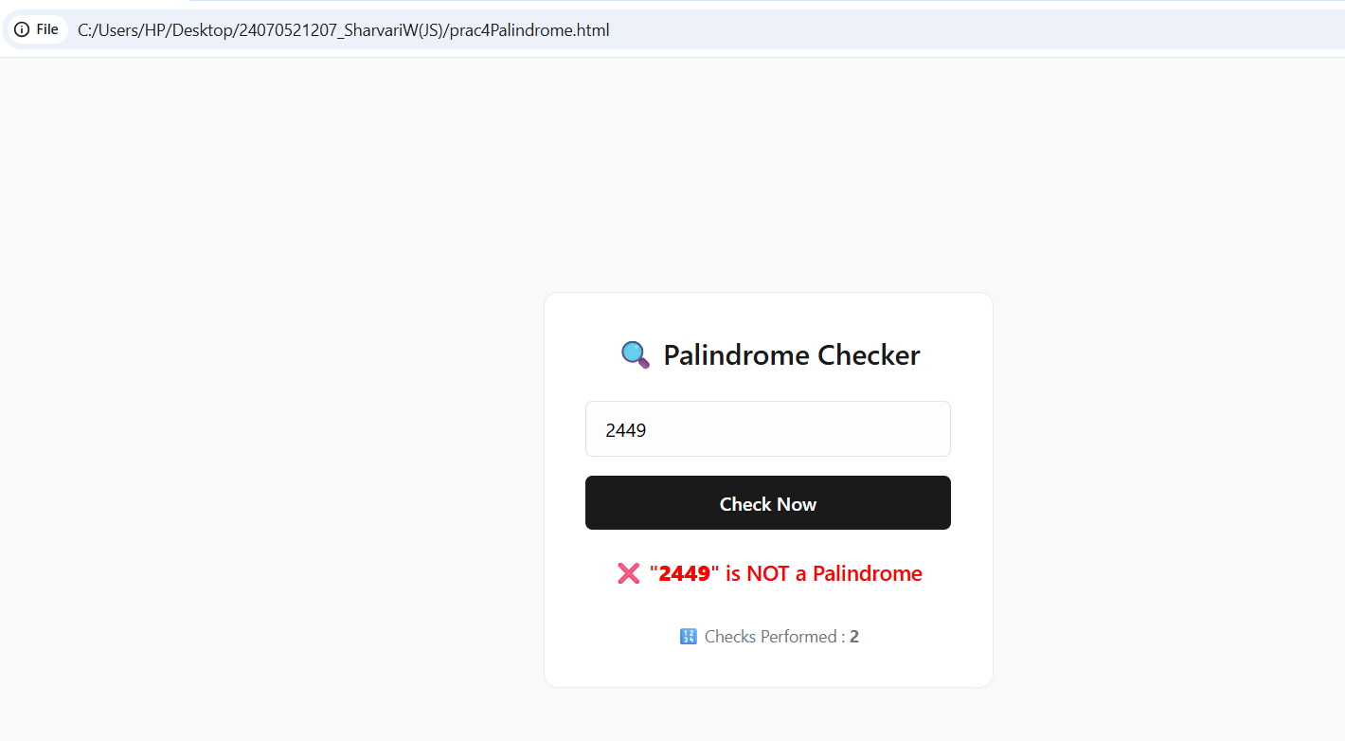

- Result/Conclusion: The JavaScript concepts such as functions, scope, closures, arrow functions, and exception handling were successfully studied and implemented. Their behavior and usage were verified through simple programs.JavaScript functions and scope mechanisms help in writing clean, reusable, and efficient code. Understanding these concepts improves programming skills and enables the development of reliable and maintainable web applications.

Case Study No.: 3
1. Case Study Title:

Case Study Program Code:

<!DOCTYPE html>

<html>

<head>

<title>ATM PIN Verification</title>

<style>

body {

font-family: Arial, sans-serif;

background-color: #f5f0eb; /* Soft beige background */

color: #4a3c31; /* Deep dark brown text */

display: flex;

flex-direction: column;

align-items: center;

justify-content: center;

height: 100vh;

margin: 0

}

.card {

background-color: #ffffff;

padding: 30px;

border-radius: 10px;

box-shadow: 0 4px 10px rgba(74, 60, 49, 0.15);

text-align: center;

border-top: 5px solid #6b4c3b; /* Medium warm brown accent */

}

h2 {

color: #5c3a21; /* Rich chocolate brown */

}

label {

display: block;

margin-bottom: 10px;

font-weight: bold;

}

/* Changed selector from input[type="password"] to input[type="text"] */

input[type="text"] {

padding: 8px;

width: 200px;

border: 1px solid #b8a398;

border-radius: 4px;

margin-bottom: 15px;

}

button {

background-color: #6b4c3b; /* Warm brown button */

color: white;

padding: 9px 18px;

border: none;

border-radius: 4px;

cursor: pointer;

font-weight: bold;

}

button:hover {

background-color: #5c3a21;

}

#result {

margin-top: 20px;

font-size: 14px;

}

</style>

</head>

<body>

<div class="card">

<h2>Sharvari's (1207) PIN Verification</h2>

<label for="pin">Enter ATM PIN:</label>

<input type="text" id="pin">

<button onclick="verifyPIN()">Verify</button>

<h3 id="result"></h3>

</div>

<script>

// Function Declaration - defines a function with the function keyword and a function name (use when main part of program and you want it available thruout the scope)

function reversePIN(pin) {

return pin.split("").reverse().join("");

}

// Function Expression - stores a function inside the variable (use when passing functions as arguments, assigning functions to variables , creating callbacks)

const isPalindrome = function(pin) {

return pin === reversePIN(pin);

};

// Arrow Function - shorter way to write a function in js. it was introduced in ES6 and uses arrow syntax

const displayMessage = (msg) => {

document.getElementById("result").innerHTML = msg;

};

// Scope and Closure

function verifyPIN() {

let pin = document.getElementById("pin").value;

function securityMessage() {

if (isPalindrome(pin)) {

return " PIN is a Palindrome. Hence, Its a weak password. Please Change it for max security";

} else {

return " PIN is Not a Palindrome. So, security verified!";

}

}

displayMessage(securityMessage());

}

</script>

</body>

</html>



Output:
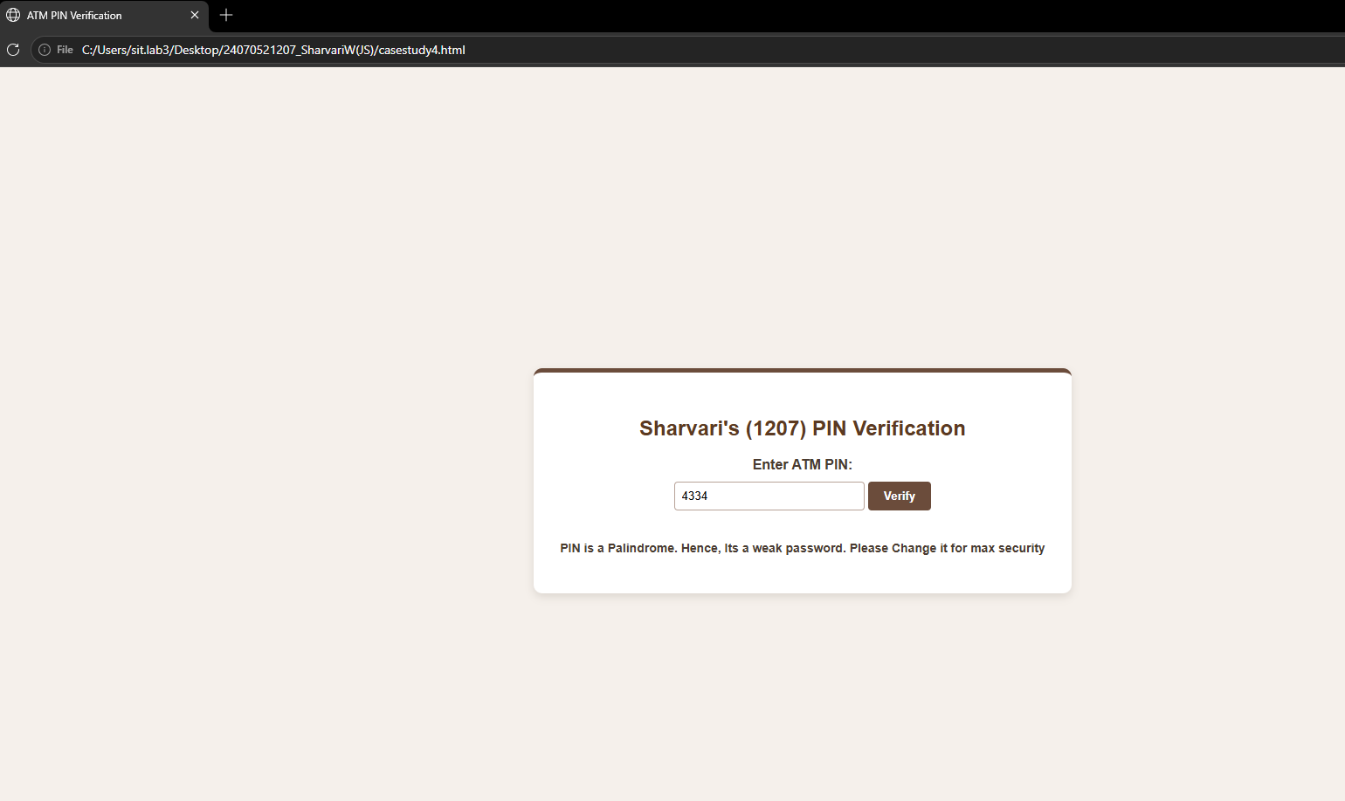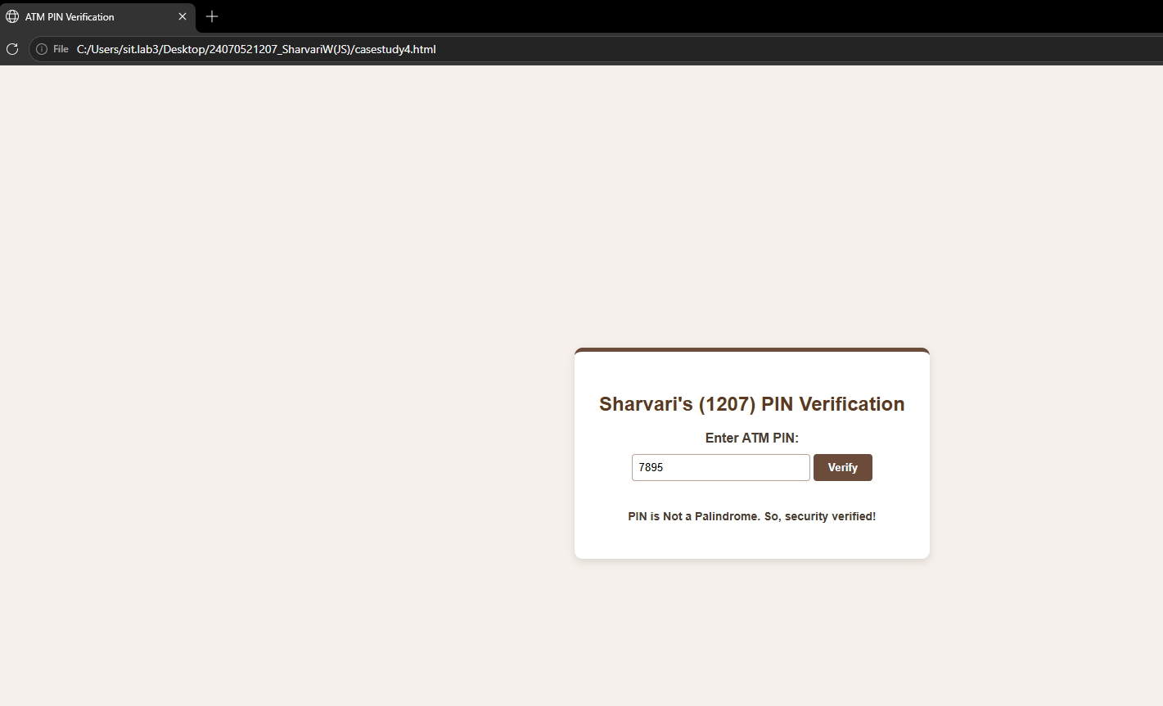

- Result/Conclusion: The Scholarship Eligibility was successfully implemented using JavaScript. The program validated the user input, assigned eligibility marks using if-else control structures, and displayed the correct Eligibility awards based on the entered marks. It effectively demonstrated the use of control structures and form validation in web development.

