Experiment No.: 1

- Title: Demonstrate inline, internal, and external JavaScript; use console methods; create a webpage showing user info and a welcome message.

- Software/Tools Required: Visual Studio Code (VS Code)Google Chrome/web browser, HTML, JavaScript.

- Theory: JavaScript is a scripting language used to make web pages interactive. It can be added in three ways:
  - Inline JavaScript: Written inside HTML elements.
  - Internal JavaScript: Written inside the <script> tag in the HTML file.
  - External JavaScript: Written in a separate .js file and linked to the HTML page.
  - Console methods like console.log(), console.info(), console.warn(), and console.error() are used for debugging and displaying messages.

Output:

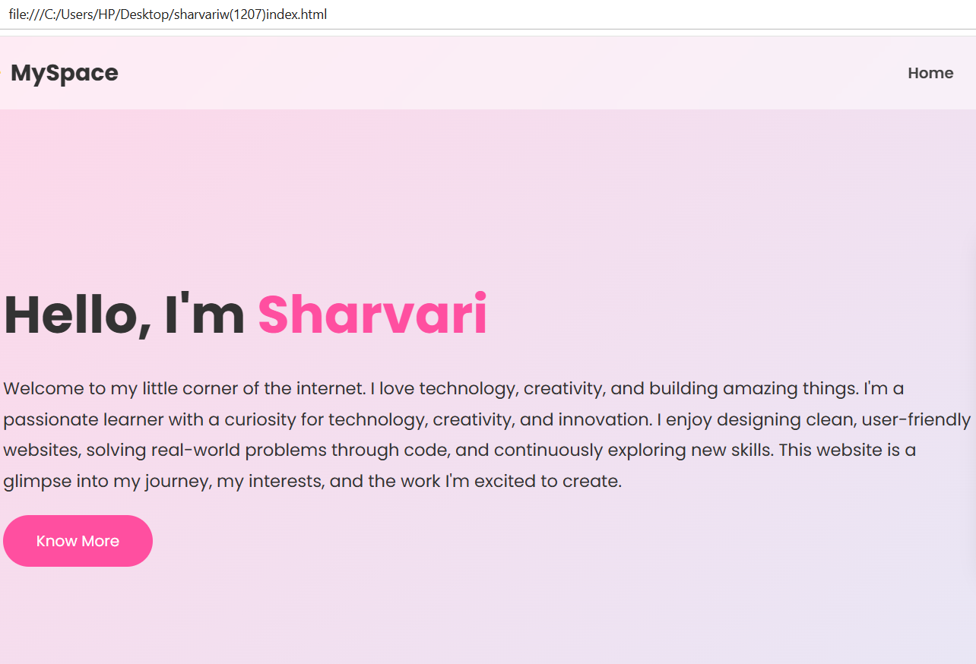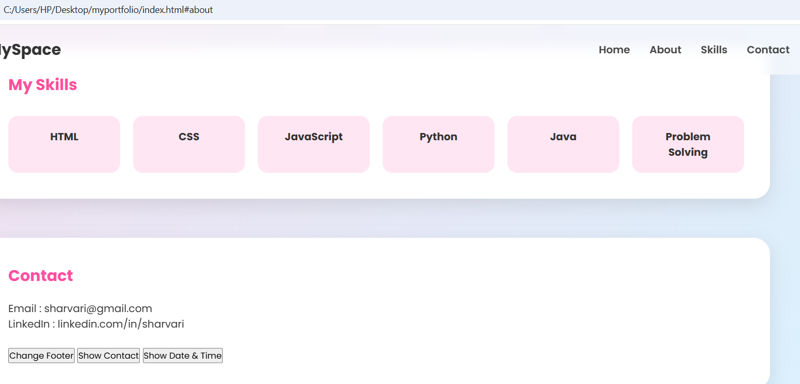
- Result/Conclusion: The experiment was performed successfully. A webpage displaying a welcome message and user information was created using inline, internal, and external JavaScript, and console methods were demonstrated successfull

Case Study No.: 1
- Case Study Title: Create a webpage for college department and link the student information page with it and write a java script to display “welcome to sit nagpur” in an alert box.

Case Study Program Code:

<!DOCTYPE html>
<html lang="en">
<head>
<meta charset="UTF-8">
<meta name="viewport" content="width=device-width, initial-scale=1.0">
<title>SYMBIOSIS INSTITUTE OF TECHNOLOGY, NAGPUR</title>
<style>
body {
font-family: 'Times New Roman', Times, serif;
background-color: #FFB6C1;
text-align: center;
margin: 0;
padding: 0;
}
h1 {
color: brown;
}
.welcome-msg {
font-size: 1.5rem;
color: #333;
margin: 20px 0;
font-weight: bold;
}
.form-container {
margin-top: 20px;
}
input {
margin: 5px;
padding: 8px;
width: 250px;
}
button {
padding: 8px 15px;
background-color: brown;
color: white;
border: none;
cursor: pointer;
font-weight: bold;
}
button:hover {
background-color: #6e1a1a;
}

/* --- CUSTOM POPUP MODAL STYLES --- */
.modal-overlay {
position: fixed;
top: 0;
left: 0;
width: 100%;
height: 100%;
background-color: rgba(0, 0, 0, 0.5); /* Dims the background */
display: flex;
justify-content: center;
align-items: center;
z-index: 1000;
}
.modal-box {
background-color: white;
padding: 30px;
border-radius: 8px;
box-shadow: 0 4px 15px rgba(0,0,0,0.2);
text-align: center;
max-width: 400px;
width: 90%;
}
.modal-box h4 {
margin-top: 0;
color: brown;
font-size: 1.3rem;
}
.modal-buttons {
margin-top: 20px;
display: flex;
justify-content: center;
gap: 15px;
}
.btn-yes {
background-color: #28a745;
}
.btn-no {
background-color: #dc3545;
}
</style>
</head>
<body>

<!-- CUSTOM POPUP MODAL -->
<div id="customModal" class="modal-overlay">
<div class="modal-box">
<h4>Registration Check</h4>
<p id="modalQuestion">Are you already registered with us?</p>
<div class="modal-buttons" id="actionButtons">
<!-- User clicks YES -->
<button class="btn-yes" onclick="handleUserChoice(true)">Yes, I am</button>
<!-- User clicks NO -->
<button class="btn-no" onclick="handleUserChoice(false)">No, I'm new</button>
</div>
</div>
</div>

<!-- MAIN BACKGROUND CONTENT -->
<header>
<h1>SYMBIOSIS INSTITUTE OF TECHNOLOGY, NAGPUR</h1>
<p class="welcome-msg">Welcome to the Student Portal!</p>
<hr>
<h2>Department Of Computer Science and Engineering</h2>
<h3>Specialization: AI & ML / Data Science</h3>
</header>

<main class="form-container">
<h3>Student Information Form</h3>
<input type="text" id="nameInput" placeholder="Enter Full Name"><br>
<input type="text" id="rollInput" placeholder="Enter Roll Number"><br>
<input type="email" id="emailInput" placeholder="Enter Email Address"><br>
<button onclick="collectData()">Submit Data</button>
</main>

<script>
// Handles what happens after clicking Yes or No
function handleUserChoice(isRegistered) {
const questionText = document.getElementById("modalQuestion");
const buttonsContainer = document.getElementById("actionButtons");

// 1. Change the text to display the "Welcome to SIT" message
if (isRegistered) {
questionText.innerHTML = "<strong>Welcome to SIT!</strong><br>Please proceed to login.";
} else {
questionText.innerHTML = "<strong>Welcome to SIT!</strong><br>Please create an account on our registration page.";
}

// 2. Replace the Yes/No buttons with a single "OK / Close" button to avoid browser blocks
buttonsContainer.innerHTML = '<button onclick="closeModal()">OK</button>';
}

// Closes the modal box completely to reveal the form
function closeModal() {
document.getElementById("customModal").style.display = "none";
}

// Logic for collecting form data
function collectData() {
const name = document.getElementById("nameInput").value;
const rollNo = document.getElementById("rollInput").value;
const email = document.getElementById("emailInput").value;

if (!name || !rollNo || !email) {
alert("Please fill out all fields.");
return;
}

localStorage.setItem("studentName", name);
localStorage.setItem("studentRoll", rollNo);
localStorage.setItem("studentEmail", email);

window.location.href = "student.html";
}
</script>
</body>
</html>
<!DOCTYPE html>
<html lang="en">
<head>
<meta charset="UTF-8">
<meta name="viewport" content="width=device-width, initial-scale=1.0">
<title>Student Information - SIT</title>
<style>
body {
font-family: 'Times New Roman', Times, serif;
background-color: #FFB6C1;
text-align: center;
padding: 20px;
}
h1 {
color: brown;
}
.info-card {
background-color: white;
max-width: 400px;
margin: 30px auto;
padding: 20px;
border-radius: 8px;
box-shadow: 0px 4px 8px rgba(0,0,0,0.1);
text-align: left;
}
.info-item {
margin-bottom: 15px;
font-size: 1.1rem;
}
.label {
font-weight: bold;
color: brown;
}
a {
display: inline-block;
margin-top: 20px;
color: brown;
text-decoration: none;
font-weight: bold;
}
</style>
</head>
<body>

<h1>SIT Student Profile</h1>
<h2>Submitted Information</h2>

<div class="info-card">
<div class="info-item"><span class="label">Name:</span> <span id="displayName"></span></div>
<div class="info-item"><span class="label">Roll Number:</span> <span id="displayRoll"></span></div>
<div class="info-item"><span class="label">Email:</span> <span id="displayEmail"></span></div>
</div>

<a href="index.html">← Go Back to Form</a>

<script>
// Fetch the stored data on page load
window.onload = function() {
const name = localStorage.getItem("studentName");
const rollNo = localStorage.getItem("studentRoll");
const email = localStorage.getItem("studentEmail");

// Display data, or show a fallback message if empty
document.getElementById("displayName").innerText = name ? name : "No data found";
document.getElementById("displayRoll").innerText = rollNo ? rollNo : "No data found";
document.getElementById("displayEmail").innerText = email ? email : "No data found";
}
</script>

</body>

Output:
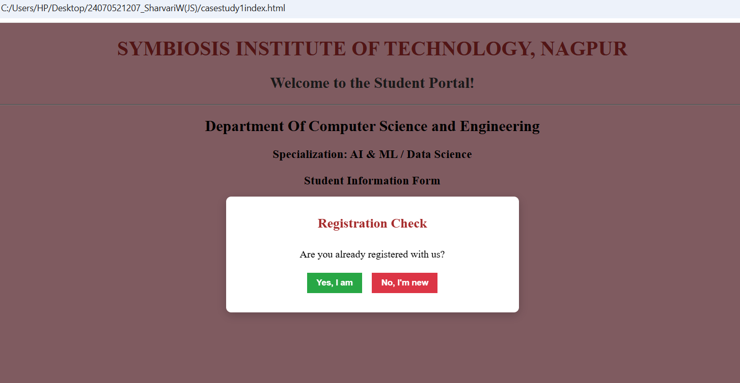
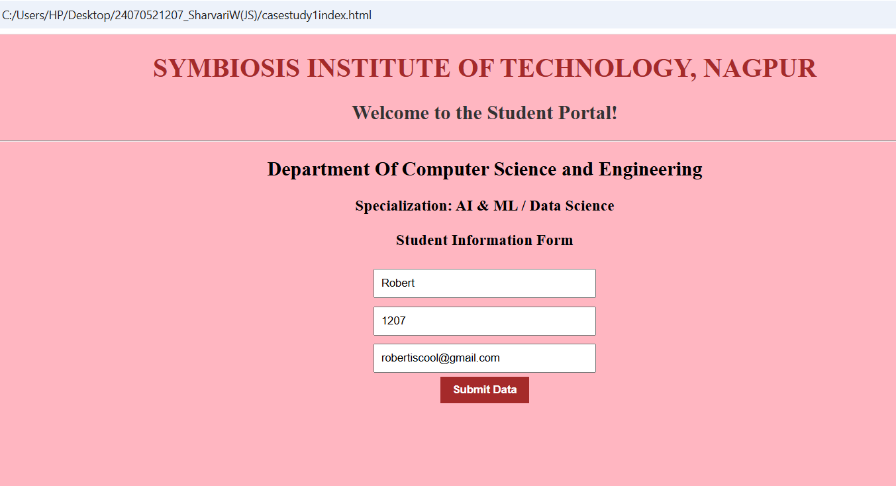

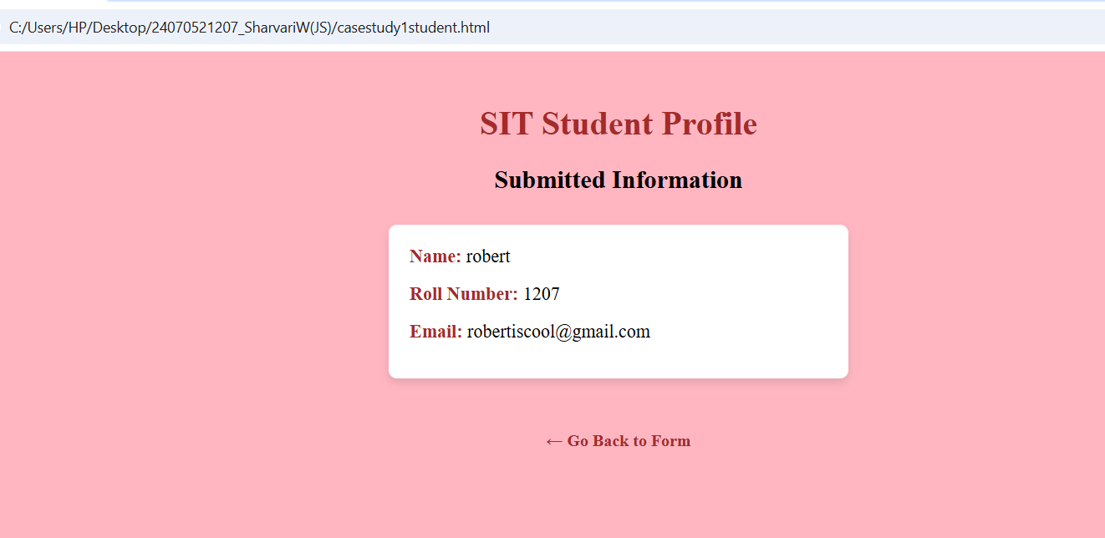

3. Result/Conclusion: The college department webpage was created successfully. The Student Information page was linked to it, and JavaScript was implemented using inline, internal, and external methods. A welcome message was displayed in an alert box, and console.log() output was verified in the browser console.

