Experiment No.: 2
- Title: Use var, let, const, and demonstrate basic features like template literals and destructuring; build a billing calculator with user input.
- Software/Tools Required: Visual Studio Code (VS Code), web browser, HTML, JavaScript.
- Theory: var is function-scoped, let is block-scoped, and const
is used for fixed values.
The prompt() function accepts user input, and Number() converts input into numeric values.
The program calculates the total amount, GST, and final bill using arithmetic operations.
An object stores all billing details together, while object destructuring extracts required values easily.
Template literals (``) are used to display formatted output with variable values using ${}.
The document.write() method displays the billing receipt on the webpage.

Output :

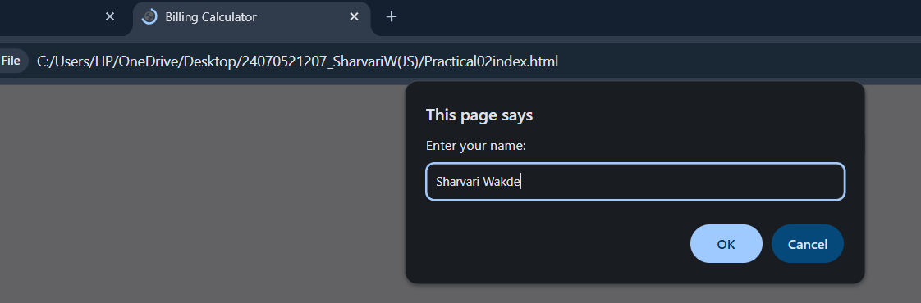

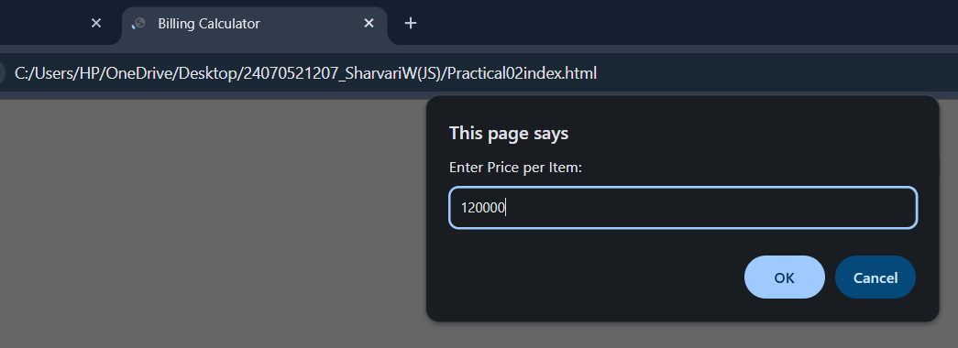
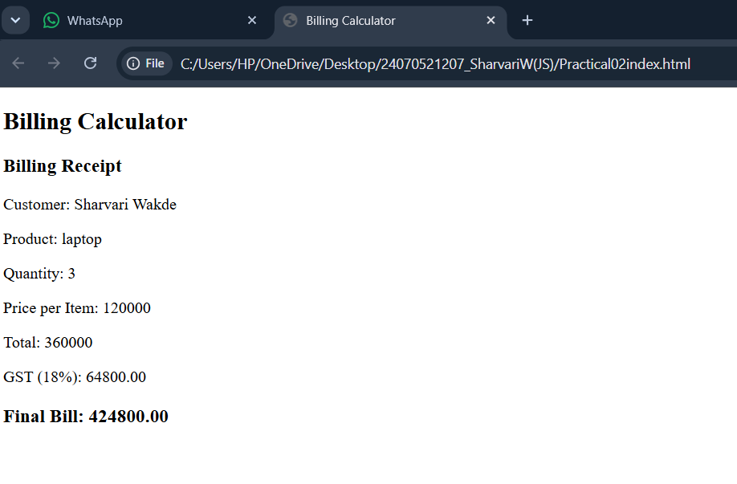

- Result/Conclusion: A billing calculator was successfully created using JavaScript. The program accepted user input, calculated the bill with GST, and demonstrated the use of var, let, const, template literals, and object destructuring effectively.

Case Study No.: 2
- Case Study Title: Develop the webpage for an online shopping website with using html,css and html tags and calculate bill,customer name,mobile no,invoice no,product no,quantity(kg),rate per kg,discount,GST,packing charges,payment mode(cash/card/UPI), Membership(yes/no).

Case Study Program Code:
<!DOCTYPE html>
<html>
<head>
<title>Online Shopping Billing System</title>

<style>
body{
font-family: Arial, sans-serif;
background:#f2f2f2;
}

.container{
width:600px;
margin:30px auto;
background:white;
padding:20px;
border-radius:10px;
box-shadow:0px 0px 10px gray;
}

h2{
text-align:center;
color:#0066cc;
}

table{
width:100%;
}

td{
padding:8px;
}

input,select{
width:100%;
padding:8px;
}

button{
width:100%;
padding:10px;
background:#0066cc;
color:white;
border:none;
font-size:16px;
cursor:pointer;
border-radius:5px;
}

button:hover{
background:#004c99;
}

#result{
margin-top:20px;
background:#e8f5e9;
padding:15px;
border-radius:5px;
font-size:18px;
}
</style>

</head>

<body>

<div class="container">

<h2>ONLINE SHOPPING BILL</h2>

<table>

<tr>
<td>Customer Name</td>
<td><input type="text" id="cname"></td>
</tr>

<tr>
<td>Mobile Number</td>
<td><input type="text" id="mobile"></td>
</tr>

<tr>
<td>Invoice Number</td>
<td><input type="text" id="invoice"></td>
</tr>

<tr>
<td>Product Name</td>
<td><input type="text" id="product"></td>
</tr>

<tr>
<td>Quantity (Kg)</td>
<td><input type="number" id="qty"></td>
</tr>

<tr>
<td>Rate per Kg</td>
<td><input type="number" id="rate"></td>
</tr>

<tr>
<td>Discount (%)</td>
<td><input type="number" id="discount"></td>
</tr>

<tr>
<td>GST (%)</td>
<td><input type="number" id="gst"></td>
</tr>

<tr>
<td>Packing Charges</td>
<td><input type="number" id="packing"></td>
</tr>

<tr>
<td>Payment Mode</td>
<td>
<select id="payment">
<option>Cash</option>
<option>Card</option>
<option>UPI</option>
</select>
</td>
</tr>

<tr>
<td>Membership</td>
<td>
<select id="member">
<option>Yes</option>
<option>No</option>
</select>
</td>
</tr>

<tr>
<td colspan="2">
<button onclick="calculateBill()">Generate Bill</button>
</td>
</tr>

</table>

<div id="result"></div>

</div>

<script>

function calculateBill()
{

var cname=document.getElementById("cname").value;
var mobile=document.getElementById("mobile").value;
var invoice=document.getElementById("invoice").value;
var product=document.getElementById("product").value;

var qty=parseFloat(document.getElementById("qty").value);
var rate=parseFloat(document.getElementById("rate").value);
var discount=parseFloat(document.getElementById("discount").value);
var gst=parseFloat(document.getElementById("gst").value);
var packing=parseFloat(document.getElementById("packing").value);

var payment=document.getElementById("payment").value;
var member=document.getElementById("member").value;

var amount=qty*rate;

var discountAmount=(amount*discount)/100;

var subtotal=amount-discountAmount;

var gstAmount=(subtotal*gst)/100;

var total=subtotal+gstAmount+packing;

if(member=="Yes")
{
total=total-(total*5/100);
}

document.getElementById("result").innerHTML=

"<h3>Invoice</h3>"+

"<b>Customer Name :</b> "+cname+"<br><br>"+

"<b>Mobile No :</b> "+mobile+"<br><br>"+

"<b>Invoice No :</b> "+invoice+"<br><br>"+

"<b>Product :</b> "+product+"<br><br>"+

"<b>Quantity :</b> "+qty+" Kg<br><br>"+

"<b>Rate :</b> ₹"+rate+" /Kg<br><br>"+

"<b>Amount :</b> ₹"+amount.toFixed(2)+"<br><br>"+

"<b>Discount :</b> ₹"+discountAmount.toFixed(2)+"<br><br>"+

"<b>GST :</b> ₹"+gstAmount.toFixed(2)+"<br><br>"+

"<b>Packing Charges :</b> ₹"+packing.toFixed(2)+"<br><br>"+

"<b>Payment Mode :</b> "+payment+"<br><br>"+

"<b>Membership :</b> "+member+"<br><br>"+

"<h2>Total Bill : ₹"+total.toFixed(2)+"</h2>";

}

</script>

</body>
</htm

Output:

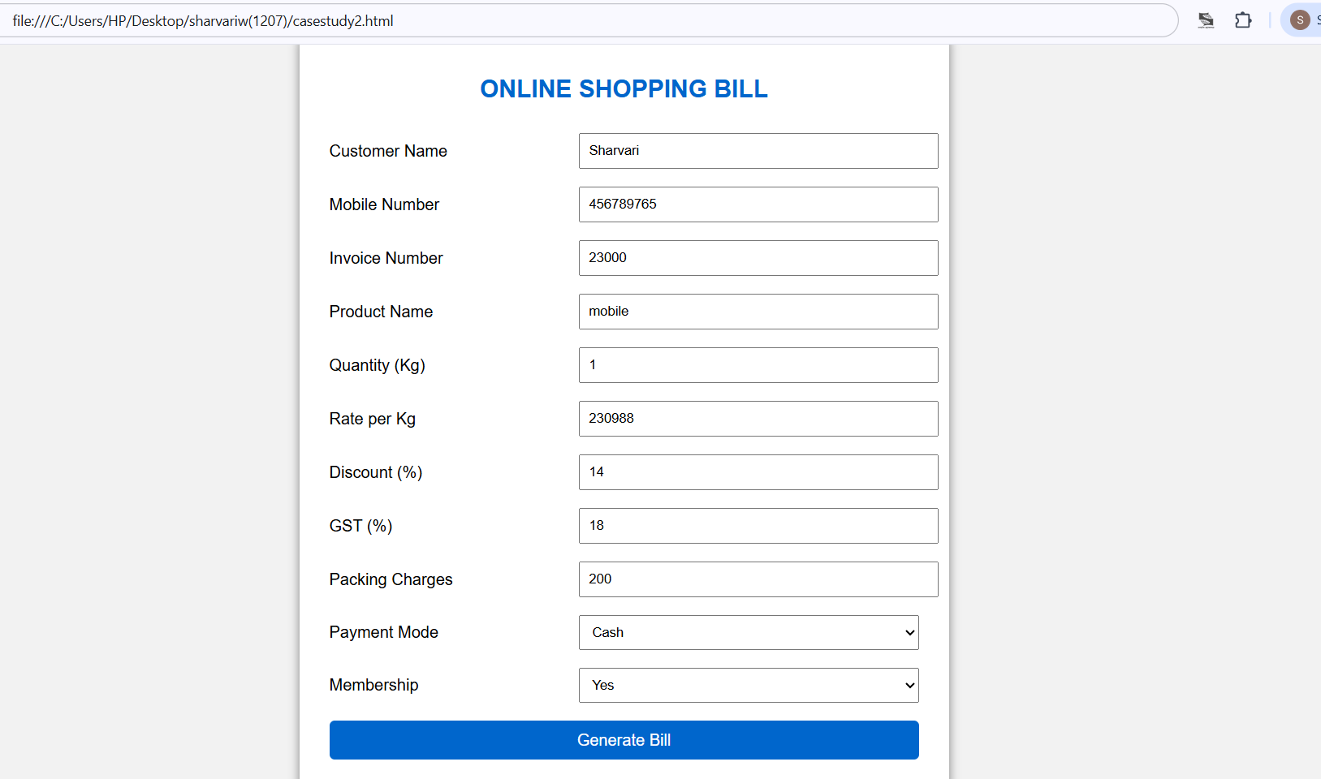

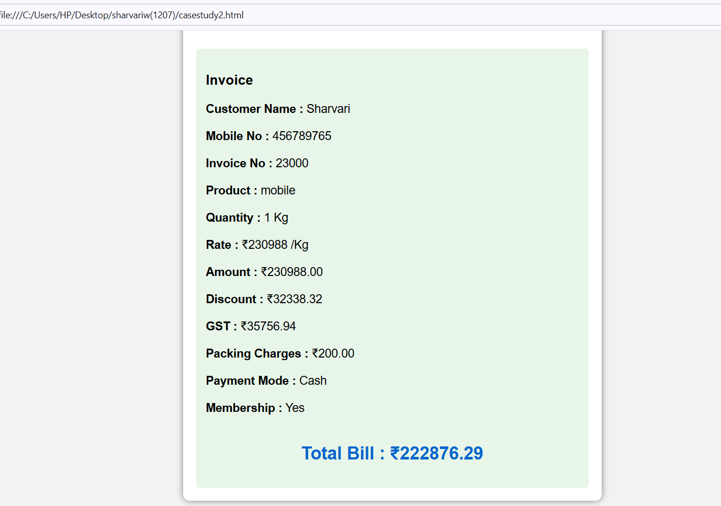

Result/Conclusion: The online shopping billing webpage was successfully developed using HTML, CSS, and JavaScript. The program accepted customer and product details, calculated the total bill including discount, GST, and packing charges, and displayed the final invoice correctly. It demonstrated the use of user input, arithmetic calculations, objects, template literals, and object destructuring in JavaScript.

.

