Student Performance Prediction — Final Report

Abstract
This study builds and evaluates two supervised classifiers—Logistic Regression (LR) and Random Forest (RF)—to predict whether a student passes using the student-mat dataset. The dataset contains 395 samples and 40 features after encoding; the target is imbalanced (passed = 265, failed = 130). LR achieved Accuracy = 0.7975, ROC-AUC = 0.887, PR-AUC = 0.948. RF achieved Accuracy = 0.7848, ROC-AUC = 0.856, PR-AUC = 0.914. Feature importance shows G1 as the dominant predictor. Both models perform well, with LR slightly outperforming RF on this split.

1. Problem Statement
The goal is to predict whether a student will pass based on demographic, academic, and behavioral features. Early detection supports interventions. Logistic Regression provides interpretability, while Random Forest captures non-linear interactions.

2. Data & Exploratory Analysis
Dataset: 395 rows, 40 encoded features. Class distribution: 67% passed, 33% failed. Issues include mild imbalance, correlated grade-related features, and outliers in absences. G1 (first period grade) strongly correlates with final outcome. Failures, absences, and behavioral features also show predictive value.

3. Methods
Train-test split used; metrics evaluated on held-out test set. LR used L2 regularization; RF tuned on depth, n_estimators, and split criteria. LR required scaling; RF did not. No SMOTE used to preserve original distribution.

4. Results — Logistic Regression
Accuracy: 0.7975
ROC-AUC: 0.887
PR-AUC: 0.948
Confusion Matrix:
Actual 0: 19 TN, 7 FP
Actual 1: 9 FN, 44 TP
LR performs strongly, especially in precision and discrimination metrics.

5. Results — Random Forest
Accuracy: 0.7848
ROC-AUC: 0.856
PR-AUC: 0.914
Confusion Matrix:
Actual 0: 18 TN, 8 FP
Actual 1: 9 FN, 44 TP
RF slightly underperforms LR in all major metrics.

6. Curve Analysis
LR shows superior ROC and PR curves. PR-AUC is particularly important for imbalance and LR achieves 0.948 vs RF’s 0.914. RF exhibits more fluctuation in precision across recall ranges.
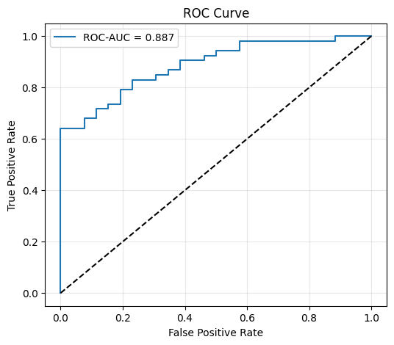
Fig.1: ROC Curve of Logistic Regression Model
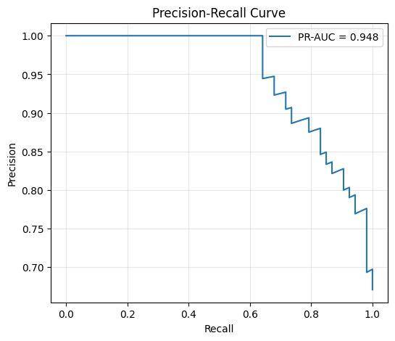
Fig.2: PR Curve of Logistic Regression Model
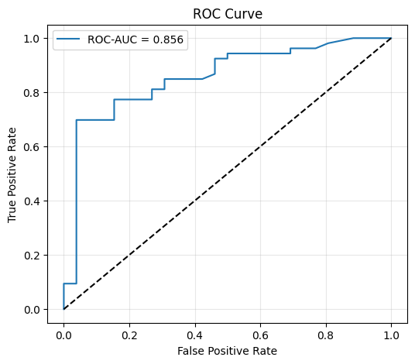
Fig.3: ROC Curve of Random Forest Model

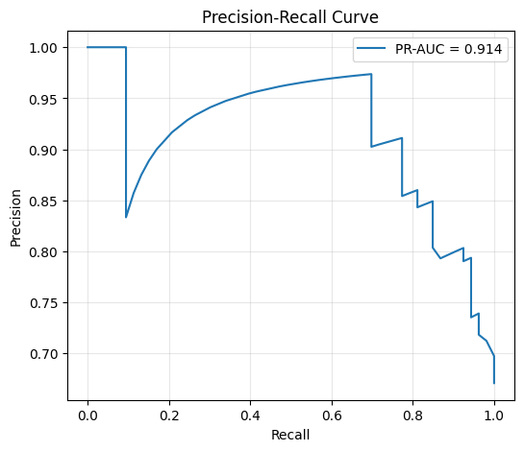
Fig.4: PR Curve of Random Forest Model

7. Error Analysis
Both models misclassify borderline cases, especially students with moderate grades but inconsistent attendance. False negatives (failing predicted as passing) remain the most problematic type: both models produce 9 FN. Over-reliance on G1 limits robustness, especially if early grades are noisy or unrepresentative.

8. Feature Importance
Top RF features:
G1: 0.329
failures: 0.068
absences: 0.063
goout: 0.036
age: 0.036
G1 dominates, indicating the need for feature engineering or regularization to avoid over-reliance.

9. Limitations
Small test size (79 samples) increases metric variance. Potential leakage risk from G1 if collected too close to outcome measurement. Single dataset limits generalization. No fairness or causality analysis conducted.

10. Conclusion
Logistic Regression slightly outperforms Random Forest on this dataset. Both models show strong predictive capability, but must be refined to reduce false negatives and over-reliance on early-term grades before real-world deployment.

