INTERNSHIP REPORT

A report submitted in partial fulfillment of the requirements for the Award of Degree of

BACHELOR OF TECHNOLOGY
in

Computer Science and Business Systems

by

SHARVESH S

23CB053

Under Supervision of
Mr. SANJAY RAJ. K.S
Managing Director
Reccsar Pvt Ltd .
Off: 1/6, 1 st Rathinasamy Nadar
Road, Madurai - 625014
(Duration: 23/06/2025 to 11/07/2025)



KPR INSTITUTE OF ENGINEERING AND TECHNOLOGY
(Autonomous, NAAC ‘A’) Avinashi Road, Arasur

COIMBATORE- 641 407

JULY-2025


KPR INSTITUTE OF ENGINEERING AND TECHNOLOGY
(Autonomous, NAAC ‘A’) Avinashi Road, Arasur
COIMBATORE- 641 407

BONAFIDE CERTIFICATE

This is to certify that the Internship report submitted by SHARVESH S (Roll No: 23CB053 ) is work done by him and submitted during the academic year 2025 – 2026, in partial fulfillment of the requirements for the award of the degree of Bachelor of Technology in Computer Science and Business Systems, at Reccsar Pvt Ltd, Madhurai. Reccsar Pvt Ltd, Madurai.

Department IIPC Coordinator | Head of the Department
Ms. R. KEERTHY, AP / I, CSBS | Dr Bazila Banu A.
Assistant Professor | Professor and Head
Department of Computer Science and Business Systems | Department of Computer Science and Business Systems
KPR Institute of Engineering and Technology  Arasur, Coimbatore - 641407 | KPR Institute of Engineering and Technology  Arasur, Coimbatore - 641407

Place : Coimbatore
Date :

INTERNSHIP COMPLETION CERTIFICATE

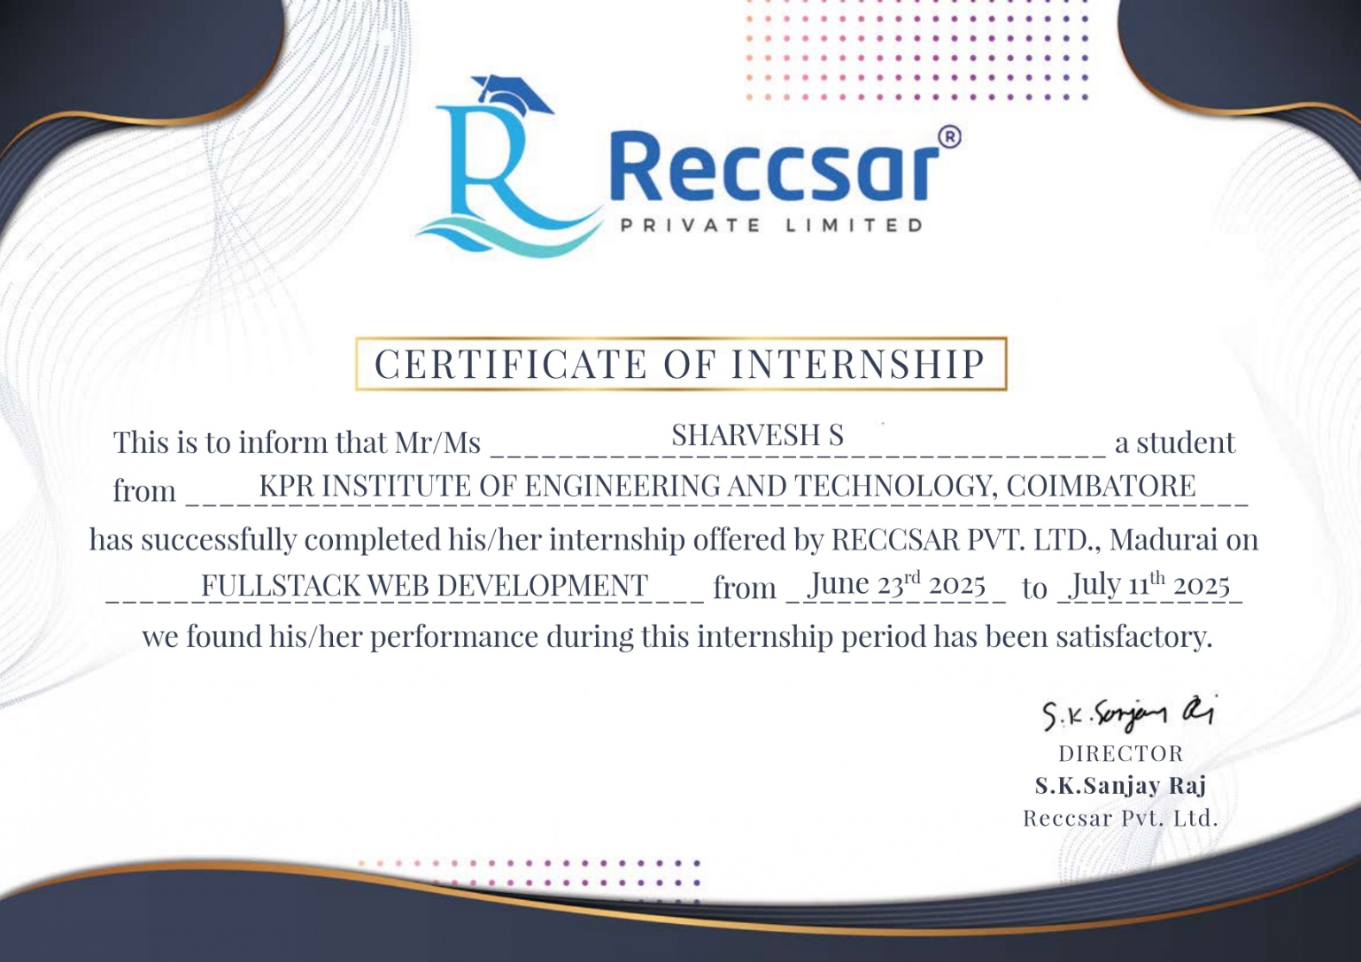

ACKNOWLEDGEMENT

First, I would like to express my sincere gratitude to Mr. Sanjay Raj, Managing Director, Reccsar
Pvt Ltd., for giving me the opportunity to undertake my internship in the organization.

I am also thankful to all the team members at Reccsar Pvt. Ltd. for their patience, guidance, and willingness to share their knowledge, which greatly enriched my learning experience and created an encouraging work environment.

It is with great pleasure and sincere gratitude that I acknowledge the support of these individuals.

I am highly indebted to our Chairman Dr. K. P. Ramasamy, our Chief Executive Officer Dr. Natarajan A. M., and our beloved Principal Dr. R. Devi Priya, for the facilities provided to accomplish this internship.

I would like to extend my sincere thanks to the Head of our Department, Dr. Bazila Banu A., for her continued support and for granting me permission to pursue this internship.

I am also thankful to Dr. R. Anandkumar, Associate Director, IIPC, KPRIET, for his invaluable guidance and support throughout the process of securing and completing my internship.

I am extremely grateful to my Assistant Professor and IIPC Coordinator, Ms. Keerthy R., as well as the faculty members and friends who supported me in the successful completion of this internship.

SHARVESH S

ABSTRACT

This internship report highlights my hands-on experience at Reccsar Private Ltd, where I delved into mern stack development during the period (14/06/2025 - 29/07/2025). Throughout This 15-day internship provided a comprehensive introduction to the core concepts of Full Stack Web Development, beginning with front-end fundamentals and gradually moving toward interactive application development. The initial phase focused on mastering HTML and CSS, where I learned how to structure web pages using semantic elements, incorporate metadata, and apply various CSS selectors effectively. I also explored essential styling techniques such as color properties, padding, margins, flexbox, and grid layouts. These concepts were applied in practical tasks, including the creation of an interactive login portal, which helped me understand how to design visually appealing, structured, and responsive web interfaces.
The next phase of the internship introduced JavaScript, enabling me to add dynamic behavior to web pages. I gained hands-on experience with key programming concepts such as variables, data types, conditional statements, loops, arrays, and destructuring. This strengthened my ability to write efficient logic and improved my overall problem-solving skills in web development.
Building on this foundation, I moved on to React JS, where I learned how modern web applications are built using a component-based architecture. Through React, I gained knowledge of JSX, props, state management, event handling, and conditional rendering. These concepts enabled me to develop reusable, efficient UI components and better understand how interactive and scalable web applications are structured.
Overall, this internship equipped me with a strong foundation in front-end development and introduced me to core principles of interactive application design. The combination of theoretical learning and hands-on project work has prepared me to pursue more advanced topics in full stack development and continue building practical, real-world applications.

TABLE OF CONTENTS

Chapter No | Title | Page No
 | SELF DECLARATION FORM | iii
 | INTERNSHIP CERTIFICATE | iv
 | ACKNOWLEDGMENT | v
 | ABSTRACT | vi
1 | About the Company | 1
2 | Plan of the internship program | 2
3 | Training Task | 4
4 | Conclusion | 9
5 | Industry Student Daily Diary
6 | Attendance Sheet  Industry Supervisor Evaluation Sheet

CHAPTER 1

About the Company



Reccsar Private Limited is a repository of practical knowledge and innovative solutions contributed by experts in the fields of IT and corporate training. Reccsar operates across the globe through its network of affiliates and partner organizations. Reccsar Private Limited offers corporate training, certification courses, skill development programs, research opportunities, and consulting services designed to empower organizations and individuals to thrive in a dynamic business environment.

Mission:
To help organizations to develop and maintain dexterity in their workforce to respond to changing market fluctuations, business demands, and keep pace as the future of work evolves.

Aim:
Reccsar Private Limited aims to deliver robust, solution-oriented IT and corporate training that equips organizations and individuals with the skills and adaptability needed to thrive in a dynamic, technology-driven environment.

Vision:
We envision to build strong relationships in communities. We know what organizations, workers,students, and experts want and we make to find better matches based on fit and performance.

CHAPTER 2

Plan of the Internship Program
My 2-week internship program offers a structured and practical introduction to Full Stack Web Development, covering the fundamentals of front-end technologies, JavaScript programming, and modern UI development with React JS.

In the initial week, I focused on the foundations of web development, starting with HTML and CSS. I learned about semantic structures, metadata, and formatting in HTML, followed by styling concepts such as selectors, colors, padding, flexbox, and grid in CSS. This week also included a mini project, where I created an interactive login portal using only HTML and CSS, reinforcing my understanding of responsive layouts and visual design.

The following week was dedicated to JavaScript and React JS. I explored programming concepts like variables, conditional statements, arrays, loops, and destructuring in JavaScript, which helped me add interactivity to static web pages. Building on this, I was introduced to React JS, where I worked with components, JSX, state, props, and conditional rendering to create dynamic and reusable UI components. This hands-on practice enabled me to understand how modern frameworks simplify complex UI development.

Throughout the internship, consistent practice and mini-projects ensured skill development and practical application. By the end of the program, I gained a strong foundation in building structured, styled, and interactive web applications, setting the stage for more advanced full stack development in the future.

WEEKLY OVERVIEW OF INTERNSHIP ACTIVITIES

Week 1: Foundations of HTML, CSS, and Basic Web Layout

DATE | DAY | NAME OF THE MODULE COMPLETED
23/06/2025 | Monday | Introduction to Full Stack Web Development
24/06/2025 | Tuesday | Introduction to HTML
25/06/2025 | Wednesday | Meta Data and Frames
26/06/2025 | Thursday | Introduction to CSS
27/06/2025 | Friday | Padding
30/06/2025 | Saturday | Flexbox, Pseudo Code, and Grid
01/07/2025 | Monday | Created an interactive Login portal using HTML and CSS

Week 2: JavaScript Essentials and Introduction to React Development

DATE | DAY | NAME OF THE MODULE COMPLETED
02/07/2025 | Tuesday | Grid Layout
03/07/2025 | Wednesday | Introduction to JavaScript
04/07/2025 | Thursday | Conditional Statements and Arrays
07/07/2025 | Friday | Looping Statements
08/07/2025 | Saturday | Destructuring
09/07/2025 | Sunday | Introduction to React JS
10/07/2025 | Monday | Props and Conditional Rendering
11/07/2025 | Friday | Recreation of a web page task and evaluation

CHAPTER 3
Training Task
During my 15-day web development internship, I completed two practical front-end tasks that helped me apply the HTML, CSS, and layout techniques I learned. These tasks involved recreating a modern login page and designing a dashboard-style web layout, allowing me to practice real-world interface building and improve my understanding of responsive and structured web design.

Task 1: Recreation of an Interactive Login Page
As part of the internship, I was assigned the task of recreating a modern interactive login page using HTML and CSS. In this task, I designed a two-section layout consisting of a graphical panel on the left and a login form on the right. I used HTML5 semantic structure to organize the content and applied CSS Flexbox to align and position the elements effectively. The login form included styled input fields, rounded buttons, social login icons, and proper spacing to maintain a clean and user-friendly interface. I also worked on visual elements such as background colors, font styling, hover effects, and responsive alignment to ensure the layout adapted well to different screen sizes. This task helped me understand how professional login pages are designed and strengthened my skills in creating clean, aesthetically appealing, and responsive front-end interfaces using HTML and CSS.
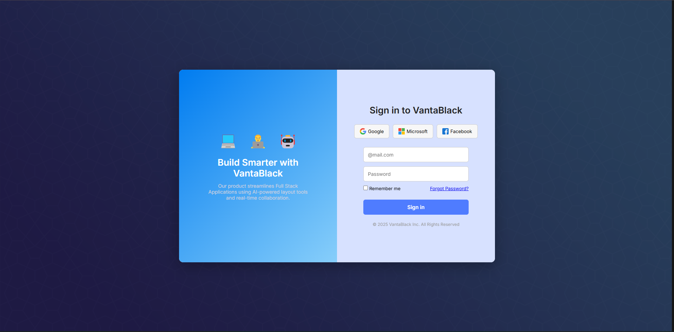

Task 2: Recreation of a Dashboard Web Page Layout
The second major task during the internship involved recreating a dashboard-style web page similar to an admin panel. For this assignment, I developed a sidebar navigation menu with multiple items, a top navigation bar containing a search box and user information, and a multi-section dashboard layout. I used CSS Grid to structure the main content area, positioning multiple cards and panels in a responsive grid format. Flexbox was applied to create the header and sidebar alignment, ensuring a consistent and organized layout. I worked on maintaining uniform spacing, choosing appropriate colors, and arranging various content blocks to achieve a professional dashboard appearance. This task provided practical experience in handling complex layouts and taught me how to combine Grid and Flexbox for detailed interface design. It enhanced my understanding of modern dashboard structures and improved my ability to create visually balanced, functional, and responsive web page layouts.

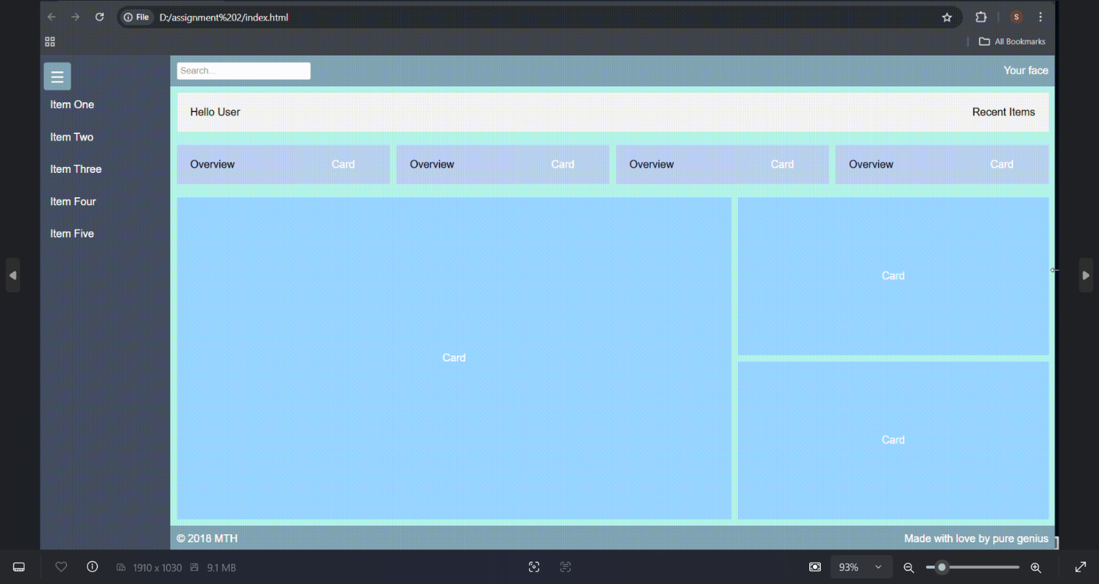

CHAPTER 4
Conclusion
In the beginning, the orientation and onboarding phase introduced me to the fundamentals of Full
Stack Web Development, covering the basics of HTML, CSS, and the core principles of front end
and back-end development. This created the perfect foundation on which I built my knowledge of
web technologies.

The subsequent days were dedicated to hands-on learning. I had the opportunity to practice HTML
and CSS extensively, create responsive layouts with flexbox and grid, and even build an interactive
login portal. Moving forward, I explored JavaScript, where I learned about variables, arrays
conditional statements, loops, and destructuring—skills that allowed me to add interactivity and
logic to web pages.

I also gained exposure to modern development practices through React JS, where I worked
with components, JSX, state, props, and conditional rendering. This gave me insights into how
developers build reusable and dynamic UI components in real-world projects. The mini-projects and
exercises helped me showcase my skills in a practical setting, blending structure, design, and
interactivity into functional web applications.

Overall, this internship has been an invaluable experience. I leave with strong foundational
knowledge in HTML, CSS, JavaScript, and React JS, along with the confidence to continue exploring
full stack development. I am grateful for the guidance and practice I received, and I am excited to
build on this experience as I move toward more advanced projects and real-world applications in the
field of web development.

